Virologica Sinica

Supplementary Data

An Integrated Rapid Nucleic Acid Detection Assay Based on Recombinant Polymerase Amplification for SARS-CoV-2

Ying Tang ^{a, b, c, 1}, Yiqin Wang ^{f, 1}, Yuchang Li ^{a, b}, Huai Zhao ^{e}, Sen Zhang ^{a, b}, Ying Zhang ^{b}, Jing Li ^{a, b}, Yuehong Chen ^{a, b}, Xiaoyan Wu ^{a, b}, Chengfeng Qin ^{a, b, d}, Tao Jiang ^{a, b, d *}, Xiaoping Kang ^{a, b, c *}

ª Department of Virology, Beijing Institute of Microbiology and Epidemiology, AMMS, Beijing 100071, China
^{b} State Key Laboratory of Pathogen and Biosecurity, AMMS, Beijing 100071, China;
^{c} Beijing University of Chemical Technology, Beijing 100029, China;
^{d} Anhui Medical University, Hefei 230032, China;
^{e} Lifereal Biotech. Inc., Hangzhou 311100, China;
^{f} Technology Center of Erenhot Customs, Erenhot 011100, China

* Corresponding authors:
Department of Virology, Beijing Institute of Microbiology and Epidemiology, AMMS, Beijing 100071, China

E-mail addresses:
kangxiaoping@163.com (X. Kang); jiangtao@bmi.ac.cn (T. Jiang)

ORCID:
0000-0002-0587-399X (X. Kang); 0000-0003-1908-2926 (T. Jiang)

¹ Ying Tang and Yiqin Wang contributed equally to this work.

Supplementary Materials
Quantitative RT-PCR assay
The qRT-PCR reaction contained 5 µL RNA, 5 µL of 4× TaqMan Fast Virus 1-step mix (Applied Biosystems,Vilnius, Lithuania), 1 µL of forward primer (10 µmol/L), 1 µL of reverse primer (10 µmol/L), 0.5 µL of probe (10 µmol/L), The sequences of the primers and probe was were as follows: Forward: 5′-TCCTGGTGATTCTTCTTCAGGT-3′, Reverse:5′-TCTGAGAGAGGGTCAAGTGC-3′, Probe: 5’FAM-AGCTGCAGCACCAGCTGTCCA-BHQ1, and 7.5 µL of sterile deionized water; final volume was 20 µl. Reactions were performed in a LightCycler 480 Real Time PCR instrument (Roche Diagnostics, Mannheim,Germany). Amplification conditions were as follows: reverse transcription at 50 °C for 5 min; pre-denaturation at 95 °C for 10 sec; and 40 cycles of PCR amplification consisting of denaturation at 95 °C for 5 sec, annealing at 60 °C for 30 sec, and fluorescence measurement.

Integrated Recombinant Polymerase Amplification (I-RPA)
The I-RPA system comprised a cartridge and an automatic nucleic acid detection device. The cartridge (Fig. 1A) consists of area 1, area 2, and area 3, adjacent areas are separated by a plunger seal.
Sample treatment buffer consisted of TECP (0.1 µmol/L) and EDTA (0.001 mol/L). RPA reaction mixture was prepared by adding 40.2 mL of buffer A (Zhongce Inc., Hangzhou, China), 10 mL of water, 2.1 mL of forward primer (10 µmol/L), 2.1 mL of reverse primer (10 µmol/L), and 0.6 mL of the probe (10 µmol/L) to the dry enzyme tube, followed by mixing. For the I-RPA assay, the plunger seals in the cartridge were turned to the open position, and 10 µL of each clinical sample was mixed with 1 µL of sample treatment buffer (Fig. 1A-a). The mixture was added to area 1 of the cartridge, after which plunger seal 1 was closed (Fig. 1A-b). Next, 2.5 μL of MgAc was placed in area 2 and plunger seal 2 was closed (Fig. 1A-c). Finally, the RPA reaction mixture was added to area 3 and plunger seal 3 was closed. The lid of the cartridge was closed tightly and the cartridge was placed in the I-RPA device (LifeReady1000, Hangzhou Lifereal Biotechnology, Hangzhou, China) for amplification (Fig. 1A-d). The cartridge was heated at 95 °C for 10 min and then removed from the I-RPA device. Next, plunger seals 1 and 2 were opened and the cartridge swung so that the liquid in areas 2 and 3 flowed into area 1 (Fig. 1A-e). Finally, the cartridge was placed back in the I-RPA device and incubated at 42 °C for 20 min. Real-time fluorescence signals were detected and analyzed over time.

Table S1. Sequences of the primers and probe used for the RPA assay
Primer name | Sequence (5’to 3’)ª | Position (size, bp)^{b}
Cov-RPA-F2 | ACATAGAAGTTATTTGACTCCTGGTGATTC | 22,269–22,298 (30)
Cov-RPA-F3 | TAGAAGTTATTTGACTCCTGGTGATTCTTC | 22,272–22,301 (30)
Cov-RPA-F1 | TATTTGACTCCTGGTGATTCTTCTTCAGGT | 22,279–22,308 (30)
Cov-RPA-P | AAAGTCCTAGGTTGAAGATAACCCACATAAFAAHCQGCAGCACCAGCTGTCCA-[3′-block] | 22,309–22,361 (53)
Cov-RPA-R1 | ACACTTTGTTTCTGAGAGAGGGTCAAGTGC | 22,411–22,440 (30)
CoV-RPA-R2 | TCAAGTGCACAGTCTACAGCATCTGTAATG | 22,389–22,418 (30)
CoV-RPA-R3 | AACAATAGATTCTGTTGGTTGGACTCTAAA | 22,489–22,518 (30)
ª F: FAM-dT, thymidine nucleotide carrying fluorescein; H: THF, tetrahydrofuran spacer; Q: BHQ1-dT, thymidine nucleotide carrying Black-Hole Quencher 1; 3′-block: 3′-phosphate introduced to block elongation.
^{b} Numbers in position column are primer positions according to SARS-CoV-2, hCoV-19/Wuhan/WH01/2019|EPI_ISL_406798|2019-12-26

Table S2. Analysis of clinical samples by I-RPA and rRT-PCR
Sample | Results |  |  | Sample | Results
 | I-RPA | Real-time Ct value  (Mean ±2SD) |  |  | I-RPA | Real-time Ct value  (Mean ±2SD)
P1 | P | 27.31±0.92 |  | P22 | P | 19.8±0.18
P2 | P | 26.98±0.33 |  | P23 | P | 25.31±0.06
P3 | P | 29.72±0.72 |  | P24 | P | 22.9±0.08
P4 | P | 29.81±0.07 |  | P25 | P | 26.59±0.72
P5 | P | 29.2±0.43 |  | P26 | P | 22.88±0.32
P6 | P | 29.07±0.78 |  | P27 | P | 31.72±0.16
P7 | P | 28.53±0.22 |  | P28 | P | 30.65±0.21
P8 | P | 27.66±0.56 |  | P29 | P | 33.79±0.37
P9 | P | 31.71±0.20 |  | P30 | P | 29.46±0.52
P10 | P | 32.9±0.14 |  | P31 | P | 25.27±0.68
P11 | P | 29.92±0.77 |  | P32 | P | 35.83±0.77
P12 | P | 29.2±0.65 |  | P33 | P | 25.75±0.89
P13 | P | 29.07±0.32 |  | P34 | P | 36.58±0.48
P14 | P | 31.59±0.35 |  | P35 | P | 20.71±0.86
P15 | P | 33.48±0.12 |  | P36 | P | 35.31±0.22
P16 | P | 33.14±0.42 |  | P37 | P | 36±0.72
P17 | N | 36.84±0.68 |  | P38 | N | 38.69±0.33
P18 | N | 37.11±0.32 |  | S1 | P | 33.21±0.71
P19 | P | 25±1.14 |  | S2 | P | 29.09±1.32
P20 | P | 27.88±0.98 |  | S3 | P | 29.91±0.62
P21 | P | 17.31±1.08 |  | S4 | P | 32.83±0.88

P: positive; N: negative; P1-P38: Pharyngeal swab samples; S1-S4:Sputum samples.
SD: standard deviation

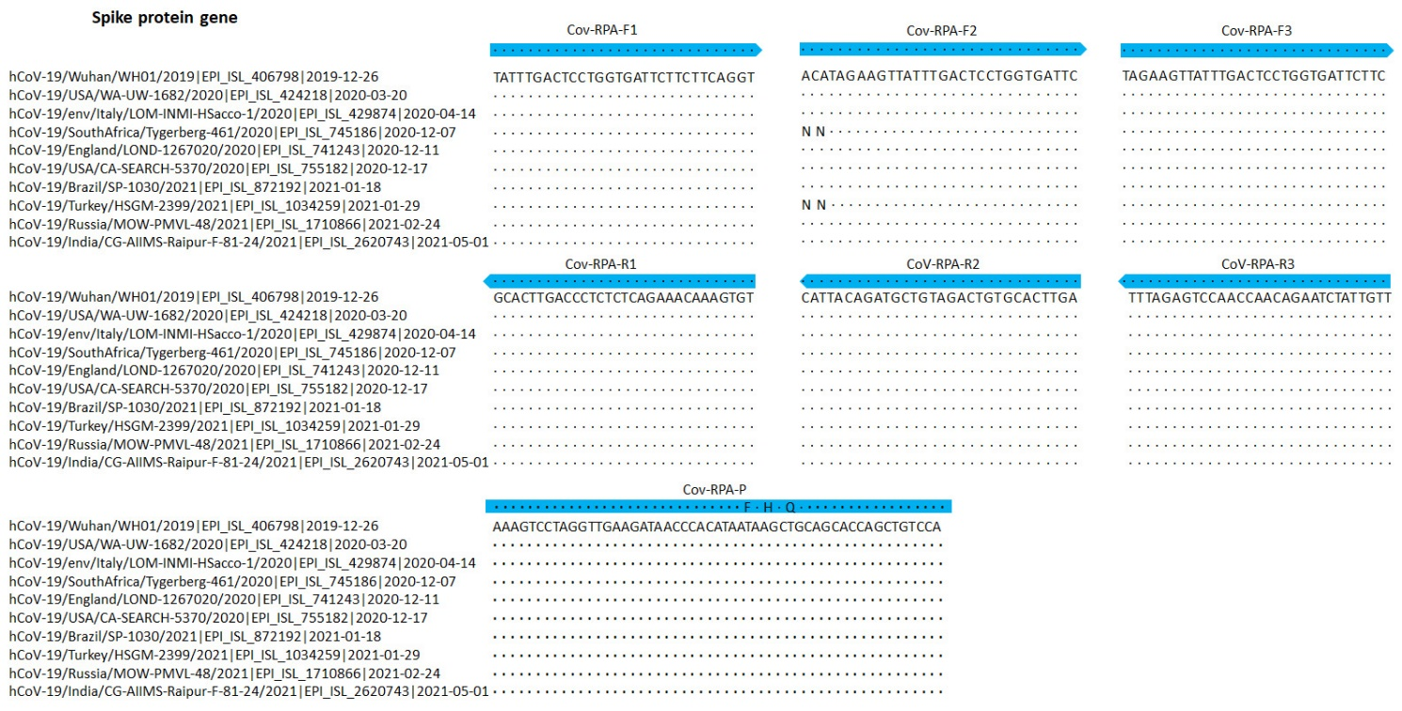
Figure S1. Partial alignments of oligonucleotide binding regions, SARS-CoV-2-related coronaviruses (n = 10). The panels show ten sequences of 2019-nCoV strains, aligned to the partial Spike protein sequences of hCoV-19/Wuhan/WH01/2019 beta coronavirus. The alignment also contains the India Delta variant (hCoV-19/India/CG-AIIMS-Raipur-F-81-24/2021, GISAID EpiFlu™ Database accession ID is EPI_ISL_2620743), the South Africa variant (hCoV-19/SouthAfrica/Tygerberg-461/2020|EPI_ISL_745186|2020-12-07) and the UK variant (hCoV-19/England/LOND-1267020/2020 |EPI_ISL_741243| 2020-12-11). Dots represent identical nucleotides compared with the hCoV-19/Wuhan/WH01/2019 beta coronavirus sequence. N: deleted nucleotide. Blue arrows: sequences of the primers and probe used for the RPA assay.

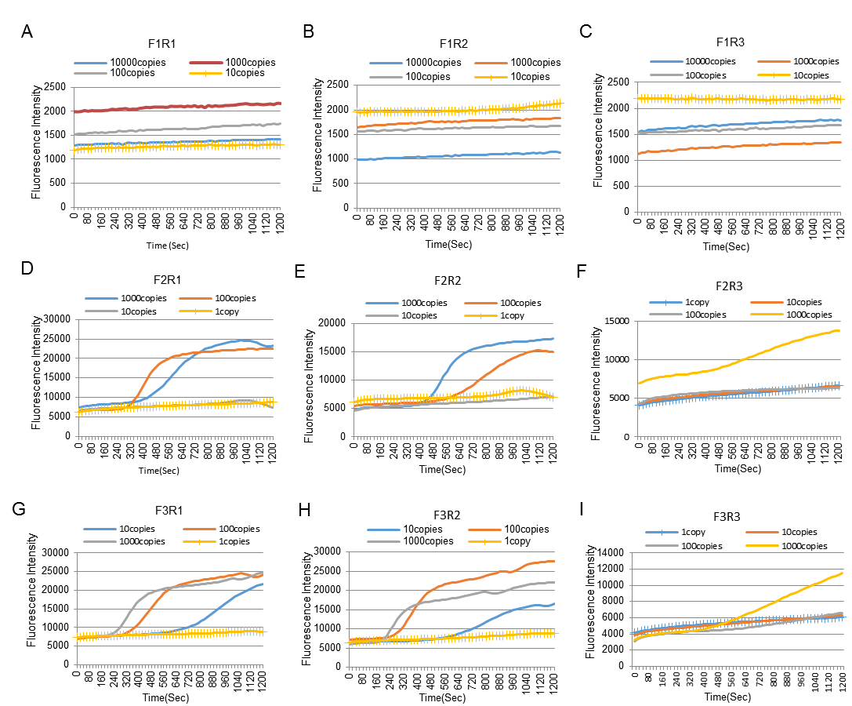
Figure S2. Sensitivity comparison of nine primer sets. (A) The sensitivity of F1R1 primers; (B) The sensitivity of F1R2 primers; (C) The sensitivity of F1R3 primers; (D) The sensitivity of F2R1 primers; (E) The sensitivity of F2R2 primers; (F) The sensitivity of F2R3 primers; (G) The sensitivity of F3R1 primers; (H) The sensitivity of F3R2 primers; (I) The sensitivity of F3R3 primers.

