Virologica Sinica

Supplementary Data

Viral metagenomics reveals diverse viruses in the fecal samples of children with diarrhea

Shixing Yang ^{a,b,1}, Yumin He ^{a,1}, Ju Zhang ª, Dianqi Zhang ª, Yan Wang ª, Xiang Lu ª, Xiaochun Wang ª, Quan Shen ª, Likai Ji ª , Hongyan Lu ^{b,*}, Wen Zhang ^{a,*}

ª School of Medicine, Jiangsu University, Zhenjiang, 212013, China
^{b} Department of Pediatrics, Affiliated Hospital of Jiangsu University, Zhenjiang, 212013 China

* Corresponding authors.
E-mail addresses: z0216wen@yahoo.com (W. Zhang), lhy5154@163.com (H. Lu).

¹ Shixing Yang and Yumin He contributed equally to this work.

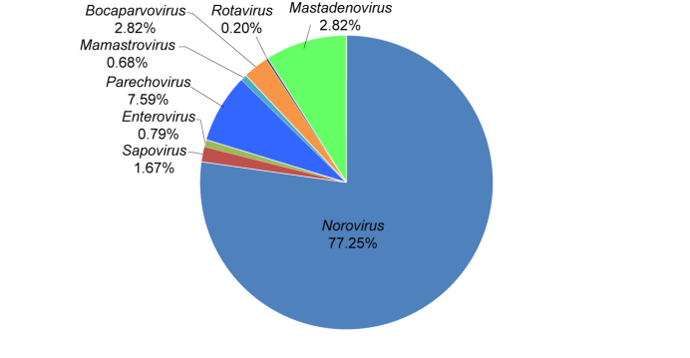
Supplementary Fig. S1 The composition of fecal virome detected in diarrheal children. The percentage of virus sequences in different virus genera was shown.
Supplementary Table S1 The summary of library information of diarrheal children.
Library ID | Sample type | No. of sample | Healthy status | Total no. of raw reads | No. of viral reads with E value < 10⁻⁵
1 | Feces | 10 | Diarrhea | 207,772 | 93,011
2 | Feces | 10 | Diarrhea | 141,866 | 21,687
3 | Feces | 10 | Diarrhea | 536,357 | 280,253
4 | Feces | 10 | Diarrhea | 291,565 | 158,285
5 | Feces | 10 | Diarrhea | 1,051,185 | 327,022
6 | Feces | 10 | Diarrhea | 223,336 | 49,758
7 | Feces | 10 | Diarrhea | 221,869 | 106,711
8 | Feces | 10 | Diarrhea | 517,793 | 100,183
9 | Feces | 10 | Diarrhea | 300,505 | 41,050
10 | Feces | 10 | Diarrhea | 120,462 | 6,103
E-value, expected value.

Supplementary Table S2 The sequence numbers of eukaryotic viruses in family level in different libraries of this study.
Virus Families | No. of viral reads with E value < 10⁻⁵
 | L1 | L2 | L3 | L4 | L5 | L6 | L7 | L8 | L9 | L10
Adenoviridae | 0 | 0 | 0 | 0 | 0 | 0 | 26,422 | 0 | 0 | 0
Anelloviridae | 0 | 0 | 0 | 0 | 0 | 111 | 0 | 0 | 0 | 14
Astroviridae | 0 | 0 | 0 | 0 | 0 | 0 | 0 | 2,823 | 671 | 0
Caliciviridae | 0 | 2,015 | 0 | 14,471 | 123,887 | 8,615 | 74,359 | 2,747 | 5,387 | 168
Parvoviridae | 0 | 0 | 0 | 0 | 0 | 616 | 0 | 7,680 | 0 | 0
Picobirnaviridae | 0 | 0 | 0 | 0 | 0 | 0 | 0 | 0 | 100 | 0
Picornaviridae | 0 | 384 | 615 | 16,393 | 2,939 | 4,354 | 0 | 0 | 0 | 22
Reoviridae | 60 | 116 | 0 | 0 | 0 | 164 | 0 | 102 | 47 | 107
L1–L10: the abbreviation of library names.
Supplementary Table S3 The sequence numbers of eukaryotic viruses in genus level in different libraries of this study.
Virus Genus | No. of viral reads with E value < 10⁻⁵
 | L1 | L2 | L3 | L4 | L5 | L6 | L7 | L8 | L9 | L10
Norovirus | 0 | 2,015 | 0 | 14,471 | 123,887 | 8,615 | 74,359 | 2,747 | 499 | 168
Sapovirus | 0 | 0 | 0 | 0 | 0 | 0 | 0 | 0 | 4,888 | 0
Mamastrovirus | 0 | 0 | 0 | 0 | 0 | 0 | 0 | 2,823 | 671 | 0
Enterovirus | 0 | 0 | 0 | 609 | 0 | 0 | 1,495 | 0 | 0 | 19
Parechovirus | 0 | 379 | 0 | 16,343 | 2,726 | 2,841 | 0 | 0 | 0 | 0
Mamastrovirus | 0 | 0 | 0 | 0 | 0 | 0 | 0 | 1,393 | 597 | 0
Bocaparvovirus | 0 | 0 | 0 | 0 | 0 | 607 | 0 | 7,680 | 0 | 0
Rotavirus | 60 | 116 | 0 | 0 | 0 | 164 | 0 | 102 | 47 | 107
Mastadenovirus | 0 | 0 | 0 | 0 | 0 | 0 | 26,410 | 0 | 0 | 0
L1–L10: the abbreviation of library names.

