Virologica Sinica

Supplementary Data

FoxJ1 inhibits African swine fever virus replication and viral S273R protein decreases the expression of FoxJ1 to impair its antiviral effect

Caina Maª, Shasha Li^{b}, Fan Yang^{b}, Weijun Cao^{b}, Huisheng Liu^{b}, Tao Feng^{b}, Keshan Zhang^{b}, Zixiang Zhu^{b}, Xiangtao Liu^{b}, Yonghao Hu^{a*}, Haixue Zheng^{b*}

- College of Veterinary Medicine, Gansu Agricultural University, Lanzhou, 730070, China
- State Key Laboratory of Veterinary Etiological Biology, National Foot and Mouth Diseases Reference Laboratory, Key Laboratory of Animal Virology of Ministry of Agriculture, Lanzhou Veterinary Research Institute, Chinese Academy of Agricultural Sciences, Lanzhou, 730046, China

Corresponding author:
haixuezheng@163.com (H. Zheng)
Supplementary Table S1. The qPCR primers and siRNA sequences used in this study.
Primer | Sequence (5’–3’) | Target gene
pIFN-β-F | GCTAACAAGTGCATCCTCCAAA | Porcine IFN-β gene
pIFN-β-R | AGCACATCATAGCTCATGGAAAGA
pISG15-F | GATCGGTGTGCCTGCCTTC | Porcine ISG15 gene
pISG15-R | CGTTGCTGCGACCCTTGT
pISG54-F | CTGGCAAAGAGCCCTAAGGA | Porcine ISG54 gene
pISG54-R | CTCAGAGGGTCAATGGAATTCC
pISG56-F | TTAGAAAACAGGGTCTTGGAGGAG | Porcine ISG56 gene
pISG56-R | CGTAAGGTAATACAGCCAGGCATA
pGAPDH-F | ACATGGCCTCCAAGGAGTAAGA | Porcine GAPDH gene
pGAPDH-R | GATCGAGTTGGGGCTGTGACT
pFoxJ1-F  pFoxJ1-R | TACTCCTATGCCACGCTCAT  GCGGAAGTAGCAGAAGTTGTC | Porcine FoxJ1 gene
mFoxJ1-F  mFoxJ1-R | GTGGACTACGCCACCAATCC  TAGATGGCCGACAGGGTGAT | Monkey FoxJ1 gene
mGAPDH-F  mGAPDH-R | CCTGCACCACCAACTGCTTA  CATGAGTCCTTCCACGATACCA | Monkey GAPDH gene
mISG15-F  mISG15-R | TGGACAAATGCGACGAACC  CCCGCTCACTTGCTGCTT | Monkey ISG15 gene
mISG54-F  mISG54-R | ACCGAACAATGCCTACCTG  TGAGCCACAGCGTGTCCTA | Monkey ISG54 gene
mISG56-F  mISG56-R | TGTATTACCACATGGGCAGAC  ATCCAGGCGATAGGCAGAG | Monkey ISG56 gene
mIFN-β-F  mIFN-β-R | GACATCCCTGAGGAGATTAAG  ATGTTCTGGAGCATCTCATAG | Monkey IFN-β gene
ASFV p72 (B646L)-F | TGCGATGATGATTACCTT | ASFV B646L gene
ASFV p72(B646L)-R | ATTCTCTTGCTCTGGATAC
ASFV p30(CP204L)-F | CTCCGATGAGGGCTCTTGCT | ASFV CP204L gene
ASFV p30(CP204L)-R | AGACGGAATCCTCAGCATCTTC
FoxJ1-siRNA-911(FoxJ1-siRNA)-F  FoxJ1-siRNA-911(FoxJ1-siRNA)-R | CUCAAAGGCAACUUCGACUTT  AGUCGAAGUUGCCUUUGAGTT | Porcine FoxJ1 gene
FoxJ1-siRNA-911(FoxJ1-siRNA1)-F  FoxJ1-siRNA-911(FoxJ1-siRNA1)-R | CUCAAAGGCAACUUCGACUTT  AGUCGAAGUUGCCUUUGAGTT | Monkey FoxJ1 gene

Supplementary Table S2. The top ten genes that were most significantly down-regulated at each time point after ASFV infection.
Gene category | 12 hpi |  | 24 hpi |  | 48 hpi
 | Gene | log²Fold Change | Gene | log²Fold Change | Gene | log²Fold Change
Downregulated | LOC100522201 | -12.873 | LOC100522201 | -12.992 | LOC100522201 | -12.735
 | FOSB | -9.033 | FOSB | -11.965 | FOXJ1 | -12.464
 | FOXJ1 | -8.936 | FOXJ1 | -10.863 | FOSB | -11.374
 | LOC100038328 | -8.756 | RRAD | -9.777 | RRAD | -10.521
 | FOS | -8.446 | ID1 | -9.281 | LOC396781 | -9.973
 | EGR4 | -8.065 | MT1D | -9.072 | CLEC12A | -9.371
 | KIF18B | -7.779 | FAM83D | -9.008 | METTL24 | -9.138
 | PLIN1 | -7.772 | ARC | -8.940 | LOC110258822 | -9.120
 | LOC102162420 | -7.567 | KIF18B | -8.861 | LOC100038328 | -8.619
 | E2F8 | -7.523 | THBD | -8.775 | PLIN1 | -8.596

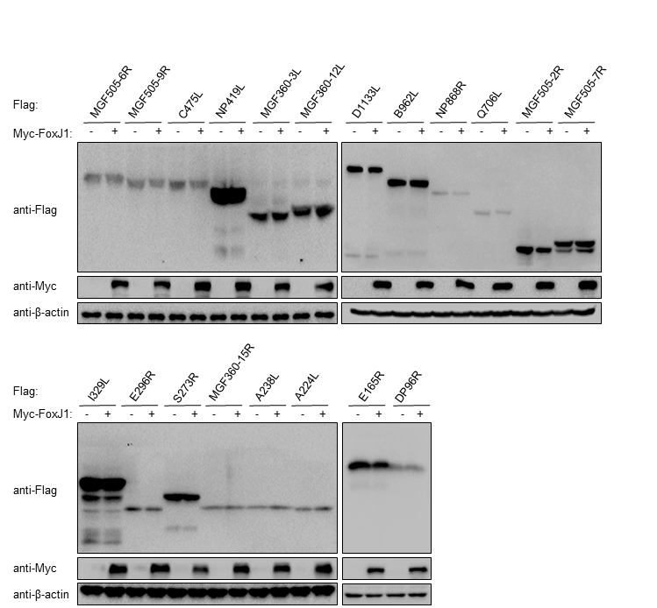
Supplementary Figure S1. Screening of ASFV proteins that interacted with FoxJ1. iPAM cells were co-transfected with empty vector (2 µg/well) or Myc-FoxJ1 (2 µg/well) expressing plasmids and the indicated ASFV protein-expressing plasmids (2 µg/well) for 24 h. The expression of the indicated viral proteins and FoxJ1 was then detected by Western blotting.

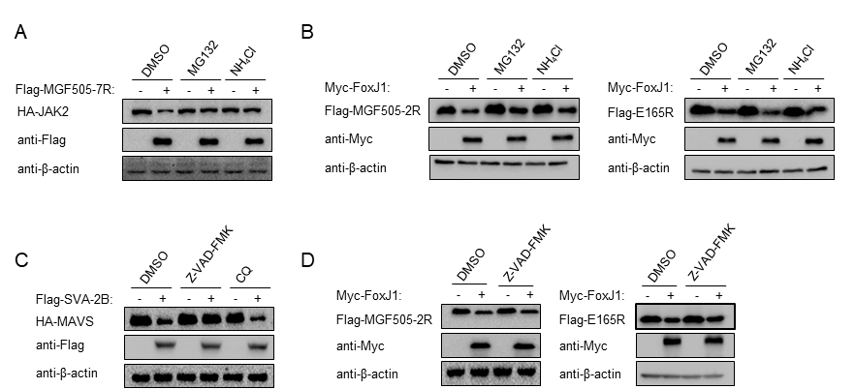
Supplementary Figure S2. Working concentration of MG132, Z-VAD-FMK, CQ, and NH₄Cl in iPAM cells. A The effects of inhibitors on the MGF-505-7R-mediated destabilization of JAK2. iPAM cells were transfected with MGF505-7R expressing plasmids or empty vector, and JAK2 expressing plasmids. MG132 (50 μmol/L) or NH₄Cl (20 mmol/L) was added after transfection for 18 h. After 6 h incubation, the expression of HA-JAK2 was detected by Western blotting. B iPAM cells were transfected with MGF505-2R or E165R expressing plasmids, and vector or FoxJ1 expressing plasmids. MG132 (50 μmol/L) or NH₄Cl (20 mmol/L) was added after18 h transfection. After 6 h treatment, the expression of Flag-MGF505-2R or Flag-E165R was detected by Western blotting. C iPAM cells were transfected with SVA-2B expressing plasmids or empty vector plasmids, and MAVS expressing plasmids. Z-VAD-FMK (50 μmol/L) and CQ (100 μmol/L) was added after 18 h transfection. After 6 h treatment, the expression of HA-MAVS was detected by Western blotting. D iPAM cells were transfected with MGF505-2R or E165R expressing plasmids, and vector or FoxJ1 expressing plasmids. Z-VAD-FMK (50 μmol/L) was added after 18 h transfection. After 6 h incubation, the expression of Flag-MGF505-2R or Flag-E165R was detected by Western blotting.

