Virologica Sinica

Supplementary Data

Saliva-based point-of-care testing techniques for COVID-19 detection

Shiwen Wang^{a,b}, Ying Liu^{d}, Yang Qiu^{c}, Qian Dou ^{a,e}, Yang Han ^{c,d}, Muhan Huang ^{c}, Ke Hong ^{d}, Bei Yang ^{a,e,*}, Xi Zhou ^{c,d,*}, Qing Dai ^{a,e,*}

ª CAS Key Laboratory of Nanophotonic Materials and Devices, CAS Key Laboratory of Standardization and Measurement for Nanotechnology, CAS Center for Excellence in Nanoscience, National Center for Nanoscience and Technology, Beijing, 100190, China
^{b} Tianjin Key Laboratory of Molecular Optoelectronic Sciences, Department of Chemistry, School of Sciences, Tianjin University, Tianjin, 300072, China
^{c} State Key Laboratory of Virology, Wuhan Institute of Virology, Center for Biosafety Mega-Science, Chinese Academy of Sciences, Wuhan, 430071, China
^{d} Joint Laboratory of Infectious Diseases and Health, Wuhan Institute of Virology & Wuhan Jinyintan Hospital, Wuhan Jinyintan Hospital, Wuhan, 430048, China
^{e} Center of Materials Science and Optoelectronics Engineering, University of Chinese Academy of Sciences, Beijing, 100049, China

* Corresponding authors.
E-mail addresses: daiq@nanoctr.cn (Q. Dai), zhouxi@wh.iov.cn (X. Zhou), yangb2020@nanoctr.cn (B. Yang)

Patient recruitment
A cohort of 100 COVID-19 patients (62 males, 38 females) was enrolled at the Wuhan Jinyintan hospital in Hubei province before July 2020, with an age range of 13–82 years (average, 52 ± 14 years). The patients were asked to simultaneously provide serum and saliva specimens. Subsequently, SARS-CoV-2-specific IgG antibody levels were detected and quantified in both samples by an enzyme-linked immunosorbent assay (ELISA) kit (provided by Wuhan KeyuanAnbo Biotechnology Co. Ltd., Wuhan, China).
Sample collection
Saliva samples were collected by chewing on a cotton swab with a saliva collection device (Salivette, Germany) for 3–5 min, or until saturation. The saturated cotton swab was then inserted into the storage tube, capped, and stored at −20 °C until processing. Blood samples were collected into serum separator tubes (SST). Both serum and saliva were heated at 50 °C and inactivated for 30 min and then stored at 4 °C until analysis. Saliva was separated from the cotton swab through centrifugation (10 min, 3010 ×g) and transferred to the attached 2-mL cryovial.
Laboratory methods
The saliva and serum samples were centrifuged for 20 min at 3010 ×g and the supernatants were extracted. SARS-CoV-2 IgG antibodies were measured in both samples using an ELISA kit (Wuhan KeyuanAnbo Biotechnology Co. Ltd., Wuhan, China). To accurately measure the level of IgG antibodies, serum samples were diluted 1:400 with the provided sample buffer, while the saliva samples were used without further processing. Serum and saliva samples were added to wells, incubated at 37 °C for 1 h, then washed with buffer containing 2% serum albumin. Thereafter, mouse anti-human antibody supplemented with horseradish peroxidase was added and incubated for 30 min at 37 °C. Next, solution A (containing carbamide peroxide) and solution B (containing tetramethylbenzidine, TMB) were added and mixed. The colorimetric reaction proceeded for 15 min at room temperature and 50 µL of H₂SO₄ was added into the wells. Finally, the optical density (OD) was recorded by an automated reader (Multimode Plate Reader, PerkinElmer).
Relationship between optical density and IgG titers
As shown in Supplementary Fig. S1, the serum samples were diluted with a known IgG titer (TCID50, 1280) (diluted from 1:100 to 1:12,800) to determine the corresponding relationship between OD and titers. The titers were linearly proportional to the OD within the range of 0.1–1.6 (dilution ratio ranges from 1:800 to 1:12,800, Y = 0.109 + 1.751X, R² = 0.9891), indicating that the OD has a good corresponding relationship with the titers.
Data stability
The testing stability of the ELISA kits was evaluated based on the repeated detection of IgG titers. Supplementary Table S1 shows that the relative standard deviations (RSD) were less than 10% for repeated IgG detections at all tested concentrations, indicating that this testing had good reproducibility.
Equation used in the present study
The cutoff value was determined as the mean optical density (OD) value for the negative control plus 0.093. The true-positive, false-positive, false-negative, and true-negative rates were estimated and used to calculate the diagnostic values (sensitivity, specificity, and others). To calculate the specificity and sensitivity of saliva-based antibody detection, the serum antibody level was regarded as the “gold standard.” The test results for 100 COVID-19 convalescent patients are shown in Supplementary Table S2.
Equation S1. The cutoff value was determined as the mean optical density value for the negative control plus 0.093 (given by the ELISA kit manufacturer).
$$C.0 = 0.093 +the average OD value of negative control (1)$$
Equation S2. Calculation of the sensitivity of saliva-based antibody detection.
$$sensitivity = \frac{true positives}{true positives + false negatives} (2)$$
Equation S3. Calculation of the specificity of saliva-based antibody detection.
$$specificity = \frac{true negatives}{true negatives + false negatives} (3)$$

Supplementary Table S1 Different dilution ratios were analyzed five times with the ELISA kit, showing RSD values of ＜ 10%.
Dilution ratio | OD |  |  |  |  | Mean | STD | RSD (%)
800 | 1.655 | 1.639 | 1.626 | 1.651 | 1.673 | 1.649 | 0.0176 | 1.06
1600 | 0.846 | 0.820 | 0.893 | 0.874 | 1.035 | 0.894 | 0.0838 | 9.37
3200 | 0.427 | 0.423 | 0.418 | 0.470 | 0.497 | 0.434 | 0.0358 | 8.23
OD, optical density; STD, standard deviation; RSD, relative standard deviation.

Supplementary Table S2 Test results of 100 COVID-19 convalescent patients
Groups | COVID-19 patients, n |  | Total, n
Positive | True positive | False positive | 83
 | 82 | 1
Negative | False negative | True negative | 17
 | 12 | 5
Total | 94 | 6 | 100

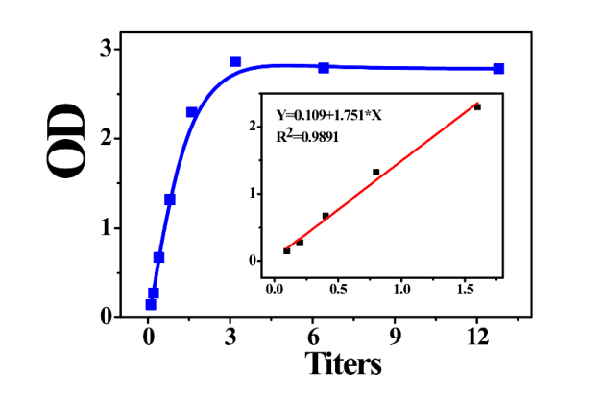
Supplementary Fig. S1 Relationship between optical density and IgG titers.

