Virologica Sinica

Supplementary Data

Diversity and independent evolutionary profiling of rodent-borne viruses in Hainan, a tropical island of China

Youyou Li^{c,d,e,1}, Chuanning Tang^{c,d,e,1}, Yun Zhang^{c,d,e,1}, Zihan Li^{c,d,e,1}, Gaoyu Wang ^{c,d,e} , Ruoyan Peng^{c,d,e} , Yi Huang^{c,d,e}, Xiaoyuan Hu^{c,d,e}, Henan Xinª, Boxuan Fengª, Xuefang Caoª, Yongpeng Heª, Tonglei Guoª, Yijun Heª, Haoxiang Suª, Xiuji Cui^{c,d,e}, Lina Niu^{c,d,e}, Zhiqiang Wuª, Jian Yangª, Fan Yangª, Gang Lu^{c,d,e}, Lei Gaoª, Qi Jinª, Meifang Xiao^{b,*}, Feifei Yin^{b,c,d,e,*}, Jiang Du^{a,c,d,*}

ªNHC Key Laboratory of Systems Biology of Pathogens, Institute of Pathogen Biology, Chinese Academy of Medical Sciences & Peking Union Medical College, Beijing, 100005, China.
^{b}Department of Clinical Laboratory, Center for laboratory Medicine, Hainan Women and Children’s Medical Center, Haikou, 571199, Hainan, China.
^{c}Key Laboratory of Tropical Translational Medicine of Ministry of Education, Hainan Medical University, Haikou, 571199, China.
^{d}Hainan Medical University-The University of Hong Kong Joint Laboratory of Tropical Infectious Diseases, Hainan Medical University, Haikou, 571199, China.
^{e}Department of Pathogen Biology, Hainan Medical University, Haikou, 571199, China

*Corresponding authors.
E-mail address: dujiangemail@163.com (J. Du), yinfeifeiff@163.com (F. Yin), xiaomeifang2006@hotmail.com (M. Xiao)

¹ Youyou Li, Chuanning Tang, Yun Zhang and Zihan Li contributed equally to this work.

Supplementary Table S1.xlsx The locations and species of rodent sampled on Hainan Island.
Supplementary Table S2.xlsx Primers used in this study.
Supplementary Table S3.xlsx Overview of virus-associated contigs.
Supplementary Table S4.xlsx Overview of sequence contigs from mammal related viral families.
Supplementary Table S5.xlsx Virus origin and accession number identified in this study.
Supplementary Table S6.xlsx Amino acid sequence identity in the L regions of novel rodent arenaviruses and known arenaviruses (AreV).
Supplementary Table S7.xlsx Amino acid sequence identity of novel rodent and well-known coronaviruses (CoVs) in the RdRp.
Supplementary Table S8.xlsx Amino acid sequence identity of novel rodent pestviruses and known pestviruses (PestV).
Supplementary Table S9.xlsx Amino acid sequence identity of novel rodent astroviruses (AstroVs) in the RdRp region.
Supplementary Table S10.xlsx NS1 region amino acid sequence identity of novel rodent parvoviruses and known parvoviruses (ParVs).
Supplementary Table S11.xlsx Amino acid sequence identity in the L regions of novel rodent papillomaviruses and known papillomaviruses (PVs).

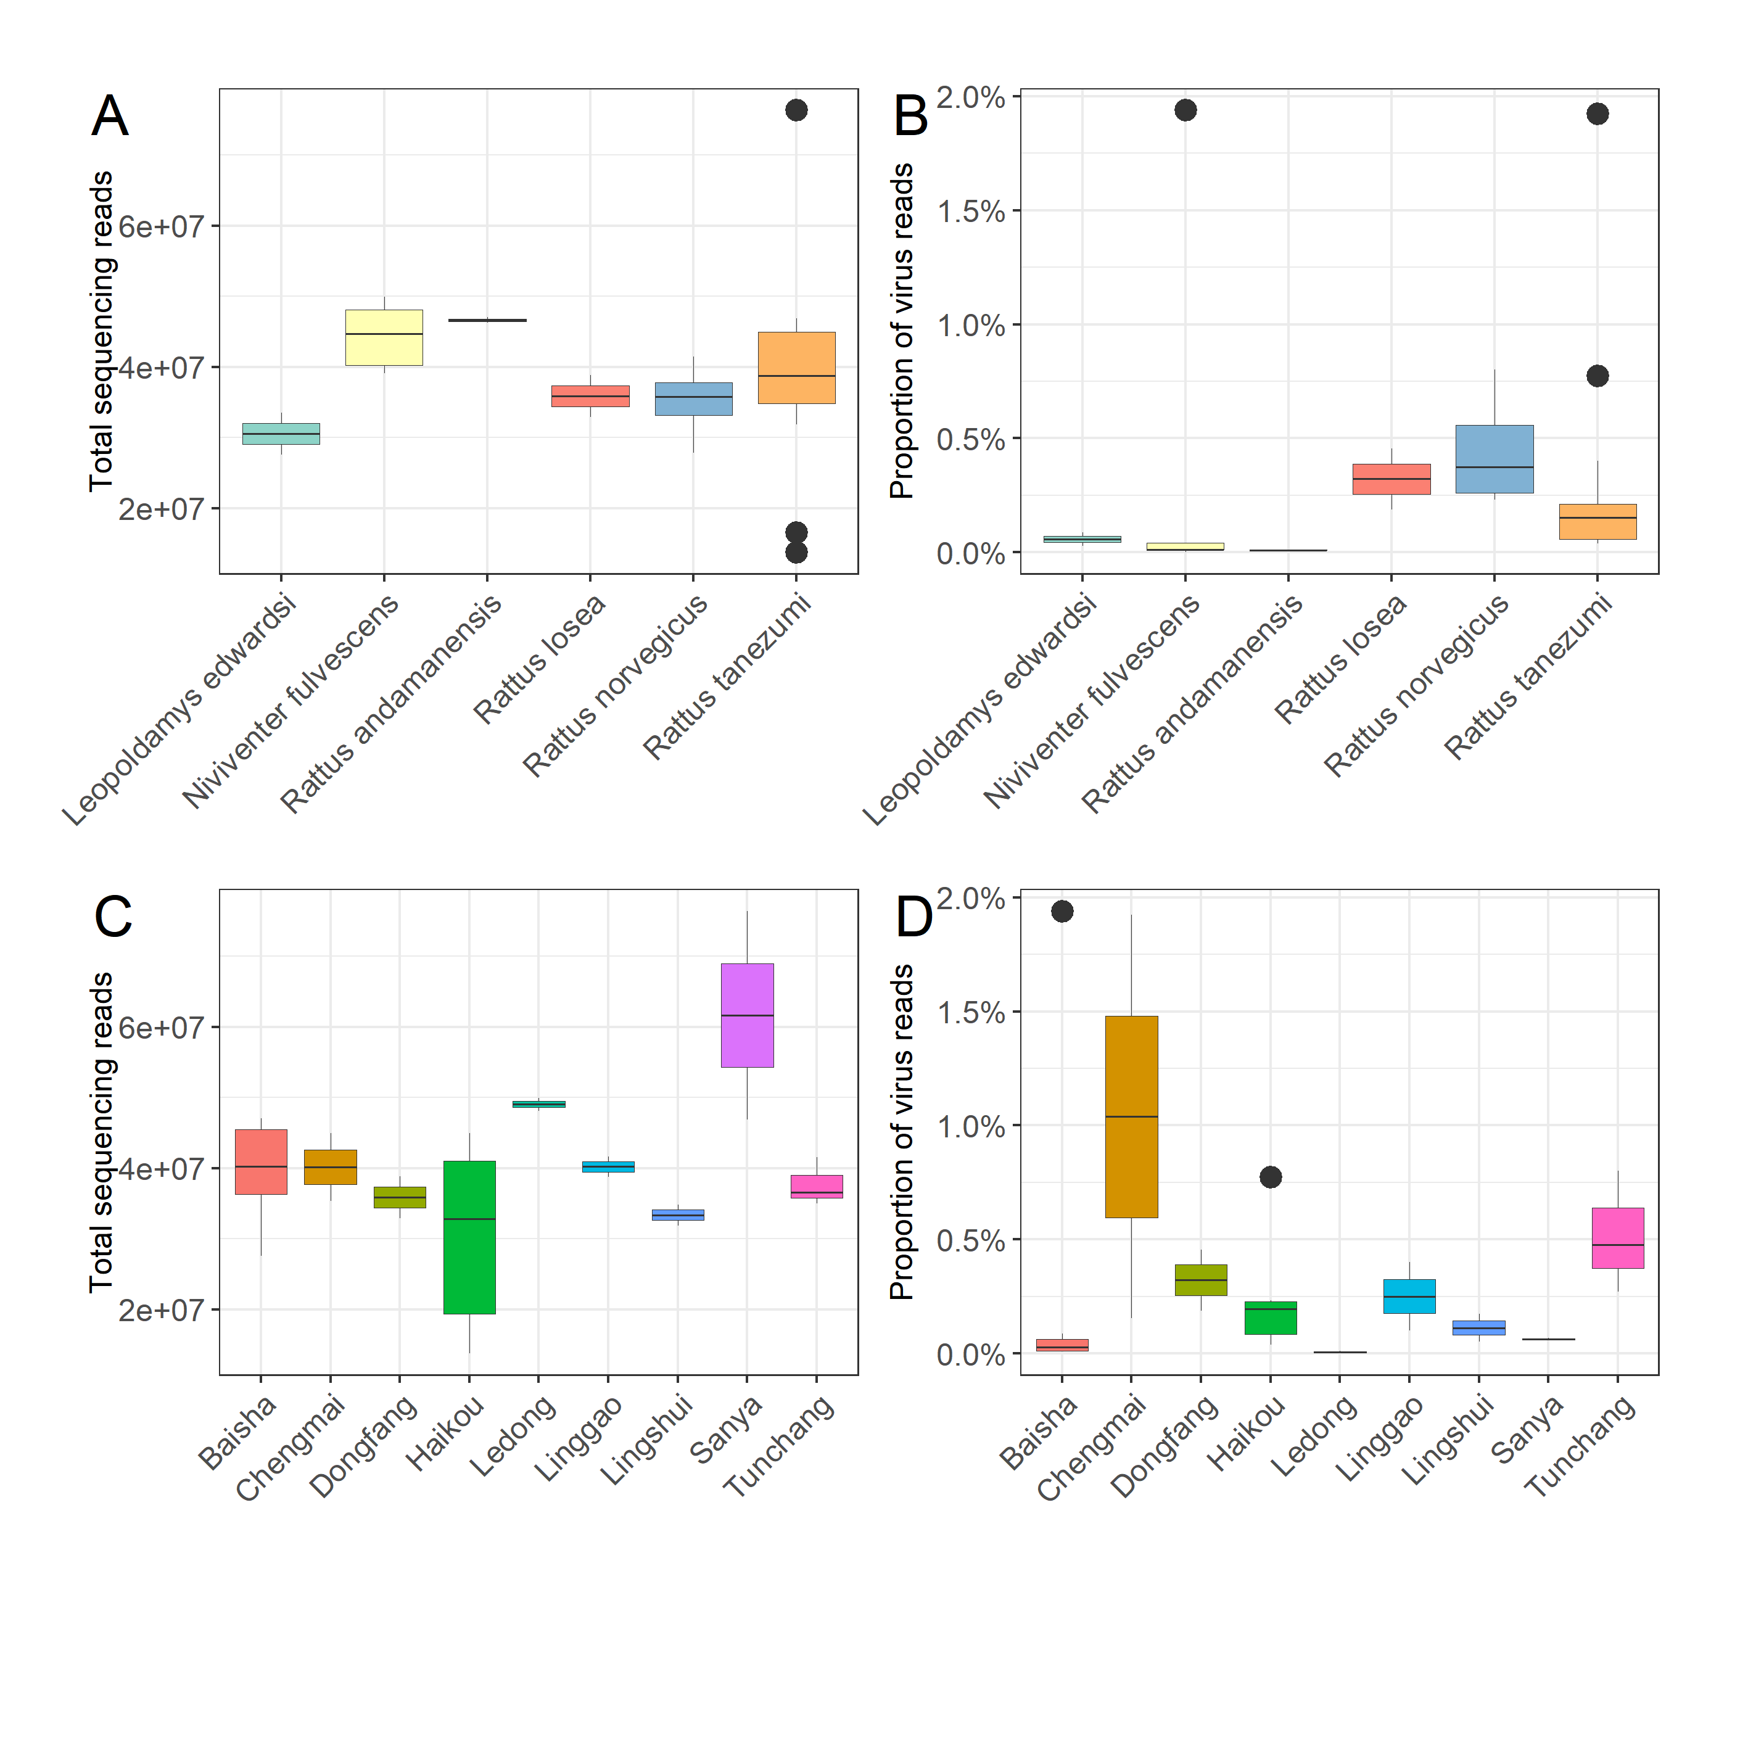
Supplementary Fig. S1 A, B Comparison of the number of total reads and proportions of viral reads from the six rodent species. C, D Comparison of the numbers of total reads and proportions of viral reads from the fifteen sampling locations.

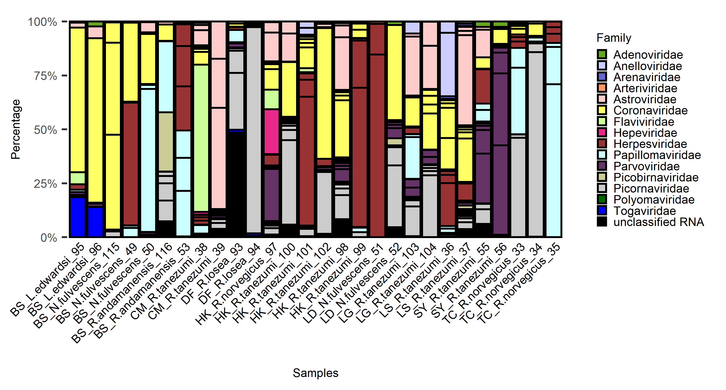
Supplementary Fig. S2. The proportions of the number of reads assigned to each viral family in each of the 28 pools are shown in the bar graph.

