Virologica Sinica

Supplementary Data

Construction and verification of an infectious cDNA clone of coxsackievirus B5

Lifang Song ^{a, 1}, Bopei Cui ^{a, b, 1}, Jinghuan Yang ª, Xiaotian Hao ª, Xujia Yan ª, Jialu Zhang ª, Dong Liu ª, Ziyang Song ª, Qian Wang ª, Qunying Mao ^{a, *}, Zhenglun Liang ^{a, *}

ª National Institute for Food and Drug Control, Beijing 102629, China
^{b} Wuhan Institute of Biological Products CO., LTD, Wuhan 430070, China

*Corresponding author

Email address: lzhenglun@126.com (Z. Liang); maoqunying@126.com (Q. Mao)
ORCID: 0000-0002-6740-0864 (Z. Liang)

¹ Lifang Song and Bopei Cui contributed equally to this work.

Materials and Methods
1.1 Cells and Viruses
Human embryonic kidney 293 (HEK 293T) cells and African green monkey kidney cells (Vero) were purchased from ATCC. HEK 293T cells were cultured at 37 °C in presence of 5 % CO₂ in Dulbecco’s modified Eagle’s medium (DMEM; Gibco, Waltham, MA, USA) supplemented with 10 % fetal bovine serum (FBS; Gibco, Waltham, MA, USA), penicillin (100 U/mL) and streptomycin (100 U/mL) (Cellmax, Lanzhou, China). Vero cells were cultured at 37 °C in presence of 5% CO₂ in Minimum Essential Medium (MEM; Gibco, Waltham, MA, USA) supplemented with 10% fetal bovine serum, penicillin (100 U/mL) and streptomycin (100 U/mL). CV-B5 Faulkner strain (GenBank No.: AF114383) was purchased from ATCC, passaged on Vero cell, and aliquoted into titres of 5.12×10⁸ CCID₅₀/mL and stored at −80 °C in our laboratory.

1.2 Construction and identification of full-length cDNA
In order to generate the cDNA clone of CV-B5, total RNA of CV-B5 was extracted by the MagMAX™-96 Viral RNA Isolation Kit (Applied Biosystems, USA). Using the extracted RNA as a template, the cDNA was generated by reverse transcription employing the SuperScript First Ⅲ-Strand Synthesis SuperMix Kit (Invitrogen, USA). Based on the sequence of CV-B5, 2 pairs of primers were designed by SnapGene 3.2.1 (Supplementary Table S1) and synthesized by Sangon Bietech (Shanghai, China). To obtain the target gene, the PrimeSTAR Max DNA polymerase (Takara, Osaka, Japan) was used for PCR amplification. Two target fragments with approximate sizes of 3300 bp and 4200 bp were obtained. The target fragments were purified, and ligated into pSVA vector, transformed into competent cells (Trans109, TransGen, Beijing, China), and selected on nutrient agar plates supplemented with ampicillin. The resultant pSVA-CV-B5 clone was sequenced by Sangon Bietech (Shanghai, China).

1.3 Viral Rescue
To rescue CV-B5, 1×10⁶ HEK 293T cells per well were laid in a 6-well plate (Thermo Fisher, USA). After the cell density reached a confluence of 80%, pSVA-CV-B5 clone (1.5 ng/μL) and T7 plasmid (1.5 ng/μL) were co-transfected into HEK 293T cell by jetPRIME kit (Polyplus, France). The transfected cells were cultured at 37 °C in an incubator with 5% CO₂. After 72 h, cells were harvested and freeze-thawed repeatedly for 3 times, centrifuged at 4000 ×g for 30 minutes at 4 °C, and 100 µL supernatant was taken and inoculated into monolayer of Vero cells. Cell suspension was collected when typical cytopathic effect (CPE) emerged, and processed with 3 freeze-thaw cycles. The suspension was centrifuged at 4000×g for 30 minutes at 4 °C. The supernatant containing the live virus was stored at 4 °C until further use.

1.4 Cytopathic effect and gene sequencing of rescued virus
Vero cells were inoculated with CV-B5 rescued virus and cultured at 37 °C with 5 % CO₂. CPE were observed under an inverted microscope every 12 hours. After CPE had occurred in 90 % of the cells, the total RNA from CV-B5 was extracted using the MagMAX™-96 Viral RNA Isolation Kit. The RNA was reversely transcribed into cDNA by SuperScript First Ⅲ -Strand Synthesis SuperMix kit. The primers shown in Table S1 were used for PCR, and the obtained fragments were sequenced by Sangon Bietech (Shanghai, China).

1.5 The growth kinetics of rescued virus
To observe the growth of the rescued virus, 1×10⁶ Vero cells were inoculated in 6-well plates per well. After 24 hours, the cells reached 80 % confluence. 1×10⁻² MOI CV-B5 was inoculated in each well and the cells were cultured at 37 °C in 5 % CO₂ for 5 days. The culture medium supernatant was collected every 12 hours after inoculation. The virus titre (CCID₅₀) at each time point was determined by the Reed-Muench method (Reed and Muench 1937).

1.6 Genetic stability of rescued virus
CV-B5 rescued virus was passaged on Vero cells for 15 successive generations, and CPE was observed in each generation, and the total RNA of each generation was extracted and reversely transcribed into cDNA. The two pairs of primers shown in Supplementary Table S1 were used for PCR, and the products were sequenced to identify whether gene mutations existed. At the same time, the viral titres of these generations were measured 3 times per generation and calculated by Reed-Muench method.

1.7 Animal experiments
Specific pathogen-free 3-day-old BALB/c suckling mice were provided by the experimental animal center of National Institute for Food and Drug Control (NIFDC). All animal experiments were approved by NIFDC prior to the commencement of the studies. The rescued and parental virus were diluted to 3.16×10⁸ TCID₅₀/mL, and serially diluted 10-fold (starting from 1.896 × 10⁷ TCID50) to inoculated intraperitoneallt (i.p.) infect 3-day-old BALB/c suckling mice, and observed for 21 days (n ≥ 6). Mean body weight, clinical score, and survival of mice in each group were recorded. Clinical scoring was levelled as follows: 0 represented health; 1 represented wasting; 2 represented forelimb paralysis; 3 represented paralysis of the hind limbs; 4 represented quadriplegia; 5 represented moribund status or death. In order to study the distribution of rescued virus in suckled mice, 11 organs including heart, liver, spleen, lung, kidney, stomach, intestine, pancreas, brain, spine and hind legs, were dissected after 5 days post infection with the virus, and the viral load of each tissue and organ was measured using One Step TB Green® PrimeScript™ PLUS RT-PCR Kit (RR096A, Takara, Osaka, Japan) according to the manufacturer’s instructions. Aiming at studying the pathological changes of suckling mice challenged by rescued virus, 3 moribund mice in the parental virus and rescued virus group were selected for hematoxylin and eosin staining, with 3 suckling mice in the blank group set for negative control.

1.8 Statistical analysis
The survival rates were evaluated by the Mantel-Coxlog-rank test in Graphpad 8.0.2. The mean clinical scores and the average body weights were compared using one-way ANOVA.

Table S1 Primers used for constructing the cDNA clone of CV-B5
Primers | Sequence (5' to 3') | Location
CV-B5-5'UTR-F | CAAGAATTGCGGCCGCGTAATACGACTCACTATAGGTTAAAACAGCCTGTGGGTTGTTCCCACC | 1
CV-B5-5'UTR-R | GCACCAGTGGTTTGCATGGTC | 3287
CV-B5-3'UTR-F | GACCATGCAAACCACTGGTGC | 3267
CV-B5-3'UTR-R | AACATGAGAATTGTCGACT……T34 | 7416

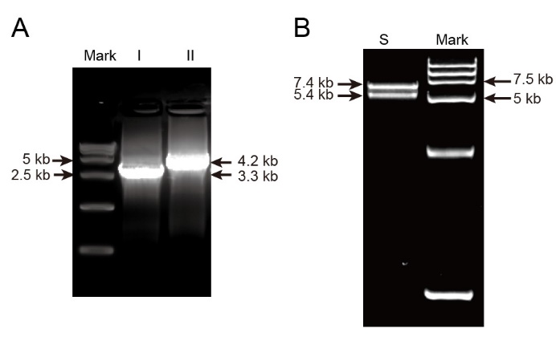
Figure S1. A Amplification of CV-B5 whole genome segments I (3.3 kb) and II (4.2 kb), respectively. B Lane S showed the double digestion results using restriction enzymes.

