Virologica Sinica

Supplementary Data

Long noncoding RNA 1392 regulates MDA5 by interaction with ELAVL1 to inhibit Coxsackievirus B5 infection

Jing Li, Jinwei Li, Peiying Teng, Fan Yang, Jihong Zhang, Bo Sun, Wei Chen*

Medical School, Kunming University of Science and Technology, Kunming, 650500, China

*Corresponding author:
Email address: wchen@kust.edu.cn (W. Chen).
ORCID: 0000-0002-6728-4277
Primer target | Forward Sequence (5′–3′) | Reverse Sequence (5′–3′)
LINC1392 | GGCTTTGCTCAACACTGGAG | GTGTATCTGTGTGCCTCCCA
LINC1392-1 | CGTCCTGAACTGGAGATGCT | ACGATGAGCTGGTGTCGAAG
LINC1392-2 | GCCAAGGTTTGTAGCTGTGC | CCTGATTTCCCACCGTGTCT
LINC1392-3 | CAGGGTTGGGGGTCTGATCT | TTCTGCCTGCATTCCATCCT
LINC1392-4 | GCTGCTAGCTGGATGCTGA | ACTTCTGTTTCACCCAGCCT
GAPDH | GTATGACAACGAATTTGGCTACAG | AGCACAGGGTACTTTATTGATGG
U6 | CTCGCTTCGGCAGCACA | AACGCTTCACGAATTTGCGT
IFN-β | CTTGGATTCCTACAAAGAAGCAGC | TCCTCCTTCTGGAACTGCTGCA
OASL | TTGTGCCTGCCTACAGAGC | TTCAGCTTAGTTGGCCGATGT
MXA | TTCAGCACCTGATGGCCTATC | TGGATGATCAAAGGGATGTGG
ISG15 | CTCTGAGCATCCTGGTGAGGAA | AAGGTCAGCCAGAACAGGTCGT
ISG20 | TGACCTGAAGCACGACTTCC | CAGGCTGTTCTGGATGCTCT
IFIT1 | TCTCAGAGGAGCCTGGCTAAG | CCACACTGTATTTGGTGTCTAGG
IFIT2 | ACCTCTGGACTGGCAATAGC | GTCAGGATTCAGCCGAATGG
IFITM3 | CATCGTCATCCCAGTGCTGAT | ATGGAAGTTGGAGTACGTGGG
Table S1 List of primer pairs.

Table S2 The predicted proteins interacting with LINC1392
Protein ID | Transcript ID | Z-score | Discriminative Power | Interaction Strength | Motif Reference | Domain Presence | Domain Score | Star Rating Score
sp|P23246|SFPQ_HUMAN | input_rna_1 | 1.86 | 0.99 | 0.72 | yes | yes | 1 | 2.88
sp|P26599|PTBP1_HUMAN | input_rna_1 | 0.84 | 0.96 | 0.65 | yes | yes | 1 | 2.68
sp|Q15717|ELAV1_HUMAN | input_rna_1 | 0.26 | 0.79 | 0.91 | yes | yes | 1 | 2.57
sp|Q6ZN17|LN28B_HUMAN | input_rna_1 | 0.22 | 0.64 | 0.96 | yes | yes | 1 | 2.55
sp|Q01130|SRSF2_HUMAN | input_rna_1 | -0.02 | 0.59 | 0.89 | yes | yes | 1 | 2.51
sp|Q13242|SRSF9_HUMAN | input_rna_1 | -0.14 | 0.47 | 0.84 | yes | yes | 1 | 2.49
sp|Q9H6T0|ESRP2_HUMAN | input_rna_1 | -0.18 | 0.45 | 0.27 | yes | yes | 1 | 2.48
sp|P84103|SRSF3_HUMAN | input_rna_1 | -0.33 | 0.32 | 0.71 | yes | yes | 1 | 2.45

Figure S1. The expression of LINC1392 after transfected with si-MDA5. si-MDA5#2 or si-MDA5#3 (50 nmol/L) was transfected into RD cells, then the cells were infected with CVB5 (MOI = 1) at 24 hours after transfection. Cells were harvested at 24 hours post-infected, and qRT-qPCR was performed to measure the MDA5 and LINC1392 expression levels.

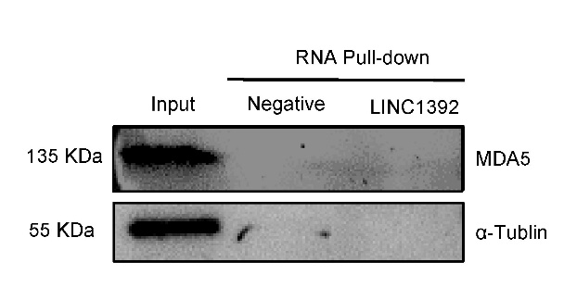
Figure S2. The interaction between LINC1392 and MDA5 by RNA pull-down. CVB5 (MOI = 1) infected RD cells and cells were harvested 24 hours post-infected. Cell lysates, the biotinylated LINC1392 positive strand (50 pmol) (the biotinylated LINC1392 negative chain as control) and magnetic beads were incubated at room temperature to obtain the protein-RNA complexes. Samples were uploaded on 8% SDS-PAGE gel and subjected to MDA5 Western blotting.
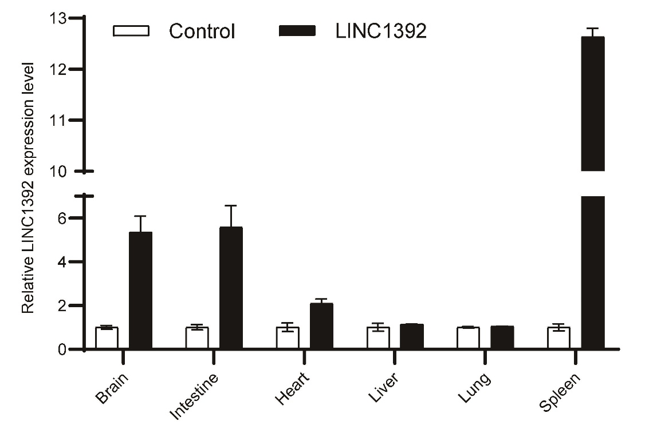
Figure S3. The expression of LINC1392 in different tissue after inject AAV2/9-CMV-LINC1392-zsgreen (AAV2/9-CMV-zsgreen as control). BALB/c mice aged three days injected AAV2/9-CMV-LINC1392-zsgreen (2 × 10¹¹ IU/mL) or AAV2/9-CMV-zsgreen (2 × 10¹¹ IU/mL) via intraperitoneal for three times. After 14 days, brain, intestine, heart, liver, lung and spleen were collected for RT-qPCR to detect the expression of LINC1392.

