Virologica Sinica

Supplementary Data

HIF-1α promotes virus replication and cytokine storm in H1N1 virus-induced severe pneumonia through cellular metabolic reprogramming

Xiaoxiao Meng^{a,1}, Yong Zhu^{a,1}, Wenyu Yangª, Jiaxiang Zhangª, Wei Jinª, Rui Tianª, Zhengfeng Yang^{b,*}, Ruilan Wang^{a,*}

ªDepartment of Critical Care Medicine, Shanghai General Hospital, Shanghai Jiaotong University, School of Medicine, Shanghai, 201620, China.
^{b}Precision Research Center for Refractory Diseases, Shanghai General Hospital, Shanghai Jiaotong University, School of Medicine, Shanghai, 201620, China.

* Corresponding authors.
Email addresses: wangyusun@hotmail.com (R. Wang), Zhengfeng.yang@shgn.cn (Z. Yang)
ORCID: 0000-0001-9555-2649

¹Xiaoxiao Meng and Yong Zhu contributed equally to this work.

Supplementary Table S1 The sequences of the siRNAs and shRNAs.
Species | ﻿Gene | ﻿Sequence (﻿5′–3′; ﻿3′–5′)
Homo sapiens | ﻿HIF-1α | CCAGCAGACUCAAAUACAATT; UUGUAUUUGAGUCUGCUGGTT
 | HK2 | CCUGCAACACUUAGGGCUUTT; AAGCCCUAAGUGUUGCAGGTT
siRNA | NC | UUCUCCGAACGUGUCACGUTT; ACGUGACACGUUCGGAGAATT
Mouse | ﻿HIF-1α | ﻿CCCATTCCTCATCCGTCAAAT
shRNA | NC | TTCTCCGAACGTGTCACGT

Supplementary Table S2 The primer sequences used in real-time quantitative PCR.
 | ﻿Gene | ﻿Primer sequence (﻿forward, 5′ –3′; ﻿reverse, 3′ –5′)
Homo sapiens | ﻿HIF-1α | GTCTGAGGGGACAGGAGGAT; CTCCTCAGGTGGCTTGTCAG
 | IFN-α | GCCTCGCCCTTTGCTTTACT; CTGTGGGTCTCAGGGAGATCA
 | IFN-β | ATGACCAACAAGTGTCTCCTCC; GGAATCCAAGCAAGTTGTAGCTC
 | IL-1β | AGCTACGAATCTCCGACCAC; CGTTATCCCATGTGTCGAAGAA
 | IL-6 | ACTCACCTCTTCAGAACGAATTG; CCATCTTTGGAAGGTTCAGGTTG
 | TNF-α | GAGGCCAAGCCCTGGTATG; CGGGCCGATTGATCTCAGC
 | IL-10 | TCAAGGCGCATGTGAACTCC; GATGTCAAACTCACTCATGGCT
 | HK2 | TTGACCAGGAGATTGACATGGG; TTGACCAGGAGATTGACATGGG
 | PDK1 | CTGTGATACGGATCAGAAACCG; TCCACCAAACAATAAAGAGTGCT
 | PFKM | GGTGCCCGTGTCTTCTTTGT; AAGCATCATCGAAACGCTCTC
 | PKM2 | ATGTCGAAGCCCCATAGTGAA; TGGGTGGTGAATCAATGTCCA
 | LDHA | TTGACCTACGTGGCTTGGAAG; GGTAACGGAATCGGGCTGAAT
 | PDH | CCTGCAAATGCACCCATTGAG; CTGCCTGGGAACAAGCACAA
 | β-actin | AAGGTGACAGCAGTCGGTT; TGTGTGGACTTGGGAGAGG
Mouse | ﻿HIF-1α | ﻿ACCTTCATCGGAAACTCCAAAG; ﻿CTGTTAGGCTGGGAAAAGTTAGG
 | IFN-α | AGGACTTTGGATTCCCCTTG; TCCTTTGATGTGAAGAGGGTCAG
 | IFN-β | TGGGTGGAATGAGACTATTGTTG; CTCCCACGTCAATCTTTCCTC
 | HK2 | ATGATCGCCTGCTTATTCACG; CGCCTAGAAATCTCCAGAAGGG
 | β-actin | TGGGAATGGGTCAGAAGGA; ATTGAGAAAGGGCGTGGC
H1N1 | M gene | GACCRATCCTGTCACCTCTGAC; AGGGCATTYTGGACAAAKCGTCTA

Supplementary Fig. S1 HIF-1α is upregulated in H1N1-infected mice and A549 alveolar epithelial cells. A HE staining of mouse lung tissues after H1N1 virus infection (n = 5, 1000 pfu per mouse) on Days 1, 3 and 5 (scale bar = 100 µm). B The expression level of HIF-1α mRNA after H1N1 virus infection in mouse lung tissues (left) and A549 cells (right) was measured by qPCR. β-Actin served as the loading control. The data are shown as the means with SDs. C The distribution of HIF-1α protein in A549 cells after H1N1 virus infection (MOI = 1 for 24 h) was evaluated with immunofluorescence (scale bar = 50 µm). D Immunoblot analysis of HIF-1α protein expression after H1N1 virus infection in mouse lung tissues (left) and A549 cells (right). β-Actin served as the loading control.

Supplementary Fig. S2 HIF-1α expression was successfully inhibited in mouse lung tissues. The expression of HIF-1α protein after H1N1 virus infection in mouse lung tissues (n = 5, 1000 pfu per mouse) with HIF-1α knockdown. β-Actin served as the loading control.

Supplementary Fig. S3 The levels of ATP, ADP and AMP in H1N1-infected mouse lung tissues or A549 cells with or without HIF-1α knockdown. The levels of ATP, ADP and AMP were measured by HPLC. The data are shown as the means with SDs. Statistical analysis was performed by one-way ANOVA. *P < 0.05.

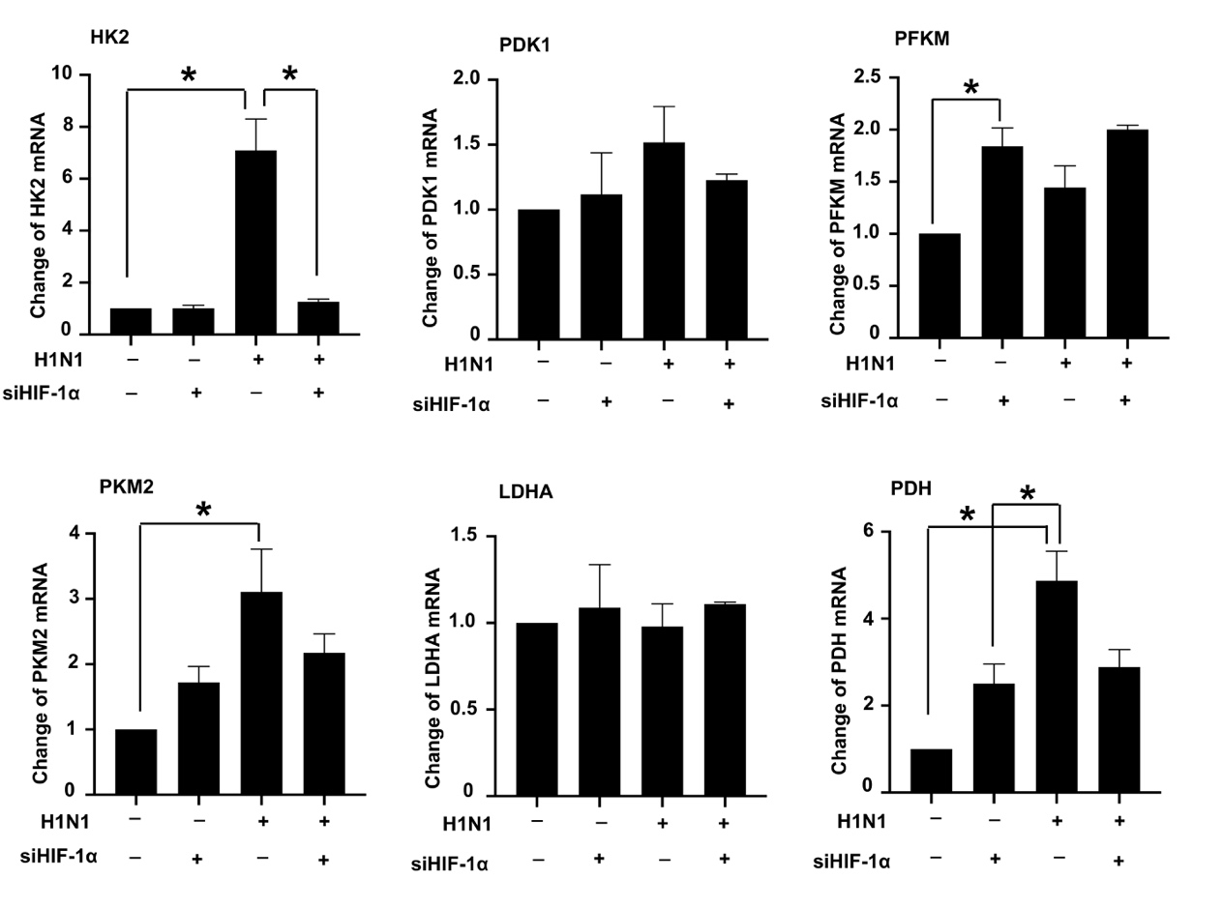
Supplementary Fig. S4 The mRNA expression of key glycolysis enzymes after inhibition of HIF-1α. A549 cells were transfected with HIF-1α siRNA and incubated with H1N1 virus (MOI = 1) for 24 h. The expression levels of HK2, PDK1, PFKM, PKM2, LDHA and PDH mRNA were measured with qPCR. β-Actin served as the loading control. The data are shown as the means with SDs. Statistical analysis was performed by one-way ANOVA. *P < 0.05 vs. control group. #P < 0.05 vs. H1N1 group.

Supplementary Fig. S5 Cell viability after transfection with HIF-1α siRNA or the HK2 plasmid. A549 cells were transfected with HIF-1α siRNA or transfected with HIF-1α siRNA together with ectopic expression of HK2. Then, cell viability was evaluated by a CCK-8 assay. The data are shown as the means with SDs.

Supplementary Fig. S6 The levels of ATP, ADP and AMP in H1N1-infected A549 cells with transfection of HIF-1α siRNA alone or together with ectopic expression of HK2. The levels of ATP, ADP and AMP were measured by HPLC. The data are shown as the means with SDs. Statistical analysis was performed by one-way ANOVA. *P < 0.05.

Supplementary Fig. S7 The knockdown efficacy of HIF-1α at the translational level was verified by Western blotting. The expression of HIF-1α protein in H1N1-infected A549 cells (MOI = 1 for 24 h) with transfection of siRNA targeting HIF-1α alone or together with ectopic expression of HK2, as indicated. β-Actin served as the loading control.

Supplementary Fig. S8 Cell viability after treatment with 2-DG. A549 cells were treated with different concentrations of 2-DG (0 mmol/L, 5 mmol/L, 10 mmol/L, 20 mmol/L, 30 mmol/L, 40 mmol/L and 50 mmol/L) for 24 h (A) or 48 h (B). Then, cell viability was evaluated by a CCK-8 assay. The data are shown as the means with SDs. Statistical analysis was performed by one-way ANOVA. *P < 0.05.

Supplementary Fig. S9 The expression levels of IFN-α/β mRNA in H1N1-infected A549 cells treated with or without 2-DG (10 mmol/L for 48 h) were measured by qPCR. β-Actin served as the loading control. The data are shown as the means with SDs. Statistical analysis was performed by one-way ANOVA. *P < 0.05.

Supplementary Fig. S10 Co-IP analysis of the expression of and interaction between MAVS and RIG-I during H1N1 infection. The MAVS, RIG-I or HIF-1α plasmid was transfected into HEK 293T cells for 48 h, and the cells were then infected with H1N1 (MOI = 1 for 24 h). The RIG-I plasmid was obtained from Genechem. The MAVS and HIF-1α plasmids were purchased from Sino Biological. β-Actin served as the loading control.

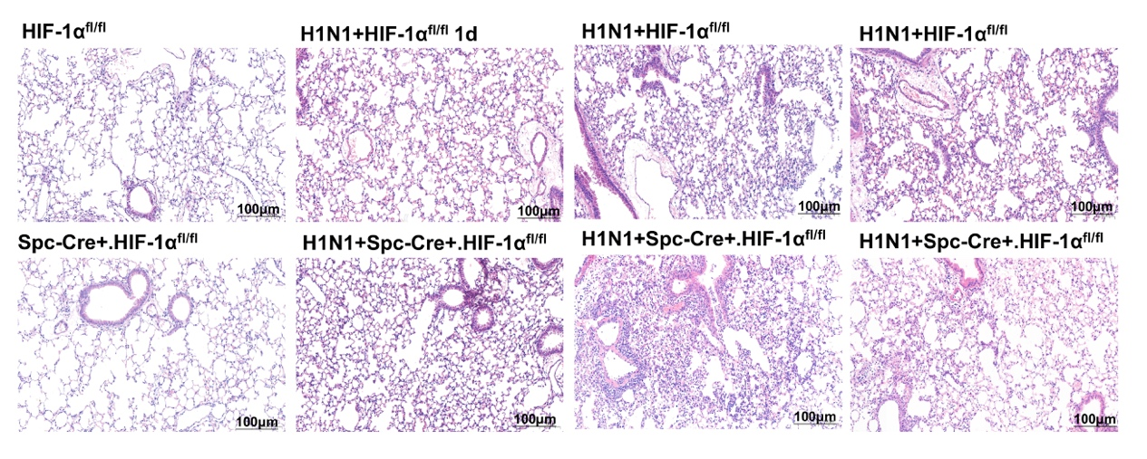
Supplementary Fig. S11 HE staining of mouse lung tissues after H1N1 infection. The infected lung tissues showed obvious inflammatory cell infiltration, pulmonary interstitial edema and increased alveolar exudation in the H1N1 + Spc-Cre+.HIF-1α^{fl/fl} group compared with the H1N1 + HIF-1α^{fl/fl} group, peaking on the 3rd day after H1N1 infection. SPF-grade 6- to 8-week-old male HIF-1α^{fl/fl} and Spc-Cre+.HIF-1α^{fl/fl} C57BL/6 mice were infected with the indicated dose (n = 5, 1000 pfu of each) of H1N1 virus via nasal drops. The mice were then placed in an isolation cage with an independent air supply, reared normally, and sacrificed at the indicated time. The lung tissues were isolated on Day 1, Day 3 and Day 5 after H1N1 infection. Scale bar = 100 µm.

