Virologica Sinica

Supplementary Data

Isolation and characterization of a novel linear-plasmid phage from the sediment of the Mariana Trench

Yali Hao^{a#}, Siyuan Wang^{a#}, Mujie Zhangª, Qingxue Tangª, Canxing Mengª, Liping Wang^{b}, Qilian Fanª, Yaxian Yan^{c}, Xiang Xiao^{a,d}, Huahua Jian^{a,d*}

ª State Key Laboratory of Microbial Metabolism, Joint International Research Laboratory of Metabolic & Developmental Sciences, School of Life Sciences and Biotechnology, Shanghai Jiao Tong University, Shanghai 200240, China
^{b} Key Laboratory of Marine Genetic Resources, Third Institute of Oceanography, Ministry of Natural Resources, Xiamen 361005, China
^{c} Shanghai Key Laboratory of Veterinary Biotechnology, School of Agriculture and Biology, Shanghai Jiao Tong University, Shanghai 200240, China
^{d} Southern Marine Science and Engineering Guangdong Laboratory (Zhuhai), Zhuhai 519082, China

*Corresponding author,
jiandy@sjtu.edu.cn (H. Jian), ORCID: 0000-0001-5507-497X

Supplementary Materials
Material and Methods
Sample collection and bacterial isolation
The deep-sea sediment sample was obtained from the Mariana Trench in the western Pacific Ocean (11°11.6988' N, 141°48.7008' E, water depth of 8636 m) during the TS01 hadal trench cruise carried out by the R/V Tan Suo Yi Hao in August 2016. Initially, the sample was diluted with artificial seawater and plated on 2216E marine agar (5 g/L tryptone, 1 g/L yeast extract, 0.1 g/L FePO₄, 34 g/L NaCl). Subsequently, single colonies were picked, and pure culture was obtained after three rounds of plate streaking. The genomic DNA of the isolated strain was extracted by the QIAamp Genomic DNA Kit (Qiagen, Hilden, Germany) following the manufacturer’s instructions. The 16S rRNA gene was amplified by PCR using the universal primer pair 27F/1492R, and the PCR product was sequenced by Personal Biotechnology (Shanghai, China).

Prophage induction
Culture of Halomonas sp. MT08-1 was grown in 200 mL 2216E medium at 15°C with a shaking speed of 200 rpm. Growth was detected using turbidity measurements at 600 nm. When reaching the early exponential growth phase, 100 mL of each culture was separated and used as a control. The remaining culture was treated with mitomycin C at a final concentration of 1 μg/mL. Prophage induction was considered to have occurred when a drop in cell density of the induced culture in comparison with the control was detected.

Quantification of viral-like particles (VLPs)
The VLPs were quantified as previously described (Jian et al. 2019). Briefly, approximately 2 ml of bacterial culture was centrifugated at 10,000 × g for 1 min. After centrifugation, the supernatant was filtered with a 0.02 μm pore-size Anodisc Al₂O₃ filter (Whatman, Kent, UK), and the filter were stained with 25× SYBR Green I (Invitrogen, Carlsbad, CA, USA) for 15 min in dark. After rinsing with 0.02 μm filter-autoclaved MilliQ H₂O, each filter was mounted on a glass slide with 0.1% (v/v) p-phenylenediamine dihydrochloride anti-fade mounting medium (Sangon Biotech, Shanghai, China). VLPs on the filter were observed with a fluorescence microscope (Nikon Eclipse 90i, Melville, NY, USA). For each sample, the number of VLPs was counted in at least 10 microscopic fields, with a total number above 200.

Phage particle purification
To concentrate and purify phage particles from the induction experiments, the cells were pelletized by centrifugation at 10000 × g for 30 min, and the supernatant was mixed with polyethylene glycol (PEG8000) at a final concentration of 10% (wt/vol). After the mixture was incubated at 4°C for 12 h, the phage particles were pelletized by centrifugation at 10000 ×g for 10 min, and the pellet was resuspended in SM buffer (100 mmol/L NaCl, 8 mmol/L MgSO₄, 0.01% gelatine, 50 mmol/L Tris-HCl, pH 7.5). The concentrated phage particle extract was further purified in 0.75 g/mL CsCl by isopycnic gradient centrifugation (200,000 ×g, 20 h, 4°C) (Beckman Coulter, CA, USA).

Electron microscopy observation
For transmission electron microscopy (TEM) observation, the purified phage extracts were placed onto a carbon-coated grid (200 mesh) and stained with 0.5% (wt/vol) phosphotungstic acid (PTA). The grid was air dried and examined under a Tecnai G2 Spirit BioTwin microscope (FEI Company, Eindhoven, Netherlands).
Genome sequencing, assembly and annotation
The phage DNA was extracted with Mag-Bind Viral DNA kit (Omega Bio-Tek, Norcross, USA) according to manufacturer’s instructions. The complete genomes were sequenced using the Oxford Nanopore GridION platform (Nextomics, Wuhan, China). The coverage depths were calculated, and the raw reads were filtered by nanofilt (https://github.com/wdecoster/nanofilt) (Coster et al. 2018) using the following parameters: -q 7 -l 1000. The Flye version 2.6 (https://github.com/fenderglass/Flye) assembler (Kolmogorov et al. 2019) was used to assemble these clean reads into a complete genome using the following parameters: –nano-raw. Pilon v1.23 (parameters: default) was used to correct these results until the complete sequence was obtained by splicing (https://github.com/broadinstitute/pilon) (Walker et al. 2014). Prodigal v2.6.3 was used to predict coding genes (https://github.com/hyattpd/Prodigal) (Hyatt et al. 2010).

Plaque assays
The Halomonas strains were cultivated in 2216E medium at 15°C to early exponential growth phase. To test the infectivity and host range of HMP1, 10 μL of the 10-fold serially diluted phage lysate (10¹¹ VLPs/mL) was spotted onto a lawn of each Halomonas strain in soft-agar overlay plate, and incubated at 15°C for 4–5 days. The E. coli K-12 strain MG1655 and its lytic phage vB_EcoS_SH2 (NCBI genome accession number NC_047828) was tested in parallel as the positive control.

Availability of data
The complete genome sequence of HMP1 generated from the current study has been deposited in the NODE (The National Omics Data Encyclopedia) database under the Accession number OER181318.

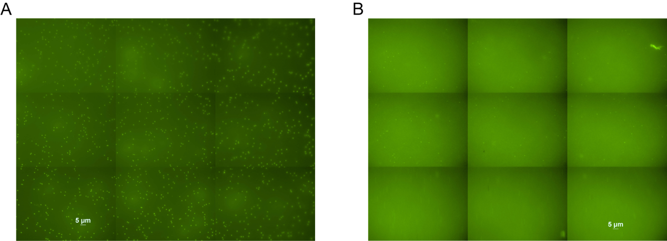
Figure S1. Quantification of viral-like particles (VLPs) derived from MMC+ (A) and MMC- (B) treated Halomonas sp. MT08-1 cultures by epifluorescence microscopy. For each sample, the number of VLPs was counted in at least 10 microscopic fields. Scale bar = 5 μm.

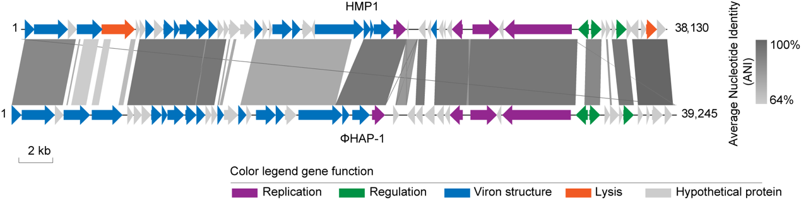
Figure S2. Comparison of HMP1 and ΦHAP-1 genomes by Easyfig (Sullivan et al. 2011). The regions sharing homology between adjacent genomes are indicated by shared areas. The bar for percent nucleotide identity is outlined on the right, and the proposed functions of the encoded proteins are indicated in the colour panels at the bottom of the figure.

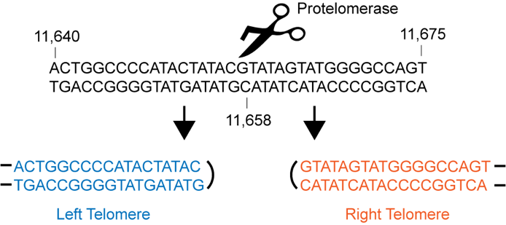
Figure S3. The nucleotide sequence of the 36-bp inverted repeat identified in the region between the parA and telN genes of HMP1. The predicted cut site of the protelomerase is indicated by scissors. The sequences below the repeat are the predicted right and left telomeric ends of HMP1.

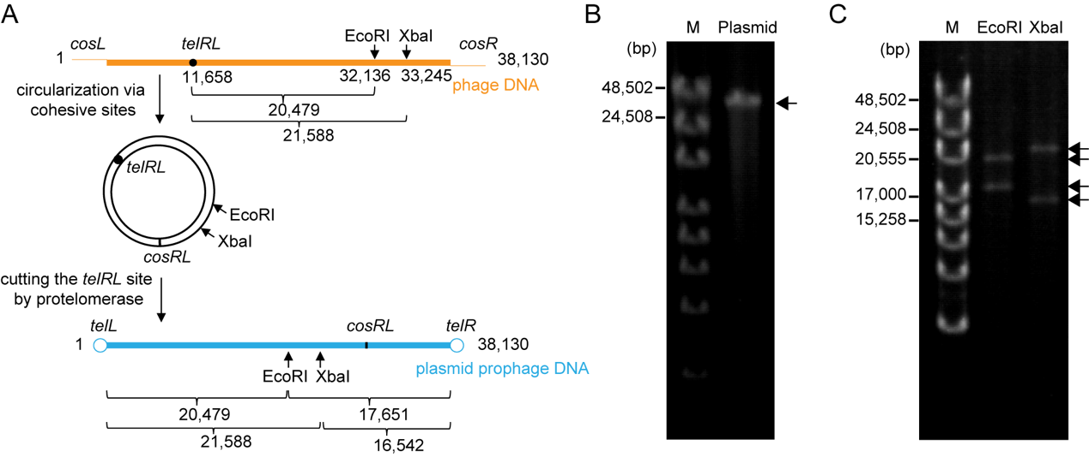
Figure S4. (A) Schematic representation of the two conformations of the HMP1 genome. The cut sites of restriction enzymes are indicated by vertical arrows. Predicted fragment sizes are shown below each map. Figures are not drawn to scale. (B-C) Gel electrophoresis of Halomonas sp. MT08-1 plasmid DNA (B) and its restriction enzyme digested products (C). The desired fragments are indicated by arrows. M. GeneRulerTM High Range DNA Ladder.

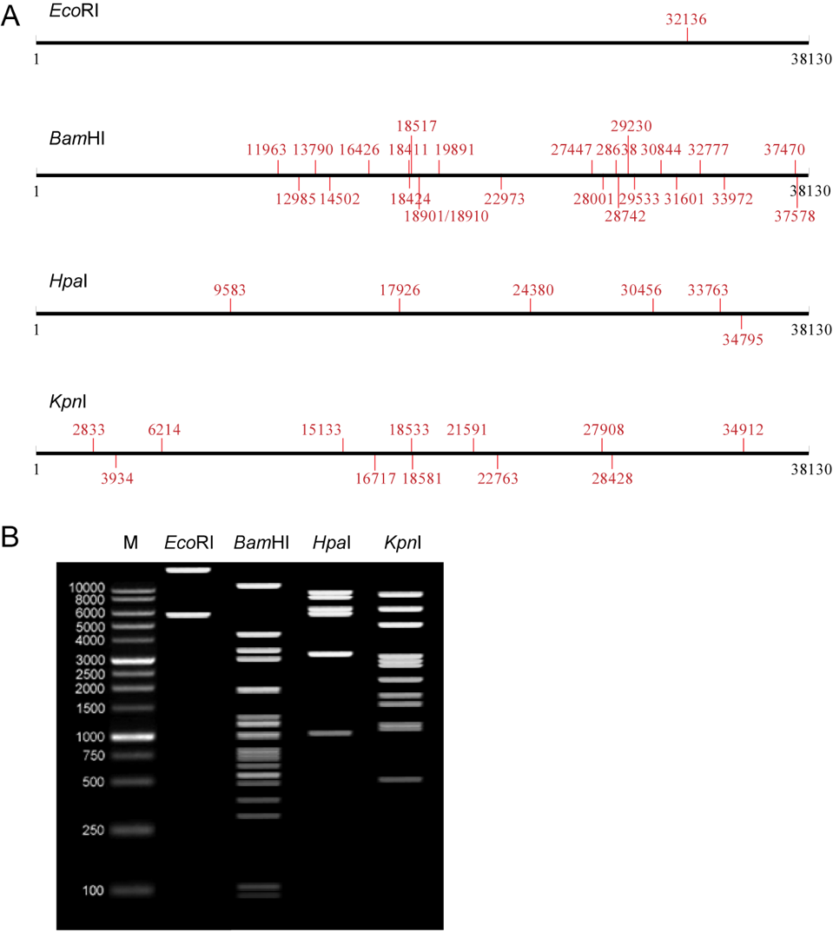
Figure S5. (A) In silico analysis of the restriction enzyme cutting sites in the HMP1 genome. (B) Simulated gel electrophoresis of HMP1 genomic DNA after digestion with different restriction enzymes. The analyses were performed by DNAMAN software (Lynnon Biosoft) and Restriction Analyzer (https://molbiotools.com/restrictionanalyzer.php), respectively.

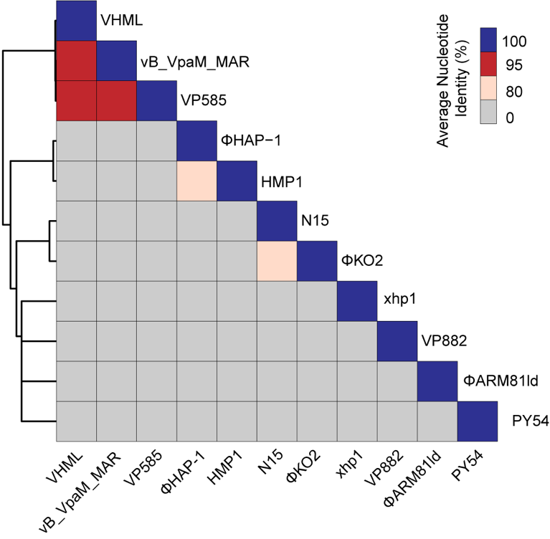
Figure S6. Comparison of the average nucleotide identity (ANI) between all isolated linear plasmid phages. The ANI values were calculated by pyani (v0.2.8) (Pritchard et al. 2019) and demonstrated as heatmap.

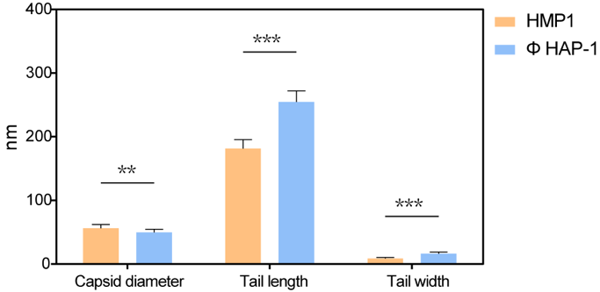
Figure S7. Comparison of the virion size between HMP1 and ΦHAP-1. The data of ΦHAP-1 phage particle is from the previous publication(Mobberley et al. 2008). The Student’s t test was performed to evaluate the difference significance. *** P<0.001; ** P<0.01.

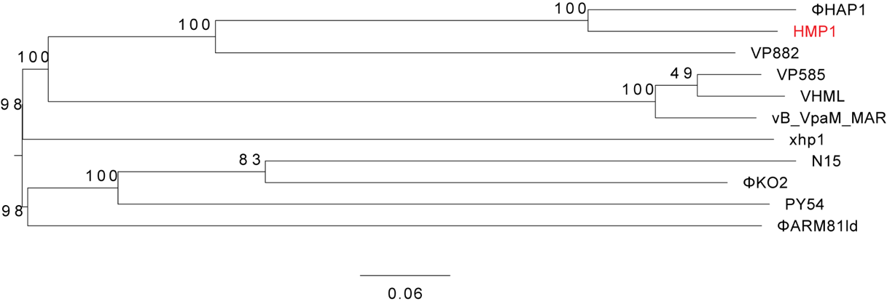
Figure S8. Genome-based phylogenetic analysis of all isolated linear plasmid phages by VICTOR (Meier-KolthoffandGӧker 2017). The recommended VICTOR tree (formula d₆) is shown and the numbers shown above the branches are Genome-BLAST Distance Phylogeny (GBDP) pseudo-bootstrap support values from 100 replications.

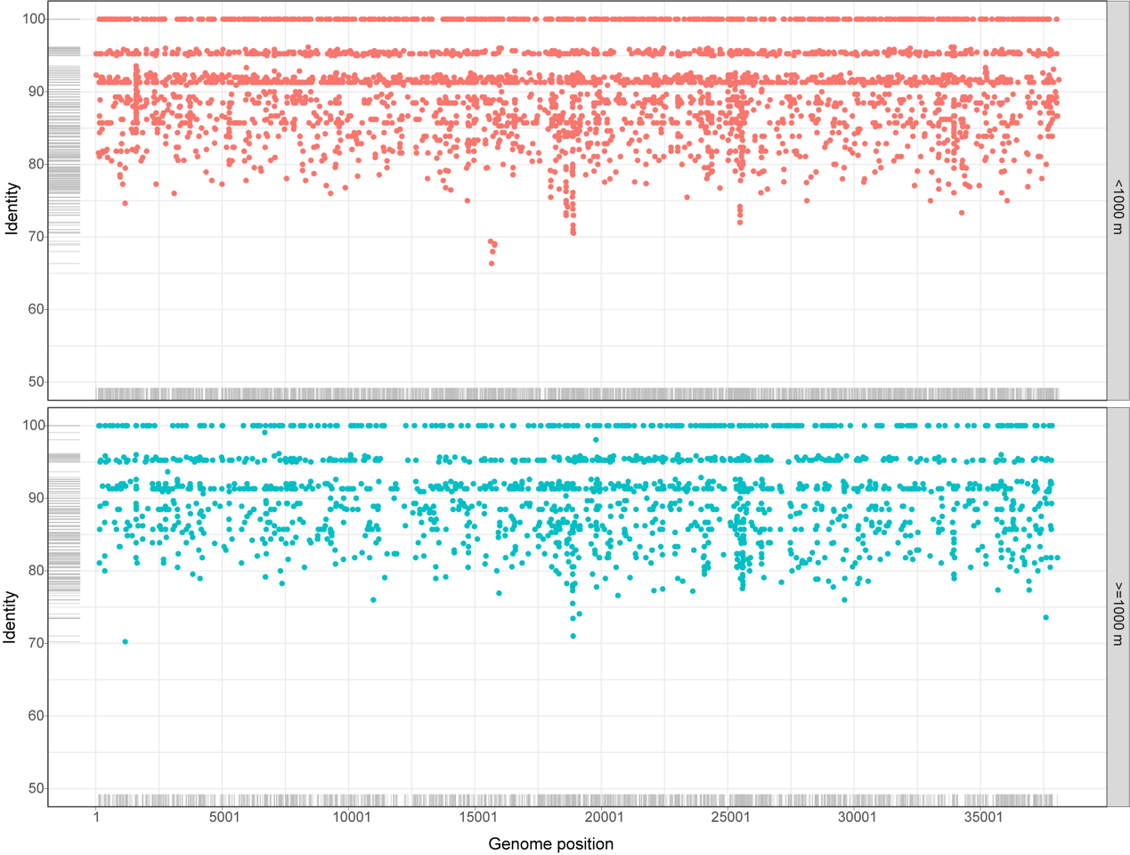
Figure S9. Recruitment analysis of HMP1-like phages in the marine virome. Recruitment plots are computed using metagenomic raw reads from the Pacific Ocean virome (POV) with water depths <1000 m (upper panel) and ≥1000 m (lower panel). The recruitment analyses were performed by BLASTn with an e-value cutoff of ≤10⁻³. Only reads that hit with ≥50% identity (nucleic acid) and query coverage were considered.
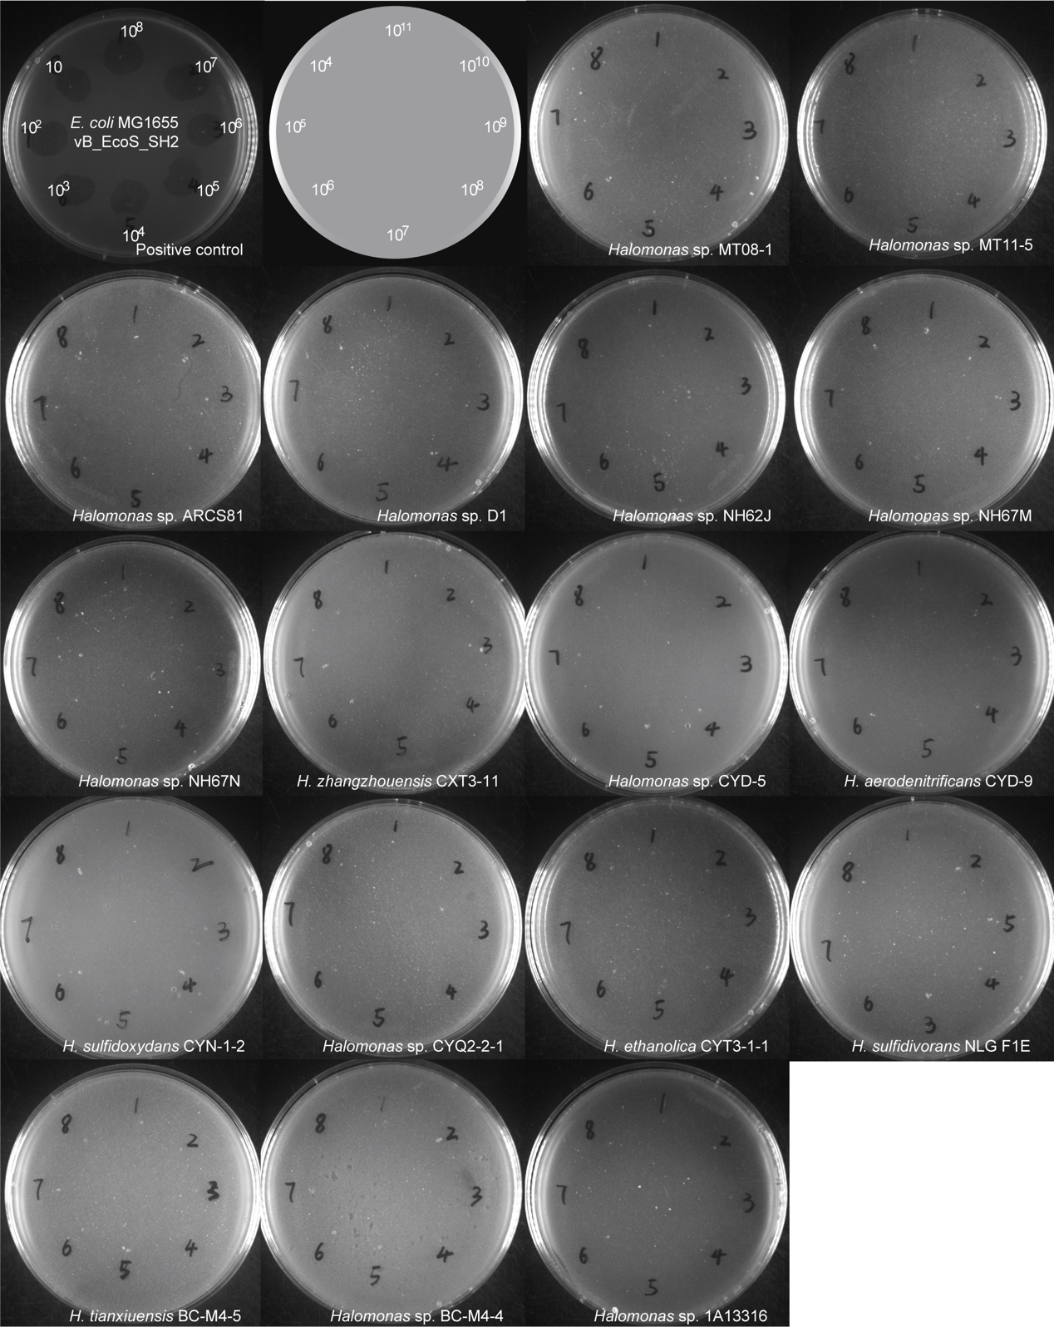
Figure S10. Plaque assay of HMP1 against 17 marine Halomonas strains. Ten microliters each of a tenfold serial dilution (10¹¹–10⁴) of HMP1 phage was spotted onto a lawn of each Halomonas strain. The E. coli K-12 strain MG1655 and its lytic phage vB_EcoS_SH2 were tested in parallel as the positive control.

Table S1. Isolated linear plasmid phages.
Phage | Taxonomy | Host | Environment | Genome size (bp) | ORFs | GC% |  | Accession number | Reference
HMP1 | Myoviridae | Halomonas sp. MT08-1 | Deep-sea sediment | 38,130 | 52 | 59.70 |  | OER181318 | This study
ΦHAP-1 | Myoviridae | Halomonas aquamarina | Marine surface water | 39,245 | 46 | 59.00 |  | NC_010342 | (Mobberley et al. 2008)
VP882 | Myoviridae | Vibrio parahaemolyticus | Marine | 38,197 | 71 | 56.95 |  | NC_009016 | (Lan et al. 2009)
PY54 | Siphoviridae | Yersinia enterocolitica | unknown | 46,339 | 67 | 44.60 |  | NC_005069 | (Hertwig et al. 2003)
N15 | Siphoviridae | Escherichia coli | unknown | 46,363 | 59 | 51.20 |  | NC_001901 | (Ravin et al. 2000)
ΦKO2 | Siphoviridae | Klebsiella oxytoca | Mineral oil water | 51,601 | 64 | 51.90 |  | NC_005857 | (Casjens et al. 2004)
ΦARM81ld | Myoviridae | Aeromonas sp. ARM81 | Waste water | 47,457 | 61 | 58.60 |  | KT898133 | (Dziewit and Radlinska 2016)
VHML | Myoviridae | Vibrio harveyi | Larvae of Panaeus monodon | 43,198 | 57 | 52.00 |  | NC_004456 | (Oakey et al. 2002)
vB_VpaM_MAR | Myoviridae | Vibrio parahaemolyticus | Seawater | 41,351 | 62 | 51.30 |  | JX556417 | (Villa et al. 2012)
Vp58.5 | Myoviridae | Vibrio parahaemolyticus | Human | 42,612 | 58 | 50.90 |  | FN297812 | (Zabala et al. 2009)
xhp1 | Siphoviridae | Actinomyces odontolyticus | Human oral cavity | 35,031 | 54 | 65.29 |  | MG941013 | (Shen et al. 2018)

Table S2. Putative ORFs identified in the HMP1 genome.
ORFs | Strand | Start | End | Length | BLASTp against RefSeq Viruses |  |  | eggNOG annotation |  | Predicted function
 |  |  |  |  | Top BLAST hit | Identity | E-value | Description | E-value
1 | - | 608 | 57 | 551 | hypothetical protein HAPgp46 [Halomonas virus HAP1] | 98.6 | 3.8E-73 | - | - | hypothetical protein
2 | - | 1240 | 605 | 635 | hypothetical protein HAPgp45 [Halomonas virus HAP1] | 100 | 2.2E-117 | Glycosyl hydrolase 108 | 1.5e-115 | Glycosyl hydrolase
3 | - | 1551 | 1237 | 314 | hypothetical protein HAPgp44 [Halomonas virus HAP1] | 100 | 4E-19 | - | - | hypothetical protein
4 | + | 1709 | 2233 | 524 | - | - | - | - | - | hypothetical protein
5 | - | 2400 | 2071 | 329 | - | - | - | - | - | hypothetical protein
6 | - | 3005 | 2397 | 608 | transcription antiterminator [Halomonas virus HAP1] | 98 | 6.2E-117 | Phage antitermination protein Q | 4.1e-115 | transcription antiterminator
7 | - | 3279 | 3043 | 236 | hypothetical protein HAPgp41 [Halomonas virus HAP1] | 81.3 | 7.9E-28 | - | - | hypothetical protein
8 | - | 3619 | 3350 | 269 | hypothetical protein HAPgp40 [Halomonas virus HAP1] | 71.1 | 2.9E-10 | - | - | hypothetical protein
9 | - | 3876 | 3622 | 254 | - | - | - | - | - | hypothetical protein
10 | - | 4490 | 3879 | 611 | prophage antirepressor [Halomonas virus HAP1] | 96 | 2.5E-110 | - | - | prophage antirepressor
11 | + | 4630 | 5274 | -644 | putative repressor protein [Vibrio virus VP882] | 35 | 5.9E-33 | - | - | repressor
12 | + | 5628 | 9611 | 3983 | replication protein RepA [Halomonas virus HAP1] | 97.4 | 0 | hydrolase activity, acting on acid anhydrides | 0.0 | replication protein RepA
13 | + | 9662 | 9949 | 287 | hypothetical protein HAPgp35 [Halomonas virus HAP1] | 97.9 | 1.1E-44 | - | - | hypothetical protein
14 | - | 11487 | 9925 | 1562 | protelomerase [Halomonas virus HAP1] | 95.6 | 3.1E-277 | Pfam:Telomere_res | 2e-275 | protelomerase
15 | + | 12074 | 12709 | 635 | ParA-like protein [Halomonas virus HAP1] | 99.5 | 3.4E-118 | - | - | ParA-like protein
16 | + | 12702 | 13001 | 299 | hypothetical protein HAPgp32 [Halomonas virus HAP1] | 100 | 7.9E-49 | - | - | hypothetical protein
17 | + | 13078 | 13227 | 149 | - | - | - | - | - | hypothetical protein
18 | + | 13224 | 13490 | 266 | hypothetical protein HAPgp31 [Halomonas virus HAP1] | 96.6 | 1.4E-41 | - | - | hypothetical protein
19 | + | 13608 | 13949 | 341 | tape measure protein [Caulobacter phage CcrSC] | 42.4 | 3.7E-10 | - | - | tape measure protein
20 | + | 13946 | 14158 | 212 | - | - | - | - | - | hypothetical protein
21 | + | 14265 | 14678 | 413 | hypothetical protein HAPgp29 [Halomonas virus HAP1] | 94.9 | 1E-75 | - | - | hypothetical protein
22 | + | 15261 | 15353 | 92 | - | - | - | - | - | hypothetical protein
23 | - | 16151 | 15396 | 755 | DNA adenine methyltransferase [Halomonas virus HAP1] | 98.8 | 5.5E-147 | D12 class N6 adenine-specific DNA methyltransferase | 3.6e-145 | DNA adenine methyltransferase
24 | - | 17317 | 16292 | 1025 | tail protein [Halomonas virus HAP1] | 96.5 | 1E-188 | Phage late control gene D protein (GPD) | 6.7e-187 | tail protein
25 | - | 17526 | 17308 | 218 | hypothetical protein phiCTXp09 [Pseudomonas virus phiCTX] | 44.1 | 0.00000032 | Tail protein | 3.9e-12 | Tail protein
26 | - | 17908 | 17492 | 416 | putative tail tape measure [Halomonas virus HAP1] | 97.8 | 1.2E-71 | Phage P2 GpU | 4.9e-35 | tail tape measure protein
27 | - | 20793 | 17908 | 2885 | putative tail tape measure [Halomonas virus HAP1] | 73.5 | 6.5E-249 | amidase activity | 4.3e-247 | tail tape measure protein
28 | + | 20796 | 21017 | 221 | - | - | - | - | - | hypothetical protein
29 | - | 21544 | 20909 | 635 | hypothetical protein HAPgp22 [Halomonas virus HAP1] | 70.5 | 5.4E-79 | Pfam:Phage_TAC_7 | 3.5e-77 | hypothetical protein
30 | - | 22131 | 21625 | 506 | putative tail tube protein [Halomonas virus HAP1] | 71.9 | 1.1E-66 | Phage tail tube protein FII | 7.2e-65 | tail tube protein
31 | - | 23301 | 22135 | 1166 | major tail sheath protein [Halomonas virus HAP1] | 91 | 8.9E-205 | Phage tail sheath protein | 5.8e-203 | major tail sheath protein
32 | - | 23498 | 23301 | 197 | - | - | - | - | - | hypothetical protein
33 | - | 23880 | 23575 | 305 | hypothetical protein HAPgp19 [Halomonas virus HAP1] | 91.1 | 3E-51 | - | - | hypothetical protein
34 | - | 24356 | 23877 | 479 | putative tail fiber assembly protein [Halomonas virus HAP1] | 66 | 3.7E-48 | - | - | tail fiber assembly protein
35 | - | 25199 | 24372 | 827 | hypothetical protein HAPgp17 [Halomonas virus HAP1] | 44.6 | 4.9E-16 | - | - | hypothetical protein
36 | - | 25870 | 25205 | 665 | hypothetical protein VPVV882_gp24 [Vibrio virus VP882] | 56.7 | 1.3E-59 | - | - | hypothetical protein
37 | - | 26176 | 25874 | 302 | hypothetical protein HAPgp15 [Halomonas virus HAP1] | 60.5 | 1.5E-23 | - | - | hypothetical protein
38 | - | 26531 | 26169 | 362 | hypothetical protein HAPgp14 [Halomonas virus HAP1] | 96.7 | 5.4E-60 | - | - | hypothetical protein
39 | - | 27058 | 26540 | 518 | putative tail protein [Halomonas virus HAP1] | 98.3 | 1.2E-89 | virus tail, fiber | 8.1e-88 | tail fiber protein
40 | - | 27787 | 27062 | 725 | putative tail protein [Halomonas virus HAP1] | 93.1 | 1.4E-99 | Phage tail protein (Tail_P2_I) | 9.2e-98 | tail protein
41 | - | 28776 | 27784 | 992 | baseplate assembly protein [Halomonas virus HAP1] | 96.1 | 2.7E-178 | Baseplate J-like protein | 1.8e-176 | baseplate assembly protein
42 | - | 29108 | 28776 | 332 | putative baseplate assembly protein [Halomonas virus HAP1] | 97.2 | 9.7E-56 | - | - | baseplate assembly protein
43 | - | 29728 | 29105 | 623 | putative baseplate assembly protein V [Halomonas virus HAP1] | 88.4 | 6.6E-106 | Phage-related baseplate assembly protein | 4.3e-104 | baseplate assembly protein V
44 | - | 30287 | 29736 | 551 | hypothetical protein HAPgp08 [Halomonas virus HAP1] | 92.3 | 2.6E-98 | - | - | hypothetical protein
45 | - | 30798 | 30268 | 530 | hypothetical protein HAPgp07 [Halomonas virus HAP1] | 96.8 | 2.1E-81 | virus tail | 1.4e-79 | tail protein
46 | - | 31135 | 30776 | 359 | hypothetical protein HAPgp06 [Halomonas virus HAP1] | 97.5 | 3.3E-65 | - | - | hypothetical protein
47 | - | 31350 | 31135 | 215 | - | - | - | - | - | hypothetical protein
48 | - | 33375 | 31417 | 1958 | putative phage-related protein [Vibrio virus VP882] | 58.4 | 2.7E-206 | N-acetylmuramoyl-L-alanine amidase activity | 1.8e-204 | N-acetylmuramoyl-L-alanine amidase
49 | - | 34834 | 33320 | 1514 | putative phage-related protein [Vibrio virus VP882] | 57.5 | 6.2E-158 | virion assembly | 4.1e-156 | virion assembly protein
50 | - | 35361 | 34834 | 527 | hypothetical protein HAPgp03 [Halomonas virus HAP1] | 58.4 | 4.1E-48 | - | - | hypothetical protein
51 | - | 37364 | 35364 | 2000 | putative terminase large subunit [Halomonas virus HAP1] | 95.1 | 0 | Phage terminase large subunit (GpA) | 0.0 | terminase large subunit
52 | - | 37908 | 37333 | 575 | putative terminase small subunit [Halomonas virus HAP1] | 99 | 5.5E-99 | Phage DNA packaging protein Nu1 | 3.6e-97 | terminase small subunit

Table S3. Halomonas strains used for the plaque assay of HMP1.
Strain | NCBI accession | Geographic origin | Isolation environment | Depth (m) | Reference/Source
Halomonas sp. NH62J | JABFTQ000000000 | South China Sea | Deep sea sediment | 1,000 | Wang and Shao, Front Microbiol, 2021
Halomonas sp. NH67M | JABFTR000000000 | South China Sea | Deep sea sediment | 1,000 | Wang and Shao, Front Microbiol, 2021
Halomonas sp. NH67N | JABFTS000000000 | South China Sea | Deep sea sediment | 1,000 | Wang and Shao, Front Microbiol, 2021
H. zhangzhouensis CXT3-11 | JABFTT000000000 | China: Zhangzhou City | Sediments from shrimp culture pond | 5 | Wang and Shao, Front Microbiol, 2021
Halomonas sp. CYD-5 | JABFTU000000000 | China: Taiwan Strait | Coastal water | 5 | Wang and Shao, Front Microbiol, 2021
H. aerodenitrificans CYD-9 | JABFTV000000000 | China: Taiwan Strait | Coastal water | 5 | Wang and Shao, Front Microbiol, 2021
H. sulfidoxydans CYN-1-2 | CP053381 | China: Taiwan Strait | Surface sediments in coastal sea | 0 | Wang and Shao, Front Microbiol, 2021
Halomonas sp. CYQ2-2-1 | JABFTW000000000 | China: Xiamen City | Sewage from municipal wastewater treatment plant | 2 | Wang and Shao, Front Microbiol, 2021
H. ethanolica CYT3-1-1 | JABFTX000000000 | China: Zhangzhou City | Sediments from shrimp culture pond | 5 | Wang and Shao, Front Microbiol, 2021
H. sulfidivorans NLG_F1E | CP053383 | Pacific Ocean | Deep sea sediment | 1,618 | Wang and Shao, Front Microbiol, 2021
H. tianxiuensis BC-M4-5 | CP035042 | Northwest Indian Ocean | Sulfide from Tianxiu hydrothermal vent | 3,440 | Wang and Shao, Front Microbiol, 2021
Halomonas sp. BC-M4-4 | JABFTZ000000000 | Northwest Indian Ocean | Sulfide from Tianxiu hydrothermal vent | 3,440 | Wang and Shao, Front Microbiol, 2021
Halomonas sp. 1A13316 | CP053382 | Pacific Ocean | Deep sea sediment | 1,618 | Wang and Shao, Front Microbiol, 2021
Halomonas sp. MT08-1 | ND | Pacific Ocean | Hadal sediment | 8,636 | Lab stock
Halomonas sp. MT11-5 | ND | Pacific Ocean | Hadal sediment | 11,094 | Lab stock
Halomonas sp. ARCS81 | ND | Pacific Ocean | Hadal sediment | 6,300 | Lab stock
Halomonas sp. D1 | ND | Pacific Ocean | Hadal sediment | 8,636 | Lab stock

References
Adriaenssens EM, Brister JR. How to Name and Classify Your Phage: An Informal Guide. Viruses. 2017;9:70.
Casjens SR, Gilcrease EB, Huang WM, Bunny KL, Pedulla ML, Ford ME, Houtz JM, Hatfull GF, Hendrix RW. The pKO2 linear plasmid prophage of Klebsiella oxytoca. J Bacteriol. 2004;186:1818-1832.
Coster WD, D'Hert S, Schultz DT, Cruts M, Broeckhoven CV. NanoPack: visualizing and processing long-read sequencing data. Bioinformatics. 2018;34:2666-2669.
Dziewit L, Radlinska M. Two novel temperate bacteriophages co-existing in Aeromonas sp. ARM81–characterization of their genomes, proteomes and DNA methyltransferases. J Gen Virol. 2016;97:2008–2022.
Hertwig S, Klein I, Schmidt V, Beck S, Hammerl JA, Appel B. Sequence Analysis of the Genome of the Temperate Yersinia enterocolitica Phage PY54. J Mol Biol. 2003;331:605-622.
Howard-Varona C, Hargreaves KR, Abedon ST, Sullivan MB. Lysogeny in nature: mechanisms, impact and ecology of temperate phages. ISME J. 2017;11:1511-1520.
Hurwitz BL, Sullivan MB. The Pacific Ocean virome (POV): a marine viral metagenomic dataset and associated protein clusters for quantitative viral ecology. PLoS One. 2013;8:e57355.
Hyatt D, Chen G-L, LoCascio PF, Land ML, Larimer FW, Hauser LJ. Prodigal: prokaryotic gene recognition and translation initiation site identification. BMC Bioinform. 2010;11:119.
Jamieson AJ, Fujii T, Mayor DJ, Solan M, Priede IG. Hadal trenches: the ecology of the deepest places on Earth. Trends in Ecology and Evolution. 2010;25:190-197.
Jian H, Xu G, Liu S, Hao Y, Meng C, Xu J, Zhang Y, Liu X, Xiao X. Multiple Mechanisms Are Involved in Repression of Filamentous Phage SW1 Transcription by the DNA-Binding Protein FpsR. J Mol Biol. 2019;431:1113-1126.
Jian H, Yi Y, Wang J, Hao Y, Zhang M, Wang S, Meng C, Zhang Y, Jing H, Wang Y, Xiao X. Diversity and distribution of viruses inhabiting the deepest ocean on Earth. ISME J. 2021;15:3094-3110.
Kolmogorov M, Yuan J, Lin Y, Pevzner PA. Assembly of long, error-prone reads using repeat graphs. Nat Biotechnol. 2019;37:540-546.
Lan S-F, Huang C-H, Chang C-H, Liao W-C, Lin I-H, Jian W-N, Wu Y-G, Chen S-Y, Wong H-c. Characterization of a new plasmid-like prophage in a pandemic Vibrio parahaemolyticus O3:K6 strain. Appl Environ Microbiol. 2009;75:2659-2667.
Meier-Kolthoff JP, Gӧker M. VICTOR: genome-based phylogeny and classification of prokaryotic viruses. Bioinformatics. 2017;33:3396-3404.
Mobberley JM, Authement RN, Segall AM, Paul JH. The Temperate Marine Phage ΦHAP-1 of Halomonas aquamarina Possesses a Linear Plasmid-Like Prophage Genome. J Virol. 2008;82:6618-6630.
Oakey HJ, Cullen BR, Owens L. The complete nucleotide of the Vibrio harveyi bacteriophage VHML. J Appl Microbiol. 2002;93:1089-1098.
pyani v0.2.8: average nucleotide identity (ANI) and related measures for whole genome comparisons [computer program]. San Francisco, CA2019.
Ravin NV. Mechanisms of replication and telomere resolution of the linear plasmid prophage N15. FEMS Microbiol Lett. 2003;221:1-6.
Ravin NV. N15: the linear phage-plasmid. Plasmid. 2011;65:102-109.
Ravin NV. Replication and Maintenance of Linear Phage-Plasmid N15. Microbiology Spectrum. 2015;3:PLAS-0032-2014.
Ravin V, Ravin N, Casjens S, Ford ME, Hatfull GF, Hendrix RW. Genomic Sequence and Analysis of the Atypical Temperate Bacteriophage N15. J Mol Biol. 2000;299:53-73.
Shen M, Yang Y, Shen W, Cen L, McLean JS, Shi W, Le S, He X. A Linear Plasmid-Like Prophage of Actinomyces odontolyticus Promotes Biofilm Assembly. Appl Environ Microbiol. 2018;84:e01263-01218.
Sullivan MJ, Petty NK, Beatson SA. Easyfig: a genome comparison visualizer. Bioinformatics. 2011;27:1009-1010.
Villa AA, Kropinski AM, Abbasifar R, Griffiths MW. Complete Genome Sequence of Vibrio parahaemolyticus Bacteriophage vB_VpaM_MAR. J Virol. 2012;86:13138-13139.
Walker BJ, Abeel T, Shea T, Priest M, Abouelliel A, Sakthikumar S, Cuomo CA, Zeng Q, Wortman J, Young SK, Earl AM. Pilon: An Integrated Tool for Comprehensive Microbial Variant Detection and Genome Assembly Improvement. PLoS One. 2014;9:e112963.
Yoshida M, Yoshida-Takashima Y, Nunoura T, Takai K. Identification and genomic analysis of temperate Pseudomonas bacteriophage PstS-1 from the Japan trench at a depth of 7000 m. Res Microbiol. 2015;166:668-676.
Zabala B, Hammerl JA, Espejo RT, Hertwig S. The linear plasmid prophage Vp58.5 of Vibrio parahaemolyticus is closely related to the integrating phage VHML and constitutes a new incompatibility group of telomere phages. J Virol. 2009;83:9313-9320.

