Virologica Sinica

Supplementary Data

Clinical and immunological features of convalescent pediatric patients infected with the SARS-CoV-2 Omicron variant in Tianjin, China

Jing-Yu Wang ª, Tian-Ning Li ª, Chun-Lei Zhou ª, Jie Zhao ª, Meng Wang ª, Yuan Wang ª, Yan Jiang ª, He-Nan Dong ^{b} , Qian-Ru Qi ^{c}, Hong Mu ^{a,} *

ª Department of Clinical Lab, Tianjin First Central Hospital, Tianjin, 300192, China;
^{b} The First Central Clinical College, Tianjin Medical University, Tianjin, 300192, China;
^{c} Department of Clinical Lab, Tianjin Children's Hospital, Tianjin, 300074, China;

* Corresponding author
E-mail address: tjmuhong@163.com (H. Mu)
ORCID: 0000-0002-8100-805X
Table S1. The difference in laboratory findings between healthy children control and convalescent pediatric patients
 | Median (IQR)
Biomarker | Total  (N = 155) | Healthy children  (n = 45) | Pediatric patients  (n = 110) | P value ª
Infection
CRP (NR: 0–10 mg/L)
Level, mg/L | 0.48 (0.2–2.51） | 3.22 (2.13–4.94) | 0.26 (0.20–0.56) | 0.003
Increased, No. (%) | 2 (1.3) | 0 (0.0) | 2 (1.8) | 1.00
Liver function
ALT (NR: M, 0–50 U/L; W, 0–35 U/L)
Level, U/L | 13.41 (11.23–16.13) | 13 (11–16) | 13.48 (11.50–16.88) | 0.201
Increased, No. (%) | 8 (5.2) | 1 (2.2) | 7 (6.4) | 0.438
AST (NR: 17–59 U/L)
Level, U/L | 25.95 (21.05–29.50) | 20.00 (18–26) | 26.91 (23.82–30.89) | < 0.001
Increased, No. (%) | 1 (0.6) | 0 (0.0) | 1 (0.9) | 1.00
Renal function
Creatinine (NR: M, 58–110 μmol/L; W, 46–92 μmol/L)
Level, μmol/L | 39.52 (33.86–46) | 44 (35–52) | 37.93 (36.63–43.51) | 0.006
Reduced, No. (%) | 99 (64.2) | 1 (2.2) | 98 (89.1) | < 0.001
BUN (NR: 2.5–7.1 mmol/L)
Level, mmol/L | 3.75 (3.11–4.56) | 3.67 (3.01–4.01) | 3.83 (3.15–4.64) | 0.083
Increased, No. (%) | 1 (0.6) | 0 (0.0) | 1 (0.9) | 1.00

Note: data are presented as median (IQR) or No. (%). No. is the number of patients with available data. Percentages may not total 100 because of rounding.
Abbreviations: IQR, interquartile range; CRP, C-reactive protein; ALT, alanine aminotransferase; AST, aspartate aminotransferase; BUN, blood urea nitrogen; NR, normal range; M, man; W, woman.
ª P values when comparing pediatric patients and healthy children using χ2 test, Fisher exact test, or Mann-Whitney U-test. P < 0.05 indicates statistically significant.

Table S2. The difference in immune features between healthy children and convalescent pediatric patients
 | Median (IQR)
Biomarker | Total  (N = 155) | Healthy children  (n = 45) | Pediatric patients  (n = 110) | P value
IgG, AU/mL | 145.19 (7.91–197.71) | 4.32 (1.28–18.78 ) | 185.45 (141.89–209.68) | < 0.001
IgM, AU/mL | 0.3 (0.18–0.7) | 0.1 (0.06–0.35) | 0.43 (0.24–0.79) | 0.819
WBCs, 10⁹/L  (NR, A 3.5–9.5, C 4.4–11.9) | 6.68 (5.62–8.19) | 6.92 (5.58–8.26) | 6.64 (5.66–8.17) | 0.816
Increased, No. (%) | 11 (7.1) | 2 (4.4) | 9 (8.2) | 0.512
Neutrophils, 10⁹/L  (NR, A 1.8–6.3, C 1.2–7.0) | 2.9 (2.24–3.87) | 2.78 (2.22–3.94) | 2.99 (2.28–3.86) | 0.752
Increased, No. (%) | 6 (5.5) | 3 (6.7) | 3 (2.7) | 0.3587
Lymphocytes, 10⁹/L  (NR, A 1.1–6.3, C 1.8–6.3) | 2.94 (2.41–3.64) | 2.87 (2.31–3.74) | 2.95 (2.53–3.56) | 0.872
Increased, No. (%) | 5 (4.6) | 2 (4.4) | 3 (2.7) | 0.6297
Monocytes, 10⁹/L  (NR, A 0.1–0.6, C 0.12–0.93) | 0.43 (0.34–0.51) | 0.43(0.38–0.51) | 0.43 (0.34–0.53) | 0.910
Increased, No. (%) | 1 (0.6) | 0 (0.0) | 1 (0.9) | 1.00
Eosinophils, 10⁹/L  (NR, A 0.02–0.523, C 0–0.68) | 0.17 (0.13–0.29) | 0.16 (0.12–0.25) | 0.18 (0.13–0.32) | 0.141
Increased, No. (%) | 4 (2.6) | 0 (0.0) | 4 (3.6) | 0.3221
Basophils,10⁹/L  (NR, A 0–0.06, C 0–0.07) | 0.03 (0.02–0.04) | 0.04 (0.03–0.05) | 0.03 (0.02–0.04) | < 0.001
Increased, No. (%) | 0 (0.0) | 0 (0.0) | 0 (0.0) | 1.00
CD3⁺ T cells  (NR, 56%–86%) | 70.83 (66.14–74.75) | 68.4（64.6–75.7） | 71.38 (67.51–74.53) | 0.240
Increased, No. (%) | 2 (1.3) | 1 (2.2) | 1 (0.9) | 0.5080
CD4⁺ T cells  (NR, 33%–58%) | 38.95 (34.21–46.22) | 52.9 (46.2–61.6) | 36.47 (32.56–40.01) | < 0.001
Increased, No. (%) | 14 (9.2) | 14 (31.1) | 0 (0.0) | < 0.001
Reduced, No. (%) | 30 (57.7) | 1 (2.2) | 29 (26.4) | < 0.001
CD8⁺ T cells  (NR, 13%–39%) | 28.13 (23.33–34.45) | 38.2 (30.2–32.7) | 25.67 (21.93–30.06) | < 0.001
Increased, No. (%) | 23 (14.8) | 21 (46.7) | 2 (1.8) | < 0.001
CD4⁺/CD8⁺  (NR, 1.4–2.0） | 1.38 (1.29–1.59) | 1.41 (1.37–1.5) | 1.42 (1.15–1.75) | 0.809
Increased, No. (%) | 30 (19.7) | 13 (28.9) | 17 (15.5) | 0.066
Reduced, No. (%) | 76 (50.0) | 24 (53.3) | 53 (48.2) | 0.560
Note: data are presented as median (IQR) or No. (%). No. is the number of patients with available data. Percentages may not total 100 because of rounding.
Abbreviations: IQR, interquartile range; WBCs, white blood cells; NR, normal range; A, adult; C, child.
ª P values when comparing pediatric patients and healthy children using χ2 test, Fisher exact test, or Mann-Whitney U-test. P < 0.05 indicates statistically significant.

Table S3. Differences in laboratory findings between vaccinated and unvaccinated adult patients during the recovery phases.
 | Median (IQR)
Biomarker | Total  (N = 320) | Unvaccinated adult patients  (n = 24) | Vaccinated adult patients  (n = 296) | P value ª
Infection
CRP
Level, mg/L | 0.97 (0.41–1.95) | 2.13 (0.56–5.29) | 0.95 (0.41–1.77) | 0.014
Increased, No. (%) | 13 (4.1) | 5 (20.8) | 8 (2.7) | 0.001
Liver function
ALT
Level, U/L | 33.44 (20.62–66.51) | 27.06 (17.04–39.58) | 34.08 (21.55–68.38) | 0.043
Increased, No. (%) | 142 (44.4) | 8 (33.3) | 134 (45.3) | 0.258
AST
Level, U/L | 23.17 (23.27–38.77) | 26.47 (23.37–39.16) | 29.42 (23.17–38.77) | 0.626
Increased, No. (%) | 41 (12.8) | 4 (16.7) | 37 (12.5) | 0.528
Renal function
Creatinine
Level, μmol/L | 59.63 (49.47–70.40) | 53.72 (43.53–64.30) | 60.14 (49.86–71.43) | 0.057
Reduced, No. (%) | 57 (17.8) | 9 (37.5) | 48 (16.3) | 0.022
BUN
Level, mmol/L | 4.00 (3.34–4.89) | 4.55 (3.41–6.23) | 3.98 (3.33–4.84) | 0.065
Increased, No. (%) | 7 (2.2) | 2 (8.3) | 5 (1.7) | 0.090
Note: data are presented as median (IQR) or No. (%). No. is the number of patients with available data. Percentages may not total 100 because of rounding.
Abbreviations: IQR, interquartile range; CRP, C-reactive protein; ALT, alanine aminotransferase; AST, aspartate aminotransferase; BUN, blood urea nitrogen.
ª P values when comparing vaccinated and unvaccinated adult cases using the χ2 test, Fisher exact test, or Mann-Whitney U-test. P < 0.05 indicates statistical significance.

Table S4. Differences in immune features between vaccinated and unvaccinated adult patients during the recovery phases
 | Median (IQR)
Biomarker | Total  (N = 320) | Unvaccinated adult patients  (n = 24) | Vaccinated adult patients  (n = 296) | P value ª
IgG, AU/mL | 207.24 (179.34–236.74) | 170.74 (2.59–183.60) | 212.1 (184.88–238.35) | < 0.001
IgM, AU/mL | 0.48 (0.26–0.87) | 0.22 (0.18–0.46) | 0.49 (0.28–0.97) | < 0.001
WBCs, 10⁹/L | 6.20 (5.24–7.38) | 6.50 (4.86–7.75) | 6.20 (5.29–7.34) | < 0.001
Increased, No. (%) | 16 (5.0) | 1 (4.2) | 15 (5.1) | 1.00
Neutrophils, 10⁹/L | 3.57 (2.85–4.35) | 3.61 (2.71–4.71) | 3.57 (2.85–4.32) | 0.979
Increased, No. (%) | 11 (3.4) | 2 (8.3) | 9 (3.0) | 0.196
Lymphocytes, 10⁹/L | 2.05 (1.61–2.43) | 1.69 (1.33–2.413) | 2.06 (1.65–2.43) | 0.057
Increased, No. (%) | 0 (0.0) | 0 (0.0) | 0 (0.0) | 1.00
Monocytes, 10⁹/L | 0.42 (0.35–0.51) | 0.49 (0.40–0.55) | 0.42 (0.35–0.51) | 0.109
Increased, No. (%) | 33 (10.3) | 2 (8.3) | 31 (10.5) | 1.00
Eosinophils, 10⁹/L | 0.13 (0.09–0.19) | 0.14 (0.11–0.18) | 0.13 (0.09–0.19) | 0.599
Increased, No. (%) | 4 (1.3) | 0 (0) | 4 (1.4) | 1.00
Basophils, 10⁹/L | 0.03 (0.02–0.04) | 0.03 (0.02–0.04) | 0.02 (0.02–0.04) | 0.834
Increased, No. (%) | 9 (2.8) | 1 (4.2) | 8 (2.7) | 0.509
CD3⁺ T cells | 73.07 (67.39–77.79) | 74.38 (69.47–80.67) | 72.80 (67.27–77.37) | 0.247
Increased, No. (%) | 8 (2.5) | 1 (4.2) | 7 (2.4) | 0.468
CD4⁺ T cells | 40.80 (34.78–47.11) | 40.50 (34.68–47.63) | 40.80 (34.78–47.01) | 0.893
Increased, No. (%) | 4 (1.3) | 0 (0.0) | 4 (3.6) | 1.00
CD8⁺ T cells | 25.02 (19.57–30.57) | 29.38 (19.52–33.50) | 24.78 (19.78–29.80) | 0.243
Increased, No. (%) | 29 (9.1) | 3 (12.5) | 26 (9.7) | 0.467
CD4⁺/CD8⁺ | 1.67 (1.19–2.15) | 1.60 (1.05–2.07) | 1.68 (1.19–2.15) | 0.497
Increased, No. (%) | 98 (30.6) | 7 (29.2) | 91 (30.7) | 0.872
Reduced, No. (%) | 105 (32.8) | 11 (45.8) | 94 (31.8) | 0.158
Note: data are presented as median (IQR) or No. (%). No. is the number of patients with available data. Percentages may not total 100 because of rounding.
Abbreviations: IQR, interquartile range; WBCs, white blood cells;
ª P values when comparing vaccinated and unvaccinated adult cases using the χ2 test, Fisher exact test, or Mann-Whitney U-test. P < 0.05 indicates statistical significance.

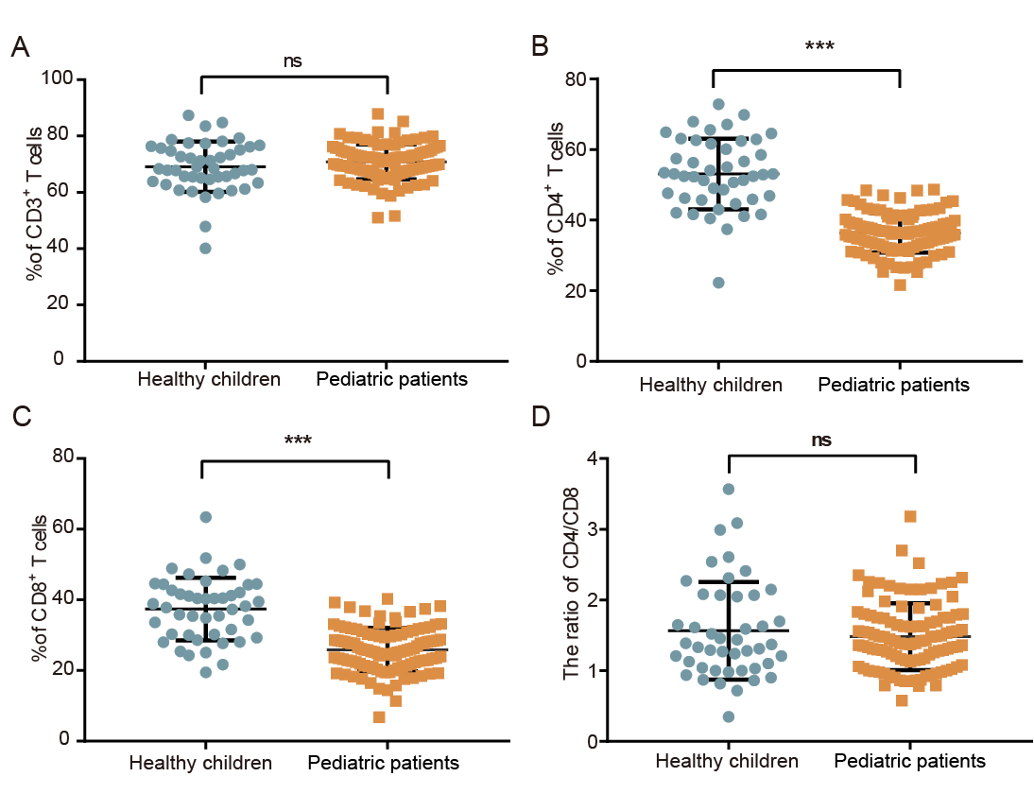
Figure. S1 T lymphocyte subsets were detected in healthy children and convalescent pediatrics infected with Omicron. A–C Comparisons of the percentage of CD3⁺ T (A), helper T cell subsets (B), and cytotoxic T cell subsets (C) between different groups. D The ratio of the CD4⁺/CD8⁺ T cell between different groups. Each dot represents one donor. Data were analyzed using Mann-Whitney U-test (ns, P > 0.05, * P < 0.05, ** P < 0.01, and *** P < 0.001). Error bars represent the mean and SD.

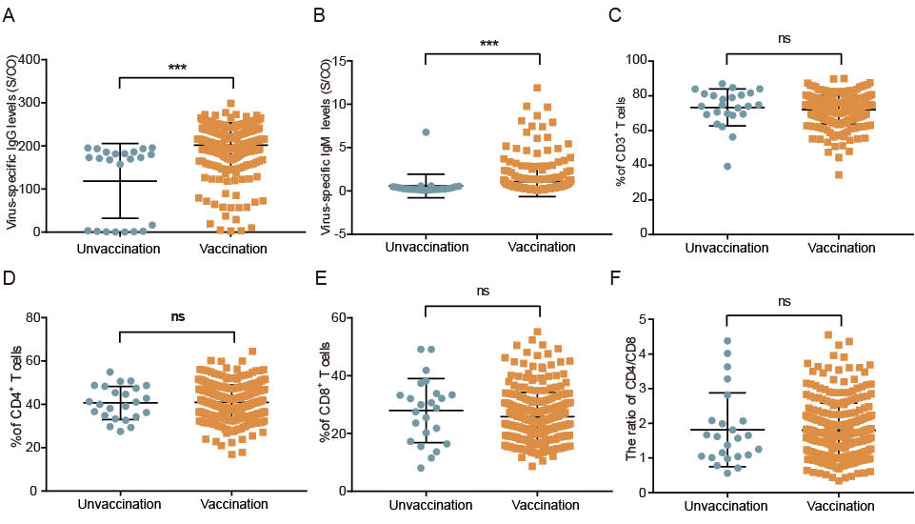
Figure. S2 Differences in immunological characteristics of adult patients with or without SARS-CoV-2 vaccination. A, B The levels of virus-specific IgG (A) and virus-specific IgM (B) between different groups. C–E Comparisons of the percentage of CD3+ T cell subsets (C), CD4+ T cell subsets (D) and CD8+ T cell subsets between different groups (E). F The ratio of the CD4+/CD8+ T cells between different groups. Each dot represents one donor. Data were analyzed using Mann-Whitney U-test (ns, P > 0.05, * P< 0.05, ** P < 0.01, and *** P < 0.001). Error bars represent the mean and SD.

