Virologica Sinica

Supplementary Data

A single nonsynonymous mutation on ZIKV E protein-coding sequences leads to markedly increased neurovirulence in vivo

Zhihua Liu^{a,b,c,1}, Yawei Zhang^{d, 1}, Mengli Cheng^{d, 1}, Ningning Ge^{a,b,c}, Jiayi Shu^{c}, Zhiheng Xu ^{e}, Xiao Su^{a,b}, Zhihua Kou^{c*}, Yigang Tong^{f*}, Chengfeng Qin^{d*}, Xia Jin^{c*}

a. Institut Pasteur of Shanghai, Chinese Academy of Sciences, Shanghai 200031, China.
b. University of Chinese Academy of Sciences, Beijing 100049, China.
c. Vaccine and Immunology Research Center, Translational Medical Research Institute, Shanghai Public Health Clinical Center, Fudan University, Shanghai 201508, China.
d. State Key Laboratory of Pathogen and Biosecurity, Beijing Institute of Microbiology and Epidemiology, Beijing 100071, China.
e. State Key Laboratory of Molecular Developmental Biology, CAS Center for Excellence in Brain Science and Intelligence Technology, Institute of Genetics and Developmental Biology, Chinese Academy of Sciences, Beijing 100101, China.
f. College of Life Science and Technology, Beijing University of Chemical Technology, Beijing 100029, China.

*Corresponding authors:
E-mail address: jinxia@shphc.org.cn (X. Jin), qincf@bmi.ac.cn (C. Qin), tong.yigang@gmail.com (Y. Tong), kouzhihua@shphc.org.cn (Z. Kou)

¹These authors contributed equally to this work

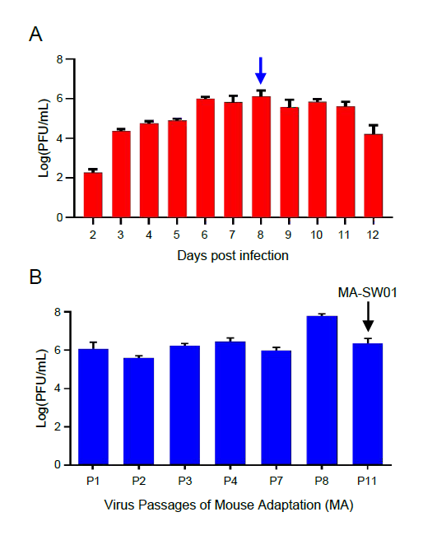
Supplementary Figure S1. ZIKV clinical isolate SW01 can grow in the brain of neonatal mice.
(A) DP2 (2 days postnatal) BALB/c mice were intracranially (i.c.) infected with 1,000 PFU ZIKV clinical isolate SW01 (n=3 for each group). Brains were collected from day 2 to day 12 after infection and homogenized. Virus titers of brains were tested by standard plaque assay. (B) Virus titers from MA-P1 to MA-P11 (MA-SW01) were determinated by standard plaque assay (n=3–5 for each group). The summary data were presented as mean ± standard deviation (SD). Data shown are representative of two independent experiments.

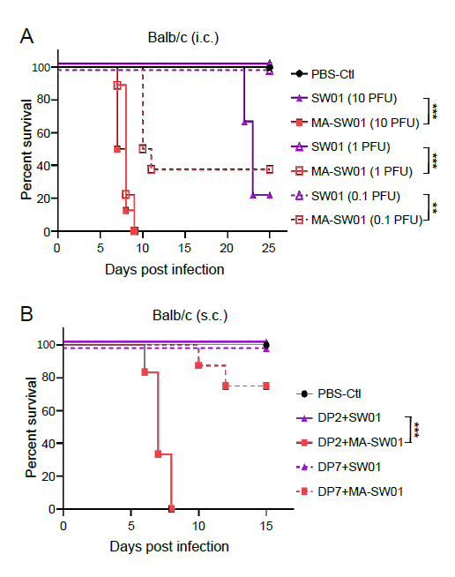
Supplementary Figure S2. Increased virulence of the adapted MA-SW01 virus is dose and age dependent.
(A). DP2 BALB/c mice were inoculated with 10, 1, and 0.1 PFU of SW01 virus or MA-SW01 virus, or the same volume of PBS control by intracranial (i.c.) route and monitored for survival rate from 0 to 25 days post infection (n=8-10 for each group). (B). DP2 and DP7 BALB/c mice were inoculated with either 100 PFU of SW01 or MA-SW01 virus, or the same volume of PBS control by subcutaneous (s.c.) route and monitored for survival rate from 0 to 15 days post infection (n=6-10 for each group). The difference between survival rate was analyzed by log rank test, P values were indicated by ** (P<0.01), or *** (P<0.001). Data shown are representative of two independent experiments.

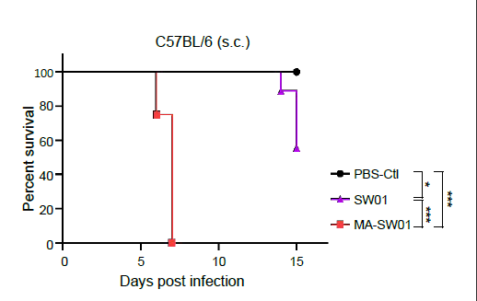
Supplementary Figure S3. Increased virulence of the adapted MA-SW01 virus is reproducible in mice of a different genetic background.
DP2 C57BL/6 mice were inoculated with 100 PFU SW01 or MA-SW01 virus, or PBS control by subcutaneous (s.c) route and monitored for survival rate from 0 to 15 days (n=8–9 for each group). The difference between survival rate was analyzed by log rank test, P values were indicated by * (P<0.05), or *** (P<0.001). Data shown are representative of two independent experiments.

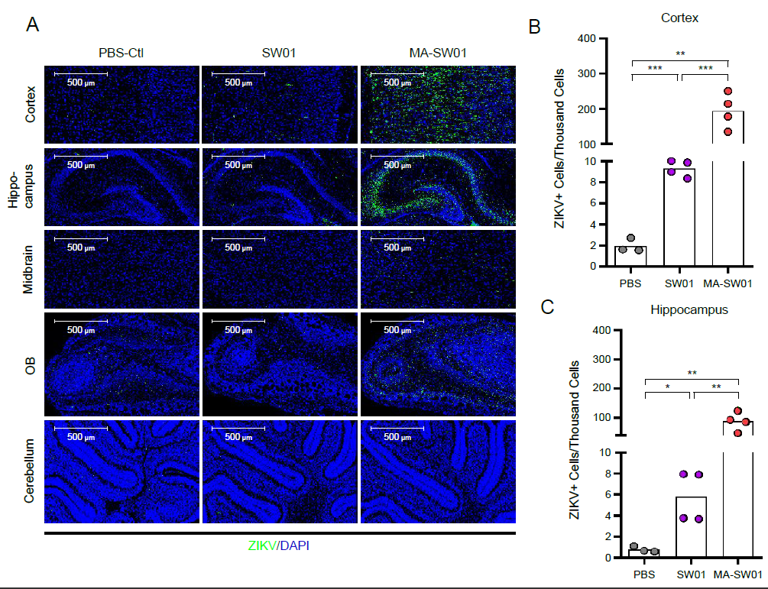

Supplementary Figure S4. Cortex and hippocampus regions are the major target sites of MA-SW01 virus infection.
(A). DP2 BALB/c mice were inoculated with 100 PFU SW01 virus, or MA-SW01 virus, or PBS control by s.c. route (n=3–4 for each group). Virus E protein expression in different brain regions (Cortex, hippocampus, midbrain, olfactory bulb (OB) and cerebellum) was shown by representative immunostaining; ZIKV positive cells in cortex (B) and hippocampus (C) were quantified and summarized as mean ± standard deviation (SD), with statistical analysis performed using student's t test, and P values were indicated by * (P<0.05), or ** (P<0.01), or *** (P<0.001). Data shown are representative of two independent experiments.

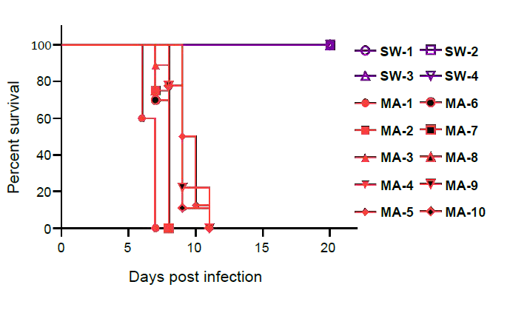
Supplementary Figure S5. Biological clones derived from the adapted MA-SW01 virus (MA) are more virulent than clones from the parental SW01 virus (SW). DP2 BALB/c mice were i.c. injected with 10 PFU of cloned viruses isolated from either SW01 (SW) or MA-SW01 (MA), and then monitored for survival from 0 to 20 days (n=8-10 for each group). Purple symbols represent clones from SW01 (SW), and red symbols represent clones from MA-SW01 (MA). The difference between survival rate was analyzed by log rank test, P values were indicated by * (P<0.05), or ** (P<0.01), or *** (P<0.001). Data shown are representative of two independent experiments.

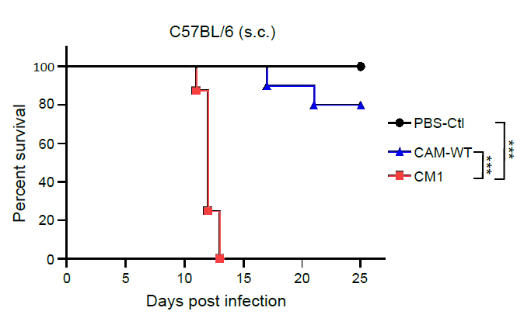
Supplementary Figure S6. Molecularly cloned ZIKV with E protein mutations (CM1) is more virulent than its parental virus (CAM-WT) in C57BL/6 mice. DP2 C57BL/6 mice were injected with 100 PFU CAM-WT or CM1 virus, or PBS control by s.c. route and monitored for survival from 0 to 25 days post infection (n=8–10 for each group). Survival rate was analyzed by log rank test, and P values were indicated by * (P<0.05), or ** (P<0.01), or *** (P<0.001). Data shown are representative of two independent experiments.

Supplementary Table S1. Deduced E protein amino acid sequences on selected positions in SW01(SW) and MA-SW01(MA) derived viruses.

Single Clone Viruses | Amino acid positions
 | 6 | 67 | 68 | 69 | 154 | 296 | 335 | 370 | 401 | 440
Consensus(WT) | V | D | M | A | N | D | T | E | H | S
1-B-2(WT) | V | D | M | A | N | D | T | E | H | S
1-C-3(WT) | V | D | M | A | N | D | T | E | H | S
1-C-4(WT) | V | D | M | A | N | D | T | E | H | S
1-D-4(WT) | V | D | M | A | N | D | T | E | H | S
1-A-1(M) | V | N | I | A | D | D | R | A | H | S
1-B-4(M) | V | N | I | A | D | D | R | E | H | S
1-B-5(M) | V | N | I | A | D | D | R | E | H | S
1-D-3(M) | V | N | I | A | D | D | R | E | H | P
1-D-5(M) | V | N | M | V | N | D | T | E | Y | S
2-B-3(M) | G | N | I | A | D | D | R | E | H | S
2-C-3(M) | V | N | I | A | D | D | R | E | H | S
2-C-5(M) | V | N | I | A | D | N | R | E | H | S
2-D-5(M) | V | N | M | V | N | D | T | E | Y | S
2-D-6(M) | V | N | M | V | N | D | T | E | Y | S

