Virologica Sinica

Supplementary Data

Spastin is required for human immunodeficiency virus-1 efficient replication through cooperation with the endosomal sorting complex required for transport (ESCRT) protein

Wenyuan Shen ^{a, b, c, 1}, Chang Liu ^{a, 1}, Yue Hu ^{a, d}, Qian Ding ª, Jiabin Feng ª, Zhou Liu ª, Xiaohong Kong ^{a,} *

ª Laboratory of Medical Molecular Virology, School of Medicine, Nankai University, Tianjin, 300071, China
^{b} Department of Spine Surgery, the Second Hospital of Shandong University, Cheeloo College of Medicine, Shandong University, Jinan, 250033, China
^{c} International Science and Technology Cooperation Base of Spinal Cord Injury, Tianjin Key Laboratory of Spine and Spinal Cord Injury, Tianjin Medical University General Hospital, Tianjin, 300052, China
^{d} Department of Infectious Diseases, Tianjin Second People’s Hospital, Tianjin 300192, China

¹ Wenyuan Shen and Chang Liu contributed equally to this work.

* Corresponding author:
E-mail: kongxh@nankai.edu.cn

ORCID: 0000-0002-2543-9066

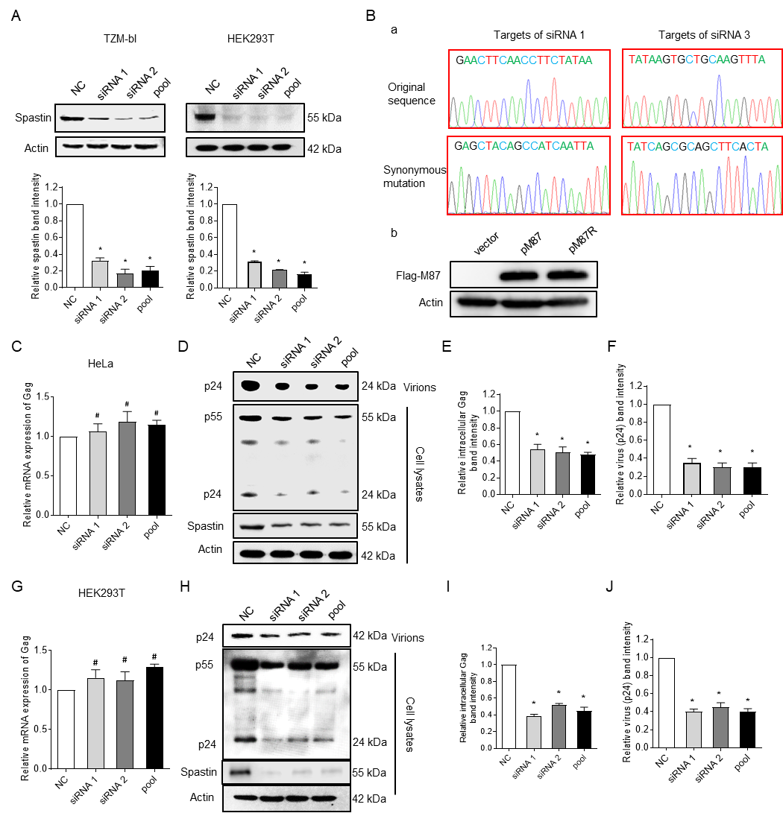
Fig. S1. Spastin affects HIV-1 production. A In TZM-bl and HEK293T cells, depletion of spastin was confirmed by Western blotting. B Synonymous mutation of siRNA-restricted M87 plasmid. B-a Sequencing results of siRNA1 and siRNA target regions of pM87 and synonymous mutant plasmids of pM87. B-b Western blot showed that the synonymous mutant plasmid pM87 could express spastin (M87) normally (1 µg/mL). C-F HeLa cells were transfected with the indicated siRNAs for 72 hours and then transfected with HIV-1 pNL4-3 (1 µg/mL). Cells and virus were harvested after 48 hours. C Gag mRNA expression in spastin knockdown HeLa cells transfected with HIV-1 pNL4-3. D-F Lysates of virus and cells were examined by Western blotting and probed with anti-Gag-CAp24 and anti-β-actin. G-J HEK293T cells were transfected with the indicated siRNAs for 72 hours and then transfected with pNL4-3 (1 µg/mL). G Gag mRNA expression in Spastin knockdown HEK293T cells. H-J Intracellular viral Gag protein levels determined by Western blotting.
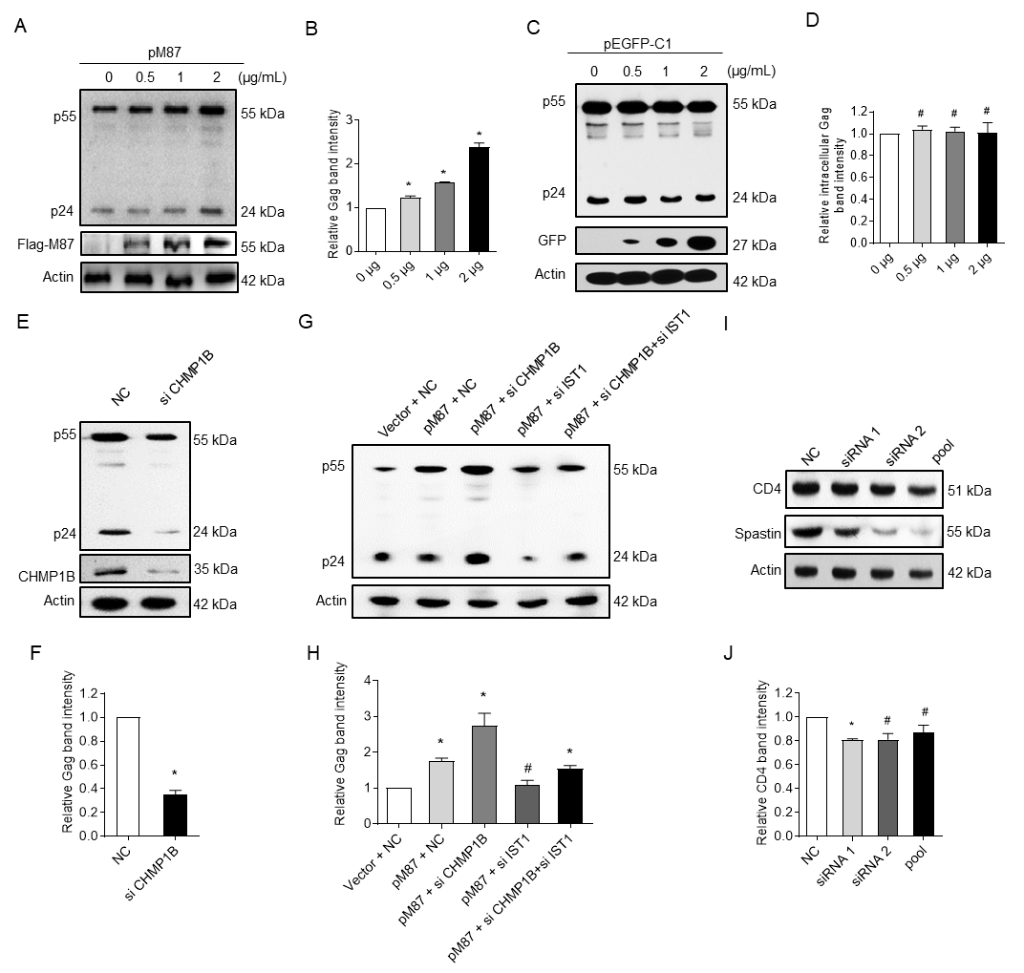
Fig. S2. Spastin affects HIV-1 replication, not through CD4 and CHMP1B. A-B Spastin promotes HIV-1 replication. HeLa cells were co-transfected with a constant amount of HIV-1 pNL4-3 (1 μg/mL) and various amounts of pM87 plasmid (0.5, 1, and 2 μg/mL). Anti-Flag antibodies were used to detect the overexpressed M87. C-D Cells were co-transfected with a constant amount of HIV-1 pNL4-3 (1 μg/mL) and pEGFP-C1 plasmid (0.5, 1, and 2 μg/mL). E-F Western blotting was used to detect the effect of CHMP1B knockdown on HIV-1 Gag expression in HeLa cells. G–H Western blotting was used to detect the effect of Spastin overexpression followed by IST1 or CHMP1B knockdown on intracellular HIV-1 Gag expression. I-J Western blotting was used to detect the effect of spastin knockdown on CD4 expression.

