Virologica Sinica

Supplementary Data

Emergence of H5N8 avian influenza virus in domestic geese in a wild bird habitat, Yishui Lake, north central China

Cheng Zhang^{a,d,#} Zhong-Yi Wang^{b,#} Huan Cui^{a,c,#} Li-Gong Chen^{d}, Chun-Mao Zhangª, Zhao-Liang Chen^{d}, Shi-Shan Dong^{d}, Kui Zhao^{c}, Ying-Ying Fu^{b}, Ju-Xiang Liu^{d,*}, Zhen-Dong Guo^{a,*}

ª Changchun Veterinary Research Institute at Chinese Academy of Agriculture Sciences, Changchun 130122, China;
^{b} Beijing Institute of Biotechnology, Beijing 100071, China;
^{c} College of Veterinary Medicine at Jilin University, Changchun 130062, China;
^{d} College of Veterinary Medicine at Hebei Agricultural University, Baoding 071000, China

# Cheng Zhang, Zhong-Yi Wang and Huan Cui are co-first authors and contributed equally to this article

*Corresponding authors.
ljx0315@126.com (J. Liu);
guozd@foxmail.com (Z. Guo)

Supplementary methods
Ethics statement
The animal studies were performed strictly consistent with the guidelines from the World Organization for Animal Health. Experimental processes were approved by the Animal Care and Use Committee of Changchun Veterinary Research Institute (approval number: SCXK 20210099). All experiments with the influenza A (H5N8) virus were performed in an animal biosafety level-3 laboratory (ABSL-3).

Receptor binding specificity assay
The receptor-binding specificities were determined by HA assays with four types of 1% cRBCs (chicken red blood cells) suspensions. Four types of cRBCs: chicken red blood cells (cRBCs); a-2,3 cRBCs (treated with VCNA and resialylated with a-2,3 glycans); a-2,6 cRBCs (treated with VCNA and resialylated with a-2,6 glycans); desialylated (Desial) cRBCs (treated with VCNA). For the HA assay, viruses were serially diluted 2-fold with 50 μL of PBS and mixed with 50 μL of a 1% RBC suspension in a 96-well plate. HA titers were read after 30 mins of the reaction at room temperature.

Cell culture and growth curves
Madin-Darby canine kidney (MDCK) and A549 cells were cultured in 6-well plates and inoculated at a multiplicity of infection (MOI) 0.001 to determine the growth kinetics of viruses. The supernatants containing the virus were collected at 12, 24, 36, 48 and 60 h post-infection (hpi), respectively. The viral titer was determined in 9-day-old specific-pathogen-free (SPF) embryonated chicken eggs and the EID₅₀ values were calculated by the method of Reed and Muench. The growth kinetics data shown were from three independent tests.

Mouse study
Six-week-old female BALB/c mice used in this study were purchased from Merial Vital Laboratory Animal Technology Company. To determine the pathogenicity of viruses to mice, seven groups (n=5) of mice was inoculated intranasally under isoflurane anesthesia with 50 μL of 10¹ –10⁶ EID₅₀ of virus or PBS. Mice of these groups were monitored for their weight loss and mortality for 14 days. To study the replication of the virus in mice, a group of 20 6-week-old female BALB/c mice was inoculated intranasally under isoflurane anesthesia with 50 μL of 10⁵ EID₅₀ of virus or PBS. Three animals were randomly selected from each group at 1, 3 and 5 dpi which was euthanized to collect 10 tissues (nasal turbinate, trachea, lung, liver, brain, heart, spleen, kidney, pancreas, intestine). The supernatants after homogenization of the above tissues were inoculated into 9-day SPF chicken eggs to test the virus titer by the Reed–Muench method. To explore the pathological changes of lung tissues of mice infected with virus, the lung tissues were collected at 3 dpi, then fixed in 4% formalin solution. The tissue samples were sectioned at a thickness of 4 μm and stained with hematoxylin and eosin. A light microscope was used to examine the pathological abnormalities in the lungs.

Guinea pig study
In the transmission studies, three guinea pigs per group were intranasally inoculated with 200 μL of virus at 10⁵ EID₅₀ and housed in a cage. The next day, three naive guinea pigs were cohoused (in the same cage) with the three infected guinea pigs to study direct-contact transmission, and another three naive guinea pigs per group were housed in a wire-frame cage adjacent to the infected guinea pigs to study aerosol transmission. The distance between the infected and aerosol-contact guinea pig cages was 5 cm. Nasal wash samples were collected from anesthetized guinea pigs at 2-day intervals by instilling 1 mL of PBS into the nostrils and collecting the wash in a Petri dish and titred in specific-pathogen-free (SPF) chicken embryos. Sera were collected from all animals on 21 days post infection for hemagglutination inhibition (HI) antibody detection.

Statistical Analysis
Quantitative data were analyzed with GraphPad Prism 8 software using the one-way ANOVA method. Differences with P values less than 0.05 were considered significant. All of the assays were run in triplicate and are representative of at least 3 separate experiments. The error bars indicate the standard deviation.
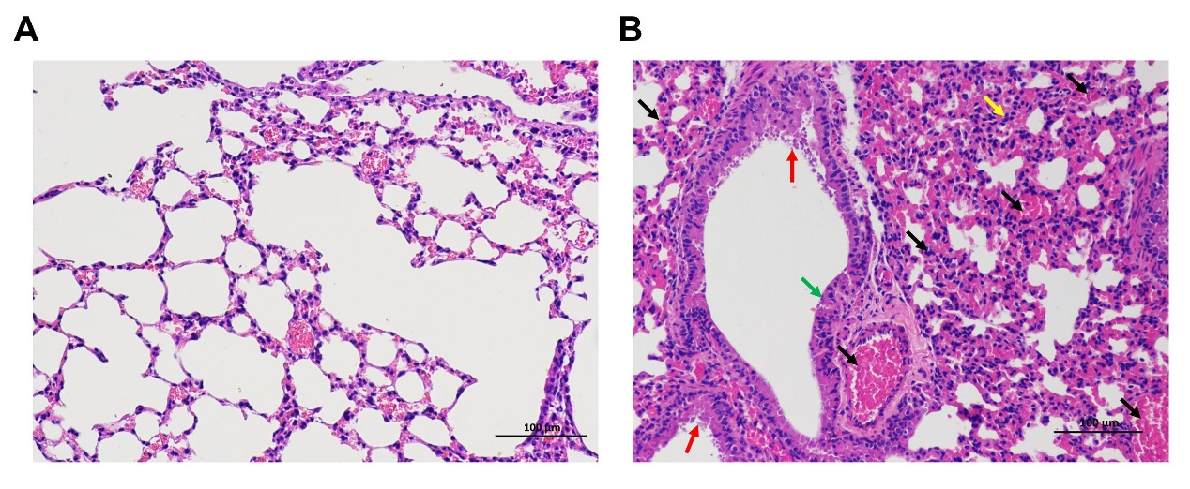
Figure S1. Histopathology of the lungs of mice inoculated with PBS (A) or HG12 (B). Black arrow: the pulmonary arterioles and alveolar wall capillaries are filled with a large number of red blood cells. Yellow arrow: Alveolar wall infiltration of lymphocytes; Green arrow: Partial epithelial degeneration of bronchioles; Red arrow: there are exfoliated epithelial cells and mucous material in the bronchioles. Images were obtained at ×20 magnification.

