Virologica Sinica

Supplementary Data

Rottlerin plays an antiviral role at early and late steps of Zika virus infection

Shili Zhou^{a,b,1}, Quanshi Lin^{a,c,1}, Changbai Huang^{a,c}, Xiaotong Luo^{a,d}, Xu Tian^{a,c}, Chao Liu^{a,d,*}, Ping Zhang^{a,c,*}

ª Key Laboratory of Tropical Diseases Control (Sun Yat-sen University), Ministry of Education, Guangzhou, 510080, China
^{b} Medical Research Center, Guangdong Second Provincial General Hospital, Guangzhou, 510317, China
^{c} Department of Immunology, Zhongshan School of Medicine, Sun Yat-sen University, Guangzhou, 510080, China
^{d} Department of Microbiology, Zhongshan School of Medicine, Sun Yat-sen University, Guangzhou, 510080, China

* Corresponding authors.
E-mail addresses: zhangp36@mail.sysu.edu.cn (P. Zhang), liuchao9@mail.sysu.edu.cn (C. Liu)

¹ Shili Zhou and Quanshi Lin contributed equally to this work.

Supplementary Table S1 Sequences of primers used in PCR.
Gene name | Sequence (5′–3′)
PKCδ WT | 5F:ATTTGCGGCCGCATGGAGCAGAAACTCATCTCTGAAGAGGATCTGGGTGGTGGTGCGCCGTTCCTGCGCATCGCC
 | 3R:CGCGGATCCTCACTTATCGTCGTCATCCTTGTAATCACCACCACCATCTTCCAGGAGGTGCTCGAATTT
PKCδ CAT | 5F:ATTTGCGGCCGCATGGAGCAGAAACTCATCTCTGAAGAGGATCTGGGTGGTGGTGGTTTCGAGAAGAAGACCGGA
 | 3R:CGCGGATCCTCACTTATCGTCGTCATCCTTGTAATCACCACCACCATCTTCCAGGAGGTGCTCGAATTT

Supplementary Table S2 Sequences of primers used in qRT-PCR.
Gene name | Sequence(5′ –3′)
ZIKV NS1 | 5F:GTCAGAGCAGCAAAGACAA
 | 3R:CAGCCTCCTTTCCCTTAACA
VSVG N | 5F:TTGGCAAGTATGCTAAGTCAG
 | 3R:AGGACTTGAGATACTCACGAA
HSV1 UL19 | 5F:AACAGCCTGTACGACGTC
 | 3R:AACTTGGTACACACGCACGC
EV71 5’UTR | 5F:CCCACCCACAGGGCCCACTGG
 | 3R:CGTTGATTTACAGCTTCTAA
EMCV 2A2B | 5F: AATGCCCACTACGCTGGT
 | 3R: GTCGTTCGGCAGTAGGGT
β-actin | 5F:GCTCCTCCTGAGCGCAAG
 | 3R: CATCTGCTGGAAGGTGGACA

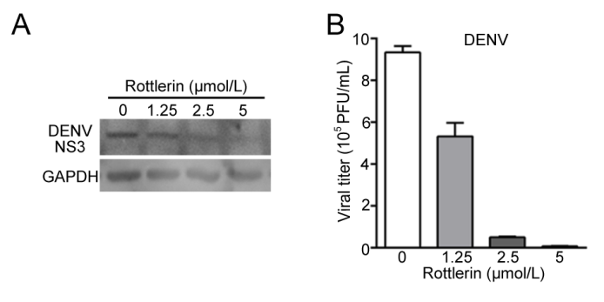
Supplementary Fig. S1 Rottlerin inhibits the replication of DENV. A549 cells were infected with DENV (MOI = 3) followed by rottlerin treatment at 1 h.p.i. Cells were harvested at 24 h.p.i. for Western blot (A), and supernatants were collected for plaque assay (B). Data are shown as mean ± standard deviation of at least three independent experiments.

