Virologica Sinica

Supplementary Data

Translation landscape of SARS-CoV-2 noncanonical subgenomic RNAs
Kai Wu ^{a, 1}, Dehe Wang ^{a, 1}, Junhao Wang ª, Yu Zhou ^{a, b, c, d, *}

ª State Key Laboratory of Virology, College of Life Sciences, Wuhan University, Wuhan 430072, China
^{b} TaiKang Center for Life and Medical Sciences, RNA institute, Wuhan University, Wuhan 430072, China
^{c} Institute for Advanced Studies, Wuhan University, Wuhan 430072, China
^{d} Frontier Science Center for Immunology and Metabolism, Wuhan University, Wuhan 430072, China

¹ Kai Wu and Dehe Wang contributed equally to this work.

* Corresponding author:
Email: yu.zhou@whu.edu.cn (Y. Zhou)
ORCID: 0000-0002-2102-9377

Table S1 — MS and RNA-seq datasets used in this project.
Table S2 — Novel sgRNA-derived peptides.
Table S3 — MS/MS information for novel peptides.
Table S4 — Predicted novel epitopes from sgRNA encoded proteins.

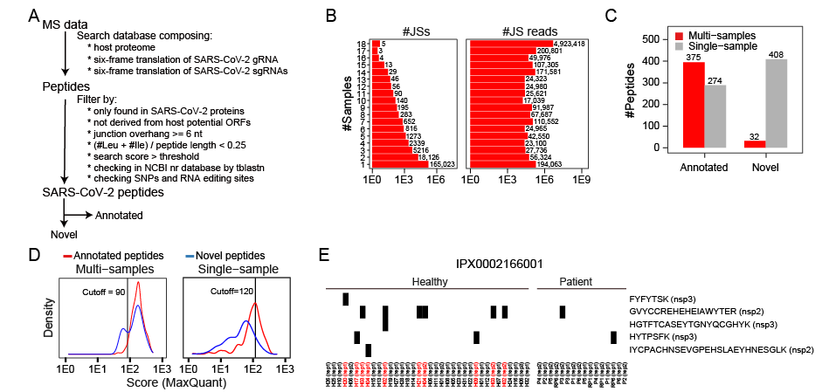
FIG S1. Filtering and quality control of mass spectrometry datasets. A Schematic diagram of filtering peptides in vipep workflow for SARS-CoV-2. B The statistics of sgRNA junction sites by numbers of the supported dataset(s) and their junction reads numbers from RNA-seq. C The number of peptides supported by multi- or single-MS dataset(s) for annotated (left) and novel peptides (right). D The distribution of MaxQuant scores for annotated and novel peptides. The vertical lines mark the chosen thresholds: 90 and 120 for multi- and single-sample(s), respectively. E Heatmap of annotated peptides in dataset IPX0002166001 (removed due to low quality). The presence of viral peptides from annotated proteins is marked by the black rectangle, and the healthy samples in red are problematic.

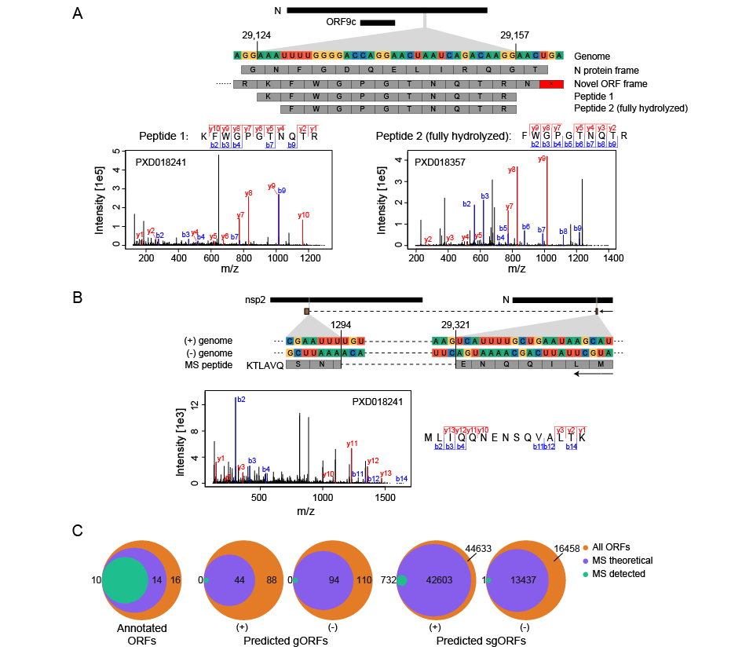
FIG S2. Two types of novel peptides detected. A A case of two novel non-junction-spanning peptides. Peptides 1 and 2 are from the same ORF, and peptide 2 is the fully hydrolyzed form. The genomic position, genome sequence, and peptide are shown at the top and the MS/MS spectra are shown at the bottom. B A novel junction-spanning peptide from negative-strand sgRNA. The genomic positions and spanning genes are shown at the top and the MS/MS spectra are shown at the bottom. C Venn diagrams of all ORFs, theoretically detectable ORFs, and MS-supported ORFs for annotated ORFs (left), predicted gORFs (middle), and sgORFs (right), respectively.

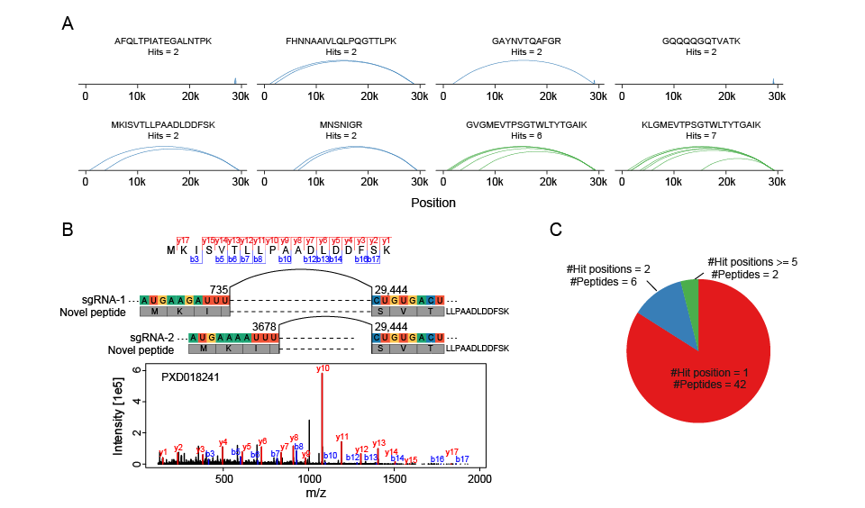
FIG S3. Overall view of novel junction-spanning peptides from multiple sgRNAs. A Global arc-view for all junction-spanning peptides possibly encoded by multiple sgRNAs. B An example of junction-spanning peptide (MKISVTLLPAADLDDFSK). Two sgRNA junctions could generate the same peptide with MS/MS spectra shown at the bottom. C Pie chart showing the numbers of novel junction-spanning peptides encoded by one or more sgRNAs.
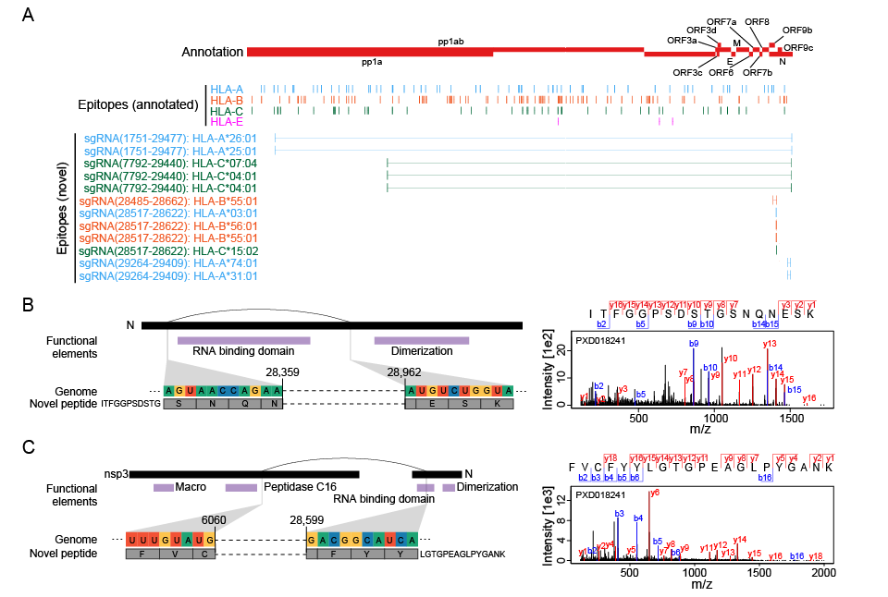
FIG S4. Overall view of novel junction-spanning peptides from multiple sgRNAs. A Global view of predicted epitopes colored by different types of antigens (HLA-A, blue; HLA-B, red; HLA-C, green; HLA-E, purple) from annotated ORFs (middle) and novel noncanonical sgRNA ORFs with MS supports. B Representative example of junction-spanning peptide supporting deletion-type sgRNA encoded protein. The annotated protein domains are shown in purple and the RNA binding domain would be lost in this sgRNA-derived protein. C Representative example of junction-spanning peptide supporting fusion-type sgRNA encoded protein. The annotated protein domains are shown in purple and the sgRNA-derived protein may fuse different functional domains from two proteins.

