Virologica Sinica

Supplementary Data

LETTER

Genetic characterization of rarely reported GII.3[P25] norovirus strain detected in patients with acute gastroenteritis in Huzhou, China, 2021

Peng Zhang ^{a, 1}, Deshun Xu ^{a, 1}, Teng Liu ^{b}, Liping Chen ª, Lei Ji ^{a,} *

ª Huzhou Center for Disease Control and Prevention, Huzhou, 313000, China
^{b} Wuxing District Center for Disease Control and Prevention of Huzhou, Huzhou, 313000, China

* Corresponding author
Email address: jileichn@163.com (L. Ji)
ORCID: 0000−0001−6753−6465

Peng Zhang and Deshun Xu contributed equally to this work.

Materials and methods
AGE outbreak surveillance and Sample collection
Cases of AGE were defined as patients with diarrhea (three or more loose stools) and/or vomiting (two or more episodes) within a 24 h period, possibly accompanied by abdominal pain, fever, and nausea. An outbreak was defined as to have three or more epidemiologically linked AGE cases within a period of three days. Outbreaks were reported to district-level Center for Disease Control and Prevention (CDC) for routine surveillance and outbreak investigations. Specimens were collected and sent to the Huzhou Municipal CDC for NoV detection. A confirmed NoV outbreak was defined as one from which at least two AGE cases tested positive for NoV.
NoV detection
Viral RNA was extracted from 200 μL fecal suspensions using a QIAamp Viral RNA Mini Kit (QIAGEN, Hilden, Germany) following the manufacturer’s instructions. The presence of GI and GII genogroup NoV was detected using a One Step PrimeScript® RT-PCR Kit (DRR064, TaKaRa, Dalian, China) and genogroup-specific primers and probes as described previously (Jothikumar et al., 2005; Ji et al., 2013).
NoV genotyping
Samples that tested positive for NoV by RT-qPCR were selected for genotyping. Sequences covering the overlap between ORF1 and ORF2 were amplified by RT-PCR using the primers MON431/G2SKR for GII viruses (Kojima et al., 2002; Vinjé et al., 2003). RT-PCR was carried out using a TAKARA One-Step RT-PCR Kit (RR057A, TaKaRa Biotechnology) with the following amplification conditions: RT at 50 °C for 30 min and denaturation at 94 °C for 2 min, followed by 40 cycles of 30 s at 94 °C, 35 s at 50 °C, and 1 min at 72 °C, and then a final extension at 72 °C for 10 min. All PCR products were purified and sent to the TaKaRa Biotechnology (Dalian, China) Company for Sanger sequencing. Preliminary genotypes were assigned by using the RIVM online NoV genotyping tool (http://www.rivm.nl/mpf/norovirus/typingtool) (Kroneman et al., 2013).
Full-length genome amplification and sequencing
One NoV-positive sample N21051 was selected for deep sequencing using the Illumina platform. The full genome was amplified by RT-PCR with a Multiple PCR Encirhment Kit for NoV (Shanghai Biogerm, China), performed in a GeneAmp PCR System 9700 (Thermo Fisher, USA). PCR products were purified using AMPure XP beads (Beckman Coulter, USA). The quantity of the purified nucleic acid sequences was examined using Qubit assay (Invitrogen, USA). Norovirus libraries were constructed using A Whole genome DNA Library Construction Kit (Shanghai Biogerm, China) according to the manufacturer’s instruction. Paired-end Illumina sequencing was performed on a Miseq platform by using a Miseq v2 Reagent Kit (Illumina, USA). The quality control and filtering of raw data were analyzed using Fastqc (v0.11.9) and Fastp (v0.23.2). Sequences were assembled using SPAdes (v3.14.1) software.
Phylogenetic analysis
All nucleotide and amino acid sequence alignments were performed using Bioedit and MEGA 7.0 software. Phylogenetic analysis was performed using MEGA software (version 7.0) (Kumar et al., 2016). The dendrograms were constructed using the neighbor-joining method validated by 1000 bootstrap replicates. Recombination analysis was conducted using the SimPlot program (version 3.5). The SimPlot analysis was performed by setting the window width and the step size to 200 bp and 20 bp, respectively.

Reference
Ji, L., Wu, X., Yao, W., Chen, L., Xu, D., Shen, Y., Shen, J.,Han, J., 2013. Rapid emergence of novel GII.4 sub-lineages noroviruses associated with outbreaks in Huzhou, China, 2008-2012. PLoS One, 8, e82627.
Jothikumar, N., Lowther, J.A., Henshilwood, K., Lees, D.N., Hill, V.R.,Vinjé, J., 2005. Rapid and sensitive detection of noroviruses by using TaqMan-based one-step reverse transcription-PCR assays and application to naturally contaminated shellfish samples. Appl Environ Microbiol, 71, 1870-1875.
Kojima, S., Kageyama, T., Fukushi, S., Hoshino, F.B., Shinohara, M., Uchida, K., Natori, K., Takeda, N.,Katayama, K., 2002. Genogroup-specific PCR primers for detection of Norwalk-like viruses. J Virol Methods, 100, 107-114.
Kroneman, A., Vega, E., Vennema, H., Vinjé, J., White, P.A., Hansman, G., Green, K., Martella, V., Katayama, K.,Koopmans, M., 2013. Proposal for a unified norovirus nomenclature and genotyping. Arch Virol, 158, 2059-2068.
Kumar, S., Stecher, G.,Tamura, K., 2016. MEGA7: Molecular Evolutionary Genetics Analysis Version 7.0 for Bigger Datasets. Mol Biol Evol, 33, 1870-1874.
Vinjé, J., Vennema, H., Maunula, L., Von Bonsdorff, C.H., Hoehne, M., Schreier, E., Richards, A., Green, J., Brown, D., Beard, S.S., Monroe, S.S., De Bruin, E., Svensson, L.,Koopmans, M.P., 2003. International collaborative study to compare reverse transcriptase PCR assays for detection and genotyping of noroviruses. J Clin Microbiol, 41, 1423-1433.

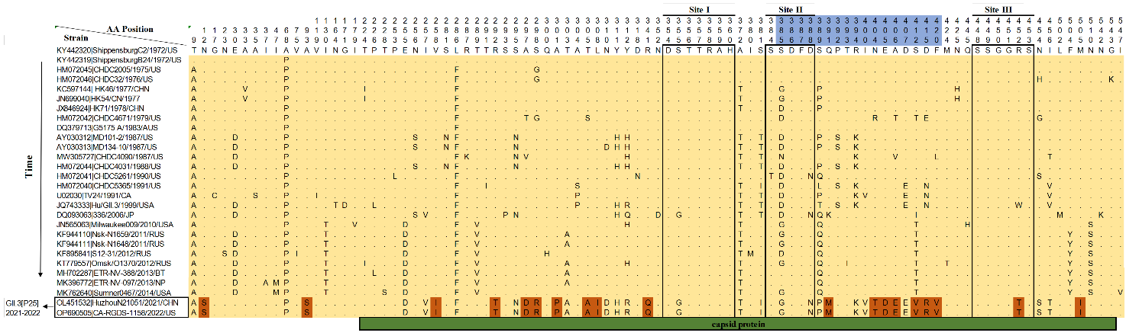
Fig. S1. Amino acid variation of the VP1 capsid region of GII.3 NoVs over time. The conserved HBGA-binding interfaces in GII.3 are indicated by empty rectangles. Blockade antibody epitopes sites defined for GII.3 strains are indicated in blue (8C7: sites 385–400; 8D1: sites 401–420). Compared with the earliest GII.3 strain (ShippensburgC2/1972/US), 19 unique amino acid substitutions carried by GII.3[P25] 2021–2022 strains are highlighted in orange.

