Virologica Sinica

Supplementary Data

Prevalence, variation, and transmission patterns of human respiratory syncytial virus from pediatric patients in Hubei, China during 2020-2021

Yi Yan ^{a, b, c, 1}, Decheng Wang ^{a, b, c, 1}, Ying Li ^{a, b, c, d, e, f, 1}, Zhiyong Wu ^{a, b, c, d}, Haizhou Liu ^{a, b, c}, Yue Shi ^{a, b, c}, Xiaoxia Lu ^{e, f, *}, Di Liu ^{a, b, c, d, *}

ª CAS Key Laboratory of Special Pathogens and Biosafety, Wuhan Institute of Virology, Center for Biosafety Mega-Science, Chinese Academy of Sciences, Wuhan, 430071, China
^{b} National Virus Resource Center, Chinese Academy of Sciences, Wuhan Institute of Virology, Center for Biosafety Mega-Science, Wuhan, 430071, China
^{c} Computational Virology Group, Center for Bacteria and Viruses Resources and Bioinformation, Wuhan Institute of Virology, Chinese Academy of Sciences, Wuhan 430071, China
^{d} University of Chinese Academy of Sciences, Beijing, 101408, China
^{e} Department of Respiratory Medicine, Wuhan Children' Hospital, Tongji Medical College, Huazhong University of Science and Technology, Wuhan 430014, China
^{f} Pediatric Respiratory Disease Laboratory, Institute of Maternal and Child Health, Wuhan Children's Hospital, Tongji Medical College, Huazhong University of Science and Technology, Wuhan 430014, China

# Yi Yan and Decheng Wang contributed equally to this work.

*Corresponding authors:
Email address: liud@wh.iov.cn (D. Liu); lusi74@163.com (X. Lu)
ORCID: 0000-0003-3693-2726 (D. Liu); 0000-0001-7450-4023 (X. Lu)

Supplementary Table S1 Detail information for patients in this study.
GISAID accession | Gender | Age | Sample  identifier | Sampling  date | Sequencing  identifier | Group | Depth | Coverage
EPI_ISL_6268437 | Girl | 2 Months | HB-28820 | 20201031 | 20201031-3 | RSV-B | 333 | 100.00%
EPI_ISL_6268457 | Girl | 42 Months | HB-31505 | 20201112 | 20201112-8 | RSV-B | 6259 | 100.00%
EPI_ISL_6268594 | Boy | 2 Months | HB-32993 | 20201119 | 20201119-5 | RSV-B | 7629 | 100.00%
EPI_ISL_6268595 | Boy | 5 Months | HB-33784 | 20201123 | 20201123-1 | RSV-B | 1459 | 100.00%
EPI_ISL_6268606 | Girl | 4 Months | HB-37781 | 20201212 | 20201212-7 | RSV-B | 749 | 100.00%
EPI_ISL_6268611 | Girl | 28 Months | HB-37875 | 20201213 | 20201213-4 | RSV-B | 344 | 100.00%
EPI_ISL_6268612 | Boy | 5 Months | HB-38291 | 20201215 | 20201215-6 | RSV-B | 439 | 100.00%
EPI_ISL_6268618 | Boy | 2 Months | HB-39147 | 20201219 | 20201219-9 | RSV-B | 567 | 100.00%
EPI_ISL_6268623 | Girl | 46 Months | HB-46486 | 20210123 | 20210123-3 | RSV-B | 552 | 100.00%
EPI_ISL_6314463 | Boy | 10 Months | HB-51132 | 20210219 | 20210219-1 | RSV-B | 2039 | 100.00%
EPI_ISL_6314465 | Girl | 6 Months | HB-57214 | 20210316 | 20210316-3 | RSV-B | 422 | 100.00%
EPI_ISL_6314585 | Girl | 2 Months | HB-60337 | 20210329 | 20210329-7 | RSV-B | 5271 | 100.00%
EPI_ISL_6314658 | Boy | 37 Months | HB-61255 | 20210402 | 20210402-3 | RSV-B | 6466 | 100.00%
EPI_ISL_6314659 | Boy | 2 Months | HB-61918 | 20210405 | 20210405-1 | RSV-B | 1207 | 100.00%
EPI_ISL_6314662 | Boy | 38 Months | HB-62566 | 20210407 | 20210407-6 | RSV-B | 353 | 100.00%
EPI_ISL_6268456 | Boy | 39 Months | HB-31344 | 20201111 | 20201111-5 | RSV-B | 31 | 99.99%
EPI_ISL_6268607 | Girl | 33 Months | HB-37714 | 20201212 | 20201212-8 | RSV-B | 213 | 99.99%
EPI_ISL_6314641 | Girl | 41 Months | HB-60725 | 20210331 | 20210331-6 | RSV-B | 122 | 99.98%
EPI_ISL_6314642 | Boy | 41 Months | HB-61266 | 20210402 | 20210402-1 | RSV-B | 68 | 99.95%
EPI_ISL_6268627 | Girl | 6 Months | HB-50071 | 20210212 | 20210212-3 | RSV-B | 395 | 99.92%
EPI_ISL_6314660 | Boy | 56 Months | HB-61984 | 20210405 | 20210405-4 | RSV-B | 211 | 99.91%
EPI_ISL_6268622 | Boy | 3 Months | HB-46289 | 20210122 | 20210122-1 | RSV-B | 222 | 99.89%
EPI_ISL_6268597 | Boy | 4 Months | HB-36125 | 20201204 | 20201204-5 | RSV-B | 103 | 99.88%
EPI_ISL_6314464 | Boy | 6 Months | HB-56392 | 20210313 | 20210313-2 | RSV-B | 232 | 99.87%
EPI_ISL_6314470 | Boy | 34 Months | HB-58492 | 20210322 | 20210322-5 | RSV-B | 107 | 99.86%
EPI_ISL_6314468 | Boy | 20 Months | HB-58490 | 20210322 | 20210322-2 | RSV-B | 54 | 99.84%
EPI_ISL_6268596 | Boy | 6 Months | HB-35522 | 20201201 | 20201201-2 | RSV-B | 71 | 99.81%
EPI_ISL_6314467 | Boy | 6 Months | HB-58211 | 20210321 | 20210321-2 | RSV-B | 230 | 99.81%
EPI_ISL_6314663 | Boy | 12 Months | HB-62717 | 20210408 | 20210408-7 | RSV-B | 155 | 99.77%
EPI_ISL_6314471 | Girl | 7 Months | HB-58777 | 20210323 | 20210323-6 | RSV-B | 30 | 99.71%
EPI_ISL_6268626 | Boy | 4 Months | HB-50073 | 20210212 | 20210212-2 | RSV-B | 78 | 99.68%
EPI_ISL_6314640 | Girl | 2 Months | HB-60417 | 20210330 | 20210330-5 | RSV-B | 62 | 99.67%
EPI_ISL_6268598 | Girl | 35 Months | HB-36915 | 20201208 | 20201208-3 | RSV-B | 86 | 99.63%
EPI_ISL_6268620 | Boy | 54 Months | HB-44330 | 20210113 | 20210113-6 | RSV-B | 120 | 99.59%
EPI_ISL_6314483 | Girl | 40 Months | HB-60082 | 20210328 | 20210328-6 | RSV-A | 74 | 99.59%
EPI_ISL_6268624 | Boy | 12 Months | HB-48869 | 20210204 | 20210204-2 | RSV-A | 173 | 99.57%
EPI_ISL_6314661 | Girl | 11 Months | HB-62086 | 20210406 | 20210406-6 | RSV-B | 93 | 99.55%
EPI_ISL_6268617 | Boy | 8 Months | HB-38946 | 20201218 | 20201218-3 | RSV-B | 38 | 99.51%
EPI_ISL_6268621 | Boy | 2 Months | HB-46126 | 20210121 | 20210121-1 | RSV-B | 59 | 99.45%
EPI_ISL_6268619 | Boy | 2 Months | HB-40255 | 20201224 | 20201224-4 | RSV-A | 703 | 99.42%
EPI_ISL_6314466 | Boy | 3 Months | HB-57844 | 20210319 | 20210319-3 | RSV-B | 91 | 99.36%
EPI_ISL_6268599 | Boy | 19 Months | HB-37292 | 20201210 | 20201210-1 | RSV-B | 25 | 99.32%
EPI_ISL_6314469 | Boy | 11 Months | HB-58581 | 20210322 | 20210322-3 | RSV-B | 26 | 99.27%
EPI_ISL_6268628 | Girl | 1 Months | HB-50619 | 20210217 | 20210217-2 | RSV-B | 83 | 99.25%
EPI_ISL_6268455 | Boy | 45 Months | HB-31271 | 20201111 | 20201111-3 | RSV-B | 25 | 99.21%
EPI_ISL_6268625 | Boy | 6 Months | HB-49998 | 20210211 | 20210211-1 | RSV-B | 40 | 99.04%
– | Boy | 9 Months | HB-48058 | 20210131 | 20210131-5 | RSV-A | 24 | 98.80%
– | Boy | 13 Months | HB-52168 | 20210223 | 20210223-5 | RSV-B | 97 | 98.74%
– | Girl | 43 Months | HB-62552 | 20210407 | 20210407-3 | RSV-B | 30 | 98.46%
– | Boy | 16 Months | HB-60737 | 20210331 | 20210331-2 | RSV-B | 17 | 97.14%
– | Girl | 41 Months | HB-46544 | 20210123 | 20210123-2 | RSV-B | 58 | 96.98%
– | Boy | 3 Months | HB-41765 | 20201231 | 20201231-4 | RSV-A | 54 | 95.28%
– | Girl | 2 Months | HB-42094 | 20210102 | 20210102-1 | RSV-B | 96 | 95.14%
– | Boy | 1 Months | HB-48716 | 20210203 | 20210203-8 | RSV-B | 181 | 93.11%
– | Boy | 40 Months | HB-38594 | 20201216 | 20201216-2 | RSV-B | 69 | 92.34%
– | Boy | 2 Months | HB-42301 | 20210103 | 20210103-3 | RSV-B | 273 | 91.32%
– | Boy | 6 Months | HB-52484 | 20210224 | 20210224-1 | RSV-A | 155 | 90.28%
– | Girl | 17 Months | HB-62202 | 20210406 | 20210406-8 | RSV-B | 15 | 90.14%
– | Boy | 2 Months | HB-53309 | 20210227 | 20210227-3 | RSV-B | 114 | 85.90%
– | Boy | 17 Months | HB-63971 | 20210413 | 20210413-3 | RSV-B | 52 | 85.78%
– | Boy | 38 Months | HB-32905 | 20201118 | 20201118-4 | RSV-B | 10 | 78.54%
– | Boy | 5 Months | HB-36810 | 20201208 | 20201208-2 | RSV-B | 9 | 73.77%
– | Girl | 14 Months | HB-58644 | 20210322 | 20210322-1 | RSV-B | 8 | 72.38%
– | Girl | 8 Months | HB-45833 | 20210120 | 20210120-1 | RSV-B | 20 | 70.96%
– | Girl | 19 Months | HB-61176 | 20210402 | 20210402-6 | RSV-B | 15 | 68.76%
– | Boy | 12 Months | HB-43762 | 20210110 | 20210110-4 | RSV-B | 10 | 63.17%
– | Boy | 17 Months | HB-61567 | 20210404 | 20210404-2 | RSV-B | 3 | 57.61%
– | Boy | 24 Months | HB-42761 | 20210105 | 20210105-3 | RSV-A | 18 | 57.52%
– | Boy | 37 Months | HB-52397 | 20210224 | 20210224-4 | RSV-B | 2 | 57.29%
– | Boy | 34 Months | HB-62608 | 20210408 | 20210408-3 | RSV-B | 3 | 56.48%
– | Girl | 40 Months | HB-49873 | 20210210 | 20210210-1 | RSV-B | 2 | 56.06%
– | Boy | 2 Months | HB-42829 | 20210106 | 20210106-3 | RSV-B | 7 | 51.71%
– | Boy | 2 Months | HB-44949 | 20210116 | 20210116-2 | RSV-B | 8 | 50.92%
– | Boy | 14 Months | HB-52581 | 20210224 | 20210224-2 | RSV-B | 17 | 47.73%
– | Girl | 45 Months | HB-59255 | 20210325 | 20210325-1 | RSV-B | 15 | 47.13%
– | Girl | 7 Months | HB-36898 | 20201208 | 20201208-1 | RSV-B | 4 | 46.26%
– | Boy | 23 Months | HB-37352 | 20201210 | 20201210-2 | RSV-B | 2 | 46.22%
– | Girl | 14 Months | HB-38727 | 20201217 | 20201217-3 | RSV-B | 1 | 45.00%
– | Girl | 13 Months | HB-53457 | 20210228 | 20210228-2 | RSV-B | 2 | 44.78%
– | Boy | 21 Months | HB-60219 | 20210329 | 20210329-3 | RSV-B | 4 | 44.40%
– | Girl | 20 Months | HB-37449 | 20201210 | 20201210-6 | RSV-B | 3 | 44.32%
– | Boy | 14 Months | HB-55241 | 20210308 | 20210308-5 | RSV-B | 1 | 41.43%
– | Boy | 18 Months | HB-50281 | 20210214 | 20210214-1 | RSV-B | 11 | 40.67%
– | Boy | 3 Months | HB-48817 | 20210204 | 20210204-1 | RSV-B | 6 | 37.53%
– | Girl | 18 Months | HB-51592 | 20210221 | 20210221-2 | RSV-B | 10 | 36.28%
– | Girl | 13 Months | HB-57609 | 20210318 | 20210318-7 | RSV-B | 3 | 35.44%
– | Girl | 3 Months | HB-57879 | 20210319 | 20210319-5 | RSV-B | 15 | 34.92%
– | Boy | 7 Months | HB-48659 | 20210203 | 20210203-6 | RSV-B | 12 | 34.54%
– | Boy | 30 Months | HB-41161 | 20201229 | 20201229-2 | RSV-B | 1 | 34.03%
– | Boy | 40 Months | HB-53365 | 20210228 | 20210228-3 | RSV-B | 10 | 33.62%
– | Girl | 5 Months | HB-47257 | 20210127 | 20210127-1 | RSV-B | 1 | 31.22%
– | Boy | 13 Months | HB-49996 | 20210211 | 20210211-3 | RSV-B | 1 | 30.85%
– | Boy | 14 Months | HB-48166 | 20210131 | 20210131-1 | RSV | 17 | 29.94%
– | Girl | 12 Months | HB-50756 | 20210217 | 20210217-3 | RSV | 1 | 28.87%
– | Boy | 16 Months | HB-41059 | 20201228 | 20201228-5 | RSV | 1 | 25.87%
– | Girl | 41 Months | HB-61059 | 20210401 | 20210401-6 | RSV | 0 | 23.75%
– | Boy | 16 Months | HB-43583 | 20210109 | 20210109-2 | RSV | 1 | 23.74%
– | Boy | 37 Months | HB-59555 | 20210326 | 20210326-4 | RSV | 4 | 21.67%
– | Boy | 73 Months | HB-37852 | 20201213 | 20201213-1 | RSV | 1 | 19.94%
– | Boy | 38 Months | HB-62395 | 20210407 | 20210407-5 | RSV | 0 | 18.27%
– | Girl | 77 Months | HB-60765 | 20210331 | 20210331-7 | RSV | 0 | 15.84%
– | Girl | 44 Months | HB-42855 | 20210106 | 20210106-1 | RSV | 0 | 13.71%
– | Girl | 4 Months | HB-39746 | 20201222 | 20201222-4 | RSV | 0 | 12.00%
– | Boy | 9 Months | HB-47478 | 20210128 | 20210128-2 | RSV | 0 | 11.56%
– | Boy | 6 Months | HB-60463 | 20210330 | 20210330-3 | RSV | 0 | 11.37%
– | Boy | 2 Months | HB-50437 | 20210215 | 20210215-1 | RSV | 0 | 8.17%

Supplementary Table S2 Recombination detection in RDP4 for all public data and genome in this study.
RSV Type | RDP Symbols | Recombinant Sequence(s) | Minor Parental Sequence(s) | Major Parental Sequence(s) | RDP | GENECONV | Bootscan | Maxchi | Chimaera | SiSscan | 3Seq
RSV-A | ~ | EPI_ISL_2582801 | EPI_ISL_2544037 | EPI_ISL_2582296 | 1.99E-08 | 3.23E-06 | – | – | – | – | 4.15E-02
 | ~^ | EPI_ISL_1653968 | EPI_ISL_2582805 | EPI_ISL_1834110 | 1.02E-03 | 1.15E-02 | 1.06E-02 | – | – | – | –
 | ~^ | EPI_ISL_1074279 | EPI_ISL_1834171 | EPI_ISL_1074195 | 3.11E-03 | – | – | 8.02E-03 | – | 2.42E-02 | –
RSV-B | ~^ | EPI_ISL_2584693 | 20210217-2 | EPI_ISL_2584888 | – | 1.92E-22 | 4.26E-16 | 2.40E-03 | 4.57E-04 | – | 2.96E-09
 |  | EPI_ISL_2575425 | EPI_ISL_1760390 | EPI_ISL_2577156 | 1.73E-06 | 4.42E-12 | – | 2.25E-12 | 1.41E-02 | 8.93E-20 | 3.35E-07
 | ~ | EPI_ISL_2584706 | EPI_ISL_2544107 | EPI_ISL_2584972 | – | 2.48E-10 | 1.76E-09 | – | – | – | 1.51E-02
 | ~ | EPI_ISL_2575517 | EPI_ISL_2577662 | EPI_ISL_2584686 | 1.17E-09 | 3.18E-08 | – | 2.23E-02 | – | 2.94E-02 | 1.18E-05
 | ~ | EPI_ISL_2584815 | EPI_ISL_2585067 | EPI_ISL_2584879 | 8.89E-07 | 3.64E-03 | 5.39E-05 | – | – | – | 4.54E-02
 | ~ | EPI_ISL_2575620 | EPI_ISL_2544100 | EPI_ISL_1074224 | 2.77E-06 | 3.48E-04 | – | – | – | – | 4.48E-02
 | ~^ | EPI_ISL_2584861 | EPI_ISL_2544190 | EPI_ISL_2584852 | 7.63E-03 | 2.42E-05 | – | 2.14E-02 | – | 1.21E-04 | –
 | ~^ | EPI_ISL_2585182 | EPI_ISL_2544144 | EPI_ISL_2585029 | 3.67E-04 | 3.32E-05 | 6.94E-05 | – | – | – | –
~, It is possible that this apparent recombination signal could have been caused by an evolutionary process other than recombination.
^, The recombinant sequence may have been misidentified (one of the identified parents might be the recombinant)
Minor Parent, Parent contributing the smaller fraction of sequence.
Major Parent, Parent contributing the larger fraction of sequence.
Unknown, Only one parent and a recombinant need be in the alignment for a recombination event to be detectable. The sequence listed as unknown was used to infer the existance of a missing parental sequence.
–, No significant P-value was recorded for this recombination event using this method.

Supplementary Table S3 Recombination detection in RDP4 and SimPlot for dataset used for analyses.
RSV Type | RDP Symbols | Recombinant Sequence(s) | Minor Parental Sequence(s) | Major Parental Sequence(s) | RDP | GENECONV | Bootscan | Maxchi | Chimaera | SiSscan | 3Seq | Simplot
RSV–B | ~^ | 20210313-2 | EPI_ISL_1760437 | 20210405-4 | 1.55E-04 | 1.54E-02 | – | 1.28E-02 | 2.92E-02 | – | 2.03E-04 | –
 | ~^ | EPI_ISL_1760417 | EPI_ISL_1647472 | EPI_ISL_1647589 | – | – | – | 3.60E-03 | – | 2.19E-03 | – | –
 | ~^ | 20201208-3 | 20210405-4 | EPI_ISL_1647589 | – | – | – | 7.12E-03 | – | 1.63E-07 | – | –
~, It is possible that this apparent recombination signal could have been caused by an evolutionary process other than recombination.
^, The recombinant sequence may have been misidentified (one of the identified parents might be the recombinant)
Minor Parent, Parent contributing the smaller fraction of sequence.
Major Parent, Parent contributing the larger fraction of sequence.
Unknown, Only one parent and a recombinant need be in the alignment for a recombination event to be detectable. The sequence listed as unknown was used to infer the existance of a missing parental sequence.
–, No significant P-value was recorded for this recombination event using this method.

Supplementary Table S4 Statistical supported diffusion rates of inter-regional diffusion for G genes.
 | FROM | TO | Mean actual rates | Mean indicators | Bayes factor
RSV-A | Asia | North America | 1.017 | 0.703 | 12.481
 | Asia | Oceania | 1.111 | 0.532 | 6.008
 | North America | South America | 1.358 | 0.961 | 131.558
 | North America | Africa | 0.926 | 0.876 | 37.232
 | Oceania | Africa | 0.808 | 0.745 | 15.405
 | Europe | Asia | 0.917 | 0.598 | 7.856
 | North America | Asia | 1.119 | 0.799 | 20.914
 | Europe | China | 0.955 | 0.872 | 35.870
 | North America | Europe | 1.949 | 1 | 11864.962
 | Oceania | Europe | 1.061 | 0.621 | 8.649
RSV-B | Asia | Europe | 0.84 | 0.588 | 7.537
 | Asia | North America | 0.82 | 0.813 | 22.920
 | Asia | Oceania | 1.087 | 0.581 | 7.319
 | Asia | South America | 1.388 | 0.998 | 2368.772
 | Europe | Oceania | 1.751 | 1 | 47475.674
 | Europe | Africa | 0.697 | 0.578 | 7.217
 | Oceania | Africa | 0.647 | 0.89 | 42.637
 | China | Asia | 0.492 | 0.897 | 45.945
 | Oceania | China | 1.014 | 0.931 | 70.694
 | Oceania | Europe | 2.96 | 1 | 47475.674
 | South America | North America | 0.783 | 0.564 | 6.837
 | South America | Oceania | 1.198 | 0.783 | 18.999

Supplementary Table S5 Statistical supported diffusion rates of inter-regional diffusion for whole genomes.
 | FROM | TO | Mean actual rates | Mean indicators | Bayes factor
RSV-A | Asia | North America | 1.119 | 0.546 | 6.334
 | Asia | Oceania | 1.172 | 0.533 | 6.019
 | Europe | Oceania | 2.319 | 0.979 | 247.283
 | North America | Oceania | 1.874 | 0.959 | 122.362
 | North America | South America | 0.718 | 0.641 | 9.439
 | North America | Africa | 0.713 | 0.763 | 17.027
 | Oceania | Africa | 0.803 | 0.611 | 8.279
 | North America | Asia | 1.514 | 0.962 | 133.153
 | Oceania | Asia | 0.854 | 0.514 | 5.590
 | Europe | China | 1.194 | 0.971 | 175.950
 | South America | Europe | 0.911 | 0.626 | 8.844
RSV-B | Europe | Oceania | 0.634 | 0.992 | 522.165
 | Oceania | South America | 0.5 | 0.901 | 38.813
 | Oceania | Africa | 0.435 | 0.978 | 188.845
 | Oceania | Asia | 0.575 | 0.954 | 89.006
 | Oceania | China | 2.307 | 1 | 38425.438
 | Oceania | Europe | 3.86 | 1 | 38425.438

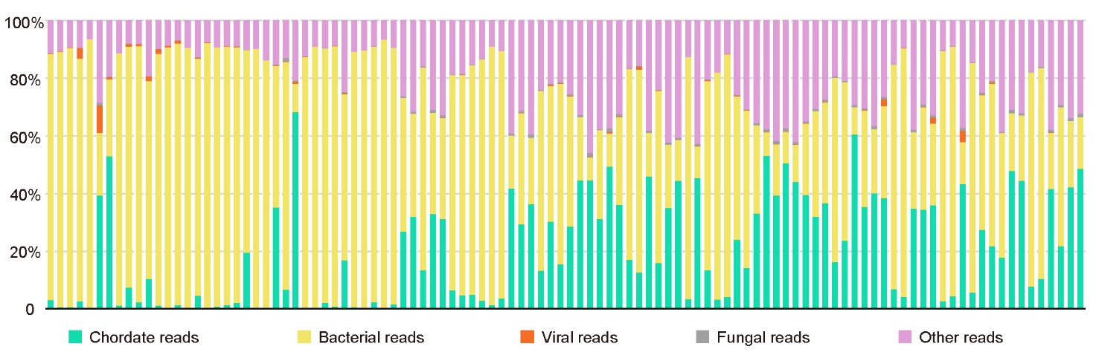
Supplementary Figure S1. Taxonomy of reads in samples. Histogram shows percentage of reads mapping to human, viruses, bacteria, fungi and others for the individual samples.
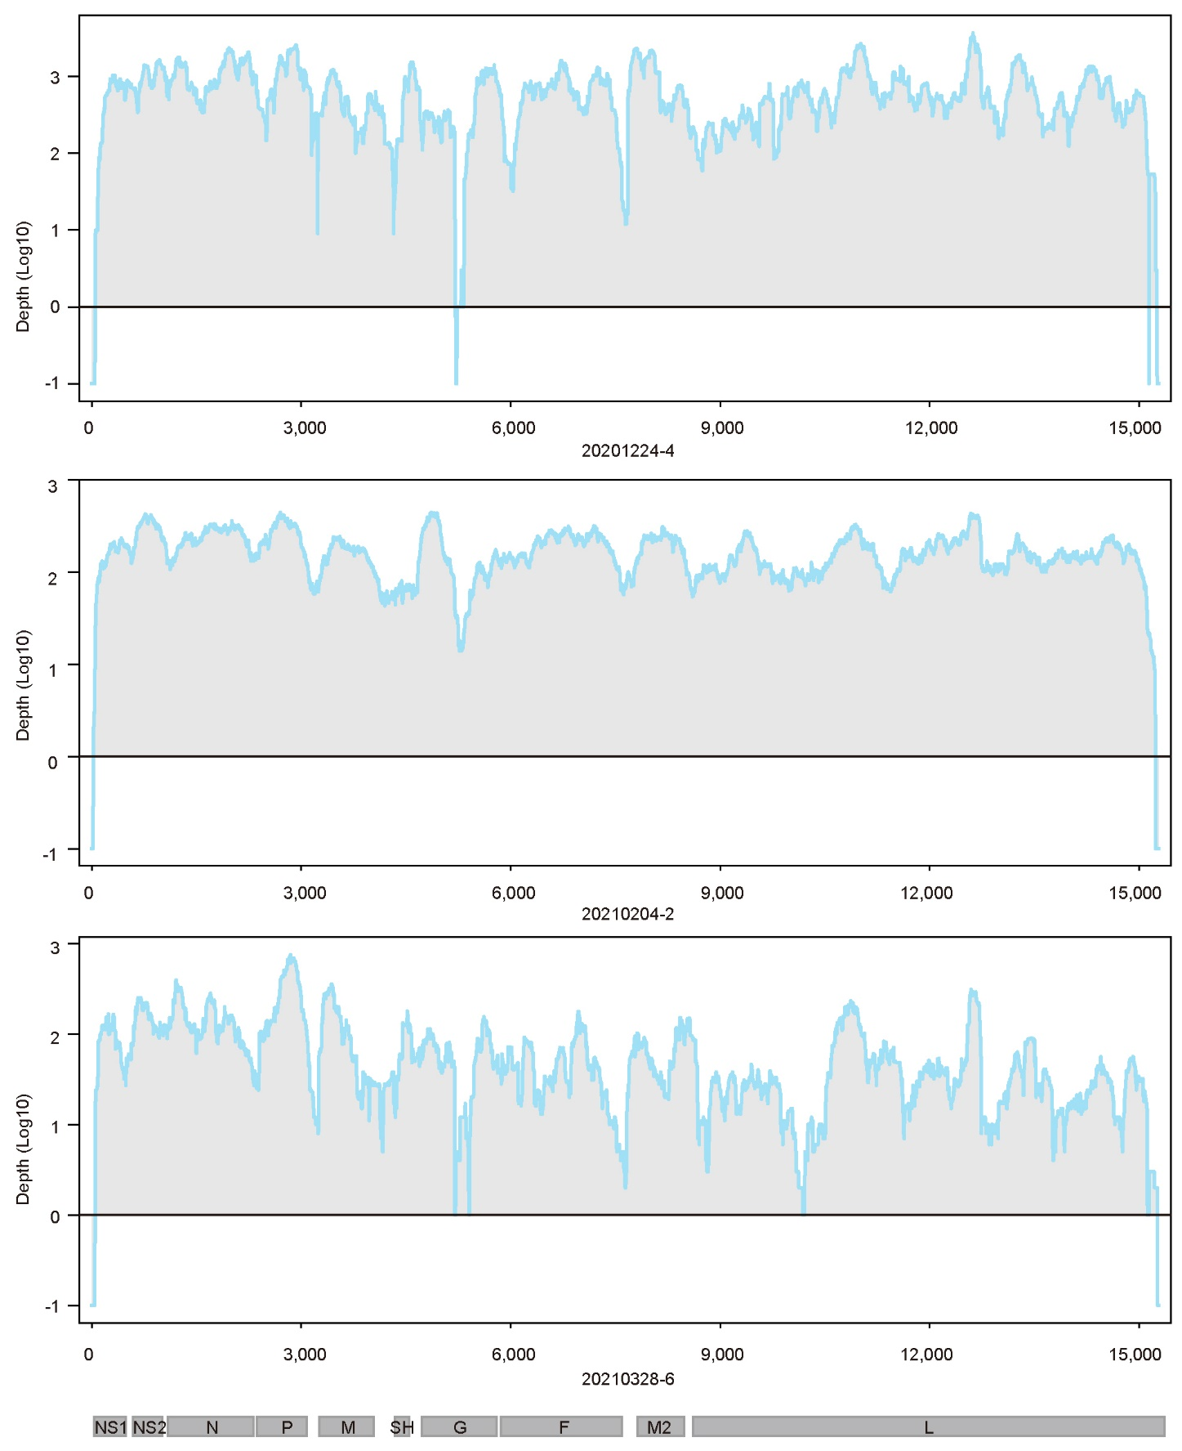
Supplementary Figure S2. Genome coverage of sequenced samples across the RSV-A genome. The x-axis represents the viral genome position, and the y-axis represents the log 10 depth of each site. Sites with zero depth are labeled by -1.
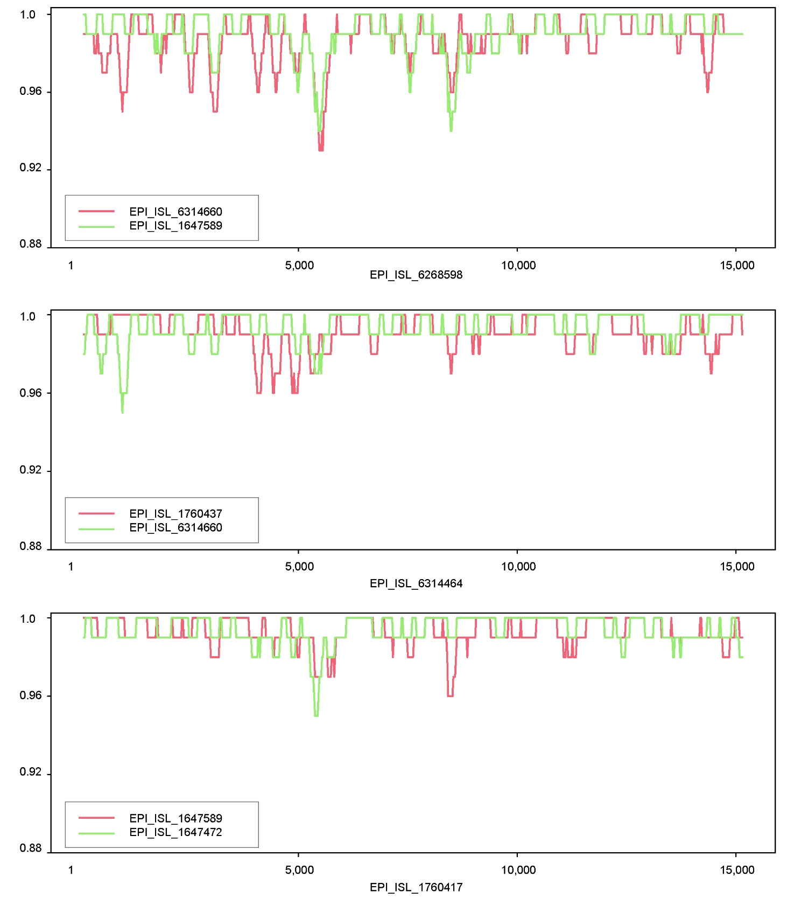
Supplementary Figure S3. Recombination analysis of RSV in SimPlot related to Supplementary Table S3. The x-axis represents the viral genome position, and the y-axis represents similarity between parental sequence and potential recombinant.

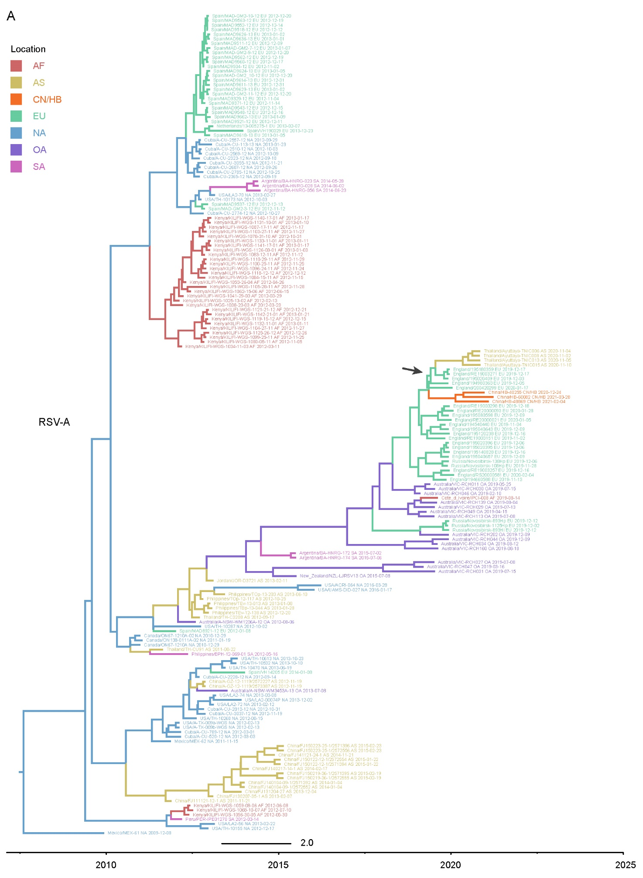
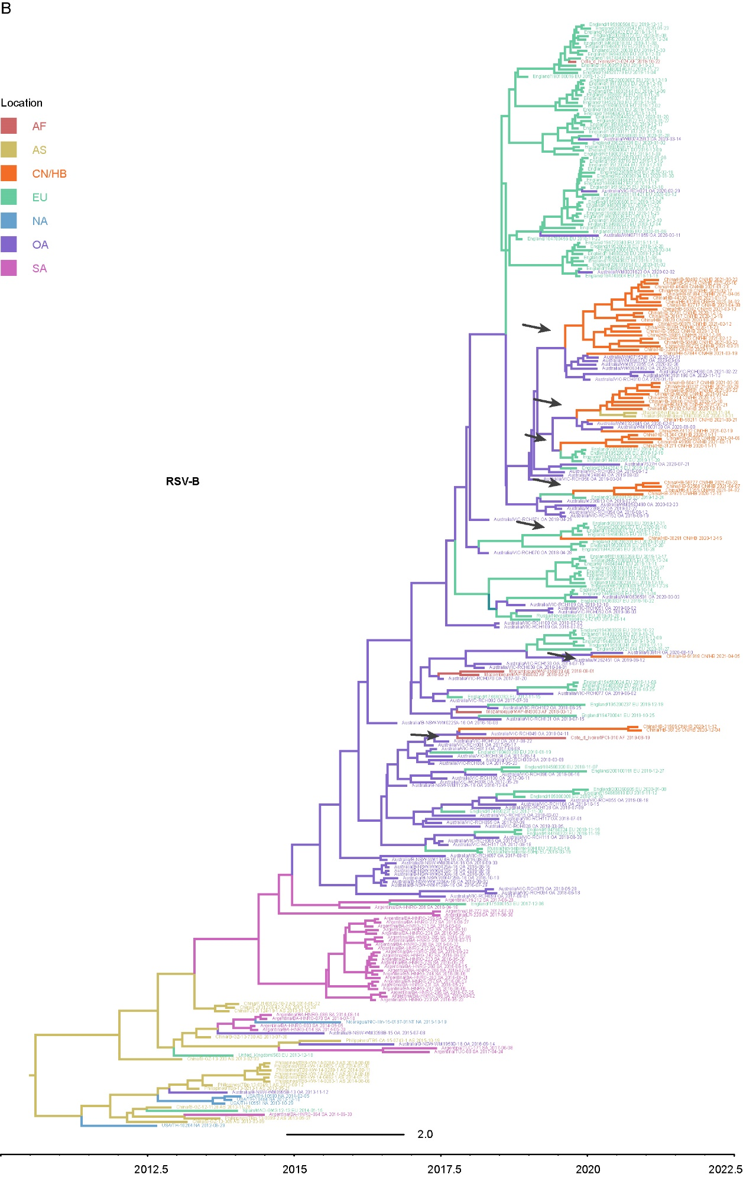
Supplementary Figure S4. Maximum clade credibility trees for RSV G genes of RSV-A (A) and RSV-B (B) related to Fig. 5 and Supplementary Table S4. Colors of branches and labels represent host group information.. Black arrows show the location transition.

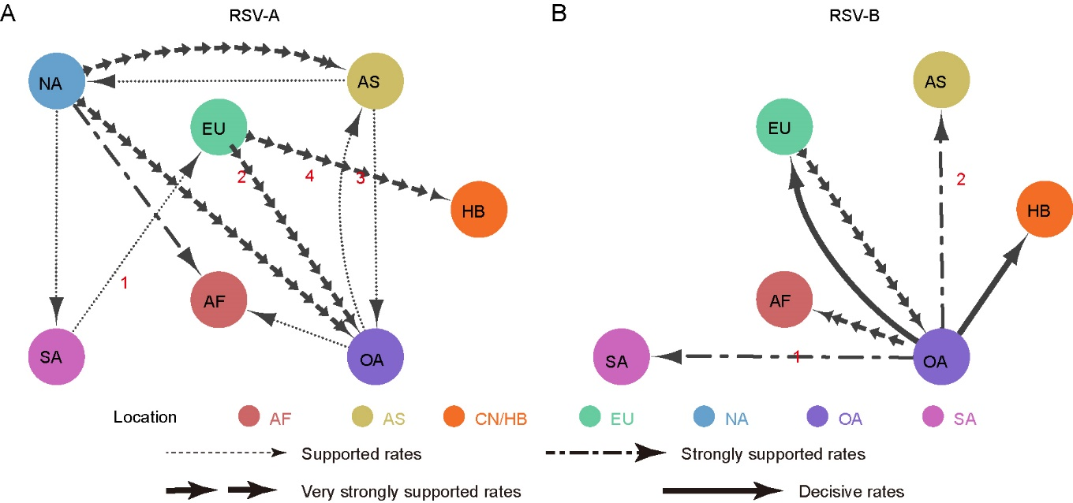
Supplementary Figure S5. Inter-regional diffusion of RSV whole genomes. A–B Spatial diffusion pathways of RSV-A (A) and RSV-B (B). Arrows show the direction of spatial diffusion. Node color and annotation represents the geographical locations: AF, Africa; AS, Asia; EU, Europe; NA, North America; OA, Oceania; SA, South America; CN/HB, China Hubei (this study). Line width and type represent statistically supported migration rates with a mean indicator of >0.5: decisive rates with BF ≥ 1,000, very strongly supported rates with 100 ≤ BF < 1,000, strongly supported rates with 10 ≤ BF < 100 and supported rates with 3 ≤ BF < 10.

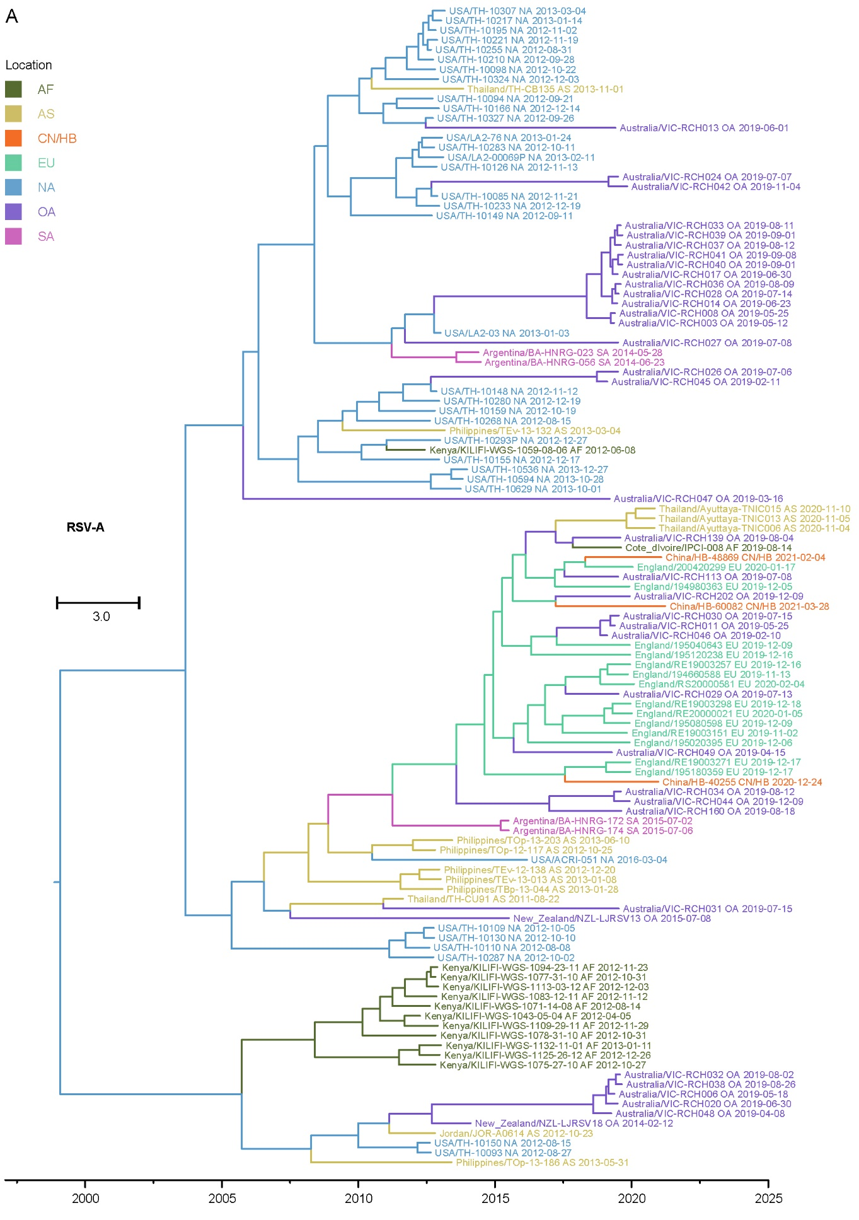
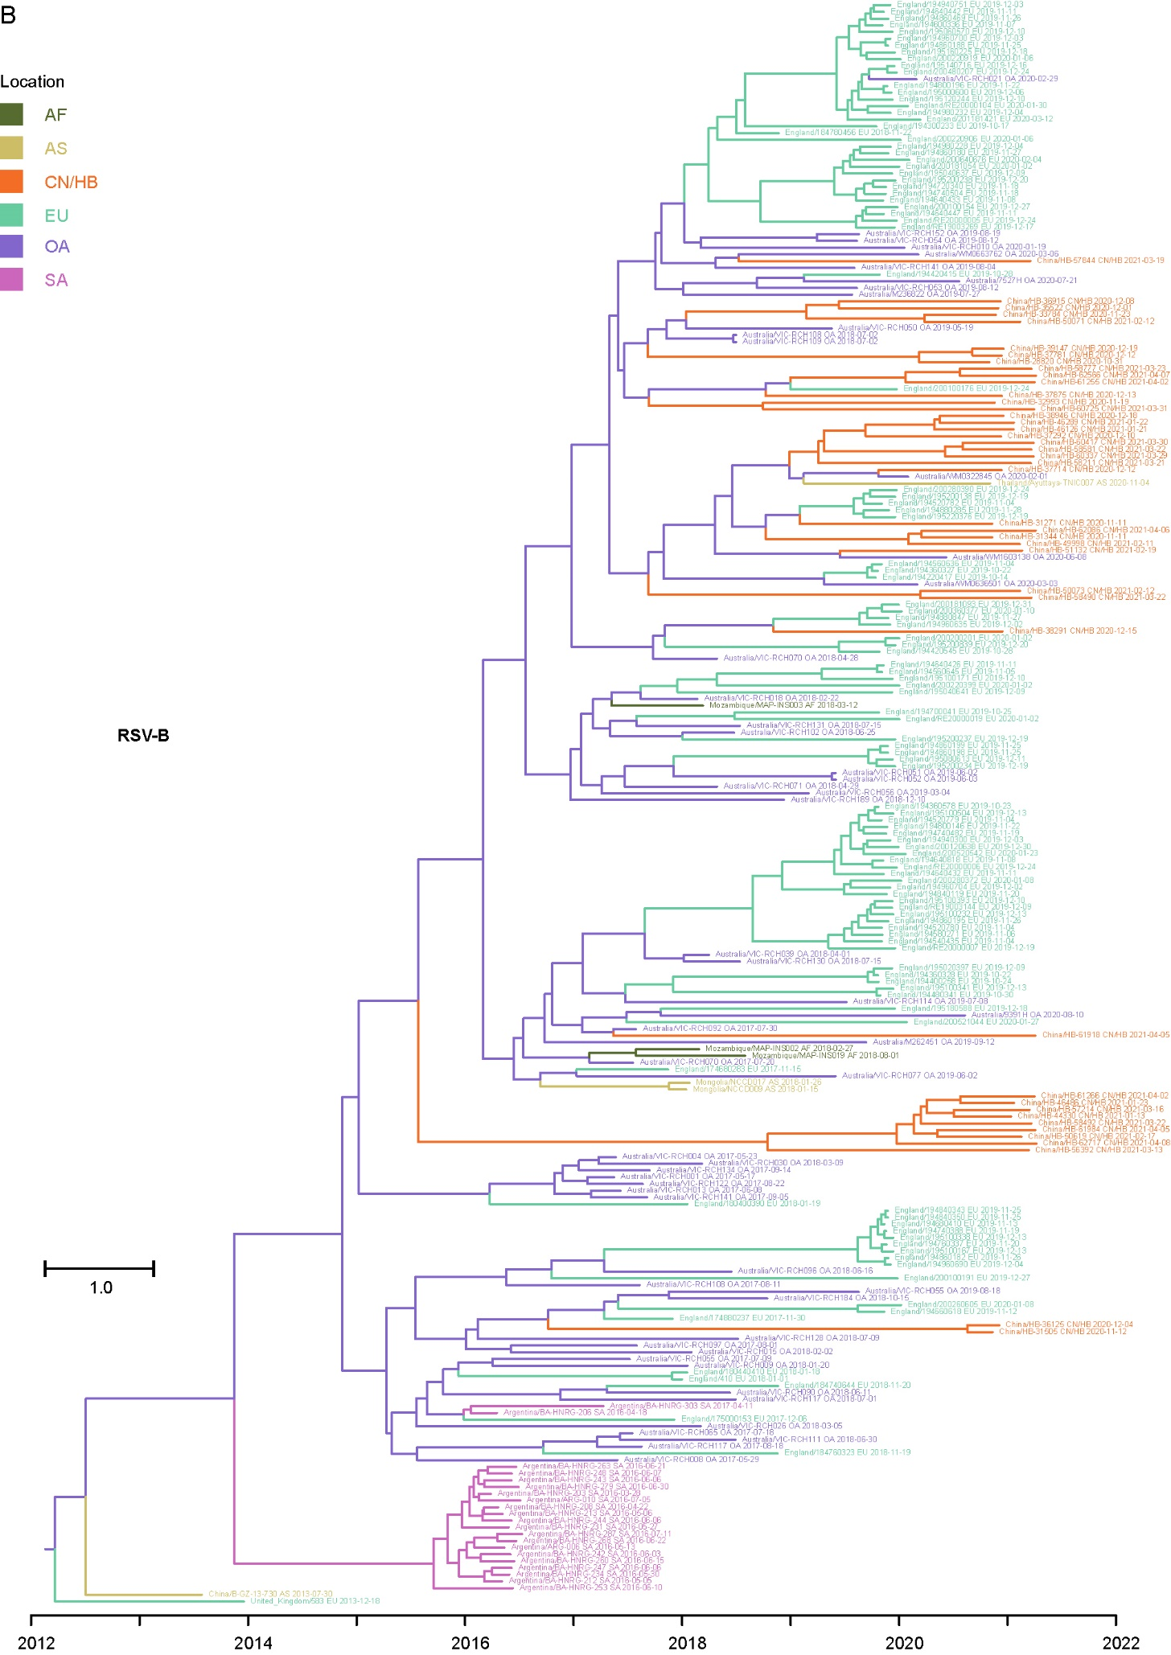
Supplementary Figure S6. Maximum clade credibility trees for RSV whole genomes related to Supplementary Figure S5 and Supplementary Table S5. Colors of branches and labels represent host group information. (A) RSV-A and (B) RSV-B.

