Virologica Sinica

Supplementary Data

FOLR1-induced folate deficiency reduces viral replication via modulating APOBEC3 family expression
Jing Wuª, Yajing Han^{e}, Ruining Lyuª, Fang Zhang^{b}, Na Jiangª, Hongji Taoª, Qiao Youª, Rui Zhangª, Meng Yuanª, Waqas Nawaz^{f}, Deyan Chen^{a,*}, Zhiwei Wu^{a, c, d,*}

ª Center for Public Health Research, Medical School of Nanjing University, Nanjing, 210093, China.
^{b} Department of Burn and Plastic Surgery, Affiliated Hospital of Zunyi Medical University, Zunyi, 563099, China.
^{c} Medical School and Jiangsu Key Laboratory of Molecular Medicine, Nanjing University, Nanjing, 210093, China.
^{d} State Key Lab of Analytical Chemistry for Life Science, Nanjing University, Nanjing, 210093, China.
^{e} Environmental Protection Key Laboratory of Environmental Pollution Health Risk Assessment, South China Institute of Environmental Sciences, Ministry of Ecology and Environment, Guangzhou, 510535, China.
^{f} Hȏpital Maisonneuve-Rosemont, School of medicine, University of Montreal, Quebec, 999040, Canada.

Corresponding authors.
E-mail: wzhw@nju.edu.cn (Z.W.), chendeyan@nju.edu.cn (D.C.)
ORCID: 0000-0002-0672-948X (Z.W.), 0000-0001-7351-4617 (D.C.)

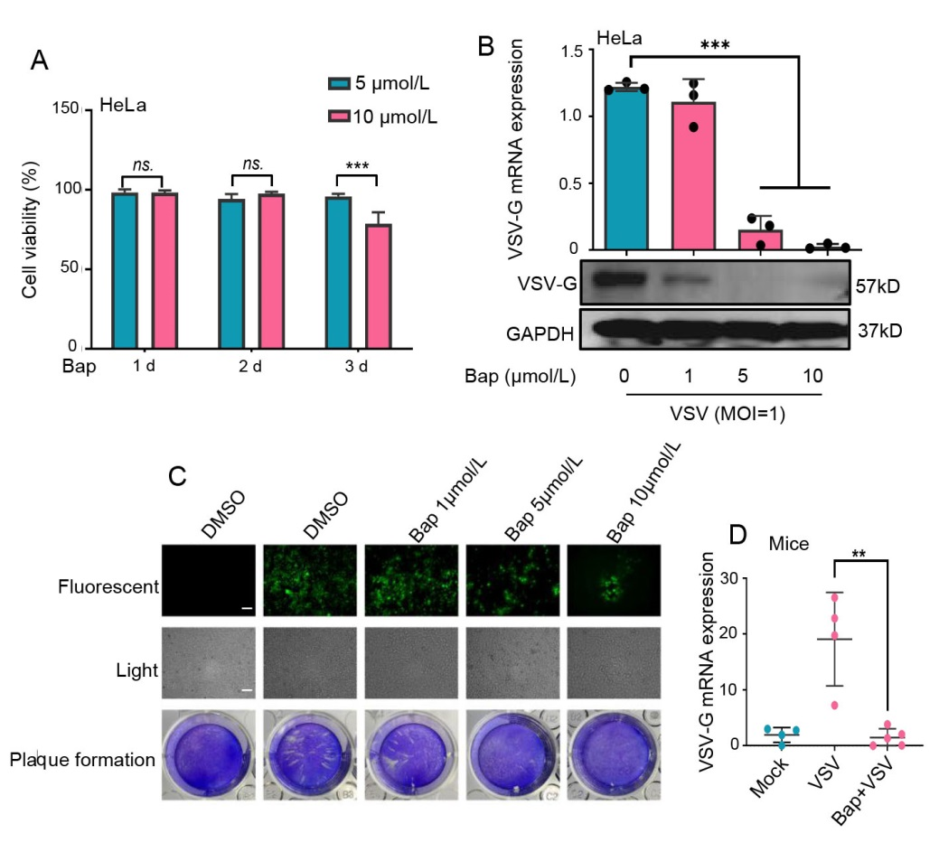
Figure S1. Bap inhibits the replication of VSV in vitro and in vivo. A HeLa cells were stimulated with Bap at 5 μmol/L and 10 μmol/L from 1 d to 3 d, and cell viability was detected by CCK-8. B HeLa cells were pre-exposed to Bap at 10 μmol/L for 2 days, and then they were infected with VSV (MOI = 1) in the presence of Bap for 24 h. The expression of virus-related protein and mRNA were detected by Western blot and qPCR, respectively. C An inverted fluorescence microscope was used to observe the effect of different concentrations of Bap on the expression of VSV-GFP, scale bar: 100 μm. D VSV-G mRNA levels in C57BL/6J mice lung tissues were detected by qPCR. GAPDH was shown as a loading control. Data expressed as Means ± SD (n=3, “ns” means no significant differences, **P<0.01, ***P<0.001).

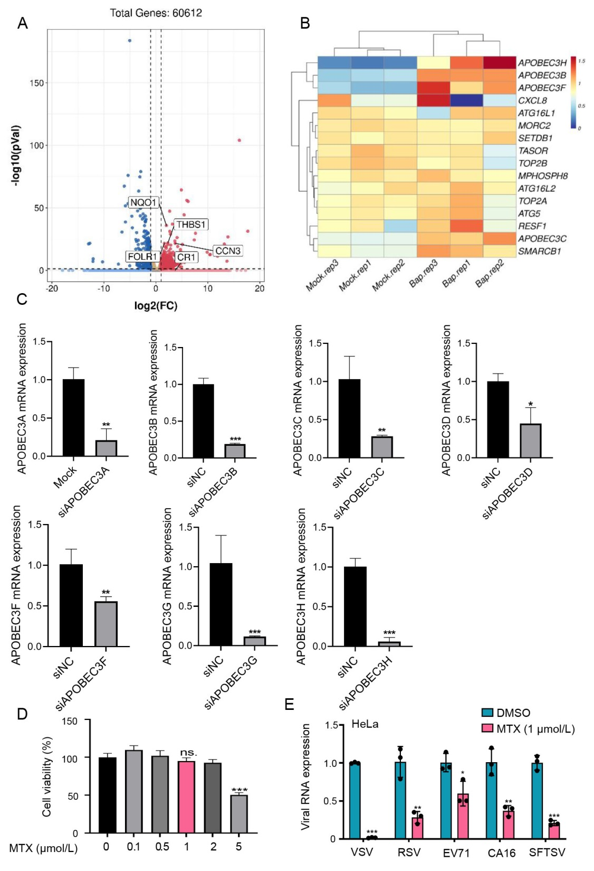
Figure S2. A Volcano map showed DEGs between Bap group and mock group. Red represents up-regulated genes and blue represents down-regulated genes. B Heat map of DEGs associated with RNA viral replication in RNA-seq results. C HeLa cell was transfected with siNC or siAPOBEC3A-H for 36 h. qPCR was performed to detect the mRNA expression of APOBEC3s. D HeLa cell was stimulated with MTX for 24 h at different concentrations, and cell viability was detected by CCK-8. E HeLa cells were pretreated with MTX at 1 μmol/L for 2 h, and then they were infected with VSV (MOI=1), RSV (MOI=1), EV71 (MOI=1), CA16 (MOI=1), and SFTSV (TCID50=1) for 24 h, respectively. The expression of virus-related mRNAs was measured by qPCR analysis. Data expressed as Means ± SD (n= 3, “ns” means no significant differences, *P<0.05, **P<0.01, ***P<0.001).

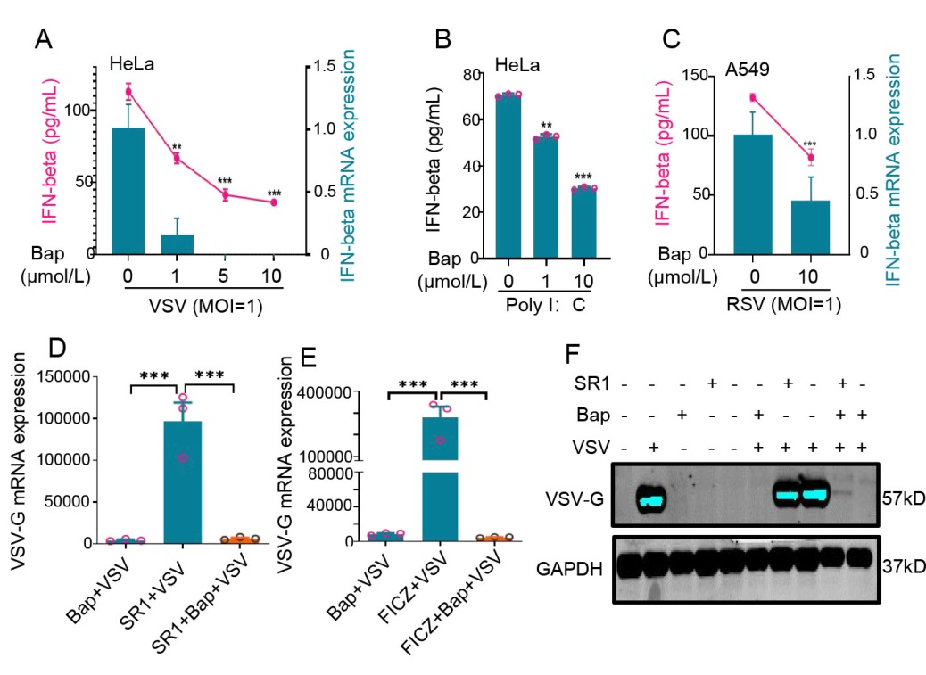
Figure S3. IFN-β and AhR were not involved in Bap-mediated inhibition of VSV replication. A–C HeLa cells were pre-exposed with Bap for 2 days, then they were infected with VSV and RSV or stimulated with poly (I:C) (2 μg/mL) in the presence of Bap for 24 h, and then ELISA and qPCR were performed to measure IFN-β expression. The pink lines and Y axis in the right side showed the expression of IFN-β protein levels in the supernatant, green chart and Y axis in the left side represented the copies of IFN-β mRNA levels in A and C. D–F HeLa cells were pre-exposed to Bap, FICZ (AhR’s natural agonist, 50 nmol/L) or SR1 (AhR's antagonist, 50 nmol/L) for 2 d, and then they were infected with VSV (MOI = 1) in presence of Bap, FICZ or SR1 for another 24 h. The expression of VSV-G mRNA was detected by qPCR analysis. The expression of VSV-G and GAPDH were measured by Western blot analysis. Data expressed as means ± SD (n = 3, **P<0.01, ***P<0.001).
Supplementary Table S1 siRNA sequences of APOBEC3 protein family used in the study.
Name | Target sequence
siAPOBEC3A | GCTT TCTA CACA ACCA GGCT A
siAPOBEC3B | CCAG GTGT ATTT CAAG CCTC A
siAPOBEC3C | CGCT GTGG AGAT CATG GACT A
siAPOBEC3D | TTTG AGAA CCAC GCAG AAAT
siAPOBEC3F | CGCG TGAA GATT ATGG ACGA T
siAPOBEC3G | GCCA GGTG TATT CCGA ACTT A
siAPOBEC3H | GCCA TGCA GAAA TTTG CTTT A

Supplementary Table S2 Primer sequences used for qPCR detection in this study.
Primer name | Forward and Reverse | (5’-3’)
VSV-G | Forward | ACGGCGTACTTCCAGATGG
 | Reverse | CTCGGTTCAAGATCCAGGT
VSV viral RNA | Forward | ACGAAGACAAACAAACCA
 | Reverse | GTTTCTCCTGAGCCTTTTA
RSV-G | Forward | AGGATTGTTTATGAATGCCTATGG
 | Reverse | GCTTTTGGGTTGTTCAATATATGGTAG
EV71 and CA16 | Forward | TCCGGCCCCTGAATGCGGCTAATCC
 | Reverse | ACACGGACACCCAAAGTAGTCGGTC
SFTSV | Forward | GGGTCCCTGAAGGAGTTGTAAA
 | Reverse | TGCCTTCACCAAGACTATCAATGT
FOLR1 (Human) | Forward | CCACTTCATCCAGGACACCTGT
 | Reverse | CATCCAGGAAGCGTTCTTTGCG
FOLR1 (Mouse) | Forward | GGACTGAACTTCTCAATGTCTGC
 | Reverse | CTTCCTGGCTTGTGTTCGTGGA
APOBEC3A (Human) | Forward | GACAATGGCACCTCGGTCAAGA
 | Reverse | CCAACTGCAAAGAAGGAACCAGG
APOBEC3B (Human) | Forward | CCTCTATGGTCGGAGCTACACT
 | Reverse | GAGGAAGCACATTTCTGCGTGG
APOBEC3C (Human) | Forward | CGGAACGAAACTTGGCTGTGCT
 | Reverse | CCAAGAGAGGAAGCACCTTTCTG
APOBEC3D (Human) | Forward | ACGTCAGTCGAATCACAGGCAG
 | Reverse | CAAACCAGGTGATCTGGAAGCG
APOBEC3F (Human) | Forward | GGAATACCGTCTGGCTGTGCTA
 | Reverse | GAGGAAGCACATTTCTGCGTGG
APOBEC3G (Human) | Forward | ATGACACCTGGGTCCTGCTGAA
 | Reverse | GAATCACGTCCAGGAAGCACAG
APOBEC3H (Human) | Forward | GCCTGTACTACCACTGGTGCAA
 | Reverse | CGGTTTCTCGTGGTCCACAAAG
APOBEC3 (Mouse) | Forward | GACAATGGTGGCAGGCGATTCA
 | Reverse | GCAGAGATGCTTGACTCGTTGG
GAPDH (Human) | Forward | GTCTCCTCTGACTTCAACAGCG
 | Reverse | ACCACCCTGTTGCTGTAGCCAA
GAPDH (Mouse) | Forward | CATCACTGCCACCCAGAAGACTG
 | Reverse | ATGCCAGTGAGCTTCCCGTTCAG

