Virologica Sinica

Supplementary Data

Continued antigenic variation of highly pathogenic avian influenza A (H7N9) virus in laying hens in China, 2020–2021

Wenming Jiang ^{a,1}, Xin Yin ^{a,1}, Shuo Liu ^{a,1}, Shaobo Liang ª, Cheng Peng ª, Guangyu Hou ª, Jinping Li ª, Xiaohui Yu ª, Yang Li ª, Jingjing Wang ª, Hualei Liu ^{a,*}

ª China Animal Health and Epidemiology Center, Qingdao, 266032, China.

* Corresponding author.
E-mail addresses: liuhualei@cahec.cn (H. Liu)

¹ Wenming Jiang, Xin Yin, and Shuo Liu contributed equally to this study.

Supplementary Table S1 The information of the H7N9 viruses isolated from layers in 2020–2021, China.
Strains | Date | Location | Abbreviation
A/chicken/Shanxi/0227-1/2020(H7N9) | 2020-2-27 | Shanxi | SX0227-1
A/chicken/Hebei/1226-5/2020(H7N9) | 2020-12-26 | Hebei | HB1226-5
A/chicken/Hebei/1229-2/2020(H7N9) | 2020-12-29 | Hebei | HD1229-2
A/chicken/Hebei/DZ0115-5/2020(H7N9) | 2020-1-15 | Hebei | DZ0115-5
A/chicken/Shanxi/0710/2020(H7N9) | 2020-7-10 | Shanxi | SX0710
A/chicken/Hebei/423/2020(H7N9) | 2020-4-23 | Hebei | HeB423
A/chicken/Hebei/HB1226-1/2020(H7N9) | 2020-12-26 | Hebei | HB1226-1
A/chicken/Shanxi/0116-1/2020(H7N9) | 2020-1-16 | Shanxi | SX0116-1
A/chicken/Shanxi/1027/2020(H7N9) | 2020-10-27 | Shanxi | HY1027
A/chicken/Shanxi/0124/2021(H7N9) | 2021-1-24 | Shanxi | SX0124
A/chicken/Shanxi/0122/2021(H7N9) | 2021-1-22 | Shanxi | SX0122
A/chicken/Yunnan/1440/2021(H7N9) | 2021-3-25 | Yunnan | Y1440
A/chicken/Yunnan/TS0328/2021(H7N9) | 2021-3-28 | Yunnan | TS0328
During active surveillance of avian influenza infections in China in 2020 and 2021, 11,520 swab samples from healthy laying hens were collected from 14 provinces (Heilongjiang, Jiangsu, Anhui, Fujian, Jiangxi, Henan, Hubei, Guangdong, Guangxi, Sichuan, Yunnan, Ningxia, Shanxi, and Hebei) and 13 strains of H7N9 viruses were identified and isolated.

Supplementary Table S2 Replication and virulence of H7N9 viruses in chickens and ducks.
Virus | Chickens | Ducks
 | IVPI | Pharynx | Cloacae | Lung | Intestine | Liver | Spleen | Kidney | Brain | Death/ Total
SX0227-1 | 3.00 | 2/10 | 1/10 | ＜ | ＜ | ＜ | ＜ | ＜ | ＜ | 0/10
HY1027 | 3.00 | 2/10 | 1/10 | ＜ | ＜ | ＜ | ＜ | ＜ | ＜ | 0/10
Y1440 | 3.00 | 1/10 | 1/10 | ＜ | ＜ | ＜ | ＜ | ＜ | ＜ | 0/10
The intravenous pathogenicity index (IVPI) test was carried out according to the OIE (World Organisation for Animal Health) manual. In brief, ten 6-week-old SPF chickens were intravenously inoculated with 0.1 mL of a 1/10 dilution of the fresh infectious allantoic fluid (HA titer > 16) and ten chickens were inoculated with 0.01 mol/L PBS as a control group. All of the chickens were examined daily for 10 days. At each observation, each chicken was scored based on the condition: 0 (normal), 1 (sick), 2 (severely sick), and 3 (dead). IVPI was the mean score per chicken per observation over the ten-day period.
Groups of ten three-week-old specific-pathogen-free ducks were inoculated i.n. with 10⁶ EID₅₀ of each virus in a 0.1-mL volume. Pharyngeal and cloacal swabs were collected from all birds on Day 3 post-infection, and then three birds in each group were euthanized, and their organs were detected for HA gene of H7N9 viruses by RT-PCR with the primers 5’-GAAAATCTATGGGAATCCAGAGTG-3’ and 5’-GCCGATTGAGTGCTTTTGTAATC-3’. The remaining seven ducks in each group were observed for two weeks. <, virus was not detected from the undiluted samples; i.n., intranasally; EID₅₀, 50% egg infectious dose.

Supplementary Table S3 Genotypes of H7N9 highly pathogenic avian influenza viruses in 2020–2021. The genotypes of the viruses isolated between February 2017 and December 2019 were reported previously. The numbers of strains of each genotype are provided in parentheses.
 | HA | M | NS | PA | NP | PB1 | PB2 | Genotype
HY1027 | 1 | 1 | 1 | 1 | 1 | 1 | 1 | G2
HD1229-2 | 1 | 1 | 1 | 1 | 1 | 1 | 1
SX0116-1 | 1 | 1 | 1 | 1 | 1 | 1 | 1
SX0710 | 1 | 1 | 1 | 1 | 1 | 1 | 1
DZ0115-5 | 1 | 1 | 1 | 1 | 1 | 1 | 1
HB1226-1 | 1 | 1 | 1 | 1 | 1 | 1 | 1
HB1226-5 | 1 | 1 | 1 | 1 | 1 | 1 | 1
Y1440 | 1 | 1 | 1 | 1 | 1 | 1 | 1
SX0124 | 1 | 1 | 1 | 1 | 1 | 1 | 1
SX0227-1 | 1 | 1 | 1 | 1 | 1 | 1 | 1
SX0122 | 1 | 1 | 1 | 1 | 1 | 1 | 1
Heb423 | 1 | 1 | 1 | 1 | 1 | 1 | 1
TS0328 | 1 | 1 | 2 | 1 | 3 | 1 | 1 | G11

Supplementary Table S4 Antigenic analysis of H7N9 avian influenza viruses by cross-HI tests.
Antigens | HI titers of antibodies against antigens
 | SX0227-1 | HB1226 | HD1229-2 | DZ0115-5 | SX0710 | HeB423 | SX0124 | SX0122 | HB1226-1 | SX0116-1 | HY1027 | TS0328 | Y1440 | H7-Re3
SX0227-1 | 64 | 128 | 128 | 128 | 128 | 256 | 256 | 512 | 1024 | 1024 | 256 | 256 | 64 | 32
HB1226 | 32 | 256 | 256 | 128 | 256 | 128 | 64 | 64 | 256 | 256 | 256 | 256 | 64 | 32
HD1229-2 | 64 | 128 | 128 | 256 | 128 | 256 | 64 | 128 | 1024 | 1024 | 256 | 256 | 128 | 32
DZ0115-5 | 32 | 32 | 64 | 256 | 128 | 256 | 64 | 64 | 128 | 128 | 256 | 256 | 64 | 32
SX0710 | 32 | 128 | 64 | 256 | 256 | 128 | 128 | 128 | 256 | 256 | 512 | 256 | 32 | 32
HeB423 | 32 | 32 | 64 | 64 | 256 | 256 | 64 | 32 | 128 | 128 | 128 | 128 | 64 | 64
SX0124 | 128 | 64 | 128 | 256 | 128 | 128 | 256 | 256 | 1024 | 1024 | 256 | 256 | 128 | 32
SX0122 | 64 | 128 | 128 | 128 | 256 | 128 | 256 | 256 | 1024 | 1024 | 512 | 512 | 64 | 16
HB1226-1 | 128 | 256 | 256 | 512 | 512 | 256 | 512 | 512 | 512 | 512 | 512 | 512 | 256 | 32
SX0116-1 | 128 | 128 | 128 | 128 | 256 | 256 | 512 | 512 | 1024 | 1024 | 256 | 256 | 128 | 16
HY1027 | 32 | 128 | 64 | 128 | 256 | 128 | 128 | 64 | 256 | 256 | 512 | 256 | 32 | 16
TS0328 | 32 | 64 | 128 | 128 | 128 | 64 | 64 | 128 | 128 | 512 | 256 | 512 | 64 | 16
Y1440 | 16 | 16 | 16 | 32 | 16 | 16 | 32 | 32 | 32 | 32 | 128 | 128 | 128 | 8
H7-Re3 | 64 | 128 | 256 | 256 | 64 | 256 | 128 | 128 | 256 | 128 | 128 | 256 | 64 | 256

Antigenic analyses were performed using cross-hemagglutination inhibition (HI) tests with polyclonal antisera against the indicated viruses. To generate the antisera, 21-day-old SPF chickens were injected with 1 mL of oil emulsion-inactivated vaccines derived from the selected viruses and sera samples were collected at 21 dpi. Antibodies to HI were tested with 0.5% (v/v) chicken erythrocytes.

Supplementary Fig. S1 Phylogenetic analyse of the PB2 gene of H7N9 highly pathogenic avian influenza viruses. Tree was constructed with MEGA5.10 software using the neighbor-joining method. Bootstrap analysis was performed with 1,000 replications. The viruses sequenced in this study are shown in red in the phylogenetic tree. Scale bar indicates nucleotide substitutions per site.

Supplementary Fig. S2 Phylogenetic analyse of the PB1 gene of H7N9 highly pathogenic avian influenza viruses. Tree was constructed with MEGA5.10 software using the neighbor-joining method. Bootstrap analysis was performed with 1,000 replications. The viruses sequenced in this study are shown in red in the phylogenetic tree. Scale bar indicates nucleotide substitutions per site.

Supplementary Fig. S3 Phylogenetic analyses of the PA gene of H7N9 highly pathogenic avian influenza viruses. Tree was constructed with MEGA5.10 software using the neighbor-joining method. Bootstrap analysis was performed with 1,000 replications. The viruses sequenced in this study are shown in red in the phylogenetic tree. Scale bar indicates nucleotide substitutions per site.

Supplementary Fig. S4 Phylogenetic analyses of the NP gene of H7N9 highly pathogenic avian influenza viruses. Tree was constructed with MEGA5.10 software using the neighbor-joining method. Bootstrap analysis was performed with 1,000 replications. The viruses sequenced in this study are shown in red in the phylogenetic tree. Scale bar indicates nucleotide substitutions per site.

Supplementary Fig. S5 Phylogenetic analyses of the M gene of H7N9 highly pathogenic avian influenza viruses. Tree was constructed with MEGA5.10 software using the neighbor-joining method. Bootstrap analysis was performed with 1,000 replications. The viruses sequenced in this study are shown in red in the phylogenetic tree. Scale bar indicates nucleotide substitutions per site.

Supplementary Fig. S6 Phylogenetic analyses of the NS gene of H7N9 highly pathogenic avian influenza viruses. Tree was constructed with MEGA5.10 software using the neighbor-joining method. Bootstrap analysis was performed with 1,000 replications. The viruses sequenced in this study are shown in red in the phylogenetic tree. Scale bar indicates nucleotide substitutions per site.

Supplementary Fig. S7 Phylogenetic analyses of the NA gene of H7N9 highly pathogenic avian influenza viruses. Tree was constructed with MEGA5.10 software using the neighbor-joining method. Bootstrap analysis was performed with 1,000 replications. The viruses sequenced in this study are shown in red in the phylogenetic tree. Scale bar indicates nucleotide substitutions per site.

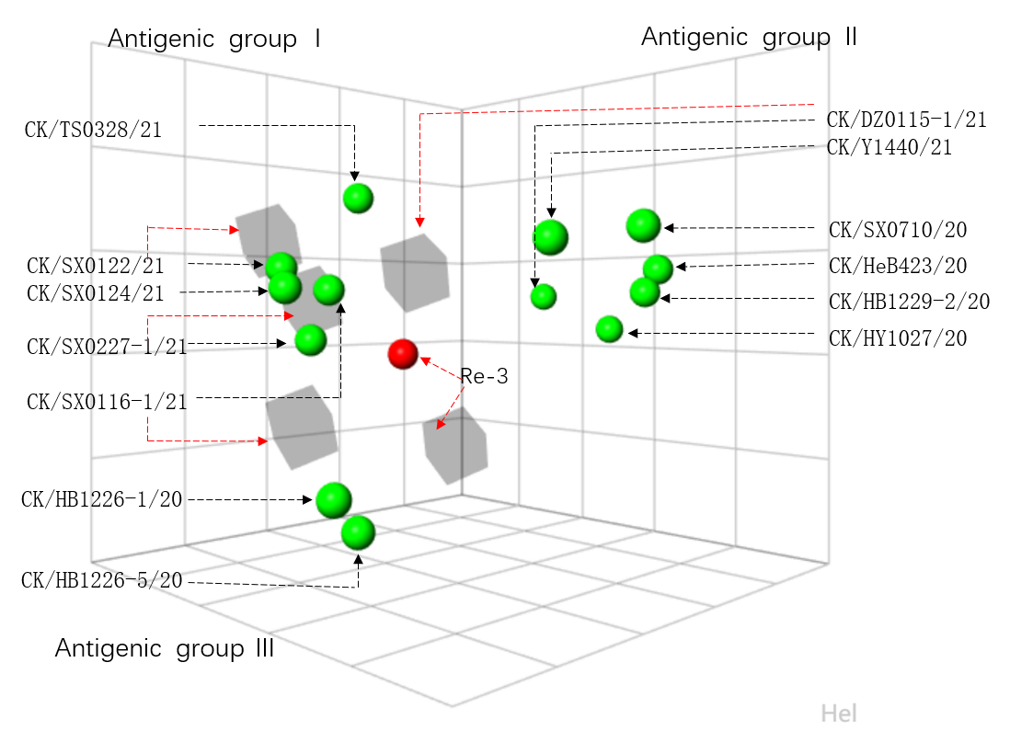
Supplementary Fig. S8 Antigenic cartography of H7N9 viruses. The antigenic map was generated by using the HI assay data shown in Supplementary Table S4. Each unit in the coordinate represents a 2-fold difference in HI titer. The grey cubes represent the antisera generated from the indicated viruses. The red ball indicates the H7N9 Re-3 vaccine, and the green balls represent the test viruses.

