Virologica Sinica

Supplementary Data

Cyclophilin A binds to AKT1 and facilitates the tumorigenicity of Epstein-Barr virus by mediating the activation of AKT/mTOR/NF-κB positive feedback loop

Shuyu Xin ^{a,b,c,d,e}, Lingzhi Liu ^{a,b,c,d,e}, Yanling Li ^{a,b,c}, Jing Yang ^{a,c}, Lielian Zuo ^{a,c}, Pengfei Cao ^{c,e}, Qijia Yan ^{e}, Shen Li ^{a,b,c}, Li Yang ^{a,b,c}, Taimei Cui ^{b}, Jianhong Lu ^{a,b,c,d,e,*}

ª Hunan Cancer Hospital/the Affiliated Cancer Hospital of Xiangya School of Medicine, Central South University, Changsha, 410013, China
^{b} Department of Microbiology, School of Basic Medical Science, Central South University, Changsha, 410078, China
^{c} The Key Laboratory of Carcinogenesis and Cancer Invasion of the Chinese Ministry of Education, NHC Key Laboratory of Carcinogenesis, Cancer Research Institute, Central South University, Changsha, 410078, China
^{d} China-Africa Research Center of Infectious Diseases, Central South University, Changsha, postcode, China
^{e} Department of Hematology, National Clinical Research Center for Geriatric Disorders, Department of Pathology, Xiangya Hospital, Central South University, Changsha, 410080, China

* Corresponding author.
E-mail addresses: jianhlu@csu.edu.cn (J. Lu)

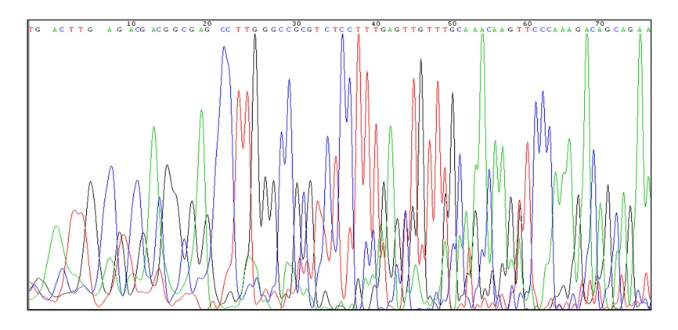
Supplementary Fig. S1 Sequencing results of CYPA gene in CYPA knockout 293 cell line.

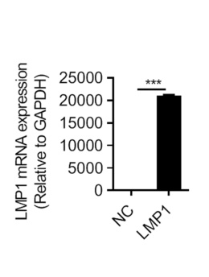
Supplementary Fig. S2 The detection of LMP1 expression by RT-qPCR in 293T cells transfected with LMP1-Flag plasmid (2μg/well in 6-well plate). At 24 h post-transfection, the cells were collected, and RNA was extracted for RT-qPCR assay.

