Virologica Sinica

Supplementary Data
STING strengthens host anti-hantaviral immunity through an interferon-independent pathway

Kerong Wang ^{a, b, 1}, Jian Zhang ^{b, 1}, Yongheng Yang ^{b, 1}, Yue Si ^{b}, Ziqing Zhou ^{b}, Xudong Zhu ^{b, c}, Sushan Wu ^{a, b}, He Liu ^{b}, Hui Zhang ^{b}, Liang Zhang ^{b}, Linfeng Cheng ^{b}, Wei Ye ^{b}, Xin Lv ^{b}, Yingfeng Lei ^{b}, Xijing Zhang ^{d},
Shilin Cheng ^{a, e}, Lixin Shen ^{a, *}, Fanglin Zhang ^{b, *}, Hongwei Ma ^{b, *}

ª College of Life Sciences, Northwest University, Xi'an 710069, China.
^{b} Department of Microbiology, School of Basic Medicine, Fourth Military Medical University, Xi'an 710032, China.
^{c} College of Medicine, Yan'an University, Yan'an 716000, China.
^{d} Department of Critical Care Medicine, Department of Anesthesiology and Perioprative Medicine, Xijing Hospital, Fourth Military Medical University, Xi'an 710032, China.
^{e} Medical Genetics and Developmental Biology, School of Basic Medicine, Fourth Military Medical University, Xi'an 710032, China.

¹ Kerong Wang, Jian Zhang, and Yongheng Yang contributed equally.

*Corresponding authors:
E-mail address: mahongwei0720@sina.com (H. Ma); flzhang@fmmu.edu.cn (F. Zhang), and shenlx@nwu.edu.cn (L. Shen)
ORCID: 0000-0003-4929-3222 (Hongwei Ma)
Table S1. Antibodies and reagents were used in this study
Antibody Or Reagent | Source | Identifier
Antibodies
Rabbit polyclonal anti-STING | Proteintech | Cat #19851-1-AP
Mouse monoclonal anti-STING | Proteintech | Cat #66680-1-Ig
Mouse monoclonal anti-GAPPDH | Sangon Biotech | Cat #D190090-0200
Rabbit polyclonal anti-ERGIC-53 | Proteintech | Cat #13364-1-AP
Rabbit polyclonal anti-Rab5A | Proteintech | Cat #11947-1-AP
Rabbit polyclonal anti-Rab7A | Abcam | Cat #ab137029
Rabbit polyclonal anti-RIG-I | Abcam | Cat #ab45428
Rabbit polyclonal anti-cGAS | Abcam | Cat #ab176177
Rabbit polyclonal anti-p-TBK1 | Abcam | Cat #ab109272
Rabbit polyclonal anti-p-STAT1 | CST | Cat #9177
Rabbit polyclonal anti-MAP1LC3B | Proteintech | Cat #14600-1AP
Rabbit polyclonal anti-SQSTM1/p62 | Proteintech | Cat #18420-1-AP
Rabbit polyclonal anti-Beclin1 | Proteintech | Cat #11306-1-AP
Rabbit polyclonal anti-HA | Abcam | Cat #ab9110
Mouse polyclonal anti-Myc | Abcam | Cat #A02060-1
Mouse polyclonal anti-Flag | Sino Biological | Cat #100233-MM01
Mouse monoclonal anti-HTNV NP | Prepared in our Lab | N/A
Alexa Fluor 488-conjugated goat anti-mouse IgG | Sangon Biotech | Cat #D110090-0001
Cy3-conjugated Donkey anti-rabbit IgG | Sangon Biotech | Cat #D110052-0100
Cy3-conjugated Donkey anti-mouse IgG | Sangon Biotech | Cat #D110082-0100
Cy5-conjugated Donkey anti-rabbit IgG | Sangon Biotech | Cat #D111133-0100
Goat Anti-Rabbit 800 CW | LI-COR | Cat #D11103-05
Goat Anti-Mouse 680 RD | LI-COR | Cat #C70427-05
Reagents
3-methyladenine (3-MA) | Selleck | Cat# S2767
Chloroquine (CQ) | Selleck | Cat# S7544
Bafilomycin A1 (BAFA1) | Selleck | Cat# S1413
cGAMP | InvivoGen | Cat# tlrlnacga23-1
MG132 | Sigma | Cat# M8699
4μ8c | TargetMol | Cat# 14003-96-4
Brefeldin A (BFA) | BioLegend | Cat# 423303
H-151 | AbMole | Cat# 941987-60-6
5,6-dimethylxanthenone-4-acetic acid (DMXAA) | AbMole | Cat# 117570-53-3
ISD: 5′-TACAGATCTACTAGTGATCTATG-3′ | Prepared in our Lab | N/A
Lyso-Tracker™ Red DND-99 | InvivoGen | Cat# L7528
Anti-Flag magnetic beads | Bimake | Cat #B26102
Anti-Myc magnetic beads | Bimake | Cat #B26302
Anti-HA magnetic beads | Bimake | Cat #B26202

Table S2. Primers were used for PCR in this study
Primer name | Primer sequences (5′–3′)
pCDNA3.1-STING-F | ATAGGATCCATGCCCC ACTCCAGCCT
pCDNA3.1-STING-R | GTCGAATTCAGAGAAATCCGTGCGGAG
pLVX-STING-F | CTAGAGGATCTATTTCCGGTGAATTCATGCCCCACTCCAGC
pLVX-STING-F | GGAGGGAGAGGGGCGGGATCCAAGAGAAATCCGTGC
pCDNA6.2-STING-F | ATAGGATCCATGCCCC ACTCCAGCCT
pCDNA6.2-STING-F | GTCGAATTCAGAGAAATCCGTGCGGAG
pCDNA6.2-△CTT-F | ATAGGATCCATGCCCC ACTCCAGCCT
pCDNA6.2-△CTT-F | GTCCTCGAGCTCTTCCTTTTCCTCCTGC
STING-TM-F | ATAGGATCCATGCCCC ACTCCAGCCT
STING-TM-R | GTCTCGAGGGCCAGGCCCTTGAGG
STING-CBD-F | GTCCTCGAGAAGAGAAATCCGTGCGGAG
STING-CBD-R | GTCCTCGAGCTCTT CCTTTTCCTCCTGC
STING-△CTT-F | ATAGGATCCATGCCCCACTCCAGCCT
STING-△CTT-R | GTCCTCGAGCTCTTCCTTTTCCTCCTGC
STING-△TM-F | GTCCTCGAGAAG AGAAATCCGTGCGGAG
STING-△TM-R | GTCGAATTCAGAGAAATCCGTGCGGAG
STING R238A-F | GATGCTGTTGCTGTAAACGGCATCCTTGATGCCAGCATG
STING R238A-R | CATGCTGGCATCAAGGATGCCGTTTACAGCAACAGCATC
STING S366A-F | GAGGGGCTTTTCCATTCCAGCGATGAGGAGCTCAGGCTCT
STING S366A-R | AGAGCCTGAGCTCCTCATCGCTGGAATGGAAAAGCCCCTC

Table S3. Sequences were used for siRNA
Genes | Sense (5′–3′) | Antisense (5′–3′)
NC | UUCUCCGAACGUGUCACGUTT | ACGUGACACGUUCGGAGAATT
STING-1 | GCCCGGAUUCGAACUUACAAU | AUUGUAAGUUCGAAUCCGGGC
STING-2 | GUCCAGGACUUGACAUCUUAA | UUAAGAUGUCAAGUCCUGGAC
STING-3 | CCTCATCAGTGGAATGGAATT | UUCCATTCCACTGATGAGGTT
cGAS | GGAAGGAAAUGGUUUCCAATT | UUGGAAACCAUUUCCUUCCTT
RIG-I | GAGGUGCAGUAUAUUCAGGTT | CCUGAAUAUACUGCACCUCTT
TBK1 | CACAAAUUUGAUAAGCAAATT | UUUGCUUAUCAAAUUUGUGTT
IRF3 | GGAGUGAUGAGCUACGUGA | UCACGUAGCUCAUCACUCCTT
ERGIC-53 | GGACAGAAUCGUAUUCAUCTT | AUGAAUACGAUUCUGUCCTT
SEC24C-1 | ACUUAUGUUAUCGAGUCAAUG | CAUUGACUCGAUAACAUAAGU
SEC24C-2 | UUGAUGUAAAGCGACUAAUAU | AUAUUAGUCGCUUUACAUCAA
TLR3 | GGUAACGAUUCCUUUGCUUTT | AAGCAAAGGAAUCGUUACCTT
TLR4 | GGAUUUAUCCAGGUGUGAATT | UUCACACCUGGAUAAAUCCTT
ATF4 | CCACGUUGGAUGACACUUGTT | CAAGUGUCAUCCAACGUGGTT
ATF6 | GCACCCAAGACUCAAACAATT | UUGUUUGAGUCUUGGGUGCTT

Table S4. The sequences for qRT-PCR primers
Genes | Forward (5′–3′) | Reverse (5′–3′)
Homo-cGAS | AGGAAGCAACTACGACTAAAGCC | CGATGTGAGAGAAGGATAGCCG
Homo-STING | CCTGAGTCTCAGAACAACTGCC | GGTCTTCAAGCTGCCCACAGTA
Mus-Sting | GGTCACCGCTCCAAATATGTAG | CAGTAGTCCAAGTTCGTGCGA
Homo-GAPDH | GTCTCCTCTGACTTCAACAGCG | ACCACCCTGTT GCTGTAGCCAA
Mus--Gapdh | CATCACTGCCACCCAGAAGACTG | ATGCCAGTGAGCTTCCCGTTCAG
Homo-IFNβ | CATTACCTGAAGGCCAAGGA | CAATTGTCCAGTCCCAGAGG
Mus-Ifnβ | GCCTTTGCCATCCAAGAGATGC | ACACTGTCTGCTGGTGGAGTTC
Homo-Mx1 | GGCTGTTTACCAGACTCCGACA | CACAAAGCCTGGCAGCTCTCTA
Mus-Il-6 | TACCACTTCACAAGTCGGAGGC | CTGCAAGTGCATCATCGTTGTTC
Mus-Il-1β | CCTTCCAGGATGAGGACATGA | TGAGTCACAGAGGATGGGCTC
Mus-Tnf-α | GCCTCTTCTCATTCCTGCTT | CTCCTCCACTTGGTGGTTTG
Homo-ISG56 | GCCTTGCTGAAGTGTGGAGGAA | ATCCAGGCGATAGGCAGAGATC
HTNV S | TCTAGTTGTATCCCCATCGACTG | ACATGCGGAATACAAATTATGGC
Homo-IRF3 | TCTGCCCTCAACCGCAAAGAAG | TACT GCCTCCACCATTGGTGTC
Homo-TBK1 | CAACCTGGAAGCGGCAGAGTTA | ACCTGGAGATAATCTGCTGTCGA
Homo-TLR3 | GCGCTAAAAAGTGAAGAACTGGA | GCTGGACATTGTTCAGAAAGAG
Homo-TLR4 | CCCTGAGGCATTTAGGCAGCTA | AGGTAGAGAGGTGGCTTAGGCT
Homo-RIG-I | CACCTCAGTTGCTGATGAAGGC | GTCAGAAGGAAGCACTTGCTACC
Homo-ATF4 | TTCTCCAGCGACAAGGCTAAGG | CTCCAACATCCAATCTGTCCCG
Homo-ATF6 | CAGACAGTACCAACGCTTATGCC | GCAGAACTCCAGGTGCTTGAAG

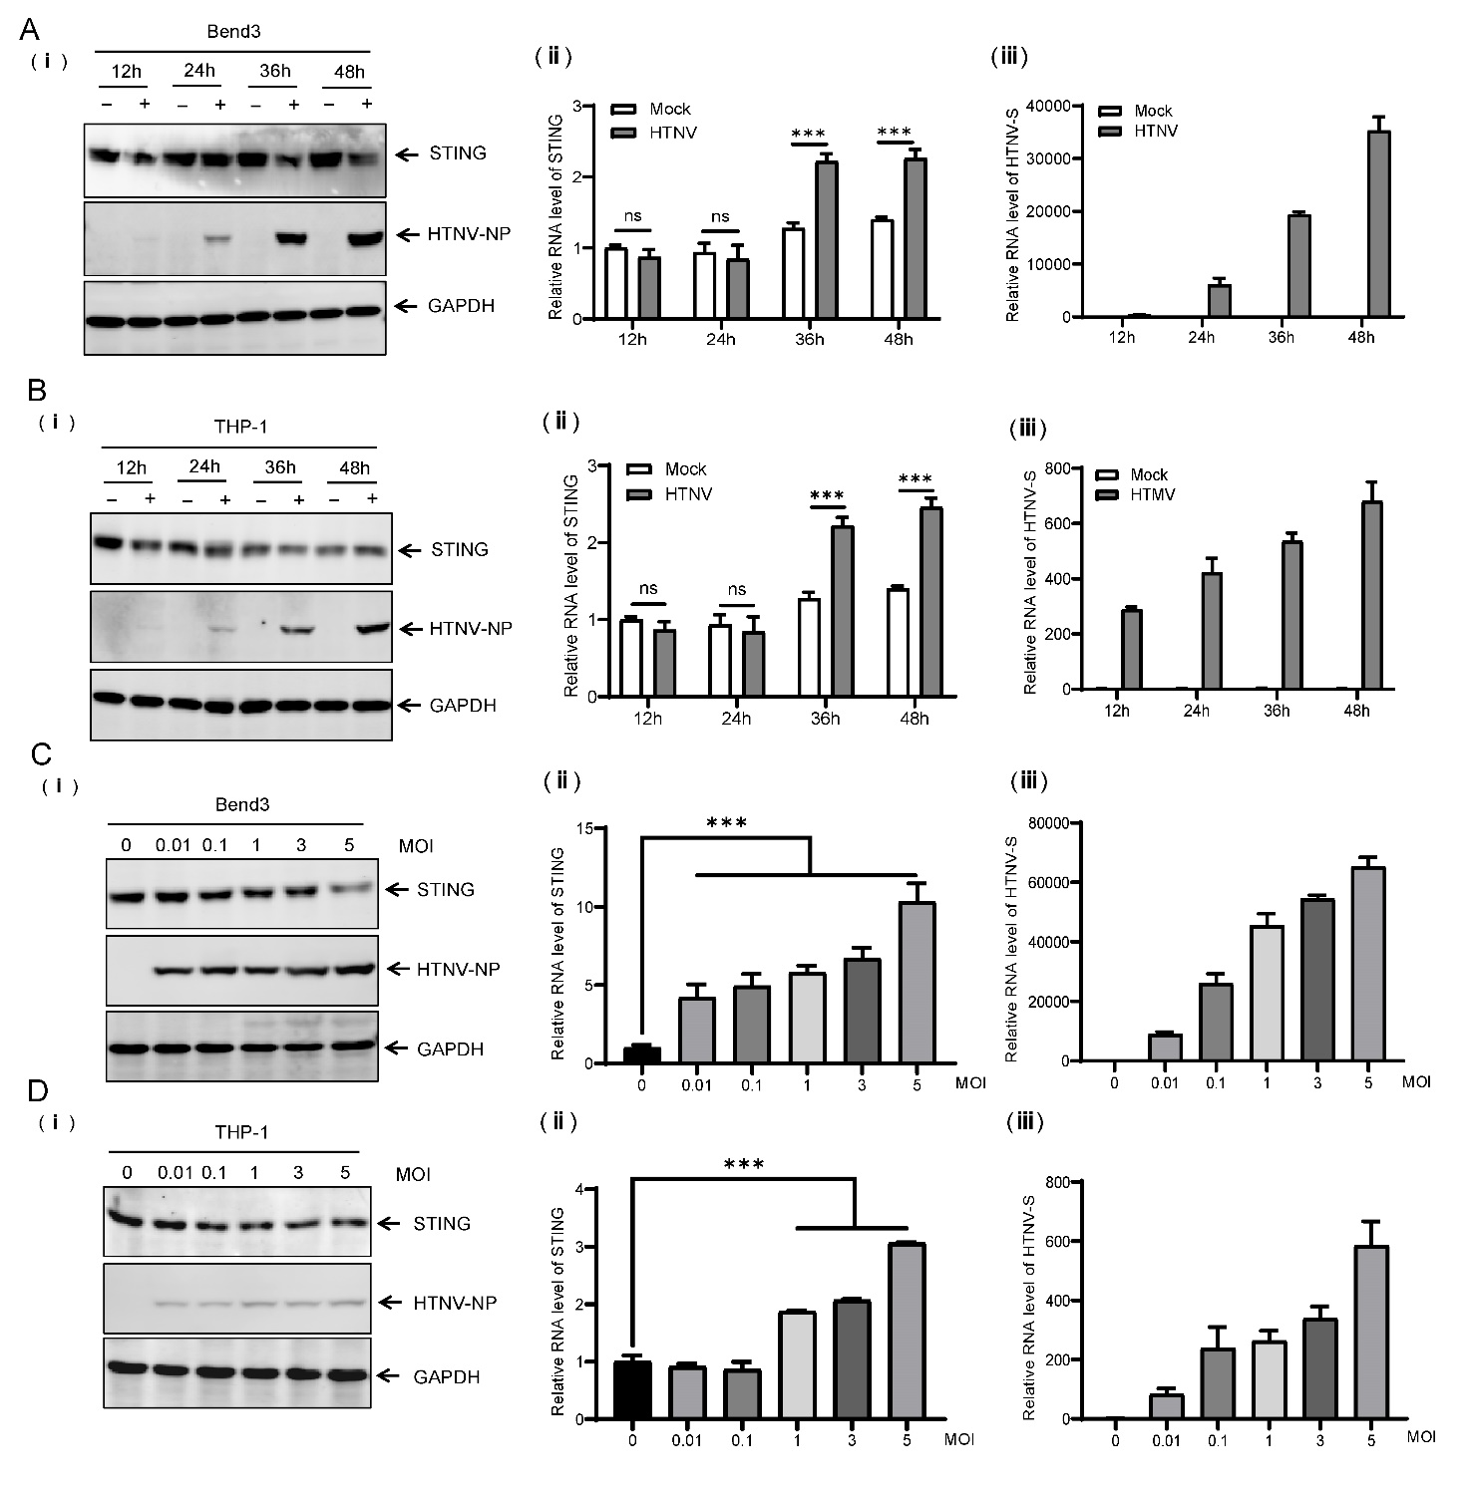
Supplementary Fig. S1. The reaction of STING during HTNV infection. A, B Bend3 (A) or THP-1 cells (B) were infected with HTNV at different time points (MOI = 1), and the lysates were harvested for immunoblot analysis of STING (A-ⅰ and B-ⅰ). The mRNA levels of STING (A-ⅱ and B-ⅱ) or HTNV S (A-ⅲ and B-ⅲ) were detected through qRT-PCR with GAPDH as the internal control. C, D Bend3 (C) or THP-1 cells (D) were infected with HTNV under different MOI for 36 h, and the lysates were harvested for immunoblot analysis of STING (C-ⅰ and D-ⅰ). The mRNA levels of STING (C-ⅱ and D-ⅱ) or HTNV S (C-ⅲ and D-ⅲ) were detected through qRT-PCR with GAPDH as the internal control. Dates are expressed as mean ± SEM (n = 3). Statistical significance was calculated using Student’s t-test or one-way ANOVA; * P < 0.05; ** P < 0.01; *** P < 0.001; ns, not significant.
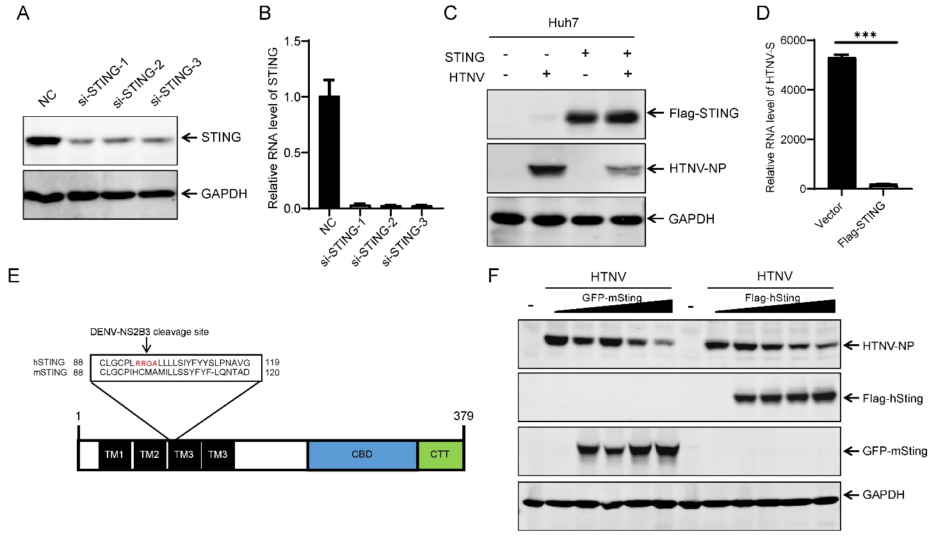
Supplementary Fig. S2. STING inhibits HTNV replication. A HUVECs were transfected with STING-specific siRNA or a negative control sequence (NC) for 24 h. The ablation efficiency of silencing STING was confirmed by immunoblotting. B HUVECs were transfected with STING-specific siRNA or a negative control sequence (NC) for 24 h. The ablation efficiency of silencing STING was confirmed by qRT-PCR. C Huh7 cells were transfected with Flag-STING for 24 h and then infected with HTNV (MOI=1) for 36 h. HTNV NP and Flag-STING were detected by immunoblotting. D Huh7 cells were transfected with Flag-STING for 24 h and then infected with HTNV (MOI = 1) for 36 h. The mRNA levels of IFN-β were detected through qRT-PCR with GAPDH as the internal control. E Schematic illustration of the domain of human STING as indicated. Highlighted in red amin-acid sequence alignment of human STING are the cleavage site of DENV NS2B3. F Huh7 cells were transfected with Flag-hSting or GFP-mting at indicated concentration for 24 h and then infected with HTNV (MOI = 1) for 36 h. HTNV NP and STING were detected by immunoblotting. Dates are expressed as mean ± SEM (n = 3). Statistical significance was calculated using Student’s t-test or one-way ANOVA; *P < 0.05; **P < 0.01; ***P < 0.001; ns, not significant.

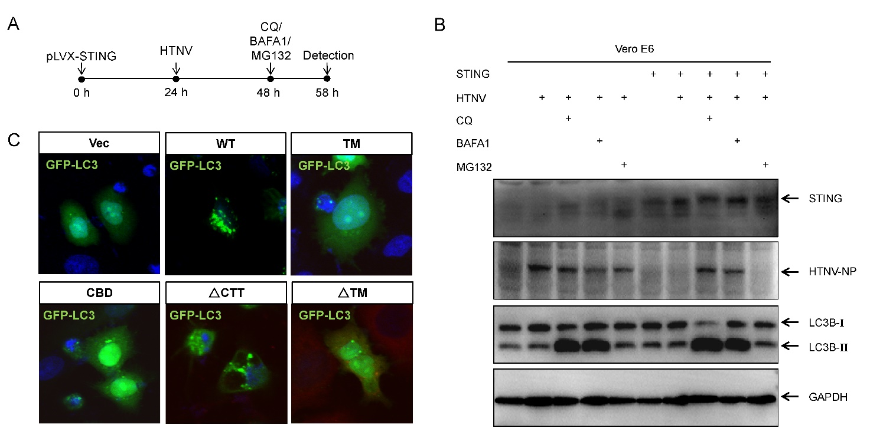
Supplementary Fig. S3. STING-mediated autophagy restricts HTNV replication. A Diagram of the assay for (B). B Vero E6 cells with overexpression STING by lentivirus infection and then infected with HTNV (MOI = 1) for 36 h, and subsequently treated with BAFA1 or MG132 for 4 h or 8 h. HTNV NP and LC3B were detected by immunoblotting. C HeLa cells were co-transfected with GFP-LC3 and indicated plasmids (Flag-Vec, Flag-WT, Flag-TM, Flag-CBD, Flag-△CTT, Flag-△TM) for 24 hrs. The cells were fixed and then observed using confocal microscopy. Scale bars, 10 µm.

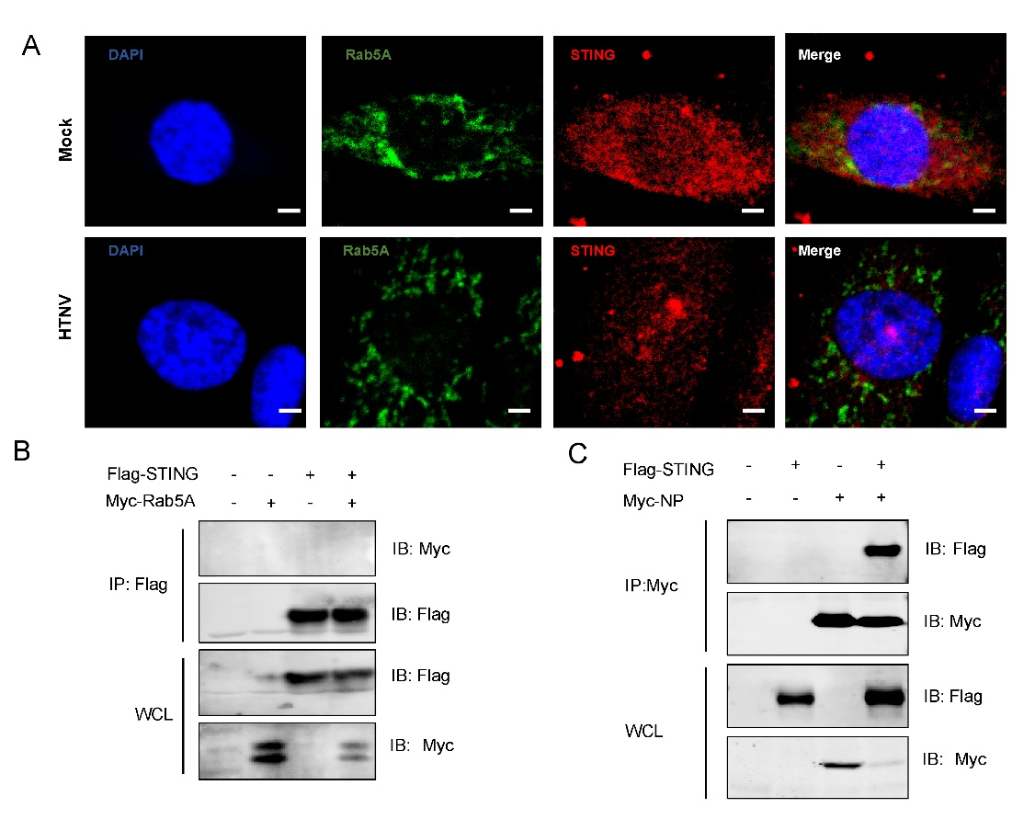

Supplementary Fig. S4. STING trafficking from ER to late endosome participate in viral protein degradation. A HUVECs were mock-infected or HTNV-infected (MOI = 1) for 24 h, and incubated with mouse anti-STING and rabbit anti-Rab5A antibodies, following stained with Cy3-conjugated anti-mouse and FITC-conjugated anti-rabbit secondary antibodies. Nuclei were stained with DAPI. Scale bar, 20 μm. B HEK293T cells were single or co-transfected with Flag-STING or Myc-Rab5A for 36 h. The cell lysates were immunoprecipitated with anti-Flag antibody, and detected by immunoblotting with anti-Flag or anti-Myc antibody. C HEK293T cells were single or co-transfected with Flag-STING or Myc-NP for 36 h. The cell lysates were immunoprecipitated with anti-Myc antibody, and detected by immunoblotting with anti-Flag or anti-Myc antibody.

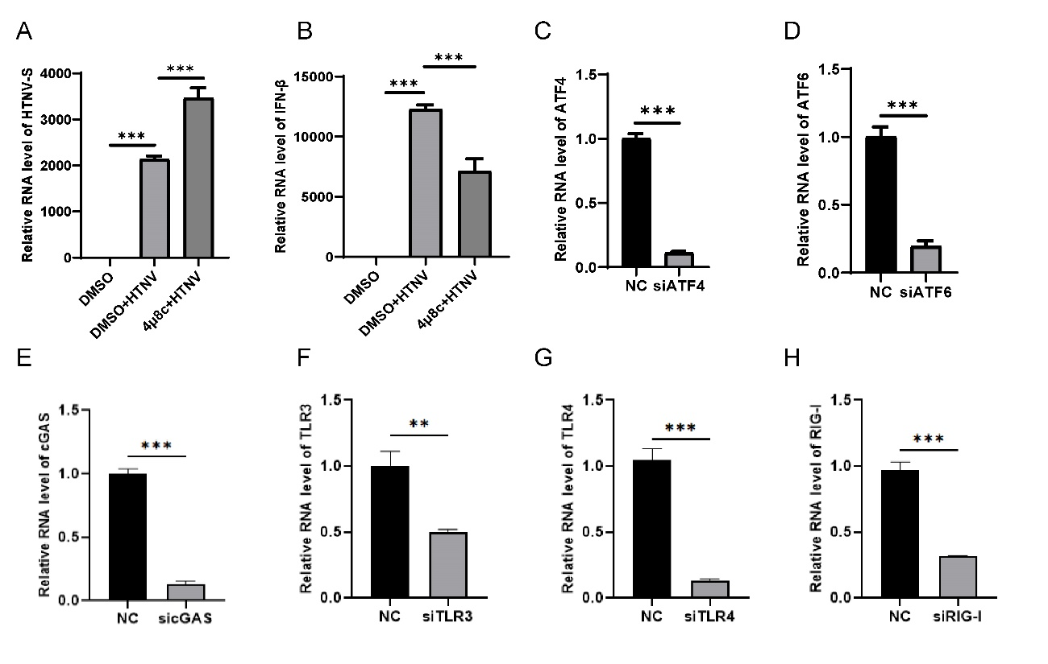

Supplementary Fig. S5. IRE1-XBP1-RIG-I signalling initiates STING-mediated autophagy post HTNV infection. A HUVECs were treated with 4μ8c or DMSO for 24 h and then infected with HTNV (MOI=1) for 36 h. The mRNA levels of HTNV S were detected through qRT-PCR with GAPDH as the internal control. B HUVECs were treated with 4μ8c or DMSO for 24 h and then infected with HTNV (MOI = 1) for 36 h. The mRNA levels of IFN-β were detected through qRT-PCR with GAPDH as the internal control. C–D HUVECs were transfected with siRNA targeting ATF4, ATF6 or NC for 24 h. The ablation efficiency of silencing ATF4 (C) or ATF6 (D) was confirmed by qRT-PCR. E HUVECs were transfected with siRNA targeting cGAS or NC for 24 h. The ablation efficiency of silencing cGAS was confirmed by qRT-PCR. F–H HUVECs were transfected with siRNA targeting TLR3, TLR4, RIG-I or NC for 24 h. the ablation efficiency of silencing TLR3 (F), TLR4 (G) or RIG-I (H) was confirmed by qRT-PCR. Dates are expressed as mean ± SEM (n = 3). Statistical significance was calculated using Student’s t-test or one-way ANOVA; * P < 0.05; ** P < 0.01; *** P < 0.001; ns, not significant.

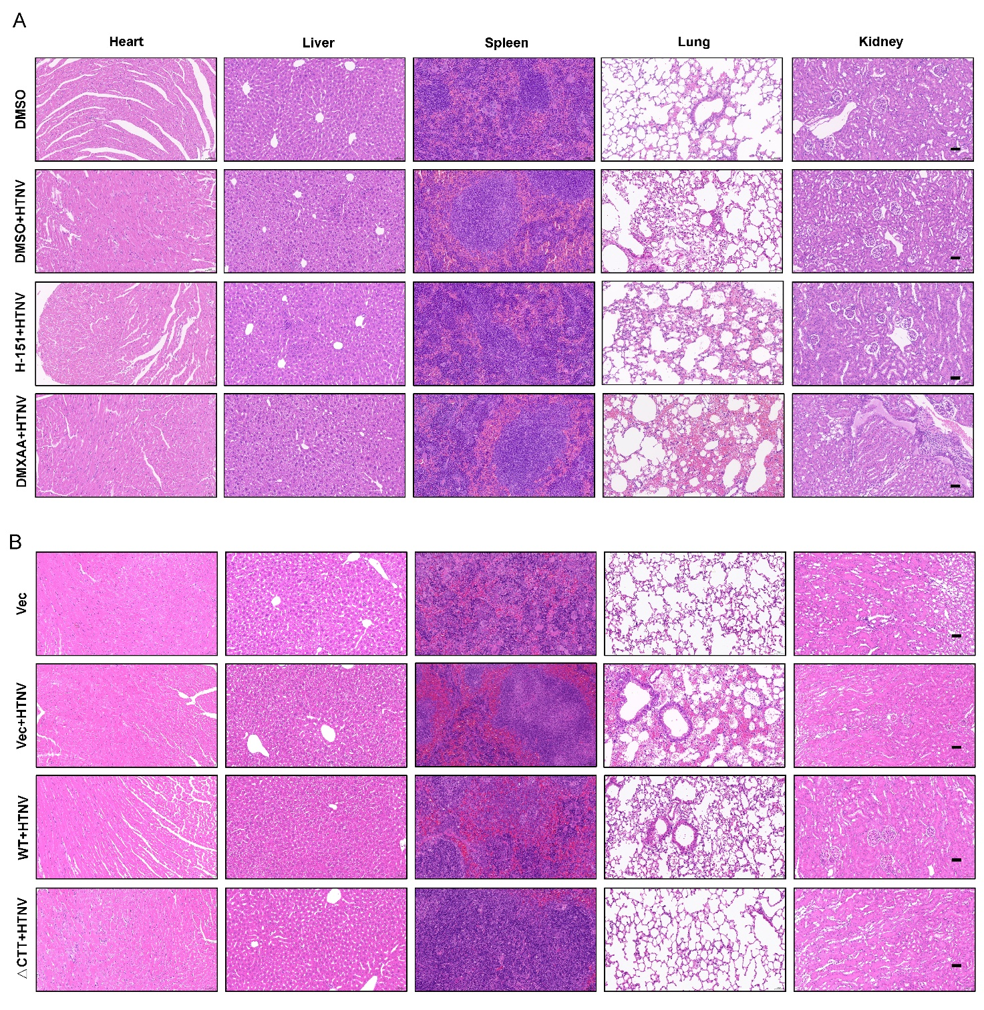
Supplementary Fig. S6. STING enhances anti-hantaviral immunity responses in vivo. A Nude mice (6–8 weeks) were intraperitoneally inoculated with HTNV (4×10⁴ TCID50/g per mouse) and intraperitoneal administration of vehicle, H-151, or DMXAA (starting at 2 day after infection). Pathology assessment by H&E images of different nude mice tissues at 6 dpi. Scale bar, 50 μm. B Nude mice (6-8 weeks) were intraperitoneally inoculated with HTNV (4×10⁴ TCID₅₀/g per mouse) and intraperitoneal administration of vector, WT, or △CTT (starting at 2 day after infection). Pathology assessment by H&E staining of different nude mice tissues at 6 dpi. Scale bar, 50 μm.

