Virologica Sinica

Supplementary Data

RIPK3 promotes hantaviral replication by restricting JAK-STAT signaling without triggering necroptosis
Yue Si ^{a, 1}, Haijun Zhang ^{b, c, 1}, Ziqing Zhou ^{a, 1}, Xudong Zhu ª, Yongheng Yang ª, He Liu ª, Liang Zhang ª, Linfeng Cheng ª, Kerong Wang ª, Wei Ye ª, Xin Lv ª, Xijing Zhang ^{d}, Wugang Hou ^{d}, Gang Zhao ^{b, e}, Yingfeng Lei ^{a, *}, Fanglin Zhang ^{a, *}, Hongwei Ma ^{a, d, *}

ª Department of Microbiology, School of Basic Medicine, Air Force Medical University, Xi’an, 710032, China.
^{b} Department of Neurology, Xijing Hospital, Air Force Medical University, Xi’an, 710032, China
^{c} Center of Clinical Aerospace Medicine, School of Aerospace Medicine, Key Laboratory of Aerospace Medicine of Ministry of Education, Air Force Medical University, Xi’an, 710032, China
^{d} Department of Anesthesiology & Critical Care Medicine, Xijing Hospital, Air Force Medical University, Xi’an, 710032, China
^{e} The College of Life Sciences and Medicine, Northwest University, Xi’an, 710069, China

1 Yue Si, Haijun Zhang and Ziqing Zhou contributed equally to this work.

* Corresponding authors.
mahongwei0720@sina.com (H. Ma), flzhang@fmmu.edu.cn (F. Zhang), yflei@fmmu.edu.cn (Y. Lei)
ORCID：Hongwei Ma (0000-0003-4929-3222); Fanglin Zhang (0000-0003-2039-509X)
Yingfeng Lei (0000-0002-1482-6124)
Supplementary Table S1 Plasmids used in experiments.
pISRE-TA-Luc | Beyotime | Cat #D2179
IgK-IFN-Luc | Miaolingbio | Cat #P1700
STAT1-Luc | Yeasen | Cat #11504ES03
pCMV3-C-Myc-STAT1 | Sino Biological | Cat #MG53362-CM
pEGFP-N1-STAT1 | Constructed in our Lab | N/A
pCMV-RIPK3-mCherry | Constructed in our Lab | N/A
pcDNA3.1-Flag-RIPK3 | Constructed in our Lab | N/A
pcDNA3.1-Flag-RIPK3(△PKD) | Constructed in our Lab | N/A
pcDNA3.1-Flag-RIPK3(△RHIM) | Constructed in our Lab | N/A
pcDNA3.1-RIPK3(D161N) | Preserved in our Lab | N/A
pcDNA3.1-RIPK3(K51A) | Preserved in our Lab | N/A

Supplementary Table S2 siRNA sequences used in experiments.
NC | 5′-UUCUUCGAACGUGUCACGUTT-3′
si-ZBP1 | 5-AGCAAGAAGAUCUCUGUGGTT-3′
si-RIPK3 | 5′-GCAGGAAAUUUCAGGCCAA-3′
si-MLKL | 5′-GAACCUGCCCGAUGACAUU-3′

Supplementary Table S3 The sequences for qRT-PCR primers.
HTNV S | forward, 5′-TCTAGTTGTATCCCCATCGACTG-3′  reverse, 5′-ACATGCGGAATACAATTATGGC-3′
mus-RIPK3 | forward, 5′-TCTGTCAAGTTATGGCCTACTGG-3′  reverse, 5′-GGAACACGACTCCGAACCC-3′
mus-MLKL | forward, 5′-AATTGTACTCTGGGAAATTGCCA-3′  reverse, 5′-TCTCCAAGATTCCGTCCACAG-3′
mus-ZBP1 | forward, 5′-AAGAGTCCCCTGCGATTATTTG-3′  reverse, 5′-TCTGGATGGCGTTTGAATTGG-3′
mus-TLR3 | forward, 5′-GTGAGATACAACGTAGCTGACTG-3′  reverse, 5′-TCCTGCATCCAAGATAGCAAGT-3′
mus-TLR4 | forward, 5′-ATGGCATGGCTTACACCACC-3′  reverse, 5′-GAGGCCAATTTTGTCTCCACA -3′
mus-IL-6 | forward, 5′-AAGAGCCAGAGTGTCAGAATCT-3′  reverse, 5′-AGCTCCAGTTGGTAATTTCTTGG-3′
mus-IL-1β | forward, 5′-GAAATGCCACCTTTTGACAGTG-3′  reverse, 5′-TGGATGCTCTCATCAGGACAG-3′
mus-IL-10 | forward, 5′-GCCTGGAACGTAGACGACAT-3′  reverse, 5′-TTCCCATGGTGCCTGAATCC-3′
mus-Arg-1 | forward, 5′-TCCTTAGAGATTATCGGAGCGCCT-3′  reverse, 5′-TTTCCAGCAGACCAGCTTTCCTCA-3′
mus-MX1 | forward, 5′-GACCATAGGGGTCTTGACCAA -3′  reverse, 5′-AGACTTGCTCTTTCTGAAAAGCC-3′
mus-MX2 | forward, 5′-CAAGGAACACCCTCATTTCAGAG-3′  reverse, 5′-GCAGCTCCTCACTTGCACT-3′
mus-IFIT1 | forward, 5′-GCCTATCGCCAAGATTTAGATGA-3′  reverse, 5′-TTCTGGATTTAACCGGACAGC-3′
mus-IFIT2 | forward, 5′-GGAGAGCAATCTGCGACAG-3′  reverse, 5′-GCTGCCTCATTTAGACCTCTG-3′
mus-ISG15 | forward, 5′-GGTGTCCGTGACTAACTCCAT-3′  reverse, 5′-CTGTACCACTAGCATCACTGTG-3′
mus-GAPDH | forward, 5′-ACCCAAAGACTGTGGATGG-3′  reverse, 5′-ACACATTGGGGGTAGGAACA-3′

Supplementary Table S4 The antibodies for immunoblot assays and immunofluorescence assays.
mouse monoclonal anti-GAPDH | Proteintech | Cat #60004-1-Ig
mouse monoclonal anti-HTNV NP | Prepared in our Lab (1A8) | N/A
rabbit polyclonal anti-t-RIPK3 | Proteintech | Cat #17563-1-AP
rabbit monoclonal anti-p-RIPK3 (ser232) | Abcam | Cat #ab195117
rabbit monoclonal anti-t-MLKL | Abcam | Cat #ab184718
rabbit monoclonal anti-p-MLKL (ser345) | Abcam | Cat #ab196436
rabbit monoclonal anti-t-JAK2 | Absmart | Cat #T55287
rabbit monoclonal anti-p-JAK2 (Y1007, Y1008) | Absmart | Cat #TU390534
mouse monoclonal anti-t-STAT1 | Proteintech | Cat #66545-1-Ig
rabbit monoclonal anti-p-STAT1 (Ser727) | Cell Signaling Technology | Cat #8826S
mouse monoclonal anti-Myc tag | Absmart | Cat #M20012
rabbit monoclonal anti-Flag tag | Proteintech | Cat #80010-1-RR
goat anti-rabbit 800CW | LI-COR | Cat #C70426-05
goat anti-mouse 680RD | LI-COR | Cat #C70427-05
goat anti-rabbit IgG, Cy3 Conjugated | ZhuangZhi Biotechnology | Cat #EK022
goat anti-mouse IgG, Alexa Fluor 488 | ZhuangZhi Biotechnology | Cat #EK011

Supplementary Table S5 The variables of murine sepsis score.
Index | Score - Description
Appearance | 0- Coat is smooth and shiny  1- Patches of hair piloerected  2- Majority of back is piloerected  3- "Puffiness", piloerection may or may not be present, mouse appears  4- Thin and emaciated, piloerection may or may not be present, mouse appears
Autonomous consciousness | 0- Active  1- Active, but avoids standing upright  2- Decreased and delayed activity, still ambulant  3- Activity occurs only after stimulation, movements have a tremor  4- Activity severely impaired. Mouse remains stationary when provoked, with possible tremor
Autonomous activities | 0- Normal activity level (feeding, drinking, climbing, walking, fighting, etc.)  1- Mildly reduced activity, only moving on the bottom of the cage  2- Suppressed activity with occasional Suppressed activity  3- Stationary  4- Sedentary, trembling (especially hind limbs)
Response to stimulation | 0- Responds quickly to sound or touch  1- No or slow response to sound, strong response to touch (flee immediately)  2- No response to acoustic stimuli, moderate intensity response to touch (moving a few steps)  3- No response to acoustic stimuli, mild response to touch (no displacement)  4- No response to sound stimulation, almost no response to touch, unable to turn over after being pushed down

Supplementary Table S6 The temperature of mice in Fig.4E.
 | Temperature
WT | day7 (head: 35.2 °C; back: 33.4 °C; tail:27.8 °C)  day8 (head: 34.4 °C; back: 32.3°C; tail:28.5°C)  day9 (head: 34.3 °C; back: 33.1 °C; tail:27.8 °C)
WT HTNV | day7 (head: 33.8 °C; back: 32.4 °C; tail:28.0 °C)  day8 (head: 35.0 °C; back: 33.7 °C; tail:29.2 °C)  day9 (head: 34.5 °C; back: 32.6 °C; tail:28.6 °C)
RIPK3^{-/-} HTNV | day7 (head: 36.2 °C; back: 34.6 °C; tail:31.1 °C)  day8 (head: 36.4 °C; back: 33.6 °C; tail:28.3 °C)  day9 (head: 36.6 °C; back: 33.6 °C; tail:30.2 °C)

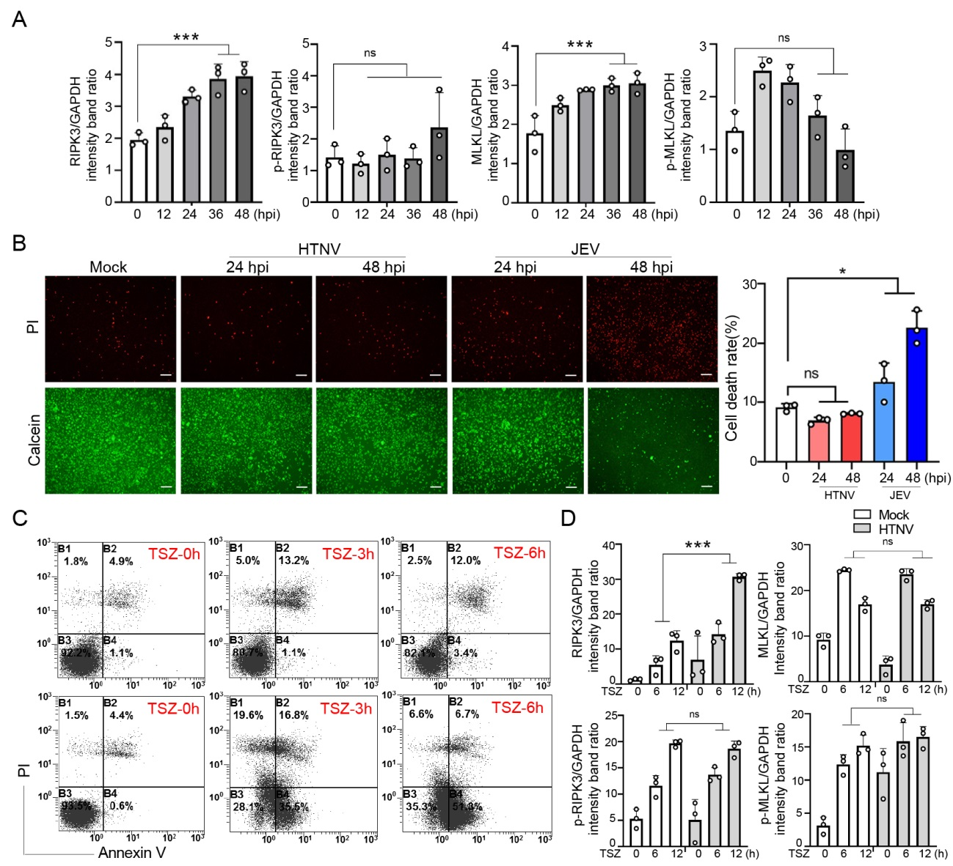
Supplementary Fig. S1. A Densitometric analysis of band intensities for RIPK3, p-RIPK3, MLKL and p-MLKL in Fig. 1D. B BMDMs were infected with HTNV/JEV in 96-well plates (MOI=1), and the cells were detected by double fluorescence staining with Calcein AM (green) and PI (red). The living cells showed green fluorescence, and PI stained dead cells, which showed red fluorescence. The histogram shows the proportion of dead cells after infection. C A549 or L929 cells were stimulated with TSZ (T: TNF, 10 ng/mL; S: SM-164, 100 nmol/L; Z: zVAD-fmk, 20 μmol/L). Then, the cells were stained with Annexin V and PI and assessed by flow cytometry. The X and Y axes represent Annexin V and PI, respectively.
D Densitometric analysis of band intensities for RIPK3, p-RIPK3, MLKL and p-MLKL in Fig. 1G. The data are the means ± SEMs. *P < 0.05, ** P < 0.01, and *** P < 0.001; ns indicates no significance.

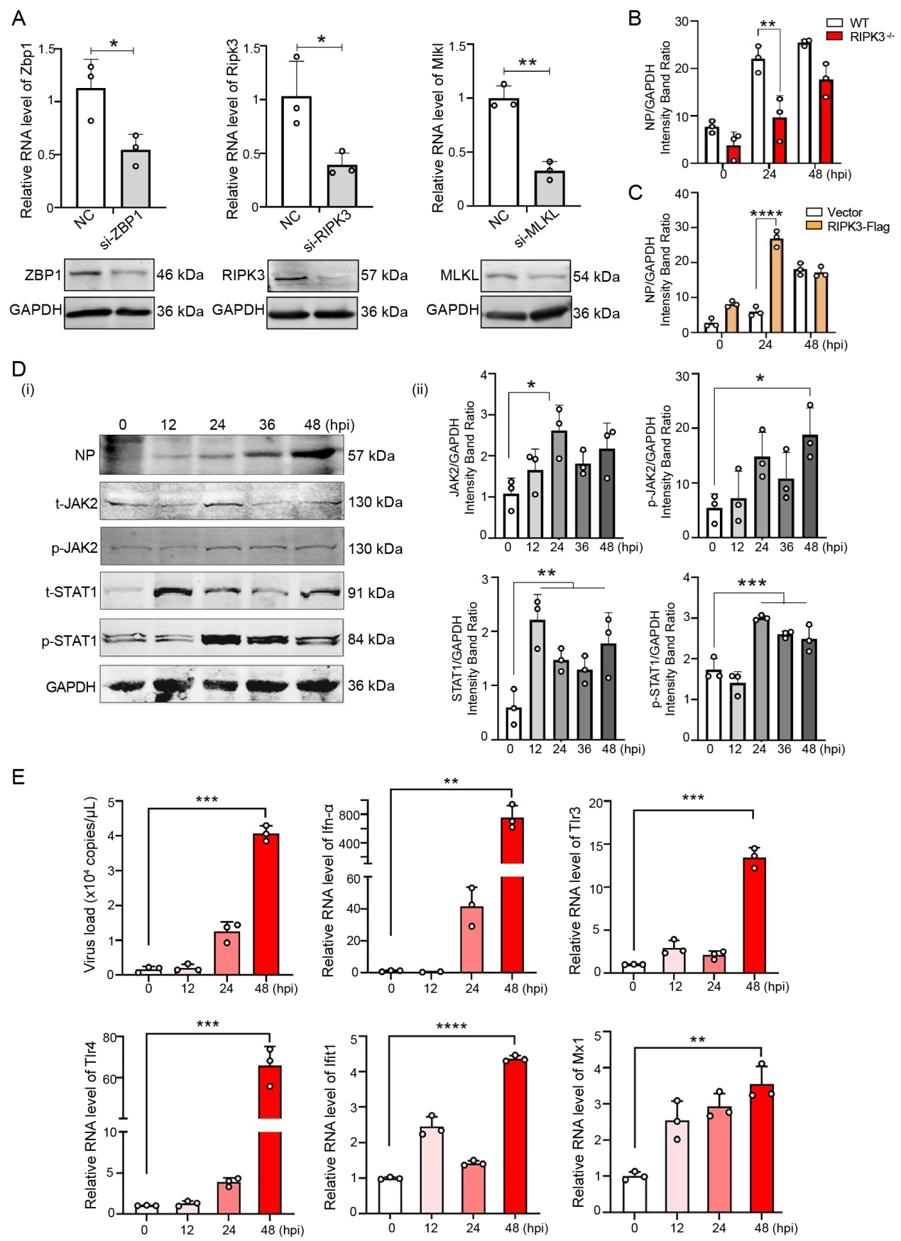
Supplementary Fig. S2. A qRT-PCR and immunoblot assays determined the effects of si-ZBP1, si-RIPK3 and si-MLKL in BMDMs. B Densitometric analysis of the band intensity for NP of Fig. 2B(i). C Densitometric analysis of the band intensity for NP of Fig. 2C(i). D BMDMs were infected with HTNV (MOI=1), and the cell lysates were then collected to analyze the levels of NP of HTNV and JAK-STAT pathway indicators using immunoblotting (i). Densitometric analysis of the band intensities for JAK2, p-JAK2, STAT1 and p-STAT1 (ii). E BMDMs were infected with HTNV (MOI=1), and the cell lysates were then collected to analyze HTNV-S levels and IFN-associated gene expression by qRT-PCR. The data are the means ± SEMs. *P < 0.05, **P < 0.01, and ***P < 0.001; ns indicates no significance.

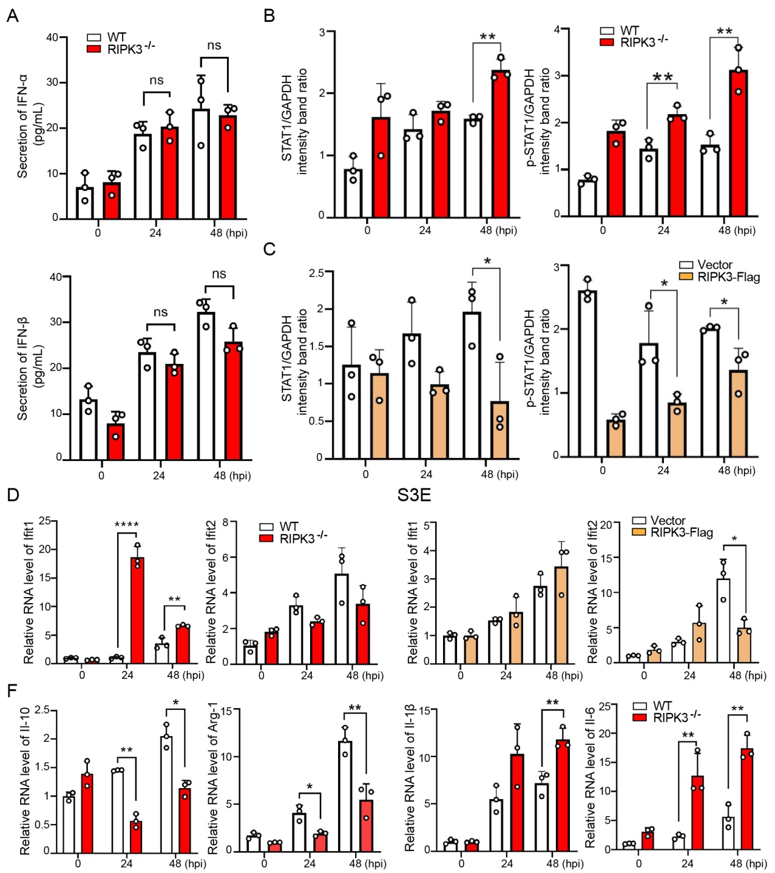
Supplementary Fig. S3. A WT/RIPK3^{-/-} BMDMs were infected with HTNV (MOI=1), and the medium supernatants were collected to detect IFN-α/β concentrations by ELISA. B Densitometric analysis of the band intensities for STAT1 and p-STAT1 in Fig. 2G. C Densitometric analysis of the band intensities for STAT1 and p-STAT1 in Fig. 2H. D WT/RIPK3^{-/-} BMDMs were infected with HTNV (MOI=1), and the cell lysates were then collected to analyze Ifit1 and Ifit2 levels by qRT-PCR. E Huh-7 cells were transfected with the RIPK3-Flag plasmid and infected with HTNV (MOI=1). The cell lysates were then collected to analyze Ifit1 and Ifit2 levels by qRT-PCR. F WT/RIPK3^{-/-} BMDMs were infected with HTNV (MOI=1), and the cell lysates were then collected to analyze Il-6, Il-1β, Il-10 and Arg-1 levels by qRT-PCR. The data are the means ± SEMs. *P < 0.05, ** P < 0.01, and *** P < 0.001; ns indicates no significance.

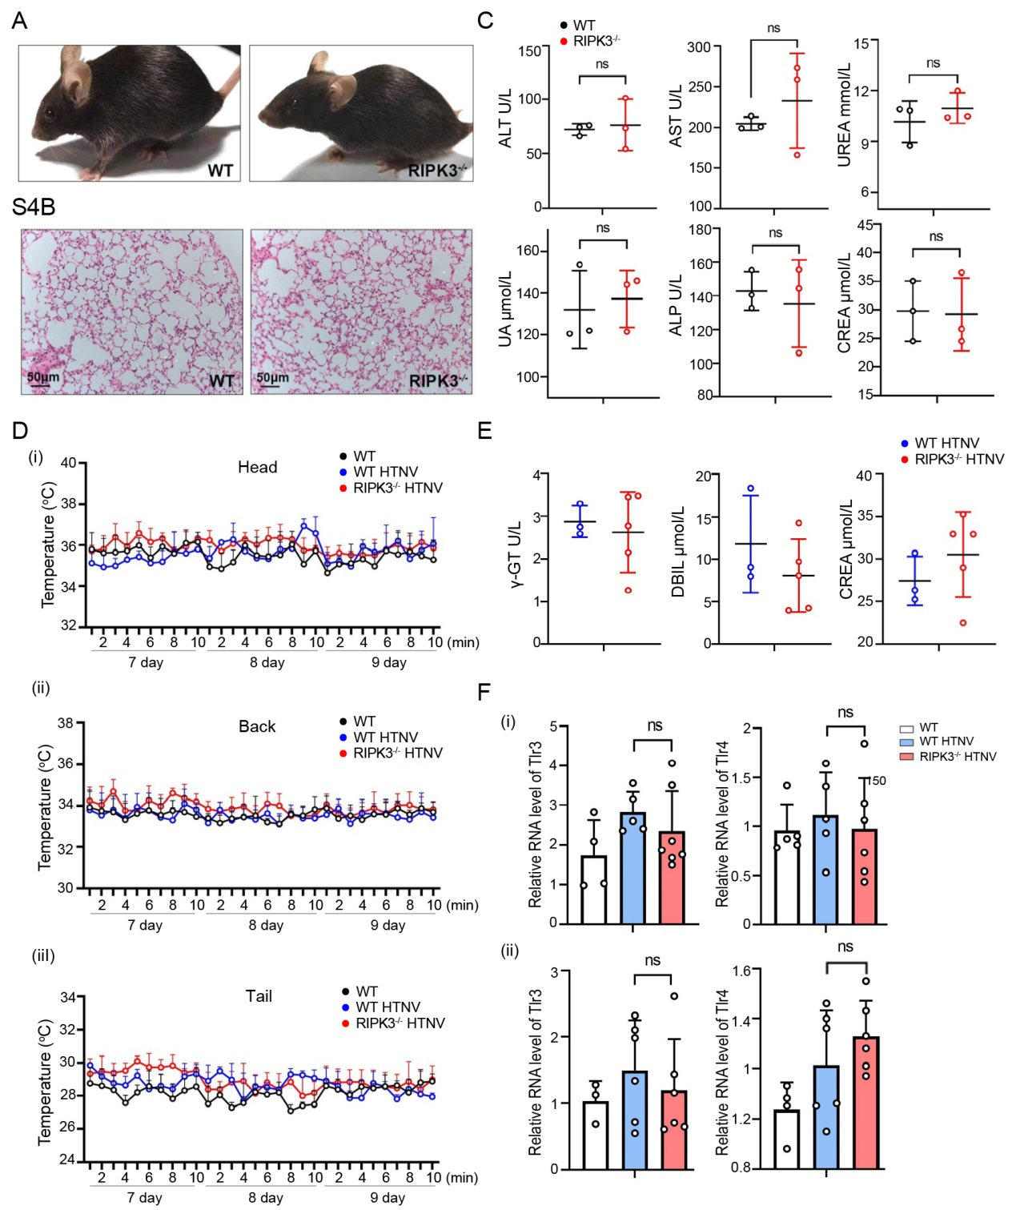
Supplementary Fig. S4. A Pictures show the clinical symptoms of WT/RIPK3^{-/-} mice. B Lungs were collected from WT/RIPK3^{-/-} mice, fixed in 4% paraformaldehyde, and subjected to H&E staining. Scale bars, 50 μm. C Whole blood collected from WT/RIPK3^{-/-} mice was centrifuged at 1,500 ×g for 10 min at room temperature (25 °C) to obtain serum for biochemical tests. D The core temperatures of the head (i), back (ii) and tail (iii) were recorded from 7~9 days after virus challenge. The temperature change was monitored for 10 min each day. E Shown are other serological indicators used by biochemical tests in Fig. 4H.
F RNA collected from liver (i) and kidney (ii) samples from WT and RIPK3^{-/-} mice after viral challenge. Samples were collected 9 dpi to detect the level of TLRs by qRT-PCR. The data are the means ± SD. *P < 0.05, ** P < 0.01, and *** P < 0.001; ns indicates no significance. F RNA collected from the liver (i) and kidney (ii) samples of WT and RIPK3^{-/-} mice after viral challenge. Samples were collected 9 dpi to detect the level of TLRs by qRT-PCR. The data are the means ± SD. *P < 0.05, ** P < 0.01, and *** P < 0.001; ns is short for no significance.

