Virologica Sinica

Supplementary Data

Characterization of bacteriophage BUCT631 lytic for K1 Klebsiella pneumoniae and its therapeutic efficacy in Galleria mellonella larvae

Pengjun Hanª, Mingfang Puª, Yahao Li^{b}, Huahao Fan^{a,*}, Yigang Tong^{a,b,*}

ª College of Life Science and Technology, Beijing University of Chemical Technology, Beijing, 100029, China
^{b} Beijing Advanced Innovation Center for Soft Matter Science and Engineering, Beijing University of Chemical Technology, Beijing, 100029, China

* Corresponding authors.
E-mail address: fanhuahao@mail.buct.edu.cn (H. Fan), tongyigang@mail.buct.edu.cn (Y. Tong).

Supplementary Table S1 Determination of drug resistance in K1 K. pneumoniae (agar dilution method).
Antibiotics | Klebsiella pneumoniae strains
 | 064 | 2752 | K7 | 2755 | S-2007 | 081 | 2024
Amikacin | S | R | R | R | S | S | S
Aztreonam | S | I | R | R | S | R | S
Cefepime | S | S | R | R | S | R | S
Cefoperazone/Sulbactam | S | I | R | R | S | R | R
Ceftazidime | S | S | R | R | S | R | R
Ciprofloxacin | S | S | S | S | S | R | I
Imipenem | S | S | R | S | S | S | R
Meropenem | S | S | R | S | S | S | S
Minocycline | S | S | R | R | S | I | S
Piperacillin/Tazobactam | S | I | S | S | S | R | R
Tigecycline | S | S | S | R | S | S | S
Tobramycin | S | S | R | R | S | R | S
Sulphamethoxazole/trimethoprim | S | S | R | R | S | S | S
Doxycycline | S | S | R | R | S | R | S
Ticarcillin/Clavulanate | S | R | S | R | S | R | S
R: resistance; I: intermediate; S: sensitivity

Supplementary Table S2 The conserved domains found in the hypothetical protein of BUCT631 genome.
ORF | Hit type | PSSM-ID | Interval | E-Value | Accession | Description
15 | Superfamily | 164817 | 3–38 | 1.89e−03 | cl10220 | Hypothetical protein
16 | Superfamily | 436822 | 5–98 | 3.15e−38 | pfam18909 | Siphovirus protein of unknown function (DUF5664)
26 | Superfamily | 222843 | 1–228 | 1.41e−124 | PHA02030 | Hypothetical protein
27 | Superfamily | 275231 | 6–31 | 8.73e−03 | cl22805 | Small Trp-rich protein
44 | Superfamily | 368775 | 4–65 | 2.38e−12 | cl05604 | Protein of unknown function (DUF987)

Supplementary Table S3 The structural proteins predicted in the hypothetical protein of BUCT631 genome using PhANNs.
ORFs | Predicted protein function
12 | Tail fiber
29 | portal
55 | Minor capsid

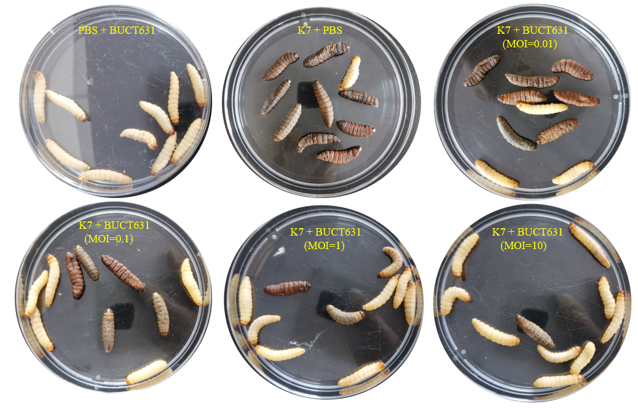
Supplementary Fig. S1 Morphology of the G. mellonella in each group in the phage treatment experiment.

