Virologica Sinica

Supplementary Data

Migrasomes released by HSV-2-infected cells serve as a conveyance for virus spread
Yalan Liu^{a, d, *}, Zhiyuan Zhu^{a, b}, Yuncheng Li^{a, b}, Mengshi Yangª, Qinxue Hu^{a, c, *}

ª State Key Laboratory of Virology, Wuhan Institute of Virology, Center for Biosafety Mega-Science, Chinese Academy of Sciences, Wuhan, 430071, China
^{b} Savaid Medical School, University of Chinese Academy of Sciences, Beijing, 100049, China
^{c} Institute for Infection and Immunity, St George’s, University of London, London, SW17 0RE, UK
^{d} Hubei Jiangxia Laboratory, Wuhan, 430200, China

*Corresponding authors.
Email addresses: liuyl@wh.iov.cn (Y. Liu); qhu@wh.iov.cn (Q. Hu),
ORCID of corresponding authors:
0000-0002-4594-9215 (Q. Hu); 0000-0003-0464-0964 (Y. Liu)

Materials and Methods
Reagents and construct
Mouse monoclonal antibody against HSV-1 + HSV-2 major capsid protein ICP5 (ab6508) was purchased from Abcam. Rabbit polyclonal antibodies against tetraspanin (TSPAN4; A10253) and carboxypeptidase Q (CPQ; A12062), respectively, were purchased from Abclonal. Rabbit polyclonal antibody against NDST1 (PHC0614S) was purchased from Abmart. Fibronectin (10314-H08H2-200) was purchased from Sino Biological Inc. The optimum density gradient medium OptiPrepTM (1114542) was purchased from Axis-Shield. The ORF of TSPAN4 was cloned into pEGFP-C1 (named pTSPAN4-GFP).

Cell lines, viruses and mice
Human normal keratinocyte HaCaT, Chinese hamster ovary cell line CHO and African green monkey kidney cell line Vero were grown in Dulbecco’s modified Eagle’s medium (DMEM, Gibco) containing 10 % fetal bovine serum (FBS), 100 Units/mL penicillin and 100 Units/mL streptomycin at 37 °C in 5% CO₂.

HSV-2 (strain G) was obtained from LGC standards. HSV-2-GFP carrying the complete genome of HSV-2 and green fluorescent protein (GFP) was kindly provided by Dr. Yasushi Kawaguchi, University of Tokyo, Japan. All viruses were grown and tittered on Vero cells. Virus stock was stored at −80 °C before used for infection.

Six to eight-week-old female C57BL/6J mice were housed in specific pathogen-free conditions, with sterile food and water supplied. All experimental procedures involving mice were approved by the Institutional Review Board (IRB), Wuhan Institute of Virology, CAS (Approval Number: WIVAF11202201).

Isolation and fractionation of migrasomes
Cells were seeded in T175 cell culture flasks (431080, CORNING) coated with 0.1 μg/mL fibronectin at 30% confluence followed by HSV-2 infection (MOI = 1). Fifteen flasks of cell cultures were used for one batch of purification. At 20 hpi, the cells and migrasomes were digested with trypsin and collected in 50 ml tubes. After centrifugation at 1000 ×g for 10 min followed by 4000 ×g for 20 min, supernatants were then collected and centrifugated at 20,000 ×g for 30 min. The crude migrasome pellets were washed with PBS and centrifuged at 20,000 ×g for 30 min. Migrasome fractionation was performed by density gradient centrifugation, using 5–50% Optiprep as the density medium (1114542, Axis-Shield). The prepared gradient was centrifuged at 150 000 ×g for 4 hr at 4°C in an SW41 rotor (Beckman). Finally, fractions were collected from top to bottom (1 mL per fraction). Each fraction was mixed with the same volume of PBS and centrifuged at 20,000 ×g for 30 min to collect the pellet. The pellets were washed with PBS and centrifuged again at 20,000 ×g for 30 min. Fractions were prepared for TEM and WB analysis.

Electron microscopy
HaCaT cells were infected with HSV-2 strain G or HSV-2-GFP at an MOI of 1. At 20 hpi, migrasomes were harvested, purified, and then fixed with 2.5% glutaraldehyde/1% paraformaldehyde in cacodylate buffer (0.1 mol/L sodium cacodylate [pH 7.4], 35 mmol/L sucrose, 4 mmol/L CaCl₂). After staining with 1% OsO₄ and 4% uranyl acetate for 2 h and dehydrating in a graded ethanol series (50%–100%), the samples were subsequently embedded in epoxy resin with an Embed 812 kit (Electron Microscopy Sciences). The embedded samples were sliced by an ultramicrotome (EM UC7, Leica). Thin sections (80–100 nm) were stained with 2% saturated uranyl acetate for 15 min, rinsed with water, and then stained with Reynolds’ lead citrate for 15 min. Electron micrographs were taken on a Tecnai transmission electron microscope (FEI Tecnai G² 20 TWIN) at an accelerating voltage of 200 kV.

Western Blot
Prepared protein samples of ultracentrifugation were separated by 10% SDS-PAGE and transferred to 0.45 µm polyvinylidene difluoride membranes (Millipore). After being blocked with 5% non-fat milk in TBS buffer containing 0.05% Tween 20 overnight at 4 °C, the membrane was incubated with a primary antibody against CPQ at a dilution of 1:500, gB at a dilution of 1:2000 or TSPAN4 at a dilution of 1:1000, for 1 h at 37 °C. The membrane was washed five times with 0.05% Tween 20/TBS, followed by incubation for 1 h with HRP conjugated goat anti-rabbit secondary antibody (1:10,000, BA1054, Boster) or HRP conjugated goat anti-mouse secondary antibody (1:10,000, BA1050, Boster). After five washes with 0.05% Tween-20/TBS, protein bands were visualized by exposure to FluorChem HD2 Imaging System (Alpha Innotech) after the addition of chemiluminescent substrate (SuperSignal® West Dura Extended Duration Substrate, 34075, Thermo Scientific Pierce).

Immunofluorescence
To detect colocalization of migrasome markers CPQ, NDST1 and TSPAN4 with HSV-2 ICP5 in migrasomes released by HaCaT cells, cells were infected with HSV-2 at an MOI of 1. At 20 hpi, cells were fixed with 4% paraformaldehyde for 20 min and permeabilized with 0.5% Triton X-100 for 10 min. The cells were subsequently blocked with 5% bovine serum albumin (BSA) at room temperature for 2 h. The cells were further incubated with mouse monoclonal antibody against HSV-2 ICP5 (ab6508, Abcam), rabbit polyclonal antibody against TSPAN4 (A10253, Abclonal), rabbit polyclonal antibody against CPQ (A12062, Abclonal) and rabbit polyclonal antibody against NDST1 (PHC0614S, Abmart) at a dilution of 1:200 for 1 h, followed by incubation with the secondary antibody (Alexa Fluor 647-labeled goat anti-mouse (1:500; A0473, Beyotime) or Alexa Fluor 488-labeled goat anti-rabbit (1:500; A0423, Beyotime)). The nuclei were stained with DAPI dye (Beyotime). The images were taken by fluorescence microscopy (NIKON).

Challenge and tissue harvesting
Five to seven days prior to challenge, mice were injected s.c. in the neck ruff with Depo-Provera (medroxyprogesterone acetate, 2 mg/mouse). Mice (n = 3/group) were anesthetized with pentobarbital sodium and challenged intravaginally (i.vag.) with 10 µL/mouse HSV-2 (G strain) at a concentration of 2 × 10⁷ PFU/mL. Postchallenge, the weight and clinical symptoms of all mice were monitored every day. Mice were sacrificed when genital ulceration and severe inflammation were observed. The intestinal and cervical tissues of each mouse were collected and sections were prepared for immunofluorescence staining and TEM. Tissue sections were used for immunofluorescence staining of TSPAN4 and HSV-2 ICP5. Migrasomes containing HSV-2 in ultra-thin sections of mouse tissues were observed under TEM.

Virus transmission
To investigate whether HSV-2 in the isolated migrasomes could be transmitted to uninfected cells and cause productive infection, cell-free HSV-2-GFP supernatant was filtered with 0.45 µm filter. Subsequently, the filtered cell-free HSV-2 and the purified migrasomes containing HSV-2 were added into culture dishes coated with HSV-2 permissive cells (HaCaT) or non-permissive cells (CHO). At 48 hpi, cells were fixed with 4% paraformaldehyde for 20 min and permeabilized with 0.5% Triton X-100 for 10 min. The nuclei were stained with DAPI dye (Beyotime). The images were taken by fluorescence microscopy (NIKON).
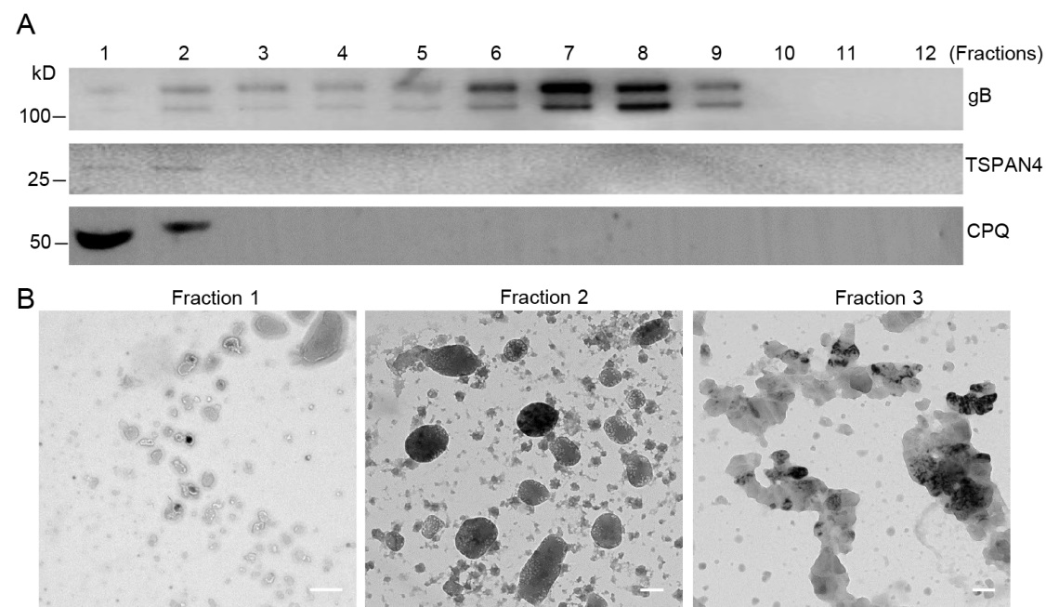
Supplementary Fig. S1. Purification and identification of migrasomes. Migrasome fractionation was performed by density gradient centrifugation, using Optiprep as the density medium. The fractions 1–12 were collected from top to bottom and prepared for WB and TEM analysis. A Western blot was used to analyze HSV-2 proteins and migrasome markers in different fractions. The exist of migrasome marker in the fractions was confirmed by WB using anti-CPQ and TSPAN4 antibody. The exist of HSV-2 in the fractions was confirmed by WB using an anti-HSV-2 gB antibody. B TEM images of negative staining samples of fraction 1, 2 and 3. Scale bar, 500 nm. One representative experiment out of three is shown.

