Virologica Sinica

Supplementary Data

Roles of the functional domains and conserved residues of the severe fever with thrombocytopenia syndrome virus L protein provide insights into the viral RNA transcription/replication mechanism

Zhiyun Yin^{a,b}, Fuli Ren^{a,c}, Min Zhouª, Shengyao Chenª, Yali Dengª, Sijing Huª, Fei Dengª, Shu Shen^{a,*}, Junming Shi^{a,*}

ª National Virus Resource Center, Wuhan Institute of Virology, Chinese Academy of Sciences, Wuhan, 430071, China
^{b} Academic Affairs Office of Cangzhou Jiaotong University, Cangzhou, 061199, China
^{c} Center for Translational Medicine, Jinyintan Hospital, Wuhan, 430023, China

* Corresponding author.
E-mail addresses: sjm@wh.iov.cn (J. Shi), shenshu@wh.iov.cn (S. Shen)

Methods
Construction of SFTSV-L truncations and site mutants
The cDNA of strain SFTSV (strain WCH/97/HN/China/2011) was used as template of each mutant by PCR to obtain the full-length SFTSV-L open reading frame (ORF). According to the structure model of SFTSV (PDB no: 6L42_A), regions of domain endoN (25–205 aa), arm1 (1615–1696 aa), CBD (1697–1810 aa), b (1811–1852 aa), arm2 (1853–1932 aa), lariat (1933–2049 aa) were removed from the clones of full-length SFTSV-L ORF by overlapping PCR. Each single-point mutation plasmid was constructed by site-directed PCR mutagenesis with specific primers containing the particular nucleotide substitution. The PCR products were purified using E.Z.N.A® Gel Extraction Kit (Omega Biotek Inc, Georgia, USA). Purified fragments of SFTSV-L were inserted into plasmid pCAGGS via infusion clone kit (One Step Cloning Kit, Vazyme, Nanjing, China). The recombinant plasmid sequences were verified by Sanger sequencing (Sangon Biotech, Shanghai, China).

Immunofluorescence assay
HEK 293T cells (ATCC no. CRL-1573) were fixed in 4% paraformaldehyde for 15 min and permeated with 0.2% Triton X-100 (PBS) for 15 min. After washing three times with PBS, the cells were blocked with 5% bovine serum albumin at room temperature for 1 h. IFA was performed using 1:2,000 diluted polyclonal antibodies against SFTSV L (anti-L) as the primary antibody according to a previous description (Ning et al., 2019), and 1:5000 diluted Alexa-fluor555-conjugated polyclonal goat anti-rabbit IgG (Abcam, Cambridge, UK）as the secondary antibodies. The nuclei were stained with DAPI (Beyotime, Nanjing, China). The fluorescence was visualized using a fluorescence microscope (ECLIPSE TE2000-S; Nikon, Japan).

Minigenome assay
The minigenome construction and reporter assays were performed as described previously (Ren et al., 2020). Briefly, the strain SFTSV-WCH was used as a template for clones of NP and RdRp ORFs, resulting in the expression plasmids pCAGGS-NP and pCAGGS-RdRp for the NP and L proteins, respectively. The M-segment-based constructs contained the enhanced green fluorescent protein (eGFP) or the Ranilla luciferase protein between a PolI promoter and a hepatitis delta virus ribozyme (HDVR) sequence in the negative sense flanked by viral genomic sense M-UTR sequences, and these were called pRF42-SFTSV-MeGFP or pRF42 h-SFTSV-MLuc.
HEK 293T cells (5 × 10⁴/well) were seeded into 24-well plates in 10% complete DMEM for 24 h at 37 °C with 5% CO₂ before transfection. Then, a total of 2.0 μg of the plasmid mixture was transfected into the cells using Lipofectamine 3000 (Invitrogen, Carlsbad, USA) according to the manufacturer’s protocols. The minigenome plasmid mixture consisted of an L protein expression plasmid (pCAGGs-SFTSV-RdRp or different truncated domains and site mutation plasmids), a reporter plasmid (pRF42-SFTSV-MeGFP or pRF42 h-SFTSV-MLuc) and a nucleoprotein expression plasmid (pCAGGs-SFTSV-NP) at a ratio of 2:1:1. The replication activity was then measured 42 h posttransfection by quantifying the eGFP signal under a high content imaging analysis system (PerkinElmer) or by detecting luciferase activity via a Dual-Lumi™ Luciferase Assay Kit (Beyotime, Nanjing, China) according to the manufacturer’s protocols. The activities of each luciferase-based minigenome system with the mutated L protein were measured as luciferase light units (llus) relative to the fold change of the llu of the minigenome with the wild L protein.

Bioinformatic analyses
Alignment of L protein amino sequences of the Guertu virus (GTV, YP_009666941), Malsoor virus (MLV, AHF71068), Hunter Island virus (HTIV, AHI10994), Heartland virus (HRTV, UDE22461) and SFTSV (AFH88226) were performed using CLUSTAL W. Modification and presentation of the alignment was performed using ESPript (Robert and Gouet, 2014). Visualization and annotation of the atomic model for SFTSV-L (PDB no. 6L42) was performed using with PyMOL Molecular Graphics System, Version 1.4.1.

Reference
Ning, Y. J., Mo, Q., Feng, K., Min, Y. Q., Li, M., Hou, D., Peng, C., Zheng, X., Deng, F., Hu, Z. & Wang, H. 2019. Interferon-gamma-Directed Inhibition of a Novel High-Pathogenic Phlebovirus and Viral Antagonism of the Antiviral Signaling by Targeting STAT1. Front. Immunol. 10, 1182.
Ren, F., Zhou, M., Deng, F., Wang, H. & Ning, Y. J. 2020. Combinatorial Minigenome Systems for Emerging Banyangviruses Reveal Viral Reassortment Potential and Importance of a Protruding Nucleotide in Genome "Panhandle" for Promoter Activity and Reassortment. Front. Microbiol. 11, 599.
Robert, X. & Gouet, P. 2014. Deciphering key features in protein structures with the new ENDscript server. Nucleic Acids Research, 42, W320-W324.

Supplementary Fig. S1 Detection of truncated and wild-type SFTSV-L protein expression in cells via IFA. The HEK 293T cells were fixed and incubated with anti-SFTSV-L polyclonal antibody and labeled with goat anti-rabbit Alexa-fluor488 (green). Nuclei were stained with DAPI (blue). Scale bar = 150 μm, 10 × magnification.

Supplementary Fig. S2 Detection of mutated and wild-type SFTSV-L protein expression via IFA. The HEK 293T cells were fixed and incubated with anti-SFTSV-L polyclonal antibody and labeled with goat anti-rabbit Alexa-fluor555 (red). Nuclei were stained with DAPI (blue). Scale bar = 150 μm, 10 × magnification.

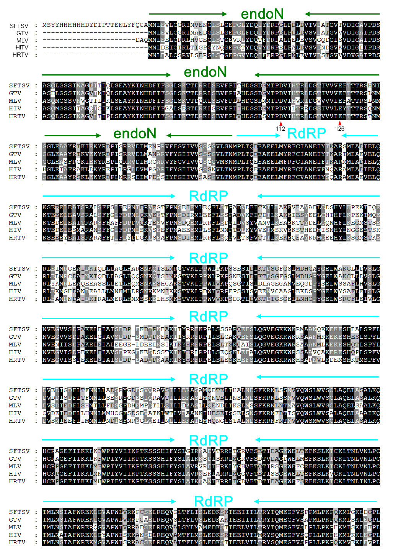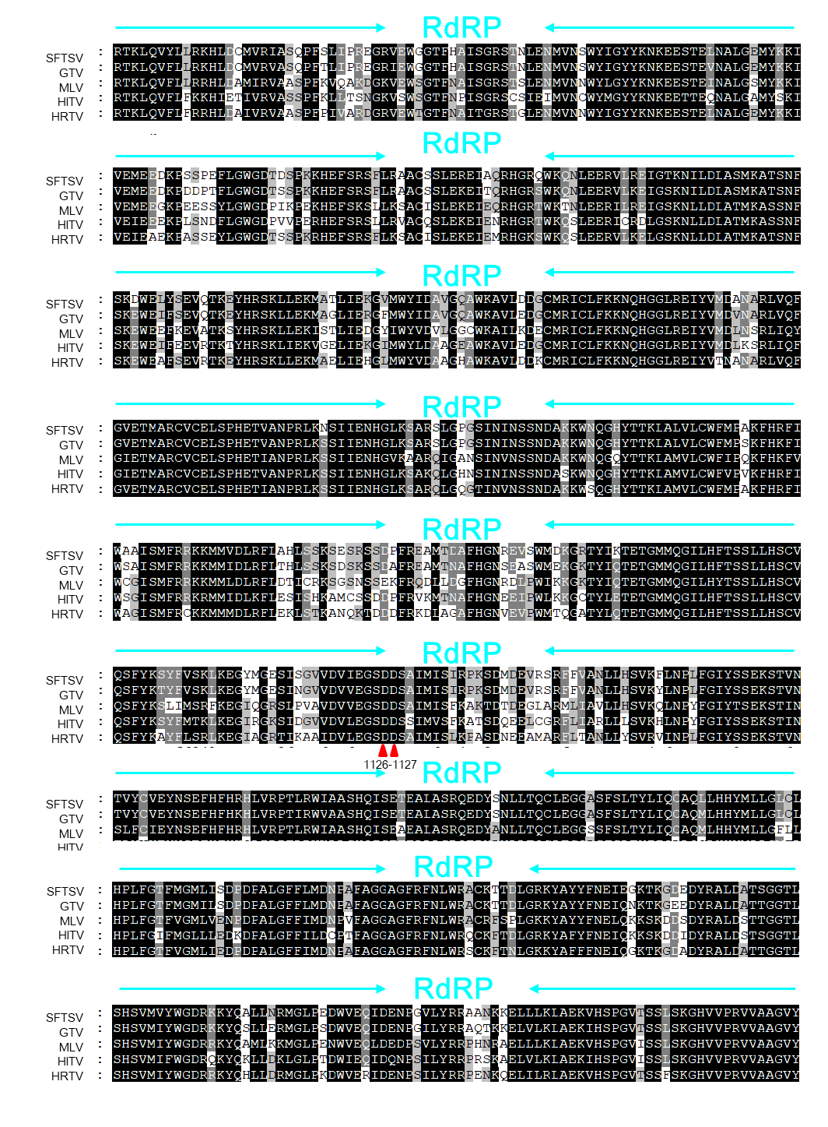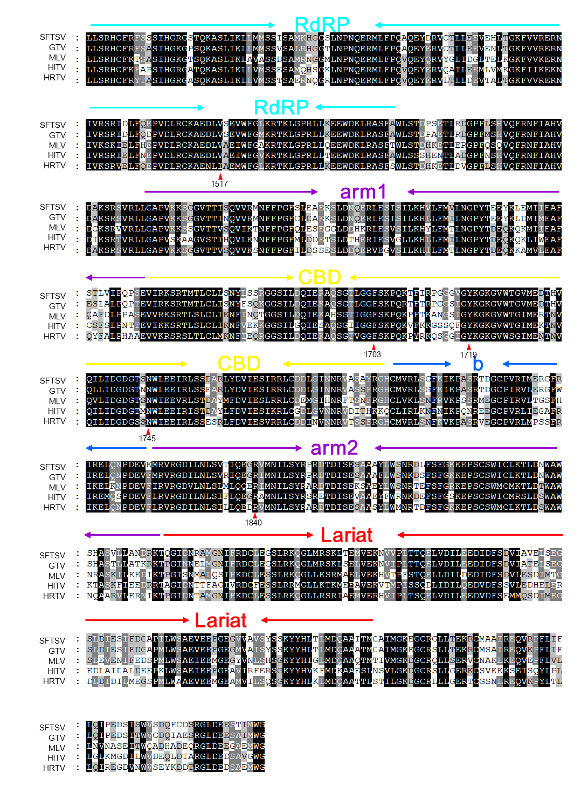
Supplementary Fig. S3 Amino acid sequences alignment of the L protein among SFTSV and other closely-related virus. The color depth corresponds to the sequence identities as the darker the color, the higher the identities. Nine of the twelve sites which showed significant influence on the L protein activity were indicated by the red triangle with position number. SFTSV, Severe fever with thrombocytopenia syndrome virus; MLV, Malsoor virus; HTIV, Hunter Island virus; HRTV, Heartland virus; GTV, Guertu virus.

