Virologica Sinica

Supplementary Data

Epidemiology and genetic diversity of norovirus GII genogroups among children in Hubei, China, 2017–2019

Jing Li ^{1, a}, Lingyao Zhang ^{1, a}, Wenjing Zou ª, Zhaohui Yang ª, Jianbo Zhan ^{a, *}, Jing Cheng ^{b, *}

ª Hubei Provincial Center for Disease Control and Prevention, Wuhan 430079, China
^{b} Wuhan university of Science and Technology, Wuhan 430065, China

¹ Jing Li and Lingyao Zhang contributed equally to this work.

* Corresponding authors:
Email: jbzhan8866@163.com (J. Zhan); chengjing84@wust.edu.cn (J. Cheng)
ORCID: ORCID: 0000-0002-5885-1970 (J. Zhan); 0000-0002-6145-1003 (J. Cheng)

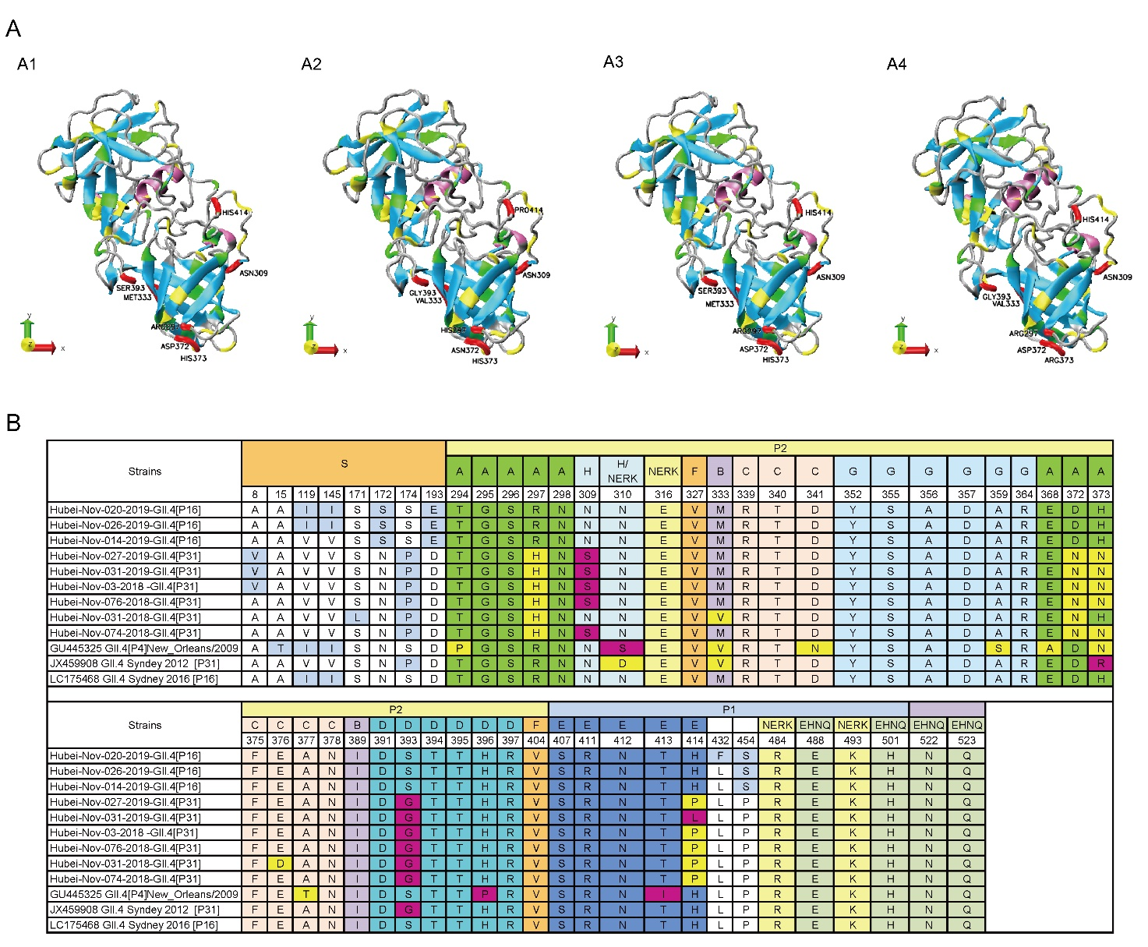
Figure S1 Predicted tertiary structures based on data from the P domain (amino acids 216–540) of the VP1 protein in GII.4 Sydney variants and antigenic variation of complete capsid sequences of norovirus GII.4 Sydney variants. A Tertiary structures of the capsid VP1 protein of GII.4 Sydney recombinant strains. Chains comprising the 3D structures are colored as follows: red, major epitope sites in the P domain (residues 297, 372, and 373 in epitope A; 333 in epitope B; 393 in epitope D; 414 in epitope E; and 309 in epitope H); mauve, helices; cyan, sheets; green, basic amino acids; yellow, acidic amino acids. A1: Hubei-Nov-014-2019, A2: Hubei-Nov-031-2018, A3: GII.4 Sydney 2012 [P16] (LC175468), A4: GII.4 Sydney 2012 [P31] (JX459908). B Comparison of VP1 amino acid sequences of norovirus Sydney 2012 variants that emerged in Hubei compared to the reference strains New Orleans/2009 (GU445325), GII.4 Sydney 2012 [P31] (JX459908), and GII.4 Sydney 2016 [P16] (LC175468).

Table S1 Accession numbers of the nucleotide sequences of noroviruses from Hubei submitted to the GenBank database
Sequence name | Accession number | Genotype | Sequence name | Accession number | Genotype
Hubei-Nov-051-2017 | OP432620 | GII.4[P31] | Hubei-Nov-025-2018 | OP433444 | GII.2[P16]
Hubei-Nov-061-2017 | OP432623 | GII.4[P31] | Hubei-Nov-042-2017 | OP433084 | GII.2[P16]
Hubei-Nov-064-2017 | OP432625 | GII.4[P31] | Hubei-Nov-057-2017 | OP433085 | GII.2[P16]
Hubei-Nov-066-2017 | OP432626 | GII.4[P31] | Hubei-Nov-072-2017 | OP433086 | GII.2[P16]
Hubei-Nov-068-2017 | OP432627 | GII.4[P31] | Hubei-Nov-07-2018 | OP433087 | GII.2[P16]
Hubei-Nov-070-2017 | OP432628 | GII.4[P31] | Hubei-Nov-08-2018 | OP433088 | GII.2[P16]
Hubei-Nov-03-2018 | OP432629 | GII.4[P31] | Hubei-Nov-012-2018 | OP433089 | GII.2[P16]
Hubei-Nov-014-2018 | OP432630 | GII.4[P31] | Hubei-Nov-015-2018 | OP433090 | GII.2[P16]
Hubei-Nov-031-2018 | OP432631 | GII.4[P31] | Hubei-Nov-016-2018 | OP433091 | GII.2[P16]
Hubei-Nov-074-2018 | OP432632 | GII.4[P31] | Hubei-Nov-018-2018 | OP433092 | GII.2[P16]
Hubei-Nov-076-2018 | OP432633 | GII.4[P31] | Hubei-Nov-028-2018 | OP433093 | GII.2[P16]
Hubei-Nov-01-2019 | OP432634 | GII.4[P31] | Hubei-Nov-033-2018 | OP433094 | GII.2[P16]
Hubei-Nov-06-2019 | OP432635 | GII.4[P31] | Hubei-Nov-034-2018 | OP433095 | GII.2[P16]
Hubei-Nov-07-2019 | OP432636 | GII.4[P31] | Hubei-Nov-035-2018 | OP433096 | GII.2[P16]
Hubei-Nov-08-2019 | OP432637 | GII.4[P31] | Hubei-Nov-037-2018 | OP433097 | GII.2[P16]
Hubei-Nov-09-2019 | OP432638 | GII.4[P31] | Hubei-Nov-048-2018 | OP433098 | GII.2[P16]
Hubei-Nov-037-2019 | OP432639 | GII.4[P31] | Hubei-Nov-054-2018 | OP433099 | GII.2[P16]
Hubei-Nov-045-2019 | OP432640 | GII.4[P31] | Hubei-Nov-055-2018 | OP433100 | GII.2[P16]
Hubei-Nov-046-2019 | OP432641 | GII.4[P31] | Hubei-Nov-057-2018 | OP433101 | GII.2[P16]
Hubei-Nov-012-2019 | OP432642 | GII.4[P31] | Hubei-Nov-058-2018 | OP433102 | GII.2[P16]
Hubei-Nov-013-2019 | OP432643 | GII.4[P31] | Hubei-Nov-060-2018 | OP433103 | GII.2[P16]
Hubei-Nov-015-2019 | OP432645 | GII.4[P31] | Hubei-Nov-065-2018 | OP433104 | GII.2[P16]
Hubei-Nov-016-2019 | OP432646 | GII.4[P31] | Hubei-Nov-010-2019 | OP433105 | GII.2[P16]
Hubei-Nov-023-2019 | OP432653 | GII.4[P31] | Hubei-Nov-028-2019 | OP433106 | GII.2[P16]
Hubei-Nov-025-2019 | OP432655 | GII.4[P31] | Hubei-Nov-012-2017 | OP433107 | GII.2[P16]
Hubei-Nov-027-2019 | OP432657 | GII.4[P31] | Hubei-Nov-032-2017 | OP433108 | GII.2[P16]
Hubei-Nov-036-2019 | OP432660 | GII.4[P31] | Hubei-Nov-033-2017 | OP433109 | GII.2[P16]
Hubei-Nov-02-2017 | OP432661 | GII.4[P31] | Hubei-Nov-034-2017 | OP433110 | GII.2[P16]
Hubei-Nov-06-2017 | OP432662 | GII.4[P31] | Hubei-Nov-035-2017 | OP433111 | GII.2[P16]
Hubei-Nov-07-2017 | OP432663 | GII.4[P31] | Hubei-Nov-038-2017 | OP433112 | GII.2[P16]
Hubei-Nov-08-2017 | OP432664 | GII.4[P31] | Hubei-Nov-045-2017 | OP432545 | GII.3[P12]
Hubei-Nov-011-2017 | OP432665 | GII.4[P31] | Hubei-Nov-058-2017 | OP432546 | GII.3[P12]
Hubei-Nov-015-2017 | OP432666 | GII.4[P31] | Hubei-Nov-065-2017 | OP432547 | GII.3[P12]
Hubei-Nov-017-2017 | OP432667 | GII.4[P31] | Hubei-Nov-069-2017 | OP432548 | GII.3[P12]
Hubei-Nov-018-2017 | OP432668 | GII.4[P31] | Hubei-Nov-073-2017 | OP432549 | GII.3[P12]
Hubei-Nov-019-2017 | OP432669 | GII.4[P31] | Hubei-Nov-074-2017 | OP432550 | GII.3[P12]
Hubei-Nov-020-2017 | OP432670 | GII.4[P31] | Hubei-Nov-02-2018 | OP432551 | GII.3[P12]
Hubei-Nov-021-2017 | OP432671 | GII.4[P31] | Hubei-Nov-06-2018 | OP432552 | GII.3[P12]
Hubei-Nov-022-2017 | OP432672 | GII.4[P31] | Hubei-Nov-010-2018 | OP432553 | GII.3[P12]
Hubei-Nov-023-2017 | OP432673 | GII.4[P31] | Hubei-Nov-013-2018 | OP432554 | GII.3[P12]
Hubei-Nov-025-2017 | OP432674 | GII.4[P31] | Hubei-Nov-017-2018 | OP432555 | GII.3[P12]
Hubei-Nov-030-2017 | OP432675 | GII.4[P31] | Hubei-Nov-019-2018 | OP432556 | GII.3[P12]
Hubei-Nov-036-2017 | OP432676 | GII.4[P31] | Hubei-Nov-020-2018 | OP432557 | GII.3[P12]
Hubei-Nov-031-2019 | OP432677 | GII.4[P31] | Hubei-Nov-021-2018 | OP432558 | GII.3[P12]
Hubei-Nov-035-2019 | OP432681 | GII.4[P31] | Hubei-Nov-022-2018 | OP432559 | GII.3[P12]
Hubei-Nov-053-2017 | OP432621 | GII.4[P16] | Hubei-Nov-023-2018 | OP432560 | GII.3[P12]
Hubei-Nov-055-2017 | OP432622 | GII.4[P16] | Hubei-Nov-024-2018 | OP432561 | GII.3[P12]
Hubei-Nov-063-2017 | OP432624 | GII.4[P16] | Hubei-Nov-026-2018 | OP432562 | GII.3[P12]
Hubei-Nov-014-2019 | OP432644 | GII.4[P16] | Hubei-Nov-027-2018 | OP432563 | GII.3[P12]
Hubei-Nov-017-2019 | OP432647 | GII.4[P16] | Hubei-Nov-029-2018 | OP432564 | GII.3[P12]
Hubei-Nov-018-2019 | OP432648 | GII.4[P16] | Hubei-Nov-032-2018 | OP432566 | GII.3[P12]
Hubei-Nov-019-2019 | OP432649 | GII.4[P16] | Hubei-Nov-02-2019 | OP432567 | GII.3[P12]
Hubei-Nov-020-2019 | OP432650 | GII.4[P16] | Hubei-Nov-03-2019 | OP432568 | GII.3[P12]
Hubei-Nov-021-2019 | OP432651 | GII.4[P16] | Hubei-Nov-04-2019 | OP432569 | GII.3[P12]
Hubei-Nov-022-2019 | OP432652 | GII.4[P16] | Hubei-Nov-05-2019 | OP432570 | GII.3[P12]
Hubei-Nov-024-2019 | OP432654 | GII.4[P16] | Hubei-Nov-038-2019 | OP432571 | GII.3[P12]
Hubei-Nov-026-2019 | OP432656 | GII.4[P16] | Hubei-Nov-039-2019 | OP432572 | GII.3[P12]
Hubei-Nov-029-2019 | OP432658 | GII.4[P16] | Hubei-Nov-040-2019 | OP432573 | GII.3[P12]
Hubei-Nov-030-2019 | OP432659 | GII.4[P16] | Hubei-Nov-042-2019 | OP432574 | GII.3[P12]
Hubei-Nov-032-2019 | OP432678 | GII.4[P16] | Hubei-Nov-014-2017 | OP432575 | GII.3[P12]
Hubei-Nov-033-2019 | OP432679 | GII.4[P16] | Hubei-Nov-016-2017 | OP432576 | GII.3[P12]
Hubei-Nov-034-2019 | OP432680 | GII.4[P16] | Hubei-Nov-026-2017 | OP432577 | GII.3[P12]
Hubei-Nov-011-2019 | OP432685 | GII.17[P17] | Hubei-Nov-027-2017 | OP432578 | GII.3[P12]
Hubei-Nov-03-2017 | OP432686 | GII.17[P17] | Hubei-Nov-029-2017 | OP432579 | GII.3[P12]
Hubei-Nov-013-2017 | OP432687 | GII.17[P17] | Hubei-Nov-030-2018 | OP432565 | GII.3[P16]
Hubei-Nov-078-2018 | OP432688 | GII.6[P7]

Table S2 Accession numbers of the complete VP1 nucleotide sequences of noroviruses from Hubei submitted to the GenBank database
Accession number | Sequence name | Genotype
OP595531 | Hubei-Nov-020-2019 | GII.4[P16]
OP595532 | Hubei-Nov-026-2019 | GII.4[P16]
OP595533 | Hubei-Nov-014-2019 | GII.4[P16]
OP595534 | Hubei-Nov-027-2019 | GII.4[P31]
OP595535 | Hubei-Nov-031-2019 | GII.4[P31]
OP595536 | Hubei-Nov-03-2018 | GII.4[P31]
OP595537 | Hubei-Nov-076-2018 | GII.4[P31]
OP595538 | Hubei-Nov-031-2018 | GII.4[P31]
OP595539 | Hubei-Nov-074-2018 | GII.4[P31]

