Virologica Sinica

Supplementary Data

Fusarivirus accessory helicases present an evolutionary link for viruses infecting plants and fungi

Assane Hamidou Abdoulaye ^{a, b, c}, Jichun Jia ^{a, b, c}, Aqleem Abbas ^{a, b, c}, Du Hai ^{a, b, c}, Jiasen Cheng ^{a, b}, Yanping Fu ^{b}, Yang Lin ^{b}, Daohong Jiang ^{a, b, c}, Jiatao Xie ^{a, b, c, *}

ª State Key Laboratory of Agricultural Microbiology, Huazhong Agricultural University, Wuhan 430070, China;
^{b} Hubei Key Laboratory of Plant Pathology, College of Plant Science and Technology, Huazhong Agricultural University, Wuhan 430070, China;
^{c} Hubei Hongshan Laboratory, Wuhan 430070, China

* Corresponding author

Email address: jiataoxie@mail.hzau.edu.cn (J. Xie)
ORCID : 0000-0003-1961-0338

Supplementary materials
Fig. S1: Amino acid sequences alignment of the conserved domains of RdRp in RsFV4 and its related members within the proposed family “Fusariviridae” and Hypoviridae. The default color scheme for percentage identity in the Jalview program was used. Numbers I–VIII refer to the eight conserved motifs characteristic of RNA viruses RdRp. The numbers within sequence correspond to the number of amino acid residues separating the motifs. The numbers of two flanks of sequences refer to the region of RdRp domain in polyprotein encoded by mycoviruses referenced.

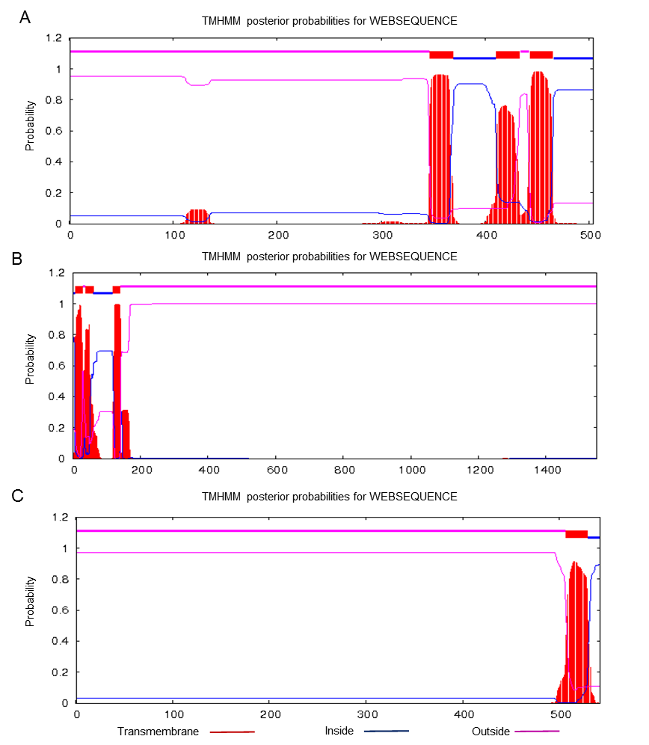
Fig. S2: Transmembrane regions in RsFV4 encoded proteins were predicted. A ORF2 encoded proteins contains three transmembrane regions at the C-terminal region. B Protein encoded by ORF3 has two transmembrane regions at the N-terminal region. C Protein encoded by ORF4 contains a single transmembrane region at the C-terminal region. Transmembrane region was predicted using the online program TMHMM-2.0 (https://services.healthtech.dtu.dk/service.php?TMHMM-2.0).

Table S1. Primer names and sequences were used to amplify RsFV4 and the amplicon size.
Primer name | Primer sequences (5′ – 3′) | Amplicon size (nts)
F1 | TCTTGTTTCCAGCGAGACCC | 1149
R1 | GTTGGTGTGACGCTACCTGA
F2 | AGGCCACAAACGAAACGTCCGA | 1294
R2 | TTCGCCGTTTGGCAGGGTGT
F3 | ACACCCTGCCAAACGGCGAAA | 1383
R3 | TGTGGCCTTGAAGCTCGGTCA
F4 | TCCTCTGCAGATGTGGGGATGACA | 1021
R4 | ACTGCCGCTGGTGCTTTAGGT
F5 | TGTGATGGACACTCTGGAGGA | 1912
R5 | GGCTTCCTCCTCTTCATCGT
F6 | TTGTGACGAGCCCCTTCCTA | 1020
R6 | GTCGCCCCAACAACTCAAAG
F7 | ACGATGAAGAGGAGGAAGCC | 1963
R7 | AGGCCACAATGGCATCAGTA
F8 | CAGGTGTCGAGGCGCTTTTA | 1972
R8 | TTCAAAATTGCCCATGCGGG
F9 | GATGGGCAAAGGGTTCCTCA | 1940
R9 | TGCAAGTGACCCAAGGTTGT
F10 | TGGGAAAGTCATGGCTGATGT | 1982
R10 | TTCCTGAGGGACGGCTTTTG
F11 | CTGCAGATGTGGGGATGACA | 1910
R11 | TTCGCATTAGTGCCAGTGTT
F12 | CCACCACCTGATGTCCCTAC | 1154
R12 | AAACTTCCGTTCCAGGACGC

Table S2. The information of the viruses used for phylogenetically analysis in this study.
Virus name | Abb. | Accession number
Rhizoctonia solani fusarivirus 4 | RsFV4 | MW149059
Rhizoctonia solani fusarivirus 3 | RsFV3 | MK558258
Rhizoctonia solani fusarivirus 2 | RsFV2 | MK558256
Rhizoctonia solani fusarivirus 1 | RsFV1 | QDW92695
Rhizoctonia solani hypovirus 3 | RsHV3 | MK558255
Cryphonectria hypovirus 1 | CHV1 | NC_001492
Cryphonectria hypovirus 2 | CHV2 | NC_003534
Cryphonectria hypovirus 3 | CHV3 | NC_000960
Cryphonectria hypovirus 4 | CHV4 | NC_006431
Rosellinia necatrix hypovirus 1 | RnHV1 | NC_036590
Sclerotinia sclerotiorum hypovirus 2 | SsHV2 | NC_022896
Sclerotinia sclerotiorum fusarivirus 1 | SsFV1 | NC_027208
Rosellinia necatrix fusarivirus 1 | RnFV1 | NC_024485
Sclerotinia homoeocarpa fusarivirus 1 | ShFV1 | MK279505
Alternaria brassicicola fusarivirus 1 | AbFV1 | NC_029056
Neurospora crassa fusarivirus 1 | NcFV1 | LC586025
Nigrospora oryzae fusarivirus 1 | NoFV1 | NC_031960
Sclerotium rolfsii fusarivirus 1 | SrFV1 | MH766491
Sclerotium rolfsii fusarivirus 2 | SrFV2 | MH766492
Auricularia heimuer fusarivirus 1 | AhFv1 | MT232758
Fusarium poae fusarivirus 1 | FpFV1 | NC_030868
Aspergillus ellipticus fusarivirus 1 | AeFV1 | MK279500
Neofusicoccum luteum fusarivirus 1 | NlFV1 | KY906214
Neurospora discreta fusarivirus 1 | NdFV1 | MK279503
Botryosphaeria dothidea fusarivirus 1 | BdFV1 | QHI00151
Agaricus bisporus virus 10 | AbV10 | AQM49937
Agaricus bisporus virus 11 | AbV11 | AQM49938
Monilinia fusarivirus G | MfFV-G | QED42908
Plasmopara viticola lesion associated fusarivirus 2 | PvLaFV2 | QHD64732
Gaeumannomyces tritici fusarivirus 1 | GtFV1 | AZT88652
Plasmopara viticola lesion associated fusarivirus 1 | PvLaFV2 | QHD64725
Plasmopara viticola lesion associated fusarivirus 3 | PvLaFV3 | QHD64735
Sodiomyces alkalinus fusarivirus 1 | SaFV1 | ATP75827
Rutstroemia firma fusarivirus 1 | RfFV1 | AZT88659
Bipolaris oryzae hypovirus 1 | BoHV1 | MH316122
Macrophomina phaseolina hypovirus 1 | MpHV1 | NC_003534
Fusarium graminearum hypovirus 1 | FgHV1 | NC_023680
Alternaria alternata hypovirus 1 | AaHV1 | MK189193
Fusarium sambucinum hypovirus 1 | FsHV1 | LC596823
Botrytis cinerea hypovirus 1 | BcHV1 | QBA69887
Valsa ceratosperma hypovirus 1 | VcHV1 | NC_017099
Phomopsis longicolla hypovirus | PlHV | NC_024685
Sclerotinia sclerotiorum hypovirus 1 | SsHV1 | NC_015939
Botrytis cinerea hypovirus 1 | BcHV1 | NC_037659
Monilinia hypovirus A | MfHVA | MK231061
Rhizoctonia solani hypovirus 1 | RsHV1 | MK558259
Rosellinia necatrix hypovirus 2 | RnHV2 | LC333749
Agaricus bisporus virus 2 | AbHV2 | KY357507
Sclerotium rolfsii hypovirus 1 | SrHV1 | MH037014
Sclerotinia homoeocarpa hypovirus 1 | ShHV1 | MK279473
Fusarium poae hypovirus 1 | FpHV1 | LC150612
Fusarium langsethiae hypovirus 1 | FlHV1 | NC_032212
Fusarium graminearum hypovirus 2 | FgHV2 | NC_026813
Agaricus bisporus virus 2 | AbV2 | KY357507
Entoleuca hypovirus 1 | EnHV1 | MF536691
Triticum mosaic virus | TriMV | NC_012799
Tomato mild mottle virus | TMMoV | NC_038920
Oat necrotic mottle virus | ONMV | NC_005136
Bellflower veinal mottle virus | BVMoV | NC_039002
Areca palm necrotic spindle-spot virus | ANSSV | NC_040836
Cardamom mosaic virus | CdMV | NC_039088
Barley yellow mosaic virus | BaYMV | NC_002990
Oat mosaic virus | OMV | NC_004016
Tobacco vein banding mosaic virus | TVBMV | NC_009994
Hordeum mosaic virus | HoMV | NC_005904
Beet mosaic virus | BtMV | NC_005304
Bean yellow mosaic virus | BYMV | NC_003492
Potato virus A | PVA | NC_004039
Hyacinth mosaic virus | HyaMV | NC_037051
Tobacco vein mottling virus | TVMV | NC_001768
Papaya ringspot virus | PRSV | NC_001785
Cucurbit vein banding virus | CVBV | NC_035134
Verbena virus Y | VVY | NC_010735
Blackberry virus Y | BlVY | NC_008558
Bean common mosaic virus | BCMV | NC_003397
Saffron latent virus | SaLV | NC_036802
Pepper yellow mosaic virus | PepYMV | NC_014327
Tobacco mosqueado virus | TMosqV | NC_030118
Panax virus Y | PanVY | NC_014252
Sclerotinia sclerotiorum endornavirus 1 | SsEV1 | NC_021706
Botrytis cinerea betaendornavirus 1 | BcEV1 | NC_031752
Gremmeniella abietina betaendornavirus 1 | GaEV1 | NC_007920
Sclerotinia minor betaendornavirus 1 | SmEV1 | NC_040631
Alternaria brassicicola betaendornavirus 1 | AbEV1 | NC_026136
Rosellinia necatrix betaendornavirus 1 | RnEV1 | NC_030938
Rhizoctonia solani endornavirus 4 | RsEV4 | MK393902
Lagenaria siceraria alphaendornavirus | LsEV | NC_023641
Cucumis melo alphaendornavirus | CmEV | NC_029064
Yerba mate alphaendornavirus | YmEV | NC_024455
Phaseolus vulgaris alphaendornavirus 1 | PvEV1 | NC_039217
Oryza sativa alphaendornavirus | OsEV | NC_007647
Persea americana alphaendornavirus 1 | PaEV1 | NC_016648
Helicobasidium mompa alphaendornavirus 1 | HmEV1 | NC_013447
Grapevine endophyte alphaendornavirus | GEEV | NC_019493
Erysiphe cichoracearum alphaendornavirus | EcEV | NC_029095
Rhizoctonia cerealis alphaendornavirus 1 | RcEV1 | NC_022619
Rhizoctonia solani alphaendornavirus 2 | RsEV2 | KT823701
Vicia faba alphaendornavirus | VfEV | NC_007648
Hot pepper alphaendornavirus | HPEV | NC_027920
Bell pepper alphaendornavirus | BPEV | NC_039216
Phaseolus vulgaris alphaendornavirus 2 | PvEV2 | NC_038422
Winged bean alphaendornavirus 1 | WBEV1 | NC_031336
Hordeum vulgare alphaendornavirus | HvEV | NC_031336
Cluster bean alphaendornavirus 1 | CBEV1 | NC_040825
Helianthus annuus alphaendornavirus | HaEV | NC_040799
Agaricus bisporus endornavirus 1 | AbV1 | KY357509
Phytophthora alphaendornavirus 1 | PEV1 | NC_007069
Phaseolus vulgaris alphaendornavirus 3 | PvEV3 | NC_040558

