Virologica Sinica

Supplementary Data

Identification of Two Novel B-Cell Epitopes on the Nucleocapsid Protein of Porcine Deltacoronavirus

Haojie Renª, Xiaoguang Yanª, Lintao Liuª, Yixuan Zhangª, Qianqian Liª, Xiumei Li^{c}, Hui Hu^{a,b*}

ª. College of Veterinary Medicine, Henan Agricultural University, Zhengzhou 450002, China
^{b.} Key Laboratory for Animal-derived Food Safety of Henan Province, Zhengzhou 450002, China
^{c.} Luoyang Laipson Information Technology Co., Ltd, Luoyang 471026, China

*Corresponding author
E-mail address:huhui2001@163.com (H. Hu)
ORCID: 0000-0003-4514-5409

Supplementary Materials
Cells and Virus
Swine testis (ST) cells and Vero cells, maintained in our laboratory, were cultured in Dulbecco's Modified Eagle's Medium (DMEM, Gibco, USA) containing 1% antibiotic-antimycotic (Gibco), 10% heat-inactivated fetal bovine serum (FBS, Gibco) at 37 °C with 5% CO₂. Murine myeloma cells (Sp2/0) were provided by Luoyang Laipson Information Technology Co., Ltd, and were cultured in DMEM containing 10% FBS at 37 °C with 5% CO₂.
PDCoV strain HNZK-02 (GenBank accession number MH708123) was isolated and identified by our laboratory (Liang et al. 2019). PDCoV were propagated on ST cell with maintenance medium (DMEM supplemented with 1% antibiotic-antimycotic and 1% pancreatin). PEDV strain CV777 strain was used in this study. PEDV was propagated in Vero cell monolayer and the cells were washed three times with serum-free DMEM, and cultured with 0.3% tryptose phosphate broth (TPB, Sigma-Aldrich, USA) and 3 μg/mL trypsin (Sigma-Aldrich, USA) in the DMEM. TGEV HN-2012 strain, isolated and identified in our laboratory, were propagated in ST cell with maintenance medium (DMEM supplemented with 1% antibiotic-antimycotic). Virus titers were determined using TaqMan real-time quantitative RT-PCR (qRT-PCR) and by plaque assay as described previously (Hu et al. 2015; Jin et al. 2018; Zhang et al. 2019).
Expression of Proteins
The total RNA of PDCoV HNZK-02 was extracted from the PDCoV-infected ST cells using Trizol reagent (Invitrogen, Carlsbad, CA, USA) according to the manufacturer’s instructions. Reverse transcription (RT) was conducted using the Vazyme Reverse Transcription Kit (Nanjing, China). The complete N gene of PDCoV was amplified from the cDNA by PCR using primers containing EcoRI and XhoI restriction enzyme sites (Table S1). The obtained N gene was digested by the corresponding restriction endonucleases and was then cloned into the prokaryotic expression vector pET-32a (+) (Sangon Biotech, China). The recombinant plasmid was verified by sequence analysis and transformed into the Escherichia coli strain Rosetta (Sangon Biotech, China). After induced expression by isopropyl β-D-1-thiogalactopyranoside (IPTG) (0.8 mmol/L) at 37 °C for 8h, the expressed His-tag fusion protein was analyzed by sodium dodecyl sulfate-polyacrylamide gel electrophoresis (SDS-PAGE). The Ni-Agarose His Purification Kit (CWBIO, China) was used to purify the recombinant protein according to the manufacturer’s instructions.
The expression vectors of N proteins from Asian leopard cat coronavirus (EF584908.1), Sparrow coronavirus (MG812377.1), Wigeon coronavirus (NC 016995.1), Chinese ferret badger coronavirus (EF192158.1) were synthesized by Biotechnology company (AuGCT, China). These N proteins and the different truncated fragments of PDCoV N protein were expressed using the above method of the whole PDCoV N protein expression.
Generation and Identification of Mab against PDCoV-N protein
BALB/c female mice aged 6 to 8 weeks were subcutaneously immunized with 30 μg of the purified N protein in 100 μL phosphate buffered saline (PBS) that emulsified with the same volume of Freund's complete adjuvant (Sigma-Aldrich, USA). Booster immunizations were performed two times at 2-week interval with incomplete Freund’s adjuvant. Two weeks after the third immunization, antibody titer was evaluated by indirect enzyme linked immunosorbent assay (ELISA). Mice with the highest antibody titers were selected for intraperitoneal injection with 30 µg of N protein in 200 μL PBS. On the third day after shock immunity, mice were sacrificed and the spleen cells were collected to fuse with SP2/0 by 50% (w/v) polyethylene glycol 1420 (PEG1420) (Sigma-Aldrich, USA). The fused cells were cultured in hypoxanthine-aminopterin thymidine (HAT) selection medium (Sigma-Aldrich, USA) with 20 % FBS in 96-well plates for seven days and maintained in hypoxanthine-thymidine (HT) medium (Sigma-Aldrich, USA) with 10% FBS thereafter. Until 10th day, the established indirect ELISA method was used to screen the positive cell lines. Positive hybridoma cells were subsequently subcloned at least three times by limiting dilution. To acquire Mabs in ascitic fluids, the hybridomas were transplanted intraperitoneally into male BALB/c mice, and the resulting ascitic fluid was collected and antibodies were purified by octylic acid ammonium sulfate method. The isotype of Mabs were identified by mouse monoclonal antibody isotyping ELISA kit (Proteintech Group, China).
Indirect ELISA
Indirect ELISA was used to detect serum antibody titer in the immunized mice and to screen the positive hybrid cells according previous report (Ruijie et al. 2019). Briefly, the purified PDCoV N protein was diluted with 0.05 mol/L carbonate buffer solution (pH 9.6) to a concentration of 2 µg/mL. 100 µL of diluted PDCoV N protein was added into each well of ELISA plates to coat for 20 h at 4 °C. The plates were washed twice with PBS containing 0.05% Tween-20 (PBST). Each well was added with 150 µL of 1.5% (w/v) bovine serum albumin (BSA) and blocked at 37 °C for 2h. Then 100 µL of the diluted serum or hybrid cell supernatant was added to each well. After 1 h incubation at 37 °C, the plates were washed 4 times with PBST, and 100 µL of horseradish peroxidase (HRP)-conjugated goat anti-mouse IgG (Proteintech Group, China, 1:6000 dilution) was added to each well and incubated for 1 h at 37 °C. After washing again, 100 µL of Tetramethylbenzidine (TMB) solution (Solarbio, China) was added to the plates for color development, and 2 mol/L H₂SO₄ was added to the plates to terminate the color development. The OD_{450nm} value was read by ELISA plate reader (Gallop, china). The OD_{450nm} value greater than 0.273 was considered positive.
Western Blotting (WB)
WB was used to identify the reactivity between different antigens and Mabs. The expressed PDCoV N protein, Asian leopard cat coronavirus N protein, Sparrow coronavirus N protein, Wigeon coronavirus N protein, Chinese ferret badger coronavirus N protein, the truncated N proteins, the inactivated cell lysates from PDCoV and TGEV-infected ST cells, PEDV infected Vero cells, were separated by 12% SDS–PAGE electrophoresis and were further transferred onto the nitrocellulose filter membrane (NC). After blocking with 5% (w/v) skim milk for 2 h at 37 °C, the membrane was incubated with PDCoV positive antibody, screened Mabs, or hybrid cell supernatant for 1 h at 37 °C, then washed three times with PBST. Finally, the membrane was stained with HRP-conjugated goat anti-mouse IgG (Proteintech Group, China, 1:5000 dilution) or HRP-conjugated goat anti-swine IgG (Proteintech Group, China, 1:6000 dilution) for 1 h at 37 °C. The reactivity was visualized with electro chemiluminescence (ECL) reagents (Solarbio, China).
Indirect Immunofluorescence Assay (IFA)
IFA was used for detecting the specific reactivity of the screened Mabs with PDCoV. Monolayer ST cells in 12-well plate were infected with PDCoV and TGEV (MOI=1), Vero cells were infected with PEDV (MOI=1), respectively. The uninfected cells were used as control groups. After 1 h of viral adsorption, serum-free cell culture medium was added and the cells were cultured until obvious cytopathic effect appeared. Cells were washed twice with PBST, and then fixed with absolute ethyl alcohol for 4 h at 4 °C. After washed three times, cells were blocking with PBST containing 5% BSA, and incubated for 2 h at 37 °C. The screened PDCoV N Mabs with 10-fold dilution were added and incubated for 12 h at 4 °C. Cells were washed three times with PBST, and 300 µL of fluorescein isothiocyanate (FITC)-conjugated goat anti-mouse IgG (Sigma-Aldrich, USA, 1:200) was added to each well and incubated for 1 h at 37 °C. Finally, the cells were washed four times with PBST, 4′, 6-diamidino-2-phenylindole (DAPI, Sangon Biotech, China) was used for the staining of cellular nuclei. The stained cells were visualized using the fluorescence microscope (Olympus, Japan).
Bioinformatics Analysis of the Screened Epitopes on PDCoV N Protein
To analyze the conservation of the antigen epitopes of PDCoV N protein, the sequences of N protein from different PDCoV strains and other coronaviruses were compared by using DNAStar. The amino acid sequences of PDCoV N proteins downloaded from NCBI were showed in Table S2–S4.
Three-Dimensional (3D) Structure Prediction of PDCoV N Proteins
To clarify the spatial locations of epitopes on PDCoV N proteins, I-TASSER (https://zhanglab.ccmb.med.umich.edu/I-TASSER/) was used to predict the 3D structure of the full-length PDCoV N-protein (Roy et al., 2010). Severn threading templates in Protein Data Bank (PDB) were selected for construction by this program (2gecB.1oqyA.1sskA.2kr0A.2nbiA.1ssk.1zvoC).

References
Hu H, Jung K, Vlasova AN, Chepngeno J, Lu Z, Wang Q, Saif LJ. Isolation and characterization of porcine deltacoronavirus from pigs with diarrhea in the united states. J Clin Microbiol. 2015; 53: 1537–1548.
Jin XH, Zheng LL, Song MR, Xu WS, Kou YN, Zhou Y, Zhang LW, Zhu YN, Wan B, Wei ZY, Zhang GP. A nano silicon adjuvant enhances inactivated transmissible gastroenteritis vaccine through activation the toll-like receptors and promotes humoral and cellular immune responses. Nanomedicine. 2018; 14: 1201–1212.
Liang Q, Li B, Zhang H, Hu H. Complete genome sequences of two porcine deltacoronavirus strains from henan province, china. Microbiol Resour Announc. 2019; 8: e01517-18.
Roy A, Kucukural A, Zhang Y. I-tasser: A unified platform for automated protein structure and function prediction. Nat Protoc. 2010; 5: 725–738.
Ruijie Y, Yunfei Z, Lingling L, Honglei Z, Yabin W, Hui H. Prokaryotic expression of n protein and establishment of an indirect elisa for antibody detection of porcine deltacoronaviru. Journal of Northwest A&F University (Nat.Sci.Ed.). 2019; 47: 1–8+17. (In Chinese)
Zhang H, Liang Q, Li B, Cui X, Wei X, Ding Q, Wang Y, Hu H. Prevalence, phylogenetic and evolutionary analysis of porcine deltacoronavirus in henan province, china. Prev Vet Med. 2019; 166: 8–15.

Table S1 Sequences of primers used in this study
Segments |  | Sequences (5′–3′) | Positions  (Amino Acid)
N | N-F | CGGAATTCATGGCAGCACCAGTAGT | 1–342
 | N-R | CCCTCGAGCGCTGGTGATTCCTGCTT
N-1 | N-1-F | CGGAATTCATGGCAGCACCAGTAGT | 1–73
 | N-1-R | CCCTCGAGTGTGCCAGTATAATCAAGGGC
N-2 | N-2-F | CGGAATTCCCTCCATCCTATGCCTT | 63–133
 | N-2-R | CCCTCGAGGCCATCTCCGGTTGGGAAT
N-3 | N-3-F | CGGAATTCCATCAACTGCTACCGCT | 121–232
 | N-3-R | CCCTCGAGTAGAGCCATGATGCGA
N-4 | N-4-F | CGGAATTCATGGCTGATCCTCGCA | 224–291
 | N-4-R | CCCTCGAGTGGCTCATAGGTCTGGTTA
N-5 | N-5-F | CGGAATTCCTCAATACGGTCGTTA | 281–342
 | N-5-R | CCCTCGAGCGCTGGTGATTCCTGCTT
N-4-1 | N-4-1-F | CGGAATTCATGGCTGATCCTCGCA | 224–286
 | N-4-1-R | CCCTCGAGAACGACCGTATTGAGCG
N-4-2 | N-4-2-F | CGGAATTCATGGCTGATCCTCGCA | 224–280
 | N-4-2-R | CCCTCGAGCGCATCCTTAAGTCTCTC
N-4-3 | N-4-3-F | CGGAATTCATGGCTGATCCTCGCA | 224–270
 | N-4-3-R | CCCTCGAGACCCTCCTTGACTGTGATT
N-4-4 | N-4-4-F | CGGAATTCATGGCTGATCCTCGCA | 224–274
 | N-4-4-R | CCCTCGAGATAGTCAGGAGAACCCTCC
N-4-5 | N-4-5-F | CGGAATTCATGGCTGATCCTCGCA | 224–278
 | N-4-5-R | CCCTCGAGCTTAAGTCTCTCATAGTCAGG
N-4-6 | N-4-6-F | CGGAATTCATGGCTGATCCTCGCA | 224–275
 | N-4-6-R | CCCTCGAGCTCATAGTCAGGAGAAC
N-4-7 | N-4-7-F | CGGAATTCATGGCTGATCCTCGCA | 224–277
 | N-4-7-R | CCCTCGAGAAGTCTCTCATAGTCAG
N-4-8 | N-4-8-F | CGGAATTCATGGCTGATCCTCGCA | 224–276
 | N-4-8-R | CCCTCGAGTCTCTCATAGTCAGGAG
N-4-9 | N-4-9-F | CGGAATTCCTAGCCAGACATGTGCC | 232–291
 | N-4-9-R | CCCTCGAGTGGCTCATAGGTCTGGTTA
N-4-10 | N-4-10-F | CGGAATTCATGCTTTTCGCTGGC | 242–291
 | N-4-10-R | CCCTCGAGTGGCTCATAGGTCTGGTTA
N-4-11 | N-4-11-F | CGGAATTCTTTCAGGCGGGAGCAATTA | 252–291
 | N-4-11-R | CCCTCGAGTGGCTCATAGGTCTGGTTA
N-4-12 | N-4-12-F | CGGAATTCCTTGAGAGCAACTTTCAGGC | 248–291
 | N-4-12-R | CCCTCGAGTGGCTCATAGGTCTGGTTA
N-4-13 | N-4-13-F | CGGAATTCAGCAACTTTCAGGCG | 250–291
 | N-4-13-R | CCCTCGAGTGGCTCATAGGTCTGGTTA
N-4-14 | N-4-14-F | CGGAATTCAACTTTCAGGCGG | 251–291
 | N-4-14-R | CCCTCGAGTGGCTCATAGGTCTGGTTA
N-4-15 | N-4-15-F | CGGAATTCAACTTTCAGGCGG | 251–276
 | N-4-15-R | CCCTCGAGTCTCTCATAGTCAGGAG
N-5-1 | N-5-1-F | CGGAATTCCTCAATACGGTCGTTA | 281–322
 | N-5-1-R | CCCTCGAGTGGCAGAGTTACCTTTTTAG
N-5-2 | N-5-2-F | CGGAATTCCAGCAGAAGAAACCT | 312–342
 | N-5-2-R | CCCTCGAGCGCTGGTGATTCCTGCTT
N-5-3 | N-5-3-F | CGGAATTCTTTCAGGCGGGAGCAATTA | 252–342
 | N-5-3-R | CCCTCGAGCGCTGGTGATTCCTGCTT
N-5-4 | N-5-4-F | CGGAATTCTTTCAGGCGGGAGCAATTA | 252–338
 | N-5-4-R | CCCTCGAGCTGCTTTATCTCAAA
N-5-5 | N-5-5-F | CGGAATTCTTTCAGGCGGGAGCAATTA | 252–335
 | N-5-5-R | CCCTCGAGAAACTCAGCATCATCCCACTC
N-5-6 | N-5-6-F | CGGAATTCTTTCAGGCGGGAGCAATTA | 252–334
 | N-5-6-R | CCCTCGAGCTCAGCATCATCCCACTC
N-5-7 | N-5-7-F | CGGAATTCTTTCAGGCGGGAGCAATTA | 252–333
 | N-5-7-R | CCCTCGAGAGCATCATCCCACTC
N-5-8 | N-5-8-F | CGGAATTCTTTCAGGCGGGAGCAATTA | 252–332
 | N-5-8-R | CCCTCGAGATCATCCCACTCCCAAT
N-5-9 | N-5-9-F | AATTCCAGCAGAAGAAACCTAAAAAGGTAACTCTGCCAGCAGACAAACAGGATTGGGAGTGGGATGATGCTC | 312–333
 | N-5-9-R | TCGAGAGCATCATCCCACTCCCAATCCTGTTTGTCTGCTGGCAGAGTTACCTTTTTAGGTTTCTTCTGCTGG
N-5-10 | N-5-10-F | AATTCAAAAAGGTAACTCTGCCAGCAGACAAACAGGATTGGGAGTGGGATGATGCTC | 317–333
 | N-5-10-R | TCGAGAGCATCATCCCACTCCCAATCCTGTTTGTCTGCTGGCAGAGTTACCTTTTTG
N-5-11 | N-5-11-F | AATTCGCAGACAAACAGGATTGGGAGTGGGATGATGCTC | 323–333
 | N-5-11-R | TCGAGAGCATCATCCCACTCCCAATCCTGTTTGTCTGCG
N-5-12 | N-5-12-F | AATTCGATTGGGAGTGGGATGATGCTC | 327–333
 | N-5-12-R | TCGAGAGCATCATCCCACTCCCAATCG
N-5-13 | N-5-13-F | AATTCCAGGATTGGGAGTGGGATGATGCTC | 326–333
 | N-5-13-R | TCGAGAGCATCATCCCACTCCCAATCCTGG

Table S2 PDCoV strains collected from NCBI and used to align the sequences of the identified epitopes
Strains | Country | Collection Date | Accession Number | Lengths of N-Protein (Amino Acid)
PDCoV HNZK-02 | China | 2018 | MH708123.1 | 342
PDCoV CH Sichuan S27 | China | 2015 | KT266822.1 | 342
PDCoV CH-01 | China | 2019 | KX443143.2 | 342
PDCoV CHGD | China | 2018 | MH715491.1 | 342
PDCoV CHJXNI2 | China | 2015 | KR131621.1 | 342
PDCoV CHN Tianjin | China | 2016 | KY065120.1 | 342
PDCoV HNZK-06 | China | 2018 | MH708125.1 | 342
PDCoV SCNC | China | 2019 | MK572803.1 | 342
PDCoV Swine CHJX | China | 2016 | KX083667.1 | 342
PDCoV Swine Taiwan22 | China | 2017 | KY586147.1 | 342
PDCoV Swine Taiwan36 | USA | 2016 | KY586149.1 | 342
PDCoV Swine Thailand S5011 | Thailand | 2016 | KU051641.1 | 342
PDCoV Swine Thailand S5015L | USA | 2016 | KU051649.1 | 342
PDCoV Swine Vietnam Binh21 | Korea | 2015 | KX834352.1 | 342
PDCoV Swine Vietnam HaNoi6 | Korea | 2017 | KX834351.1 | 342
PDCoV USA Illinois272 | USA | 2016 | KR265856.1 | 342
PDCoV USA Minnesota140 | USA | 2016 | KX022603.1 | 342
PDCoV USA Ohio137 | USA | 2014 | KJ601780.1 | 342
PDCoV NH | China | 2016 | KU981059.1 | 342
PDCoV CH Hunan | China | 2017 | KY513724.1 | 342
PDCoV CH JXJGS01 P50 | China | 2020 | MH025764.1 | 342

Table S3 Deltacoronavirus strains used to align the sequences of the identified epitopes
Strains | Country | Collection Date | Accession Number | Lengths of N-Protein (Amino Acid)
PDCoV HNZK-02 | China | 2018 | MH708123.1 | 342
Asian leopard cat CoV Guangxi F230 | China | 2016 | EF584908.1 | 342
Bulbul CoV HKU11-934 | China | 2018 | NC 011547.1 | 349
Chinese ferret badger CoV DM95 | China | 2007 | EF192158.1 | 382
Common-moorhen CoV HKU21 | China | 2018 | NC 016996.1 | 351
Magpie-robin CoV HKU18 | China | 2018 | NC 016993.1 | 341
Munia CoV HKU13-3514 | China | 2008 | FJ376622.1 | 352
Night-heron CoV HKU19 | China | 2018 | NC 016994.1 | 342
Sparrow delta CoV strain ISU42824 | USA | 2018 | MG812377.1 | 343
Thrush CoV HKU12-600 | China | 2018 | NC 011549.1 | 341
White-eye CoV HKU16 | China | 2018 | NC 016991.1 | 347
Wigeon CoV HKU20 | China | 2018 | NC 016995.1 | 350
Table S4 Coronaviruses strains used to align the sequences of the identified epitopes
Strains | Country | Collection Date | Accession Number | Lengths of N-Protein (Amino Acid)
PDCoV HNZK-02 | China | 2018 | MH708123.1 | 342
Equine CoV Tokachi09 | Japan | 2016 | LC061272.1 | 447
Feline CoV C1Je | England | 2006 | DQ848678.1 | 376
Human CoV OC43 | Mexico | 2016 | KX344031.1 | 448
Infectious bronchitis virus | India | 2018 | MG763935.1 | 409
Murine hepatitis virus strain ML-10 | USA | 2002 | AF208067.1 | 454
Porcine epidemic diarrhea virus YZ | CHINA | 2019 | MK841495.1 | 441
Porcine hemagglutinating encephalomyelitis CoV (PHEV) USA-15TOSU1582 | USA | 2017 | KY419113.1 | 449
Severe Acute Respiratory Syndromes CoV (SARS) ZJ0301 | China | 2005 | DQ182595.1 | 422
Porcine transmissible gastroent eritis virus (TGEV) Purdue P115 | China | 2016 | DQ811788.1 | 382
Bovine CoV 2014 13 | France | 2017 | KX982264.1 | 448
Beluga Whale CoV SW1 | USA | 2018 | NC 010646.1 | 379
Canine CoV strain CB 05 | Italy | 2015 | KP981644.1 | 382
Canine respiratory CoV BJ202 | China | 2016 | KT852998.1 | 448
SARS-CoV-2 | USA | 2020 | MT419849.1 | 419

Figure legends
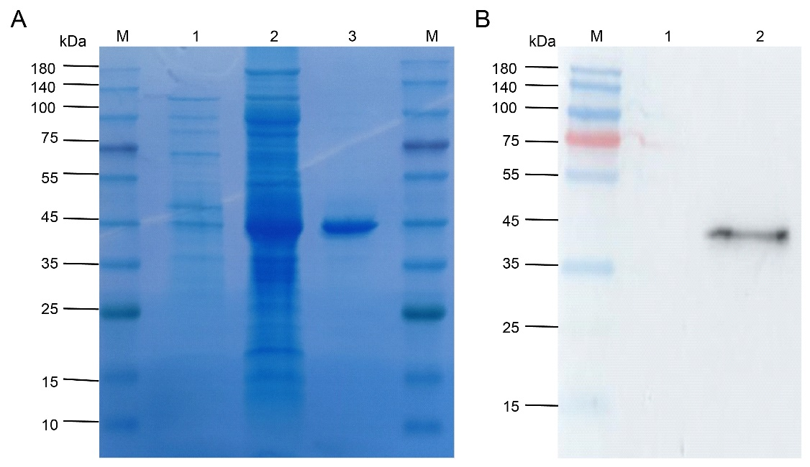
Figure S1 Expression, purification and WB validation of PDCoV N protein. (A) The expression and purification of PDCoV N protein were analyzed by SDS-SAPE. (B) Identification of N protein using PDCoV positive serum (1:1000 dilution) by WB. M: Protein molecular weight marker; Lane 1: E. coli Rosseta (DE3) with empty vector pET-32a (+); Lane 2: Induced E. coli Rosseta (DE3) with pET-32a-PDCoV-N; Lane 3: Purified PDCoV N protein.

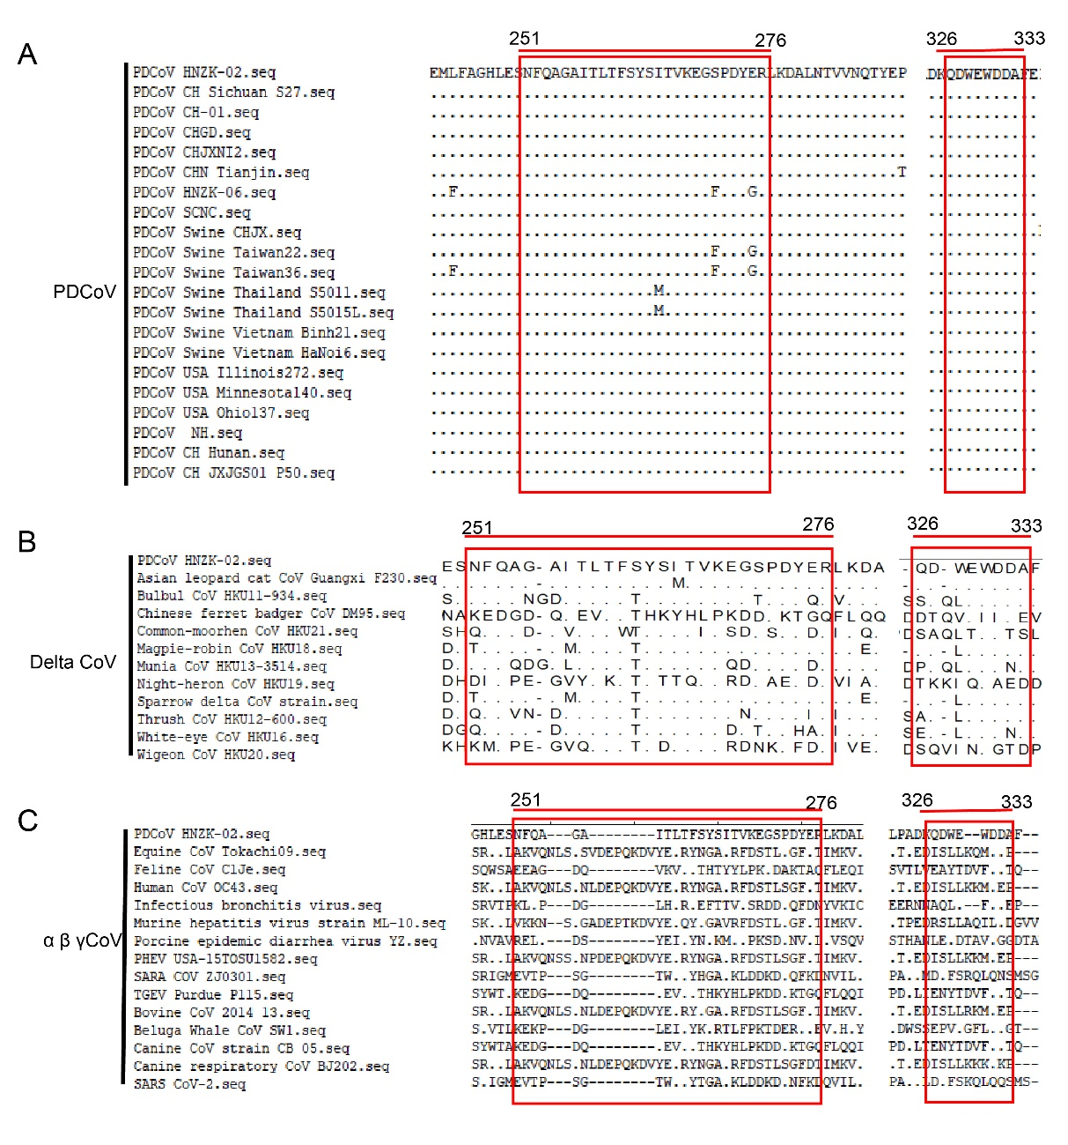
Figure S2 Sequence analysis of the two identified epitopes among different virus strains. (A) Homology comparison of the identified epitopes between PDCoV HNZK-02 strain and other 20 PDCoV reference strains collected from GenBank. The sequences of epitope 6B7 and epitope 7F8 for all strains are surrounded by red frames. (B) Homology comparison of the identified epitopes between PDCoV HNZK-02 strain and some deltacoronavirus strains collected from GenBank. (C) Homology comparison of the identified epitopes between PDCoV HNZK-02 strain and some coronavirus strains collected from GenBank.

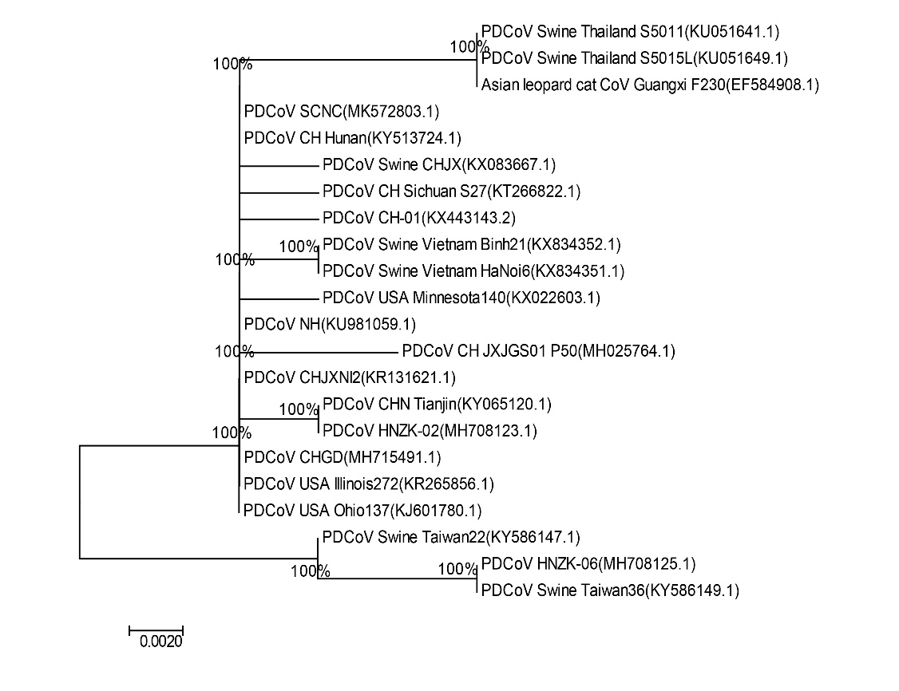
Figure S3 The homology analysis of amino acid sequences of N proteins between PDCoV and other coronaviruses of the delta genus.

