Virologica Sinica

Supplementary Data

Cytoplasmic domain and enzymatic activity of ACE2 are not required for PI4KB dependent endocytosis entry of SARS-CoV-2 into host cells

Hang Yang ª, Huijun Yuan ª,Xiaohui Zhao ª, Meng Xun ª, Shangrui Guo ª, Nan Wang ^{b}, Bing Liu ^{c,d}, Hongliang Wang ^{a,e,*}

ª Department of pathogen biology and immunology, School of Basic Medical Sciences, Xi'an Jiaotong University Health Science Center, Xi'an, 710061, China
^{b} School of Pharmacy, Xi’an Jiaotong University Health Science Center, Xi'an, 710061, China
^{c} BioBank, The First Affiliated Hospital of Xi'an Jiaotong University, Xi'an, 710061, China
^{d} Department of Life Sciences, Faculty of Natural Sciences, Imperial College London, London, SW7 2AZ, United Kingdom
^{e} Key Laboratory of Environment and Genes Related to Diseases, Xi'an Jiaotong University, Xi'an, 710061, China

* Corresponding author.
E-mail addresses: hongliangwang@xjtu.edu.cn (H. Wang)

Supplementary Table S1 Primers used for DNA construct preparation.
Construct | Fragment | Forward/  Reverse | Sequence
ACE2 |  | F | AATC ACGCGT GCCACC atgtcaagctcttcctggctc
 |  | R | GATTCGTACG AAAGGAGGTC TGAACATCAT CAG
Sac1(cytoplasmic domain) |  | F | GCTA cgtacg ATGGCGACGGCGGCCTACGAG
 |  | R | AGCGTTAATT AATCATGGAA CACTTAAAGG ACTATG
INPP5E 5-ptase domain |  | F | GCT GCTAGC tcggatcttgcagacta
 |  | R | AGCTGAATTC CTAAGAAACG GAGGCGATGG TG
ACE2-TM |  | F | AATC ACGCGT GCCACC atgtcaagctcttcctggctc
 |  | R | GCATCGTACG GATCAGGATG ACAATGCCAA C
ACE2-ACE chimera |  | F | AATC ACGCGT GCCACC atgtcaagctcttcctggctc
 |  | R | GGAGTGTCTCAGCTCCACCTCGGAGCCGAACTGGGGCCCG TGGGAGTGCCGGTGGAGGCTGCGGTGGCGGATGCTGAAGA GCCGCTGGAT CAGGATGACA ATGCCAAC
ACE2-EGFR chimera |  | F | AATC ACGCGT GCCACC atgtcaagctcttcctggctc
 |  | R | CGATCGTACGCATGAAGAGGCCGATCCCCAGGGCCACCACCAGCAGCAAGAGGAGGGCCCCCACCATCCCAGTGGCTATG GAAACAGGGG GCTGG
ACE2CM1 | F1 | F | AATC ACGCGT GCCACC atgtcaagctcttcctggctc
 |  | R | TATCATACTGGATATTCCCCATCTCATTATGAGCTGTCAG GAAGTCGTC
 | F2 | F | CCTGACAGCTCATAATGAGATGGGGAATATCCAGTATGATA TGGCATATGC
 |  | R | GATTCGTACG AAAGGAGGTC TGAACATCAT CAG
ACE2CM2 | F1 | F | AATC ACGCGT GCCACC atgtcaagctcttcctggctc
 |  | R | GAATGAGTAA TCATTAGAAA CAAGGAACAG AGATGCGGGG TC
 | F2 | F | CCGCATCT CTGTTCCTTG TTTCTAATGA TTACTCATTC ATTCG
 |  | R | GATTCGTACG AAAGGAGGTC TGAACATCAT CAG
ACE2CM3 | F1 | F | AATC ACGCGT GCCACC atgtcaagctcttcctggctc
 |  | R | GAATGAGTAA TCATTAGAAA CAAGGAACAG AGATGCGGGG TC
 | F2 | F | CCGCATCT CTGTTCCTTG TTTCTAATGA TTACTCATTC ATTCG
 |  | R | GATTCGTACG AAAGGAGGTC TGAACATCAT CAG
Spike_{fur/mut} | F1 | F | GTGAACGCGTgccaccatgttcgtcttcctggtcc
 |  | R | CCACGCTCCG AAGGATTGTC TGGGTCTGGT AAGAGGC
 | F2 | F | acccagaca ATCCTT cggagcgtggcctcccag
 |  | R | GTCCGTAGCACAGCAGGAGCCACAGC
Spike_{delta} | F1 | F | CATTTCAGGTGTCGTGAAC
 |  | R | CGAAGGGCTTCAGATTGCTCTTTCTAAACAGCCGGTACCG ATAATTGTAG TTGCCGCCC
 | F2 | F | gggacatctctacagaaatctaccaggccggcagcaAGccttgcaatggcgtggag
 |  | R | GCGAGAGTTT GTCTGGGTCT GG
 | F3 | F | ccagacccagacaaactctcGc agaagagcccggagcgtg
 |  | R | CGTCATCGTC TTTGTAGTCC

Supplementary Table S2 Primer sequences for qPCR.
Gene | Sequence
PI4KB-F | AACTTGCCCGAATGTGGTATT
PI4KB-R | GCCTATGTCATCCACCGACC
GAPDH-F | CTCTGCTCCTCCTGTTCGAC
GAPDH-R | TTAAAAGCAGCCCTGGTGAC
Gag-F | AGGCTGTAGACAAATACTGGG
Gag-R | GCACACAATAGAGGGTTGC

Supplementary Table S3 shRNA, sgRNA target sequences.
Gene | Sequence
CHC sgRNA-1 | TGCAGCTATATTCTGTAGAT
CHC sgRNA -2 | ATGGCGCTGTCTGCTGAAAT
CHC sgRNA -3 | GAATACGGTTGCTCTTGTTA
CAV1 sgRNA -1 | AGTGTACGACGCGCACACCA
CAV1 sgRNA -2 | TAAACACCTCAACGATGACG
CAV1 sgRNA -3 | CCTTCACTGTGACGAAATAC
PI4KB shRNA-1 | GATGGCAGTATGCGGTCTATC
PI4KB shRNA-2 | GCAAGAAACACGAAGGATCAT
PI4KB shRNA-3 | TCTCGGTACTTAGGACTTGAT

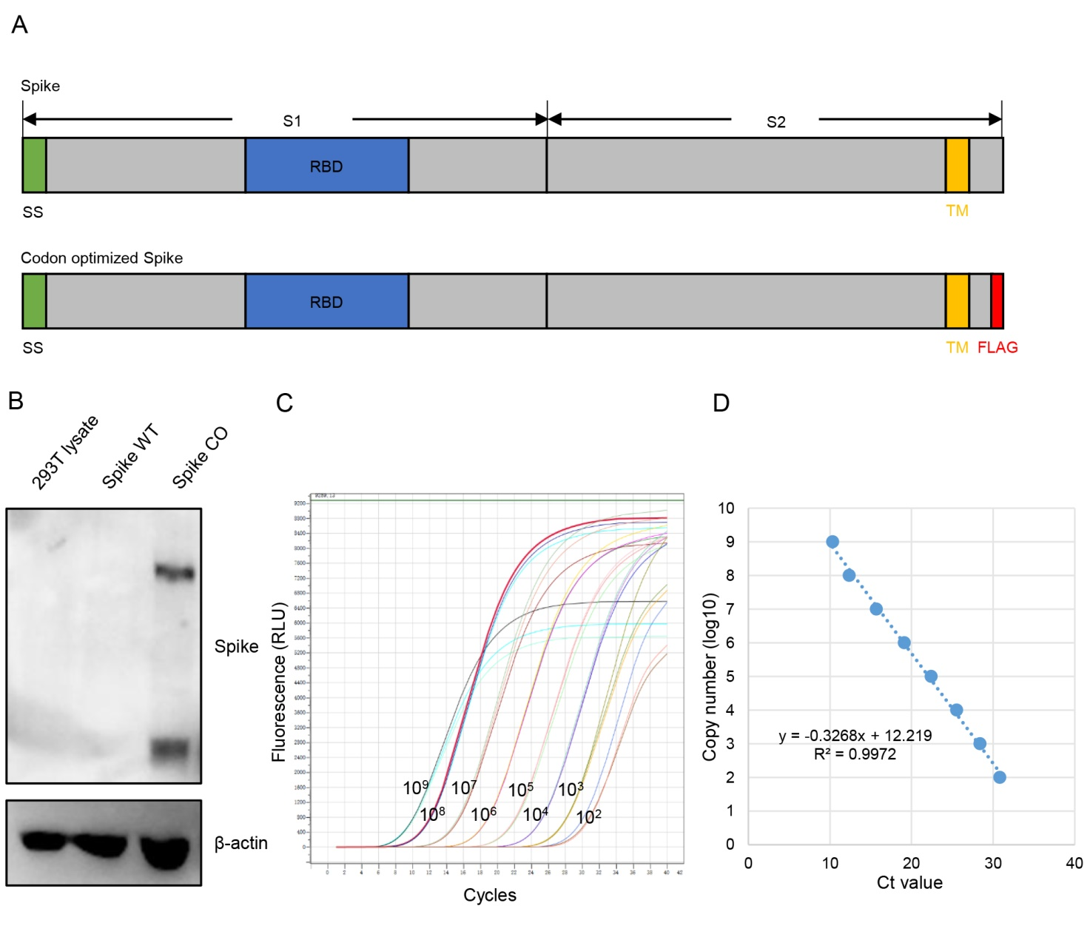
Supplementary Fig. S1 S pseudovirus preparation and characterization. A Diagram of SARS-CoV-2 Spike domains and codon optimized spike used for pseudovirus package. SS, signal sequence; RBD, receptor-binding domain; TM, transmembrane domain. B Wild type or codon optimized spike construct was transfected into 293T cells and S expression was determined with immunoblotting. C Serial dilutions of psPAX2 construct were quantitated with qPCR and amplification curves are shown. D Standard curve was plotted for virus titer calculation.

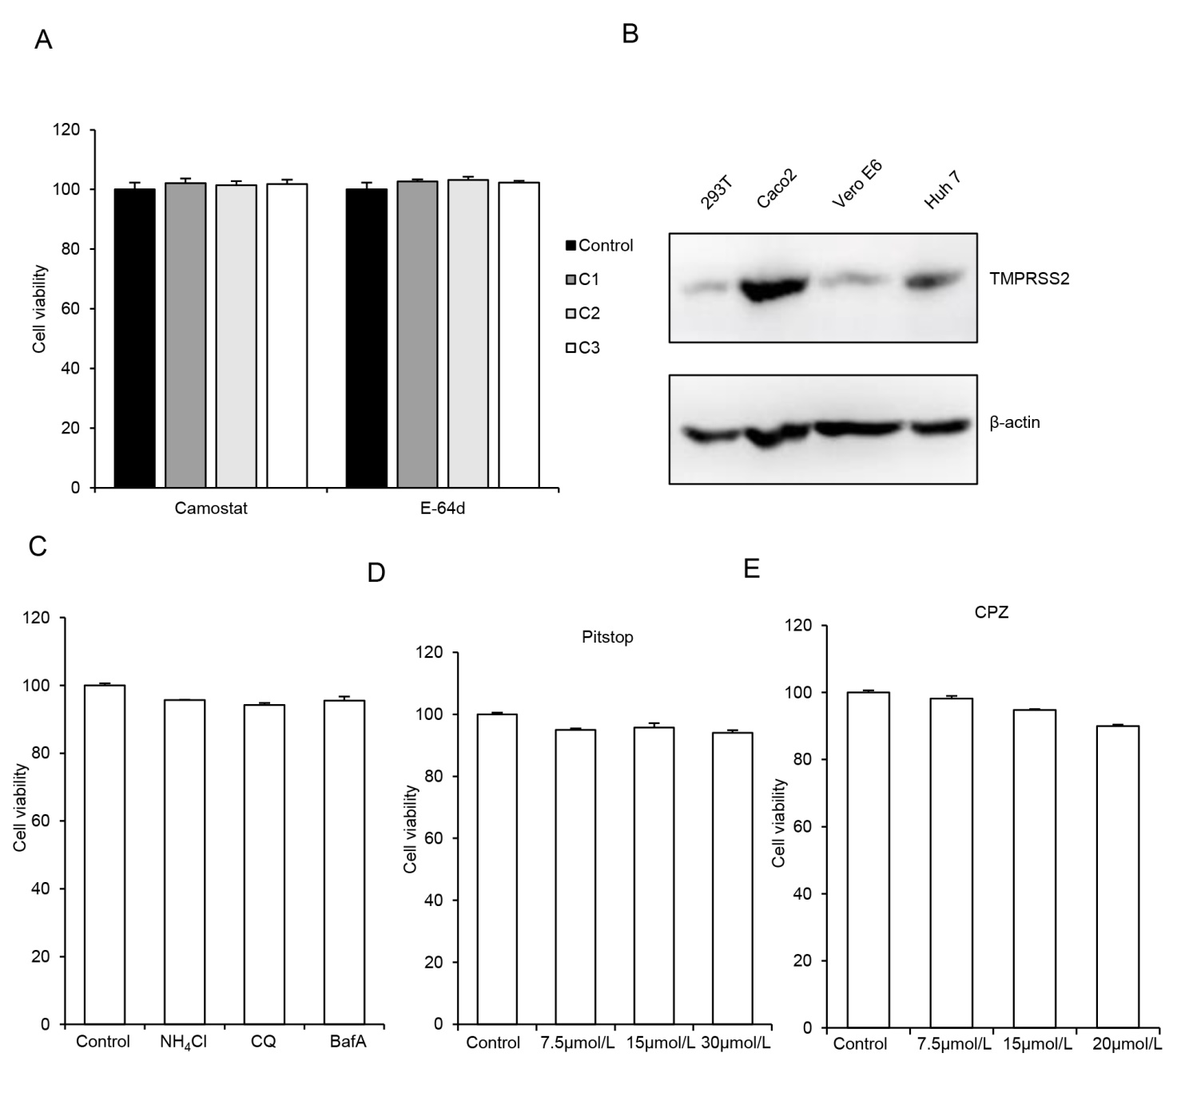
Supplementary Fig. S2 SARS-CoV-2 enters Huh 7 cells via clathrin-mediated endocytosis A Huh 7 cells were mock treated or treated with 5, 15, 50 μmol/L camostat mesylate or 5, 10, 25 μmol/L E-64d for 30 h and cell viability was determined with Cell Titer Glo. Values were normalized to control and expressed as mean ± SD. B TMPRSS2 expression in 293T, Caco2, Vero E6 or Huh 7 cells was determined by immunoblotting. C–E Huh 7 cells were mock treated or treated with 50 mmol/L NH₄Cl, 100 μmol/L chloroquine or 100 nmol/L bafilomycin A (C), or indicated amount of pitstop (D), or CPZ (E) for 30 h and cell viability was measured with Cell Titer Glo. Values were normalized to control and expressed as mean ± SD. SD, standard deviation.

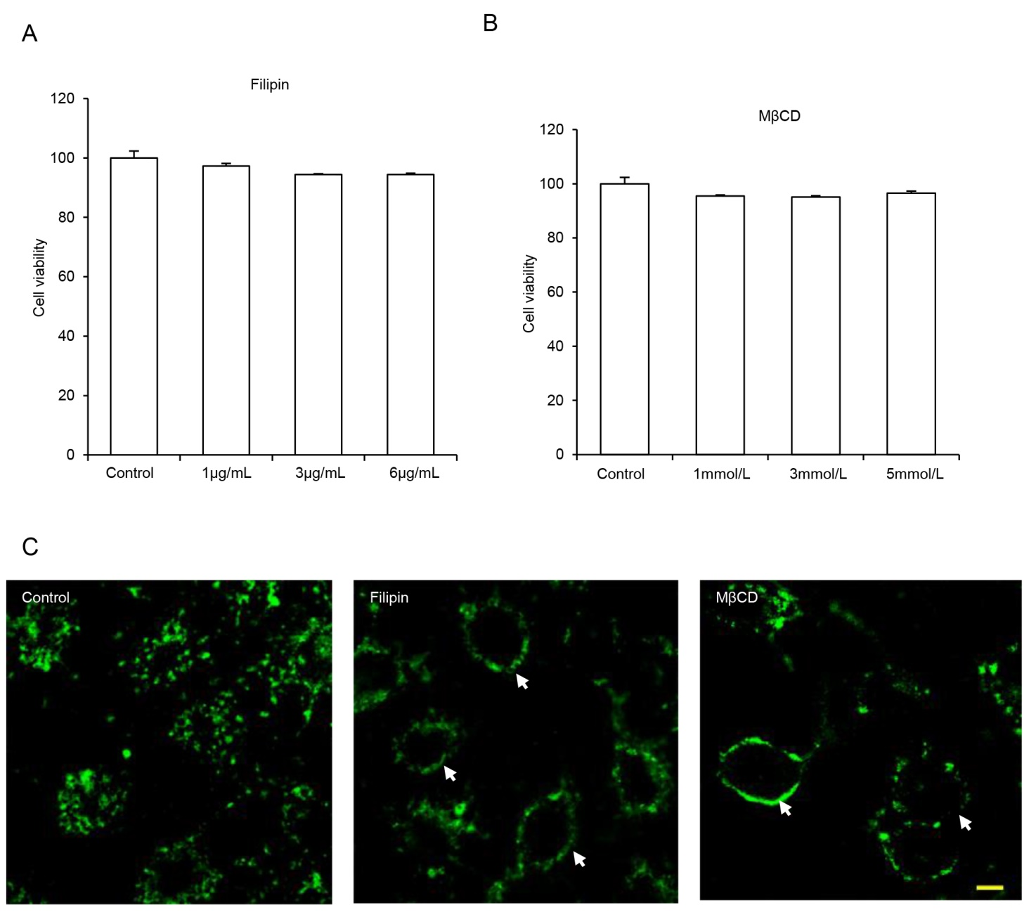
Supplementary Fig. S3 SARS-CoV-2 enters Huh 7 cells independent of caveolae-mediated endocytosis. A–B Huh 7 cells were mock treated or treated with indicated amount of filipin (A), or MβCD (B) for 30 h and cell viability was measured with Cell Titer Glo. Values were normalized to control and expressed as mean ± SD. SD, standard deviation. C Filipin or MβCD blocked the uptake of CTB. Huh 7 cells pretreated with 5 μg/mL filipin or 5 mmol/L MβCD were incubated with Alexa Fluor™ 488 Conjugated CTB for 1 h before images were taken. Arrows indicate blocked CTB on cell surface. Scalebar, 10 μm.

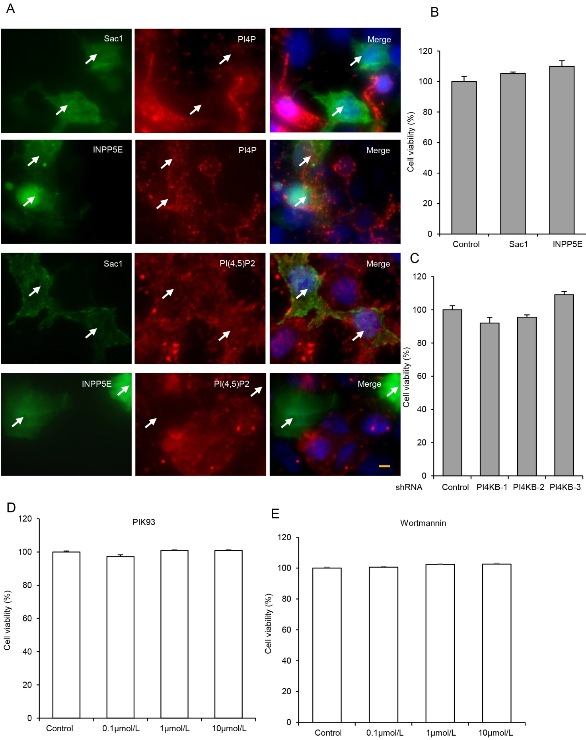
Supplementary Fig. S4 PI4KB is relevant to S pseudovirus infection. A Effect of Sac1 and INPP5E on PI4P and PI(4,5)P2 expression. 293T-ACE2 cells transfected with HA-Sac1 or HA-INPP5E were immunolabelled with anti-HA (green) and anti-PI4P (red, upper panels) or anti-PI(4,5)P2 antibody (red, lower panels). Cell nuclei was counterstained with DAPI. Arrows indicate cells with HA expression. Scalebar, 10 μm. B 293T cells were mock transfected or transfected with construct expressing HA-Sac1 or HA-INPP5E, and cell viability was determined with Cell Titer Glo after 30 h. Values were normalized to control and expressed as mean ± SD. C Huh 7 cells stably transduced with the indicated shRNAs were tested for cell viability with Cell Titer Glo. Values were normalized to control and expressed as mean ± SD. D–E Huh 7 cells were mock treated or treated with indicated amount of PIK93 (D), or wortmannin (E) for 30 h and cell viability was measured with Cell Titer Glo. Values were normalized to control and expressed as mean ± SD. SD, standard deviation.

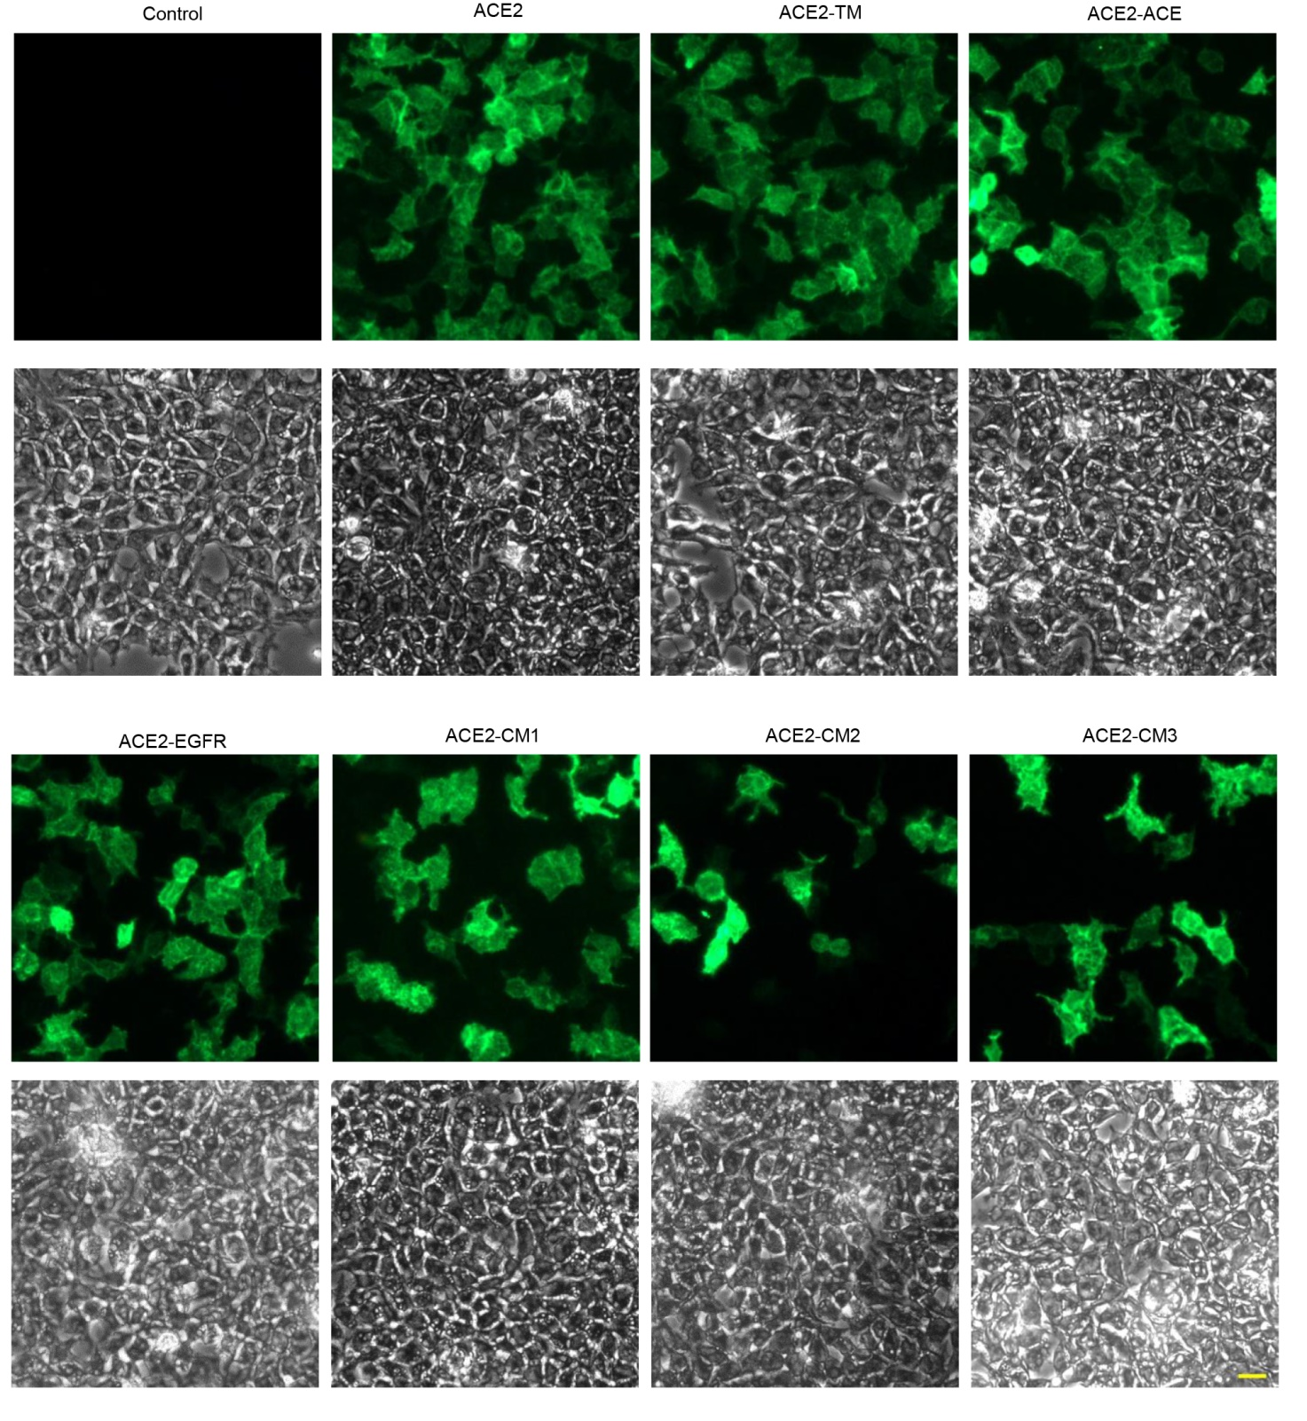
Supplementary Fig. S5 ACE2 mutants express on cell surface. 293T cells were mock transfected or transfected with ACE2 or indicated mutant for 30 h before cells were fixed and ACE2 cell surface expression was determined with immunofluorescence (upper panel). Corresponding DIC images were shown below to indicate the presence of cells. Scalebar, 20 μm.

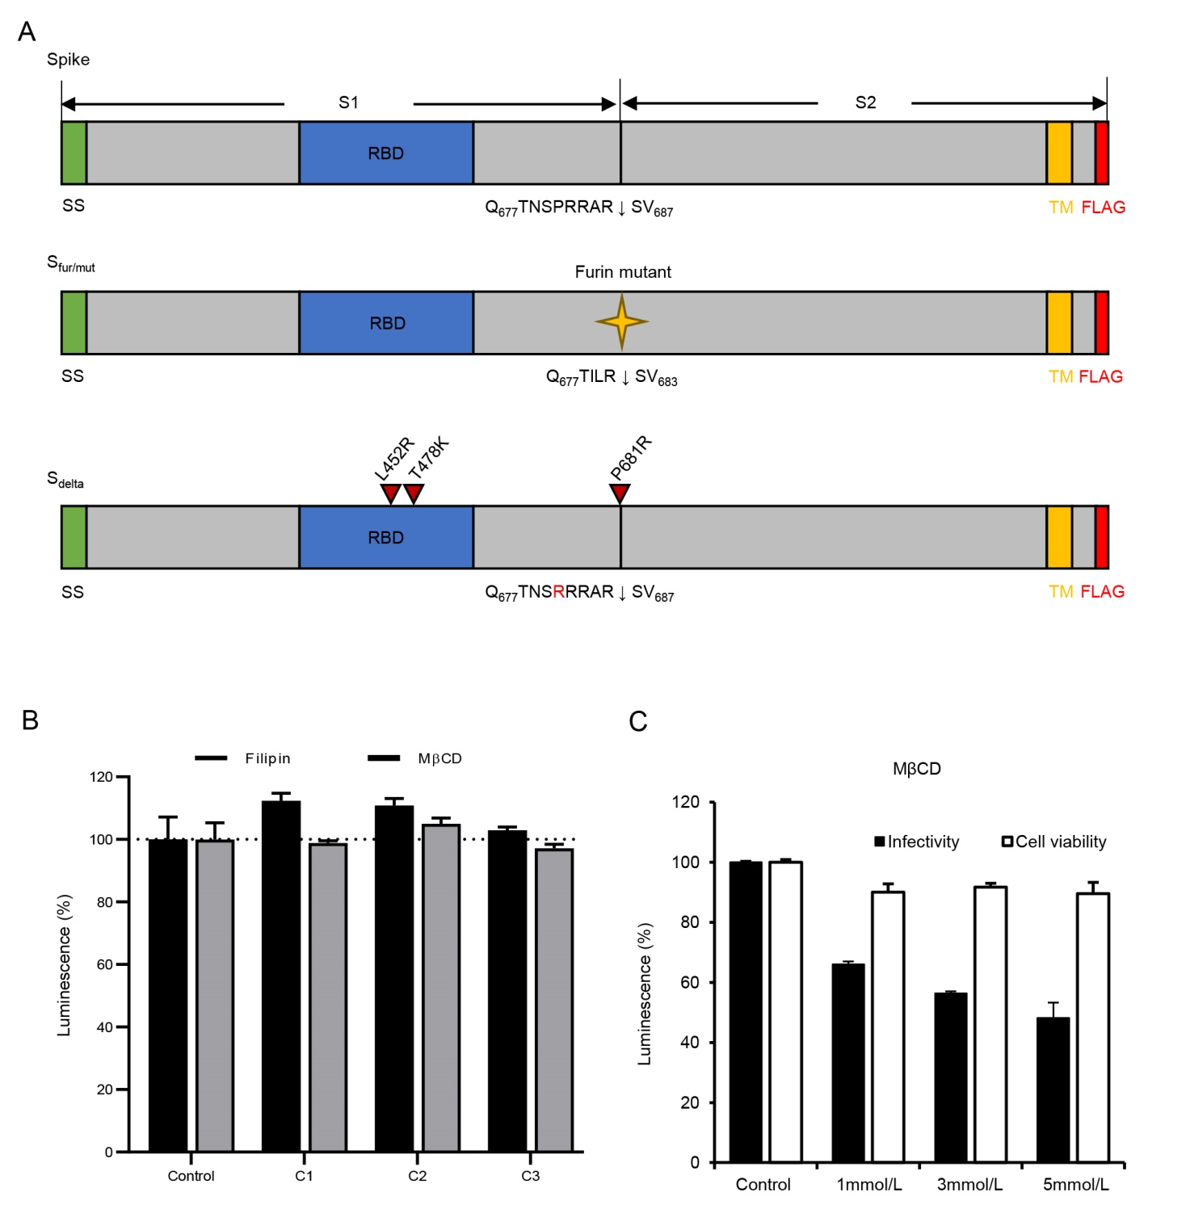
Supplementary Fig. S6 Delta variant enters Huh 7 cells via clathrin-mediated endocytosis. A Diagram of Spike and Spike mutants. The amino acid sequences of furin cleavage site are shown for each spike protein. SS, signal sequence; RBD, receptor-binding domain; TM, transmembrane domain. B Huh 7 cells pretreated with 1, 3, 6 μg/mL filipin or 1, 3, 5 mmol/L MβCD were transduced with Sdelta pseudovirus and luciferase was measured. Values were normalized to control and expressed as mean ± SD. C 293T-ACE2 cells pretreated with 1, 3, 5 mmol/L MβCD were transduced with S pseudovirus and luciferase as well as cell viability were measured. Values were normalized to control and expressed as mean ± SD. SD, standard deviation.

