Virologica Sinica

Supplementary Data

Recombinant human interferon-α1b inhibits SARS-CoV-2 better than interferon-α2b in vitro

Danrong Shi ^{a,1}, Keda Chen ^{b, 1}, Xiangyun Lu ª, Linfang Cheng ª, Tianhao Weng ª, Fumin Liu ª,
Nanping Wu ^{a,*} , Lanjuan Li ^{a, *}, Hangping Yao ^{a, *}

ª State Key Laboratory for Diagnosis and Treatment of Infectious Diseases, National Clinical Research Center for Infectious Diseases, National Medical Center for Infectious Diseases, The First Affiliated Hospital, Zhejiang University School of Medicine, Hangzhou 310003, China
^{b} Shulan International Medical College, Zhejiang Shuren University, Hangzhou 310015, China

¹ Danrong Shi and Keda Chen contributed equally to this work.

*Corresponding authors

Email addresses:
yaohangping@zju.edu.cn (H. Yao); ljli@zju.edu.cn (L. Li); flwnp2013@163.com (N. Wu)

ORCID:
0000-0001-6742-7074; 0000-0001-6945-0593; 0000-0001-5119-3058

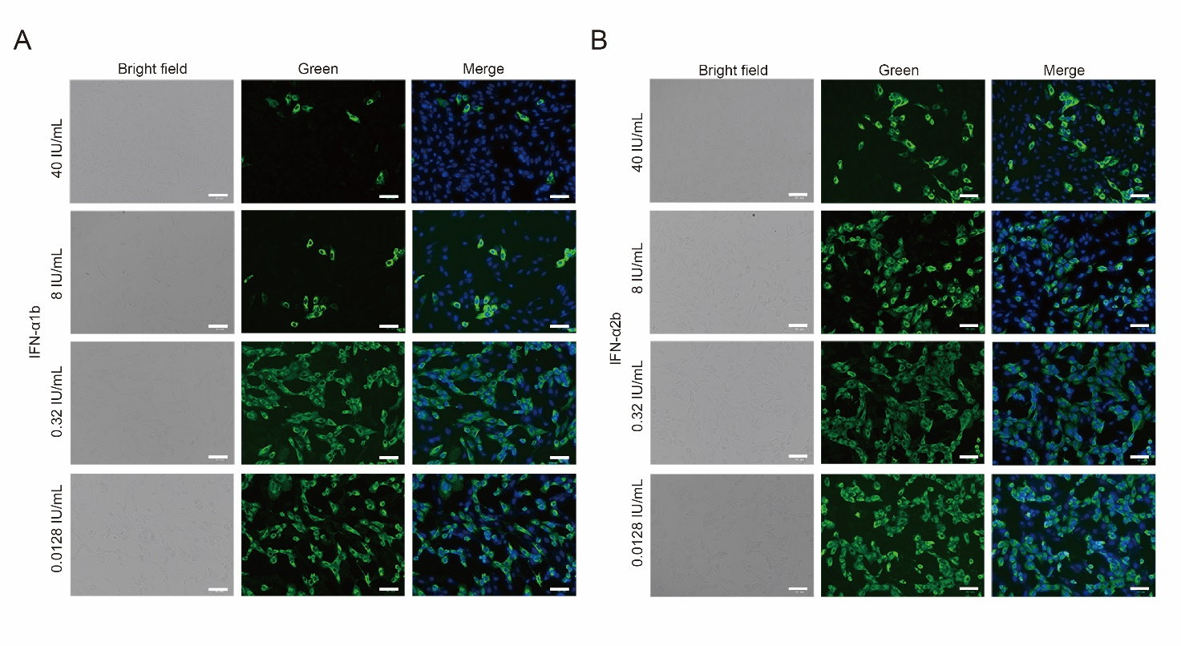
Fig. S1. Immunofluorescence microscopy of Calu-3 cells infected with SARS-CoV-2 on treatment with rHuIFN-α1b (A) and rHuIFN-α2b (B). Cells were fixed in 80% precooled acetone for 30 min. Then, anti-SARS-CoV-2 Spike RBD rabbit monoclonal antibody was used as the primary antibody, and Alexa Fluor488®-conjugated goat anti-rabbit IgG as the secondary antibody. Nuclei were stained with DAPI. The stained cells were observed by fluorescence microscopy. The scale bar represents 50 μm.

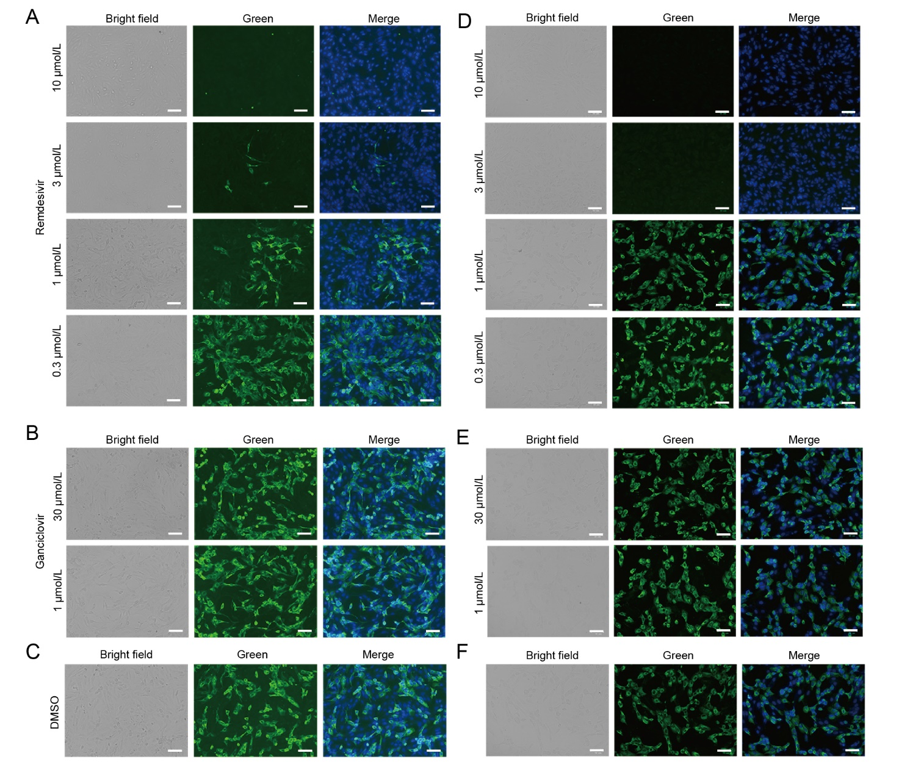
Fig. S2. Immunofluorescence microscopy of Vero (A-C) and Calu-3 (D-F) cells infected with SARS-CoV-2 on treatment with remdesivir, ganciclovir and DMSO.

