Virologica Sinica

Supplementary Data

Construction of coxsackievirus B5 viruses with luciferase reporters and their applications in vitro and in vivo

Shangrui Guo ^{a, 1}, Meng Xun ^{a, 1}, Tingting Fan ª, Xinyu Li ª, Haoyan Yao ^{b}, Xiaozhen Li ª, Bo Wu ª, Hang Yang ª, Chaofeng Ma ^{c}, Hongliang Wang ^{a,} *

ª. Department of Pathogen Biology and Immunology, Xi’an Jiaotong University Health Science Center, Xi’an, 710061, China
^{b}. Department of gynecology and obstetrics, The First Affiliated Hospital of Xi'an Jiaotong University, Xi’an, 710061, China.
^{c}. Department of Viral Diseases Laboratory, Xi’an Center for Disease Control and Prevention, Xi’an, 710061, China

1 Shangrui Guo and Meng Xun contributed equally to this work.

* Corresponding author:
Email: hongliangwang@xjtu.edu.cn (H. Wang)
ORCID: 0000-0002-3304-2683 (H. Wang)

Table S1. Primers used in this study.
Clone | Fragment | Forward/Reverse | Sequence
pRBCU-CVB5 | F1 | F | TAATACGACTCACTATAGGTTTAAAACAGCCTGTGGGTTG
 |  | R | GCGTGCAATGGCCCTCTC
 | F2 | F | CGGTGGAGAGGGCCA
 |  | R | TTGATCTCTCTATACACGGG
 | F3 | F | TTCCAAGGCCCACCCGTGTATAG
 |  | R | TTTTTTTTTTTGATTGCACCGAATGCGG
NanoLuc-CVB5 | F1 | F | CTCCTTCGGTCCTCCGAT
 |  | R | TCCTTGAAACAAAGCGACGTTGATGCGAGCTGA
 | F2 | F | GCTTTGTTTCAAGGAGCTCAGGTATCAACACAA
 |  | R | CGTTTGGCTAATCCATGGAA
pSGR-Rluc-CVB5 | F1 | F | CTCCTTCGGTCCTCCGAT
 |  | R | TTTGCTGTATTAAGTATCAAAATGAGG
 | F2 | F | ACTTAATACAGCAAAATGGCTTCCAAGGTGTAC
 |  | R | GCTAATCCATGGAATTCCTTGAAACAAAGCGGCACCGGGCTTGCGGGT
pSGR-Rluc-CVB5/GND | F1 | F | TCCAGATCCAGACCATTTTG
 |  | R | AGCAATGACGTCGTTGCCATATGCAATCATCCT
 | F2 | F | AACGACGTCATTGCTTCATATCC
 |  | R | GCGGCCGCGAATAAGCT

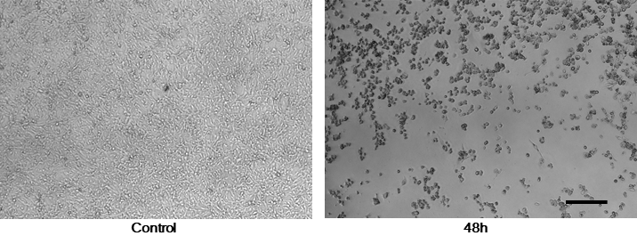
Figure S1. Recombinant CVB5 RNA transfection caused CPE in RD cells. RD cells were transfected with in vitro transcribed RNA with recombinant full-length CVB5 genome and images were taken 48 h.p.i. Bar, 100μm.

