Virologica Sinica

Supplementary Data

Tilorone confers robust in vitro and in vivo antiviral effects against severe fever with thrombocytopenia syndrome virus

Jingjing Yang ^{a,b,1}, Yunzheng Yan ^{b,1}, Qingsong Dai ^{b}, Jiye Yin ^{b}, Lei Zhao ^{b}, Yuexiang Li ^{b}, Wei Li ^{b}, Wu Zhong ^{b}, Ruiyuan Cao ^{b,}*, Song Li ^{a,b,}*

ª School of Pharmaceutical Sciences, Hainan University, Haikou, 570228, China
^{b} National Engineering Research Centre for the Emergency Drug, Beijing Institute of Pharmacology and Toxicology, Beijing, 100850, China

* Corresponding authors.
E-mail addresses: lis.lisong@gmail.com (S. Li), 21cc@163.com (R. Cao)

¹ Jingjing Yang and Yunzheng Yan contributed equally to this work.
Supplementary information
Cells, viruses and animals
Huh7 cell line was purchased from National Infrastructure of Cell Line Resource, China. Huh7.5 cell line was kindly provided by Prof. Charles M. Rice. All cell lines are maintained in Dulbecco’s modified Eagle’s medium (DMEM, 11995-065, Gbico, Grand Island, USA) supplemented with 10% heat inactivated FBS (16000-044, Gibco), 1% penicillin/streptomycin at 37 °C in a 5% CO₂ humidified incubator. Severe fever with thrombocytopenia syndrome virus (SFTSV) was isolated from clinical sample according to standard operating procedures (GenBank accession numbers: MZ561690, MZ561691, and MZ561692). Virus stocks were propagated and titrated in Huh7 cells by plaque-forming assays and 50% tissue culture infectious dose (TCID₅₀) assay. Specific-pathogen-free ICR and BALB/c mice used in this research were purchased from Beijing Vital River Laboratory Animal Technology Co., Ltd. Ifnar^{−/−} A129 mice were bred and housed in the Laboratory Animal Center, Beijing Institute of Pharmacology and Toxicology. All animal experiments performed in this study are approved by the IACUC (Institutional Animal Care and Use Committee) of Beijing Institute of Pharmacology and Toxicology. All work with infectious virus was carried out in Biosafety Level 2 (BSL-2) or animal Biosafety Level 2 laboratory (ABSL-2).
Chemicals and reagents
Tilorone dihydrochloride (≥ 99%) was purchased from Selleck and was then stored in DMSO as a 100 mmol/L solution at −20 °C. Rabbit anti-SFTSV HB29 polyclonal antibody was purchased from Abnova (PAB27171, Taipei, China). Alexa Fluor™ 488 donkey anti-rabbit IgG (H+L) (A21206, Rockford, USA) and Hoechst 33342 Fluorescent Stain Solution (H21492, Rockford, USA) were obtained from Invitrogen by Thermo Fisher Scientific (USA).
CPE-based High-throughput Screening of FDA-approved library
Huh7 cells were seeded into 96-well plates at 5000 cells/well and cultured overnight. Then, cells were infected with 100 TCID₅₀ of SFTSV in the presence of 3 μmol/L indicated drugs for 6 days. Antiviral activity based on cytopathogenic effect (CPE) inhibition assay was determined using CellTiter-Glo® Luminescent Cell Viability Assay (G7573, Promega, Madison, USA) kit following the manufacturer’s instructions (Tan et al. 2004).
In Vitro anti-SFTSV assay
Confluent Huh7 cells cultured in 96-well plates were infected with 100 TCID₅₀ of SFTSV in the presence of gradient dilutions of tilorone for 6 days. The anti-SFTSV activity of tilorone was evaluated as described above.
Cytotoxicity assay
The cytotoxicity of tilorone against Huh7 and Huh7.5 cells was evaluated using a CellTiter-Glo® Luminescent Cell Viability Assay (Promega) kit following the manufacturer’s instructions.
Quantitative Real-Time PCR (qRT-PCR)
Viral inhibition experiments were performed as previously described (Yang et al. 2020). In brief, Huh7 and Huh7.5 cells were seeded in 12-well plates and incubated overnight. SFTSV, gradient-diluted tilorone and raloxifene were added and incubated for 48 h. And then, the supernatants were collected for subsequent virus titers determination. After the total cellular RNA was harvested, qRT-PCR was performed using One Step PrimeScript™ RT-PCR Kit (RR064A, TaKaRa, Shiga, Japan) according to the manufacturer’s instructions. The specific PCR primers set for SFTSV RNA detection were as follows: forward primer (5′-GGGTCCCTGAAGGAGTTGTAAA-3′), reverse primer (5′-TGCCTTCACCAAGACTATCAATGT-3′) and probe (5′-TTCTGTCTTGCTGGCTCCGCGC-3′). Virus RNA copy numbers were calculated after comparison with a standard curve produced using serial tenfold dilutions of SFTSV plasmid DNA.
Plaque reduction Assay
Plaque reduction assay was performed as previously described (Yang et al. 2020). Briefly, overnight incubated Huh7 cells in 12-well plates were infected with gradient diluted supernatant collected above for 2 h. After incubation, the cells were washed with PBS for three times and incubated in a DMEM media overlay containing 2% low-melting point agarose (Promega). The inoculum was aspirated at 72 hpi, and the cells were fixed and stained with 4% paraformaldehyde and 1% crystal violet dye solution. Plaque forming units (PFU) were counted by the average of three independent tests for each sample.
Immunofluorescence assay
Huh7 cells were inoculated overnight in 96-well black plates at 5 × 10³ cells/well, and were infected with the SFTSV at an MOI of 1, with or without tilorone. At 24 hpi, cells were fixed with 4% paraformaldehyde at room temperature for 30 min and permeabilized with 0.25% Triton-X-100. Then, cells were blocked with 5% BSA and incubated with primary antibody (rabbit anti-SFTSV HB29 polyclonal antibody) at 37°C for 1 h. And an aliquot of 1:500 diluted Alexa Fluor™ 488 donkey anti-rabbit IgG (H+L) were used as the second antibody. The cell nucleus was stained with Hoechst 33342 fluorescent stain for 30 min at room temperature. Immunofluorescence was viewed and mounted with Leica Inverted microscope DMi8 (Leica Microsyetems, Germany).
Combinational effects of tilorone and favipiravir in vitro
Huh7 cells were seeded in 96-well plates at 5 × 10³ cells/well. After 24 h, cells were infected with SFTSV at 100 TCID₅₀, followed by the addition of tilorone and favipiravir in different dilutions (for tilorone, 0.01 to 1.00 μmol/L; for favipiravir, 0.27 to 200 μmol/L). After incubation for 6 days, the antiviral effect was detected by CellTiter-Glo® Luminescent Cell Viability Assay (Promega) kit following the manufacturer’s instructions. Data were analyzed using MacSynergy II software (Prichard et al. 1990).
SFTSV infection in mice
6-week-old female BALB/c mice were intraperitoneally (i.p.) treated with tilorone (5 mg/kg, 10 mg/kg) or the vehicle reagent 12 h prior subjected to SFTSV infection i.p. (5 × 10⁵ PFU SFTSV). At the same time of infection, tilorone and vehicle mice were administrated for the second time, and after 12 h, for the third time. At 24 hpi, the viral burdens were determined by qRT-PCR as described above.
For mouse lethal protection experiments, 1-day-old ICR suckling mice were inoculated through intracranial (i.c.) way with 5 × 10³ PFU SFTSV. Meanwhile, mice in different groups were i.p. administrated with different doses of tilorone (5 mg/kg, 10 mg/kg and 20 mg/kg) and vehicle reagent. The treatment was continued daily for seven days. The survival, disease signs and weight loss of suckling mice were monitored daily until 21 days post infection (dpi). And in the lethal infection model of A129 mice, 6- to 8-week-old female A129 mice were i.p. treated with gradient dosages of tilorone or vehicle 12 h prior to being i.p. infected with 10 PFU SFTSV. Tilorone treatment was continued daily for 7 days, and observations were sustained for up to 14 dpi. The survival rate was processed using the Log-rank (Mantel-Cox) test.
For the prevention effect of tilorone, 1-day-old ICR suckling mice were pretreated with tilorone (25 mg/kg, 50 mg/kg) or vehicle for three consecutive days prior to viral infection. Then, 5 × 10⁴ PFU SFTSV was injected to each suckling ICR mice through intracranial (i.c.) way with a volume of 25 μL. The experimental mice were observed daily for weight or morbidity until 21 dpi. Brain samples from different treatments were sectioned and stained for pathological analysis.
Statistical analysis
All data were analyzed using GraphPad Prism 8.0 software and presented as mean ± standard error of mean (SEM) from three independent samples. Statistical evaluations were performed by Student’s unpaired t-test, One-Way ANOVA followed by Dunnett’s test. The survival analysis was performed by the Log-rank test.

References
Prichard M, Shipman C. A three-dimensional model to analyze drug-drug interactions. Antiviral Res. 1990;14:181–205
Tan E, Ooi E, Lin C, Tan H, Ling A, Lim B, Stanton L. Inhibition of SARS coronavirus infection in vitro with clinically approved antiviral drugs. Emerg Infect Dis. 2004;10:581–586
Yang J, Xu Y, Yan Y, Li W, Zhao L, Dai Q, Li Y, Li S, Zhong J, Cao R, Zhong W. Small molecule inhibitor of ATPase activity of HSP70 as a broad-spectrum inhibitor against flavivirus infections. ACS Infect Dis. 2020;6:832–843

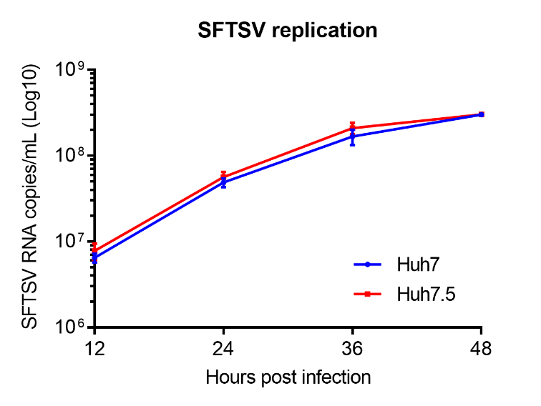
Supplementary Fig. S1 The replication capability of SFTSV in Huh7.5 cells and Huh7 cells is identical. Total cellular RNA was extracted from SFTSV infected Huh7 and Huh7.5 cells at indicated time points, and subjected to qRT-PCR assay to determine SFTSV RNA copies. Data are presented as mean ± SEM. No significant difference was found between two cell lines at each time point. SFTSV, severe fever with thrombocytopenia syndrome virus; SEM, standard error of mean.

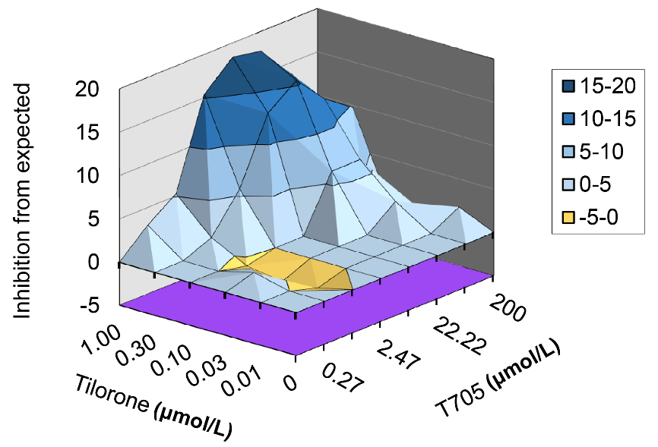
Supplementary Fig. S2 Synergetic antiviral effect of tilorone and favipiravir in Huh7 cells infected with SFTSV. The synergetic effect of tilorone and favipiravir was analyzed by MacSynergy II and shown in a three-dimensional plot. The volumes above and below the planes represent synergy and antagonism, respectively. SFTSV, severe fever with thrombocytopenia syndrome virus.

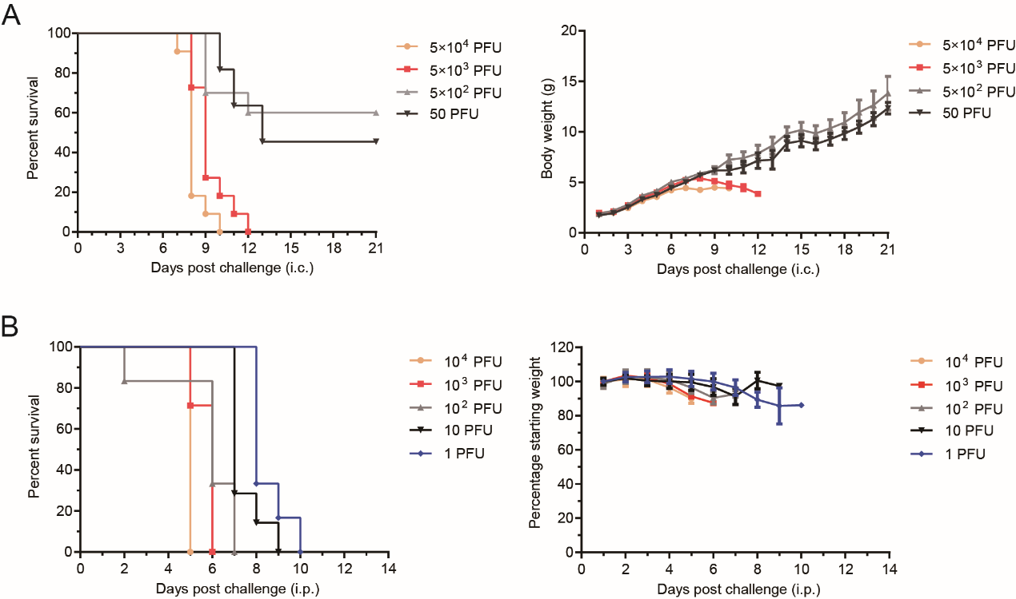
Supplementary Fig. S3 Lethal mouse models of SFTSV. A 1-day-old ICR mice i.c. challenged with gradient inoculation doses of SFTSV. B 6- to 8-week-old female A129 mice i.p. challenged with gradient inoculation doses of SFTSV. SFTSV, severe fever with thrombocytopenia syndrome virus; i.c., intracranially; i.p., intraperitoneally.

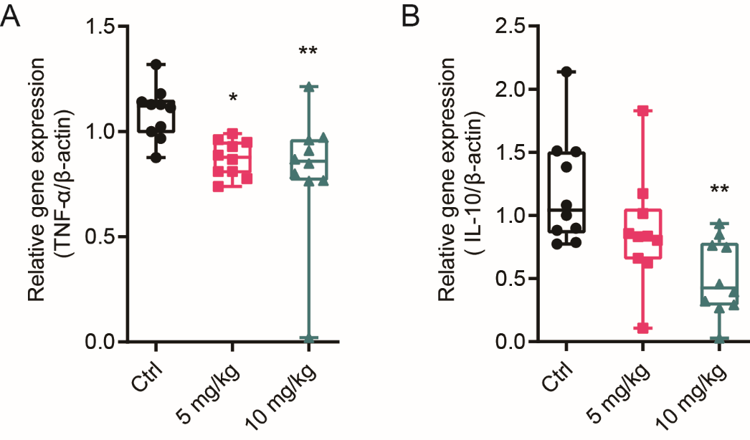
Supplementary Fig. S4 Tilorone reduced the expression of TNF-α and IL-10 in SFTSV infected BALB/c mice. The overexpression of TNF-α and IL-10 was reduced by tilorone in a dose-dependent manner. *P < 0.05, **P < 0.01. SFTSV, severe fever with thrombocytopenia syndrome virus.

