Virologica Sinica

Supplementary Data

GCRV NS38 counteracts SVCV proliferation by intracellular antagonization during co-infection

Zhuo-Cong Li^{a,b,1}, Long-Feng Lu^{a,b,1}, Can Zhang^{a,b}, Xue-Li Wang^{b,d}, Jin-Feng Tong^{a,b}, Ke-Jia Han^{b,d}, Dan-Dan Chen^{a,b}, Xi-Yin Li^{b,c}, Li Zhou^{b,c}, Jian-Fang Gui^{b,c}, Shun Li^{a,b,*}

ª Institute of Hydrobiology, Chinese Academy of Sciences, Wuhan, 430072, China
^{b} University of Chinese Academy of Sciences, Beijing, 100049, China
^{c} State Key Laboratory of Freshwater Ecology and Biotechnology, Hubei Hongshan Laboratory, the Innovation Academy of Seed Design, Institute of Hydrobiology, Chinese Academy of Sciences, Wuhan, 430072, China
^{d} College of Fisheries and Life Science, Dalian Ocean University, Dalian, 116023, China

* Corresponding author.
E-mail addresses: bob@ihb.ac.cn (S. Li)

¹ Zhuo-Cong Li and Long-Feng Lu contributed equally to this work.

Supplementary Table S1 Primers used in this study.
Name | Sequence (5′→3′) | Purpose
pCMV-HA/Myc/Tag2C-NS38-F | CCGGAATTCGGATGGCACACACAGGCACC | Eukaryotic expression
pCMV-HA/Myc/Tag2C-NS38-R | CCGCTCGAGTTACATACCCCCGATCGGC
mCherry-N1-NS38-F | CCCATCGATGCCACCATGGCACACACAGGCACC
mCherry-N1-NS38-F | CCGGAATTCCGCATACCCCCGATCGGCAG
pCMV-Myc/Tag2C-N-F | CCGGAATTCCGATGAGTGTCATTCGGATCAA
pCMV-Myc/Tag2C-N-R | CCGCTCGAGTTATCCATAGGTTTGTTTTATCC
pCMV-Myc/Tag2C-P-F | CCGGAATTCCGATGTCTCTACATTCGAAATTG
pCMV-Myc/Tag2C-P-R | CCGCTCGAGTTACAACCTATATTTTTGATAC
pcDNA3.1-Flag-G-F | CGGGGTACCATGGGATCTATCATCAGCTACATC
pcDNA3.1-Flag-G-R | CCGCTCGAGTCATTTATCGTCATCATCTTTGTAGTCCTTGTCATCATCGTCCTTATAGTCCTTATCGTCGTCATCCTTGTAATCAACTAAAGACCGCATTTCG
pCMV-HA/Myc/Tag2C-S7-F | CCGGAATTCGGGCCACCATGCCTTGCCAGGATACTGTC
pCMV-HA/Myc/Tag2C-S7-R | CCGCTCGAGCTACTGAAACGCCTCAGGC
mCherry-N1-N-F | CGCGGATCCGCCACCATGAGTGTCATTCGGATC
mCherry-N1-N-R | CCGGAATTCCGTCCATAGGTTTGTTTTATCC
pEGFP-N3-N-F | CTAGCTAGCATGTACCCATACGATGTTCCAGATTACGCTAGTGTCATTCGGATCAA
pEGFP-N3-N-R | CGCGGATCC TCCATAGGTTTGTTTTATCC
pEGFP-N3-P-F | CTAGCTAGCATGTACCCATACGATGTTCCAGATTACGCTTCTCTACATTCGAAATTG
pEGFP-N3-P-R | CGCGGATCCCAACCTATATTTTTGATAC
DsRed-N1-G-F | CTAGCTAGCATGTCTATCATCAGCTAC
DsRed-N1-G-R | CCGCTCGAGTCAAACTAAAGACCGCATTTC
pCMV-HA/Myc-p62-F | CCGCTCGAGGTATGTCGATGACAGTGAGAG
pCMV-HA/Myc-p62-R | ATTTGCGGCCGCCTACTTCTGTTGTCCTGGTGTTTTGGAG
pCMV-Tag2C-p62-F | CCCAAGCTTGGATGTCGATGACAGTGAGAGCTT
pCMV-Tag2C-p62-R | CCGCTCGAGCTACTTCTGTTGTCCTGGTGTTTTGG
pCMV-Tag2C-Tollip-F | CCGGAATTCGGATGGCGACAACAATAAG
pCMV-Tag2C-Tollip-R | CCGCTCGAGTTAAAGCTCCTCCGCCAT
pCMV-Tag2C-NDP52-F | CCGGATATCAAATGAGCGACAGAACGGAG
pCMV-Tag2C-NDP52-R | CCGCTCGAGCTAATCCGCATGACTGTAGAC
pCMV-Tag2C-OPTN-F | CCGGAATTCGGATGAATGGGGACATTAGTCAC
pCMV-Tag2C-OPTN-R | CCGCTCGAGTCAGATGATGCAATCCATGATGTGGATCTGCAGGGAG
pCMV-Tag2C-NBR1-F | CCGGAATTCGGATGAACCTCCCCGTCACTG
pCMV-Tag2C-NBR1-R | CCGCTCGAGCTAATGTCTTGAGATGTGC
Drifn-F | GAATGGCTTGGCCGATACAGGATA | qPCR
Drifn-R | TCCTCCACCTTTGACTTGTCCATC
Drirf3-F | AAGGTGCTGTCGGTGGTTTG
Drirf3-R | ATGTGGTTGAGTGGCAGTCT
S9-F | GCCGCTCGTGATTTGTTA
S9-R | GGGTAGGTGTCGGGTAGTTC
EPCβ-actin-F | CACTGTGCCCATCTACGAG
EPCβ-actin-R | CCATCTCCTGCTCGAAGT
Drβ-actin-F | CACTGTGCCCATCTACGAG
Drβ-actin-R | CCATCTCCTGCTCGAAGTC
n-F | TGAGTGCTGAGGACGAT
n-R | TTTGTGAGTTGCCGTTA
p-F | TTGGACCTGGGATAGTGA
p-R | CTTGCTTGGTTTGTGGG
m-F | TACTCCTCCCACTTACGA
m-R | CAAGAGTCCGAGAAGGTC
g-F | CGACCTGGATTAGACTTG
g-R | AATGTTCCGTTTCTCACT
l-F | GCCCACTTTGCATCCAGTCC
l-R | GAGATGCCACAGACTCCTCC
sh-S9#1-FP | CCGGGCACCGCTACTCTGATCAATGCTCGAGCATTGATCAGAGTAGCGGTGCTTTTTG | RNAi
sh-S9#1-RP | AATTCAAAAAGCACCGCTACTCTGATCAATGCTCGAGCATTGATCAGAGTAGCGGTGC
sh-S9#2-FP | CCGGGCTCACACCGCTACCAATACTCTCGAGAGTATTGGTAGCGGTGTGAGCTTTTTG
sh-S9#2-RP | AATTCAAAAAGCTCACACCGCTACCAATACTCTCGAGAGTATTGGTAGCGGTGTGAGC
sh-p62#1-FP | CCGGGCCCTTTCAAATGCACTATAACTCGAGTTATAGTGCATTTGAAAGGGCTTTTTG
sh-p62#1-RP | AATTCAAAAAGCCCTTTCAAATGCACTATAACTCGAGTTATAGTGCATTTGAAAGGGC
sh-p62#2-FP | CCGGGGACTCACCTGAGCTCTAAAGCTCGAGCTTTAGAGCTCAGGTGAGTCCTTTTTG
sh-p62#2-RP | AATTCAAAAAGGACTCACCTGAGCTCTAAAGCTCGAGCTTTAGAGCTCAGGTGAGTCC

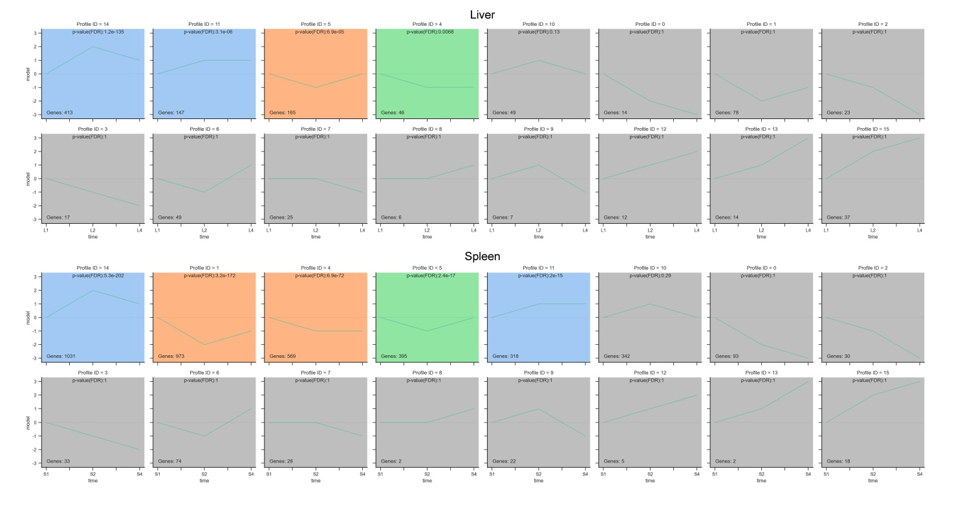
Supplementary Fig. S1. The gene modules enriched by STEM analysis in liver and spleen tissues of zebrafish. Three different treatment groups (Null, SVCV, and SVCV&GCRV) of genes were analyzed, with grey representing modules with no-significant changes and FDR less than 0.05 being distinguished by colour. The same colours represent similar patterns of gene variation.

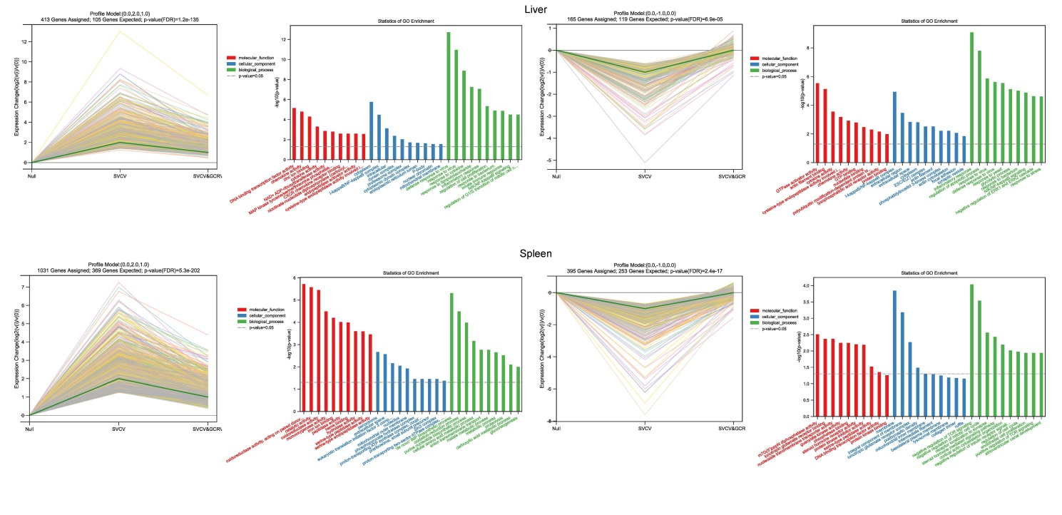
Supplementary Fig. S2. Gene profiles and GO analysis of representative gene modules in STEM analysis for different tissues.

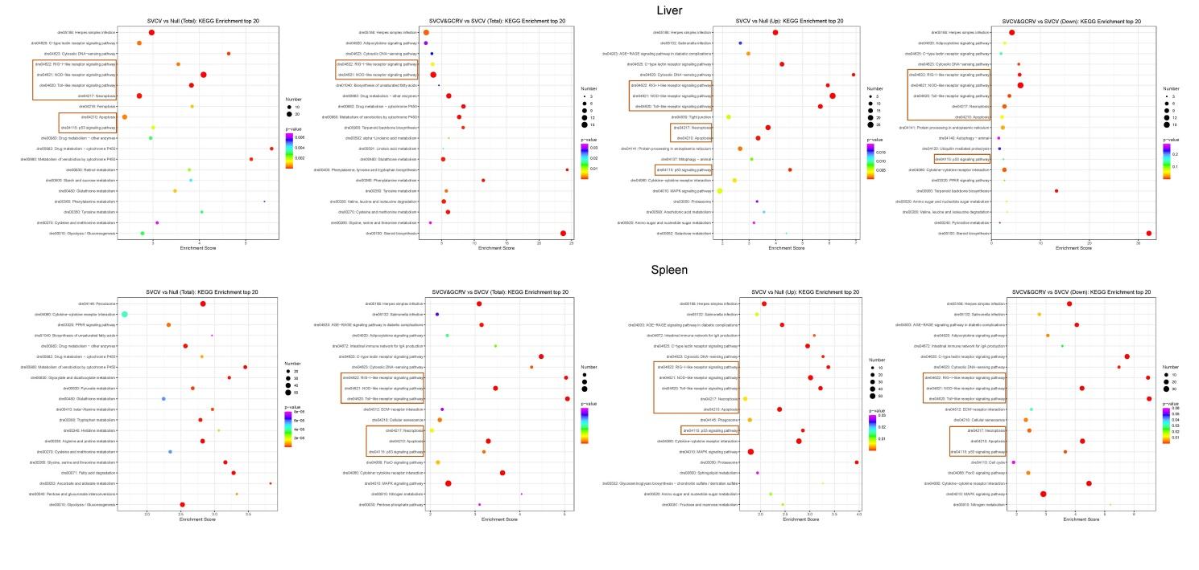
Supplementary Fig. S3. KEGG enrichment top 20 of two comparison groups (SVCV versus Null and SVCV&GCRV versus SVCV). Typical immune and cell-cycle related signaling pathways are framed in orange.

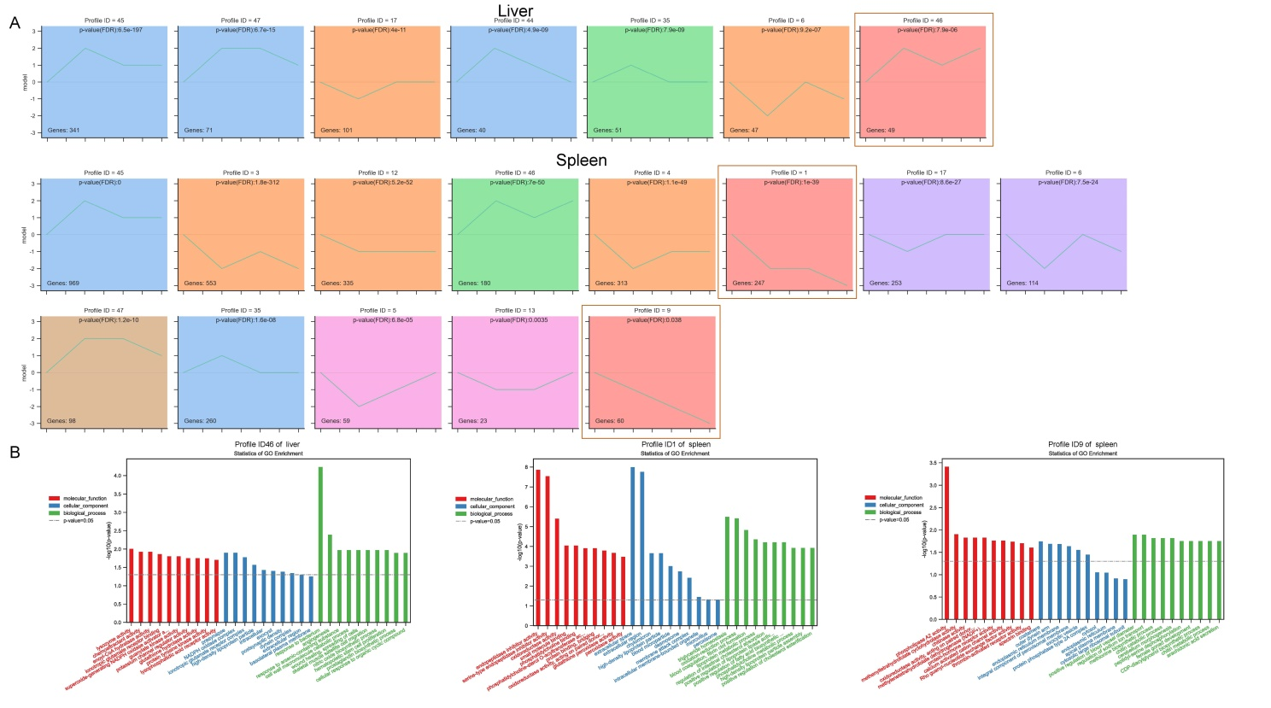
Supplementary Fig. S4. STEM analysis in liver and spleen tissues of zebrafish. Four different treatment groups (Null, SVCV, SVCV&GCRV and GCRV) of genes were analyzed. Gene modules with the same gene expression trends in the groups GCRV and SVCV were framed and subjected to GO analysis.

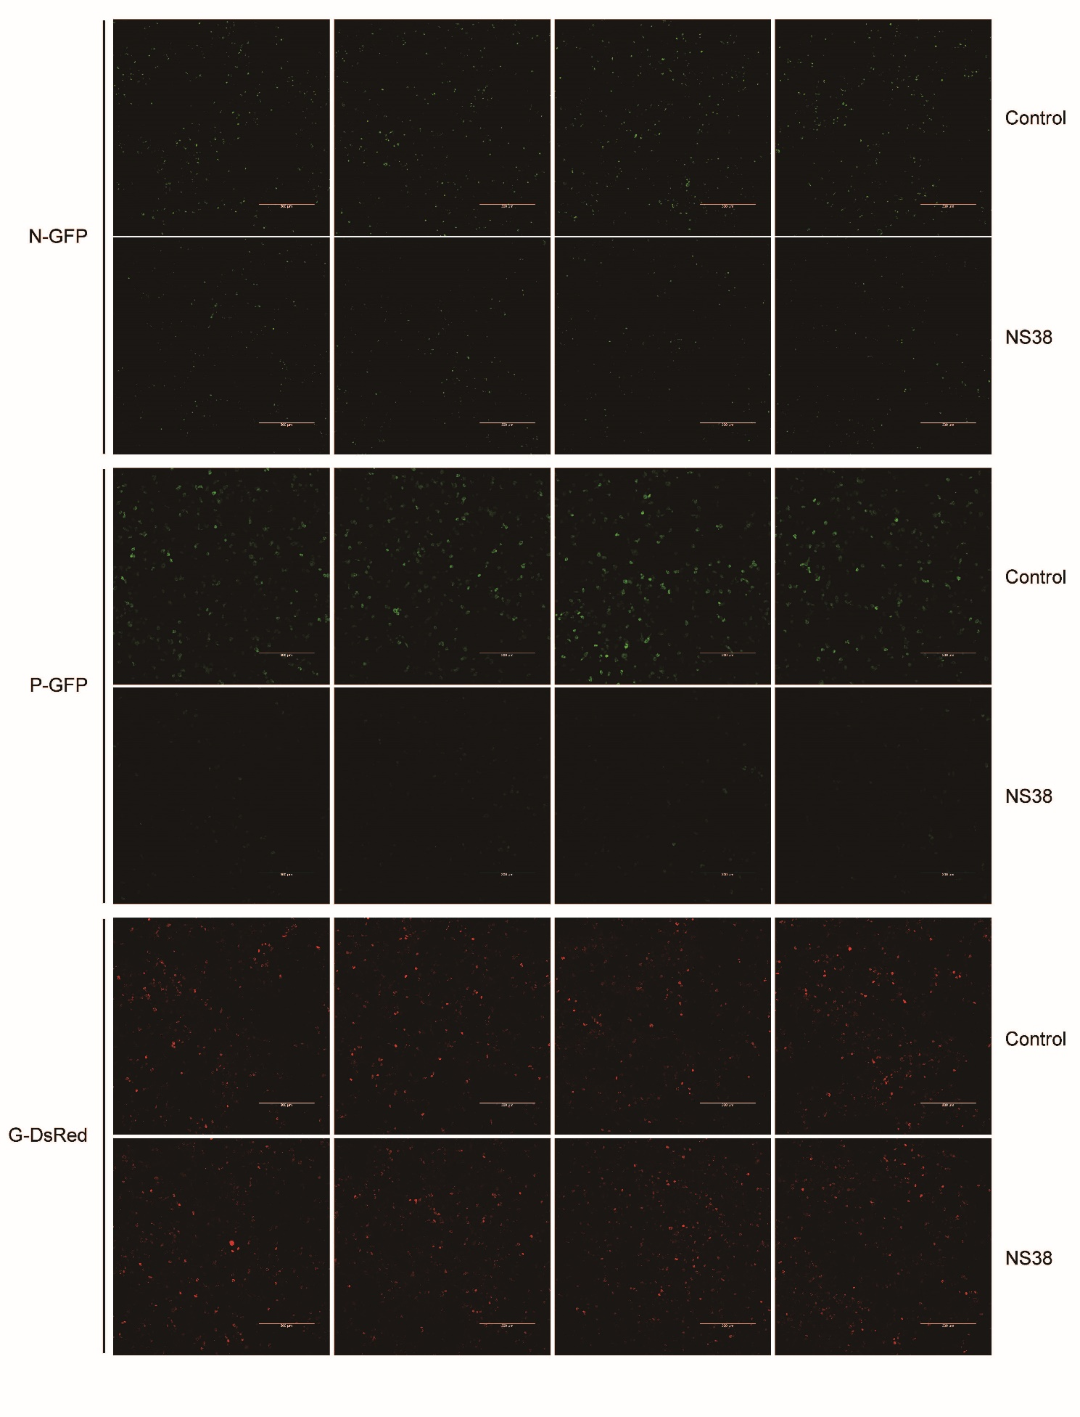
Supplementary Fig. S5. Reference images for fluorescence intensity analysis of NS38-induced fluorescently labelled N/P proteins degradation. EPC cells were plated onto coverslips in 6-well plates and transfected with indicated plasmids (1 μg each). After 24 h, the cells were fixed and subjected for confocal microscopy analysis. Green or red signals represent overexpressed N, P, and G proteins (original magnification 10×; Non-immersion objective). Scale bar, 300 μm.

