Virologica Sinica

Supplementary Data

A visual assay panel for the identification of monkeypox virus DNA belonging to the clades I and II

Pei Huangª, Zanheng Huangª, Meihui Liuª, Yujie Baiª, Hongli Jinª, Jingbo Huangª, Xingqi Liuª, Zhenhong Guanª, Ming Duanª, Haili Zhangª, Yuanyuan Liª, Sandra Chiu^{b,*}, Hualei Wang^{a,*}

ª State Key Laboratory for Diagnosis and Treatment of Severe Zoonotic Infectious Diseases, Key Laboratory for Zoonosis Research of the Ministry of Education, Institute of Zoonosis, and College of Veterinary Medicine, Jilin University, Changchun, 130062, China
^{b} Division of Life Sciences and Medicine, University of Science and Technology of China, Hefei, 244199, China

* Corresponding authors.
E-mail addresses: wanghualei@jlu.edu.cn (H. Wang), qiux@ustc.edu.cn (S. Chiu)

Plasmids and viruses
The sequence of the clade I (GenBank No. NC_003310.1) and the clade II published in 2022 (GenBank No. ON563414.3) were used as templates for designing primers and probes in this study. The recombinant plasmid pUC57-clade I containing the F3 L, D13 L, D14 L, D15 L, D16 L, D17 L and D18 L genes of clade I (GenBank No. NC_003310.1) was synthesized, meanwhile, the recombinant plasmid pUC57-clade II containing the F3 L and D18 L genes of clade II (GenBank No. ON563414.3) was synthesized (Sangon Biotech, Shanghai, China). The total DNA isolated from Vero cells infected with HSV-2 strain G (ATCC® VR-734D™), and DNA of VSV Oka-BK WGS strain (GenBank No. MF898328) were given by Professor Bin Yu of Jilin University. The DNA of VACV TianTan strain (GenBank No. AF095689.1) was presented by Professor Na Feng of Changchun Veterinary Research Institute.
Primer design
Prior to the study, in order to confirm the target, the gene sequences of 14 MPXV strains, VACV, and cowpox virus were aligned and analysed using MEGA7 software (Supplementary Fig. S1). Preliminary data suggest that the F3 L gene could use as the universal target for the clades I and II. The N-terminal of D18 L gene shares a 70 bp crossover gene fragment with the C-terminal of D13 L gene. Furthermore, the clade II exhibited a 1953 bp deletion after the D13 L and D18 L crossover gene fragment spanning between the D14L to D17L genes compared to the clade I. Given this, this unique sequence was used to design primers to distinguish the two clades. The specific primers and probes of the visual assay panel were designed and were able to distinguish between two clades (Supplementary Table S1).
RAA amplification reaction for MPXV two clades
The recombinant plasmids pUC57-clade I and pUC57-clade II was used as the template for the RAA assay, and the RAA reaction solution was prepared using the RAA nfo kit (Bio-Sci&Tech, Hangzhou, China). The total reaction volume was 50 μL and contained 2 μL of each primer (10 μmol/L), 0.6 μL of probe (10 μmol/L), 25 μL of rehydration buffer, 2 μL of template and 15.9 μL of ddH₂O. The above 47.5 μL mixture was added to the reaction tube with lyophilized powder after it was mixed well and blown on until completely dissolved. Then, 2.5 μL of 280 mmol/L magnesium acetate solution was added, and the reaction tube was incubated within 20 min. Subsequently, the reaction solution was loaded onto a closed vertical flow visualization strip (Ustar Biotechnologies, Hangzhou, China) for detection.
Optimization of amplification conditions
The recombinant plasmids pUC57-clade I and pUC57-clade II containing F3 L and D18 L genes of clade I or clade II respectively, with a concentration of 1 × 10¹¹ copies/μL, were subjected to 10-fold serial dilution to 1 × 10⁻¹ copies/μL, and were used as templates for this panel. Amplification was performed at 37 °C, 39 °C and 42 °C for 20 min, respectively. Followed the instructions, the RAA reaction mixture was prepared using the RAA nfo kit. The result showed that both the F3 L and D18 L assays could detect as low as of 1 copy/μL recombinant plasmids at 39°C (Supplementary Fig. S2). The result of F3 L assay was positive only when the plasmid concentration was ≥ 10 copies/μL plasmids at 37 °C and 42 °C. The amplification efficiency of D18 L assay was slower at 42°C than 37°C. Considering that the operation of the panel for MPXV should not be too complicated, 39 °C was recommended as optimal reaction temperature for both F3 L and D18 L assays.
Different concentrations of recombinant plasmids (ranging from 1 × 10⁻¹–1 × 10² copies/μL) were used as templates for this panel. Amplification was performed at 39 °C for 10 min, 20 min, or 30 min, respectively. The results showed that the red band was visible in the test line of strip when the template concentration was higher than 100 copies/μL with 10 min of amplification in F3 L assay, while D18 L assay could detect as lower as 10 copies/μL of plasmid with 10 min of amplification. But 1 copy/μL recombinant plasmid could be identified within 20 min or 30 min of amplification in both assays (Supplementary Fig. S3). Therefore, the optimal amplification time for this panel was 20 min.
Real-time PCR assay targeting MPXV F3 L gene
According to the instructions of PerfectStart® II Probe real-time PCR SuperMix (TransGen Biotech, Beijing, China), 20 μL reaction mixture contained 10 μL of 2× PerfectStart® II Probe real-time PCR SuperMix, 6.7 μL of ddH₂O, 0.4 μL of 10 μmol/; primers, 0.1 μL of 10 μmol/L probe, 0.4 μL of the Enzyme Mix, and 2 μL of the template. The amplification reaction was performed using a Step One Plus Real-Time PCR Systems (Thermo fisher scientific, Massachusetts, USA), and thermal cycling was performed at 94 °C for 30 s and 40 cycles of 94 °C for 5 s and 60 °C for 30 s.
Supplementary Table S1 Primers and probes of the RAA-VF assays and real-time PCR for the MPXV.
Primer Name | Sequence（5′ to 3′） | Assay
F3 L-F | Biotin-AACACCTTTCCAATAAATAATTTTTTTAACCG | The RAA-VF assay targeting F3 L gene
F3 L-R | TTGGTCTACGACAATGGATGCTGATACACGGC
F3 L-P | FAM-CTGATACACGGCCTACAGATTCTGATGCTGA[THF]GCTATAATAGATGATGTATCCCG-C3 spacer
D18 L-F | Biotin-CCAATTCATTTCTAATAGTATCAAACTCTCCA | The RAA-VF assay targeting D18 L gene
D18 L-R | TATAAGGATGTTTAACTTTTCTAAAAGATA
D18 L-P | FAM-AAACTATATAATACGTCGATGTCAGAAATAATCAACA[THF]TATTACTGCGGTGAC  -C3 spacer
F3 L_upper | 5′-CATCTATTATAGCATCAGCATCAGA-3′ | Real-time PCR assay targeting F3 L gene
F3 L_lower | 5′-GATACTCCTCCTCGTTGGTCTAC-3′
F3 L_probe | FAM-5′-TGTAGGCCGTGTATCAGCATCCATT-3′-BHQ1

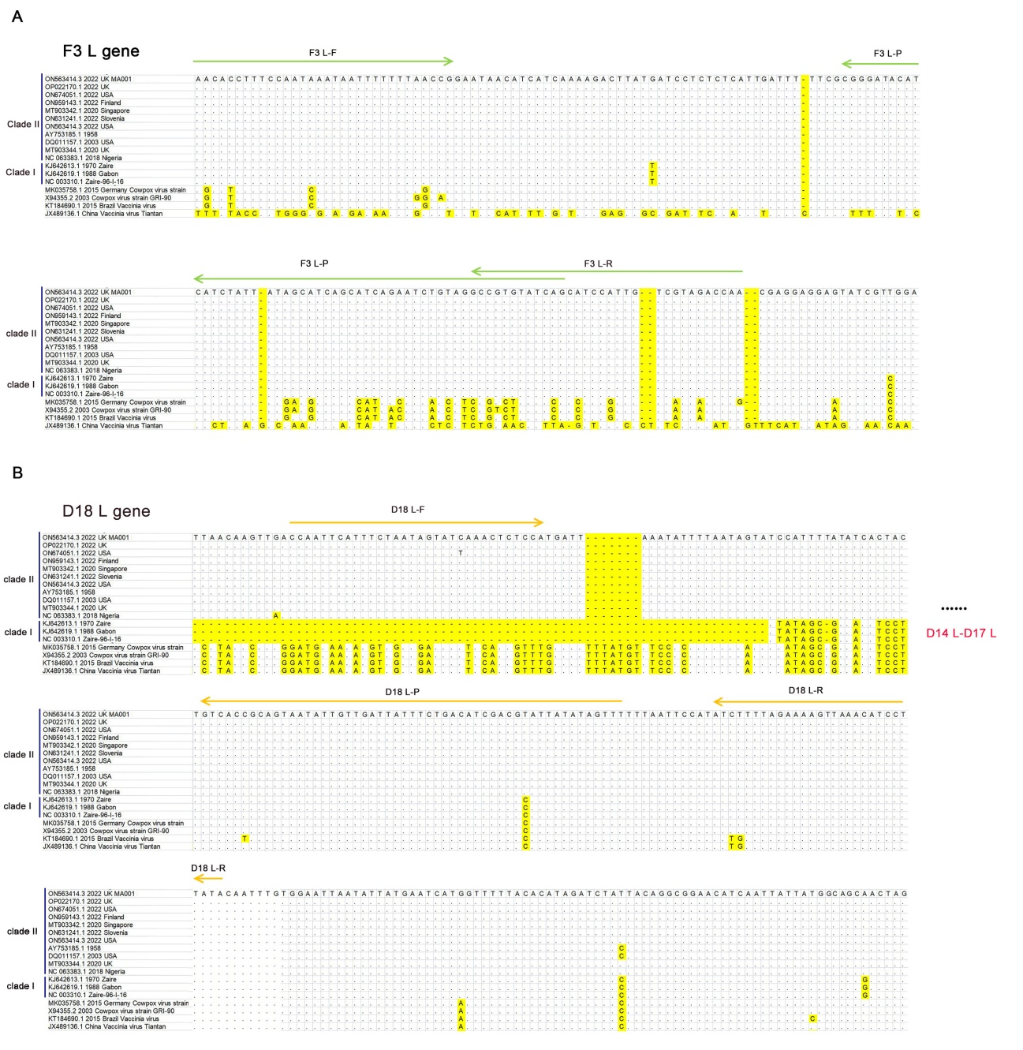
Supplementary Fig. S1 The primers and probes for visual assay panel are aligned with the targeted DNA sequence of two clades of MPXV and other orthopoxvirus. A The primers and probe sequence of F3 L gene are completely homologous between clades I and II. B The deletion of D14 L, D15 L, D16 L and D17 L genes of clade II compared with clade I. And lost sequence is located between the D18 L-F and D18 L-P.
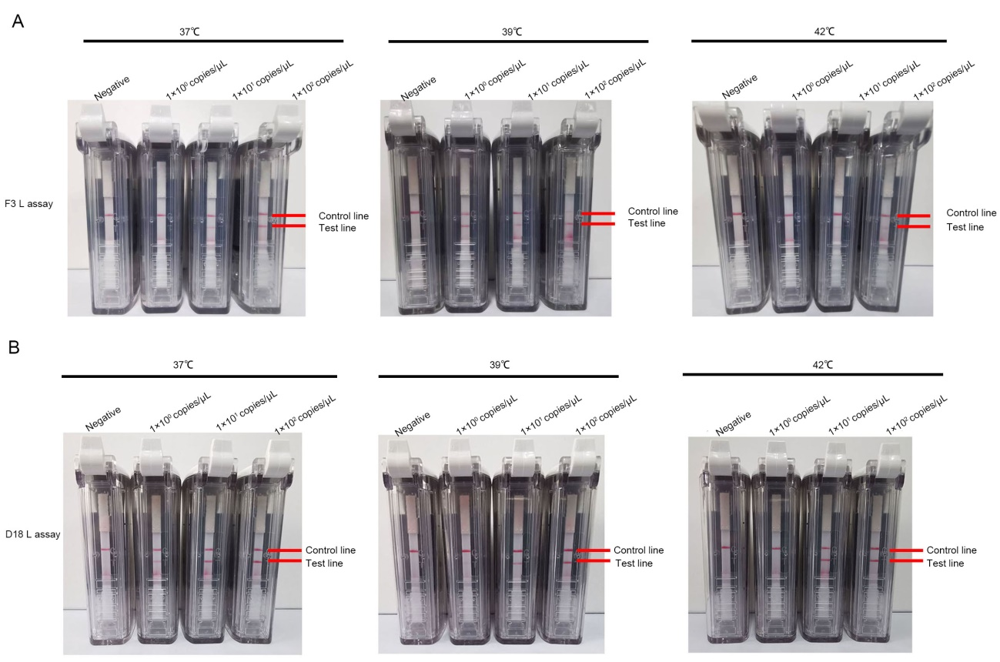
Supplementary Fig. S2 Optimization of amplification temperatures for the MPXV visual assays panel. The plasmids containing F3 L and D18 L gene of MPXV clade I or clade II, with a concentration of 1 × 10¹¹ copies/μL, were subjected to 10-fold serial dilution to 1 × 10⁻¹ copies/μL and were used as templates for this panel. Amplification was performed at 37 °C, 39 °C or 42 °C for 20 min, respectively. The results showed that both the F3 L and D18 L assays could detect as low as 1 copy/μL of recombinant plasmids at 39 °C. A Different concentrations of plasmids were utilized as templates for F3 L assay at 37 °C, 39 °C, and 42 °C, respectively. B Multiple concentrations of plasmids were employed as templates for RAA amplification at 37 °C, 39 °C, and 42 °C, for screening the optimal temperature for amplification.
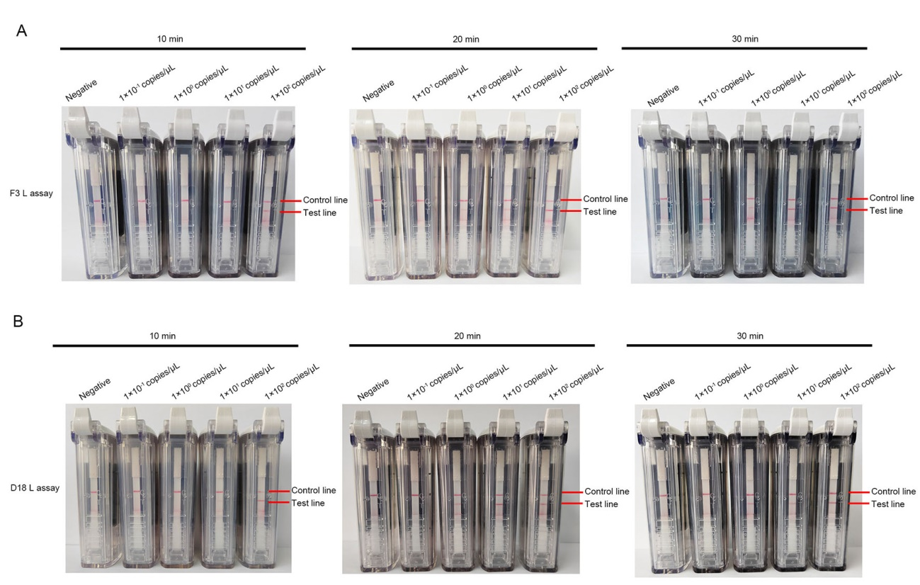
Supplementary Fig. S3 Optimization of amplification time for the MPXV visual assays panel. Different concentrations of plasmids (ranging from 1 × 10⁻¹ – 1 × 10² copies/μL) were used as templates for this panel. Amplification was performed at 39 °C for 10 min, 20 min, or 30 min, respectively. A Determination of the optimal timing for conducting the F3 L assay. B Optimization of amplification time for the D18 L assay.

