Virologica Sinica

Supplementary Data

Fish ACE2 is not susceptible to SARS-CoV-2

Shi-Zhe Xie^{a,b}, Mei-Qin Liu^{a,b}, Ren-Di Jiang^{a,b}, Hao-Feng Lin^{a,b}, Wei Zhangª, Bei Liª, Jia Su^{a,b}, Fei Ke^{c}, Qi-Ya Zhang^{c}, Zheng-Li Shiª, Xing-Lou Yangª*

a. CAS key laboratory of special pathogens, Wuhan Institute of Virology, Chinese Academy of Sciences, Wuhan 430071, China.
b. University of Chinese Academy of Sciences, Beijing 100049, China
c. State Key Laboratory of Freshwater Ecology and Biotechnology, Institute of Hydrobiology, Chinese Academy of Sciences, Wuhan 430072, China

*Corresponding author,
Email: Yangxl@wh.iov.cn (X-L Yang), ORCID: 0000-0002-5317-8983

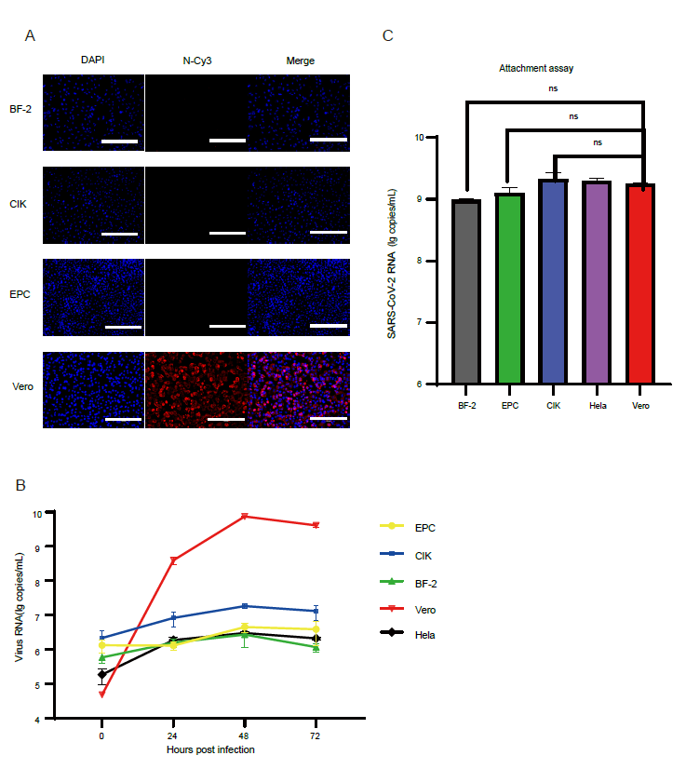

Fig. S1 Susceptibility of different fish cells to SARS-CoV2
(A)SARS-CoV-2 N protein expression was detected by IFA using the rabbit anti-SARS-CoV-2 N protein polyclonal antibody followed by Cy3-conjugated goat anti-rabbit IgG. Scale bars, 200 µm. (B)Viral RNA copies in supernatant were quantified by qRT-PCR in triplicates. The supernatant was harvested at 0, 24, 48, and 72 hpi. (C) The cells were harvested and viral RNA was extracted for determining the virion attachment at the cell surface.

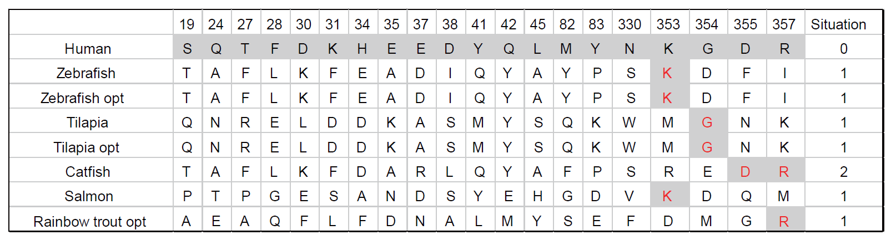
Fig. S2 Characteristics of the SARS-CoV-2 RBD-binding residues of fish ACE2s. The 8 ACE2s (including human) are shown in the right column. 20 residues of hACE2 which are crucial in the interaction with the SARS-CoV-2 RBD are listed. The red letters indicate the identical aa residues in the 7 fish ACE2 sequences as human ACE2.

