Virologica Sinica

Supplementary Data

Isolation and oral immunogenicity assessment of porcine epidemic diarrhea virus NH-TA2020 Strain: one of the predominant strains circulating in China from 2017 to 2021

Xiaowen Li ^{a, c, 1}, Yang Li ^{a, c, 1}, Jiapei Huang ^{a, c}, Yali Yao ^{b}, Wenying Zhao ^{b}, Yunjing Zhang ^{b}, Jie Qing ^{a, c}, Jing Ren ^{d}, Zhong Yan ª, Zewei Wang ^{a, c}, Xiaofang Hu ^{a, c}, Duli Kang ^{e}, Hongqiang Liu ^{e}, Zhichun Yan ^{a, c, *}

ª New Hope Liuhe Co., Ltd., Chengdu, 610041, China.
^{b} National Research Center for Veterinary Medicine, Luoyang, 471000, China;
^{c} Shandong New Hope Liuhe Agriculture and Animal Husbandry Technology Co., Ltd. (NHLH Academy of Swine Research), Dezhou, 253034, China.
^{d} Swine Health Data and Intelligent Monitoring Project Laboratory, Dezhou University, Dezhou, 253011, China.
^{e} Pulike Biological Engineering Inc., Luoyang, 471000, China.

*Corresponding author:
Email: Jasonynh@126.com (Z. Yan)
ORCID: orcid.org/0000-0001-7297-9578

¹ Xiaowen Li and Yang Li contributed equally to this work.

Table S1 Primers information used in this study.
Primers | Sequences (5’-3’) | Product Length/bp
PEDV-F | TTCGGTTCTATTCCCGTTGATG | 663
PEDV-R | CCCATGAAGCACTTTCTCACTATC
TGEV-F | TTACAAACTCGCTATCGCATGG | 528
TGEV-R | TCTTGTCACATCACCTTTACCTGC
PDCoV-F | GACCCTAAATCTGCCGTTAGAG | 543
PDCoV-R | TGTTGGAGAGGTGAATGCTATG
PoRV-F | CCCCGGTATTGAATATACCACAGT | 333
PoRV-R | TTTCTGTTGGCCACCCTTTAGT
PEDV-S1-F | TTTGTGGCTTTTCTAATC | 2286
PEDV-S1-R | CACCTATGTTACTATACACC
PEDV-N-F | GAGGGTGTTTTCTGGGTTG | 226
PEDV-N-R | TGCCTCTGTTGTTACTTGG
PEDV-S-1-F | ACAATGTTCTGTACCAGTGTT | 1300
PEDV-S-1-R | TTAAACCTCAGAGCCTCTGGTGCA
PEDV-S-2-F | TGTCCAATGATTCCACTTTGG | 1588
PEDV-S-2-R | CTCATACTAAAGTTGGTGGG
PEDV-S-3-F | ATTCTAATGATGGCTCTAATTG | 1605
PEDV-S-3-R | AAACATCTAGAGAAAGACTTG
PEDV-S-4-F | TTGAGAGTTGTGTGGTCACC | 1105
PEDV-S-4-R | AACAATTTGATGTTGCGAAAAG

Table S2 Viral shedding of NH-TA2020 strain infected gilts.
Gilts NO. | Weeks after immunization
 | 1 | 2 | 3 | 4 | 5 | 6 | 7 | 8 | 9
1 | + | + | + | + | - | - | - | - | -
2 | + | + | + | + | + | - | - | - | -
3 | + | + | + | + | - | - | - | - | -
4 | + | + | + | + | + | - | - | - | -
5 | + | + | + | - | + | - | - | - | -
6 | + | + | + | + | - | - | - | - | -
Six gilts were challenged with 2×10⁷ TCID₅₀ NH-TA2020 viruses orally 60 days before delivery (corresponding to group A and group C of Table 3). Disinfection was performed every day and PEDV RNA was detected every week by qPCR. Six gilts delivered at the 8th week. +: positive; -: negative.

Table S3 The GenBank accession numbers for nucleotide sequences.
PEDV strains | Accession NO.
CH-JX-YT3-2021 | ON168750
CH-JS-YC349-2021 | ON168751
CH-JS-XZ672-2020 | ON168752
CH-HeB-XJXM7-2020 | ON168753
CH-GX-XZC304-2021 | ON168754
CH-JX-XRC186-2021 | ON168755
CH-SD-XJ-2020 | ON168756
CH-HeB-TS75-2020 | ON168757
CH-HeN-TQ1-2021 | ON168758
CH-HeN-RZF8-2020 | ON168759
CH-JS-RG-2020 | ON168760
CH-ShaanXi-PC-2021 | ON168761
CH-GX-IM253-2021 | ON168762
CH-SD-LQL6-2020 | ON168763
CH-GX-LP74-2021 | ON168764
CH-SD-LY241-2020 | ON168765
CH-SD-LYXJA68-2020 | ON168766
CH-SD-LYGZG250-2020 | ON168767
CH-SD-LYDWJ01-2020 | ON168768
CH-SD-LX9-2020 | ON168769
CH-GX-LB58-2021 | ON168770
CH-LN-KPE18-2021 | ON168771
CH-LN-KPA4-2021 | ON168772
CH-JX-6-2021 | ON168773
CH-Shanxi-HR301-2020 | ON168774
CH-Shanxi-HRP3-2021 | ON168775
CH-HuB-900-2020 | ON168776
CH-HuN-HN839-2021 | ON168777
CH-LN-HS23-2020 | ON168778
CH-Shaanxi-HY1-2021 | ON168779
CH-SC-GY7-2021 | ON168780
CH-JS-DHA426-2020 | ON168781
CH-SD-BZC53-2021 | ON168782
CH-GS-BYC195-2021 | ON168783
CH-HeN-AY112-2021 | ON168784
CH-SC-AYC500-2020 | ON168785
CH-SC-SZ1704-2017 | ON168786
CH-SD-XJ1710-2017 | ON168787
CH-SD-XJ1704-2017 | ON168788
CH-SD-XJ1703-2017 | ON168789
CH-SD-LY1803-2018 | ON168790
CH-SD-LY1711-2017 | ON168791
CH-SD-LY1702-2017 | ON168792
CH-SD-LS1803-2018 | ON168793
CH-SD-LS1712-2017 | ON168794
CH-SD-LS1702-2017 | ON168795
CH-SD-LQ1803-2018 | ON168796
CH-SD-LQ1712-2017 | ON168797
CH-SD-LQ1802-2018 | ON168798
CH-SD-LQ1706-2017 | ON168799
CH-SD-LK1801-2018 | ON168800
CH-HeB-HS1711-2017 | ON168801
CH-SD-GM1701-2017 | ON168802
NH-TA2020 | ON168803
CH-HeB-RY-2020 | ON168804
CH-LN-KJW-2021 | ON168805
CH-SD-SX-2020 | ON168806
CH-GX-LP-2021 | ON168807
CH-AH-XX-2021 | ON168808
CH-HeB-HH-2021 | ON168809
CH-GS-GS1-2021 | ON168810
CH-HuN-HY-2021 | ON168811
CH-HuB-LH-2021 | ON168812
CH-LN-2021 | ON168813
CH-LN-SY-2021 | ON168814
CH-IM-TL-2020 | ON168815
CH-SD-DY-2021 | ON168816
CH-HeB-HS-2021 | ON168817
CH-AH-WH-2021 | ON168818
CH-HuB-GL-2021 | ON168819
CH-IM-ZN-2021 | ON168820
CH-BJ-2021 | ON168821
CH-GS-2021 | ON168822
CH-GS-LZ-2021 | ON168823
CH-SD-LS-2020 | ON168824
CH-HeB-HHY-2020 | ON168825
CH-HuB-LQ-2020 | ON168826
CH-HeB-QHY-2020 | ON168827
CH-HeB-FC-2020 | ON168828
CH-HeB-XQH-2020 | ON168829
CH-SD-XJYF-2018 | ON168830
CH-SD-XJ-2018 | ON168831
CH-HeB-HS-2018 | ON168832
CH-HeB-FHS-2018 | ON168833
CH-SD-XJ-2017 | ON168834
CH-SD-LY-2019 | ON168835
CH-SC-QS-2019 | ON168836
CH-SC-KQTP-2019 | ON168837
CH-SC-XP-2019 | ON168838
CH-SC-QQ1-2018 | ON168839
CH-SC-RC-2018 | ON168840
CH-SC-SW-2018 | ON168841
CH-SC-YM-2018 | ON168842
CH-SC-JY-2019 | ON168843
CH-SC-SZ-2019 | ON168844
CH-SC-QQ-2019 | ON168845
CH-SC-TZ-2019 | ON168846
CH-SC-JH-2020 | ON168847
CH-SC-DYS5-2020 | ON168848
CH-SC-DY1-2018 | ON168849
CH-SC-SZF1-2018 | ON168850
CH-SC-TZ-2018 | ON168851
CH-SC-XP1-2018 | ON168852
CH-SC-SZ4-2020 | ON168853

Figure S1. The isolation and identification of PEDV NH-TA2020 strain. A Detecting the causative agents of the diarrhea material. The small intestine of a piglet with diarrhea was collected. The potential diarrhea agents, including TGEV (lane 4), PDCoV (lane 5), PoRV (lane 6) were detected using specific primers listed in Supplementary Table S1 by PCR, respectively. The PEDV positive sample control (lane 1), the negative sample control (lane 2), the negative nucleic acid extraction control (lane 3), and the diarrhea material (lane 7) were detected using specific primers of PEDV-F and PEDV-R by PCR. M, DL 2000 Marker. B The complete sequence of PEDV S gene was amplified in four reactions using specific primers by PCR. 1, fragment of S-1; 2, fragment of S-2; 3, fragment of S-3; 4, fragment of S-4.

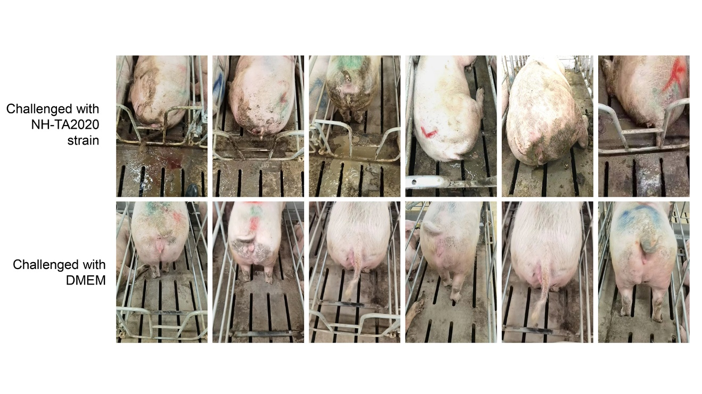

Figure S2. NH-TA2020 strain exhibited strong pathogenicity in gilts. Six gilts were challenged with 2×10⁷ TCID50 NH-TA2020 viruses orally 60 days before delivery (corresponding to group A and group C of Table 3). The clinical symptoms including depression, diarrhea and anorexia were found in all six gilts within three days after immunization. The negative control gilts were treated with DMEM and no clinical symptoms of PED was observed.

