Virologica Sinica

Supplementary Data

Recombinant chimpanzee adenovirus vector vaccine expressing the spike protein provides effective and lasting protection against SARS-CoV-2 infection

Yali Hao^{a#}, Siyuan Wang^{a#}, Mujie Zhangª, Qingxue Tangª, Canxing Mengª, Liping Wang^{b}, Qilian Fanª, Yaxian Yan^{c}, Xiang Xiao^{a,d}, Huahua Jian^{a,d*} Mingqing Lu^{a,b,c#}, Kunpeng Liu^{b,c,#}, Yun Peng^{d,#}, Zhe Ding^{a,c,#}, Yingwen Li^{a,c}, Alexander Tendu^{a,c}, Xue Hu^{b}, Ge Gao^{d}, Weiwei Guo^{b,c}, Hang Liu^{d}, Juhong Rao^{b,c}, Jiaxuan Zhao^{b,c}, Miaoyu Chen^{d}, Zhiming Yuan^{d}, Gary Wong^{a,*}, Chao Shan^{b,*}, Yanfeng Yao^{d,*}, Jiaming Lan^{a,*}

ª CAS Key Laboratory of Molecular Virology & Immunology, Institut Pasteur of Shanghai，Chinese Academy of Sciences, Shanghai, 200031, China
^{b} State Key Laboratory of Virology, Chinese Academy of Sciences, Wuhan, 430071, China
^{c} University of Chinese Academy of Sciences, Beijing, 100049, China
^{d} Center for Biosafety Mega-Science, Wuhan Institute of Virology, Chinese Academy of Sciences, Wuhan, 430071, China

#Mingqing Lu, Kunpeng Liu, Yun Peng and Zhe Ding contributed equally to this work.
*Corresponding Authors:
jmlan@ips.ac.cn (J Lan); yaoyf@wh.iov.cn (Y. Yao); shanchao@wh.iov.cn (C. Shan); garyckwong@ips.ac.cn (G. Wong)

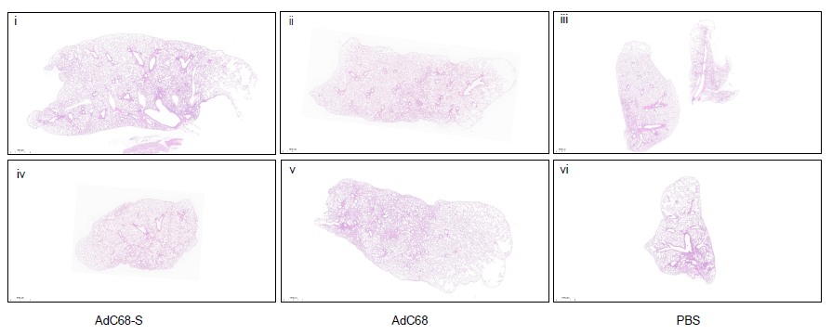
Figure S1. The panoramic scans for the transgenic mice given 1 (i to iii) or 2 dose (iv to vi) immunizations after challenge with SARS-CoV-2 at 21 days after the last vaccination.

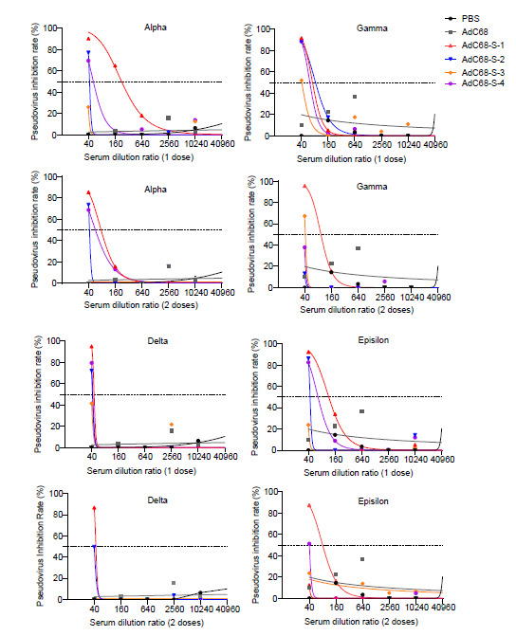
Figure S2. Neutralization of different SARS-CoV-2 variant pseudovirus at 6 months after 1 dose and 2 doses immunization. Different variants of SARS-CoV-2 include Alpha, Gamma, Delta and Epsilon respectively. The vaccine had the highest neutralization ability against the Alpha variants of SARS-CoV-2, while it has the least neutralization ability against the Delta variants.

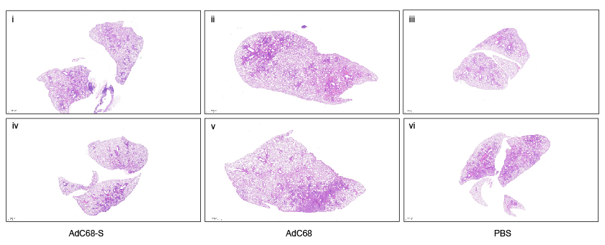
Figure S3. The panoramic scans for the wild-type mice given 1 (i to iii) or 2 dose (iv to vi) immunizations after challenge with SARS-CoV-2 at 6 months after the last vaccination.

