Virologica Sinica

Supplementary Data

A Pair of SARS-CoV-2 Nucleocapsid Protein Monoclonal Antibodies Shows High Specificity and Sensitivity for Diagnosis
An-Kai Zhuª, Sa-Sa Liª, Shu-Pei Yuª, Zhao-Yong Zhang^{b}, Huan Liª, Jing-Feng Liª, Shan-Shan Gaoª, Heng Chenª, Jincun Zhao^{b}, Run Shi^{a, *}, Mingjian Lu^{c, *}, Chaoyang Li^{a, *}

a Affiliated Cancer Hospital and Institute of Guangzhou Medical University, State Key Laboratory of Respiratory Disease, Key Laboratory for Cell Homeostasis and Cancer Research of Guangdong High Education Institute, 78 Heng Zhi Gang Road, Guangzhou, 510095, China.
b State Key Laboratory of Respiratory Disease, National Clinical Research Center for Respiratory Disease, Guangzhou Institute of Respiratory Health, The First Affiliated Hospital of Guangzhou Medical University, Guangzhou, 510182, China.
c Department of Interventional Radiology, Affiliated Cancer Hospital and Institute of Guangzhou Medical University, 78 Heng Zhi Gang Road, Guangzhou, 510095, China.

*Corresponding authors:
chaoyangli@gzhmu.edu.cn (C. Li);
Email: runshi@gzhmu.edu.cn (R. Shi);
Email: sange1234@sina.com (M. Lu)

Supplementary Materials
ELISA for screening hybridoma cells
For all ELISA reactions, the volume of each well is kept at 100 μL. To screen hybridoma cells, full length SARS-CoV-2 N protein (200 μg/well) was used to coat the ELISA plates. After blocking the plates with 3% BSA in Phosphate-buffered saline (PBS), culture medium from each well was loaded (100 μL) into the corresponding well of the ELISA plates at 25 ℃for one hour. Bound mAb was further detected with HRP conjugated goat anti-mouse secondary antibody (1:10,000) in blocking buffer for one hour. After rinse with PBS for six times, the ELISA plates were subjected for color development with Tetramethylbenzidine TMB). Finally, the colorimetric reaction was sopped and the ELISA plates were read at OD450 nm. The positive clones were collected and the experiments were repeated at least three times.
To investigate the specificity of the mAbs to N proteins of different coronaviruses, N proteins of SARS-CoV-2, HCoV-229E, SARS-CoV-1, and MERS-CoV (50 ng/well) were used to coat the ELISA plate. The plate was then blocked with 3% BSA in PBS at 4℃ overnight with constant rocking. Purified mAbs (50 ng/well) were then loaded in blocking solution and added into ELISA plate wells for one hour at room temperature. All the other steps were the same as those in screen hybridoma cells.
To identify the domain of SARS-CoV-2 N protein recognized by different mAbs, full length and truncated SARS-CoV-2 N protein (50 ng/well) were used to coat the ELISA plate. All the other steps were the same as those in investigating the specificity of the mAbs.
To determine which mAbs pair have the best sensitivity, the ELISA plate was coated with 1C7, 4F10, or 2G11 (100 ng/well). The plate was then blocked with 3% BSA in PBS at 4℃ overnight with constant rocking. After blocking, different concentrations of SARS-CoV-2 N protein in blocking solution were added for one hour. We then added bio-2G11, bio-1C7, or bio-4F10 (50 ng/well) into the ELISA plate as indicated. The reaction was kept for an additional hour at room temperature. Finally, biotin associated with bound mAbs was detected with HRP conjugated streptavidin (1:10,000) for one hour at room temperature. All the other steps were the same as those in screen hybridoma cells.
To determine the sensitivity and specificity of the 2G11/bio-1C7 mAbs combination, the ELISA plate was coated with 2G11 (50 ng/well) and then blocked with 3% BSA in PBS at 4℃ overnight with constant rocking. After blocking, different concentrations of SARS-CoV-2 N protein or control proteins used at the same concentrations were added for one hour. We then added bio-1C7 in blocking solution for an additional hour. All the other steps were the same as those in determining which mAbs pairs have the best sensitivity.

Karyotyping of the hybridoma cells
Hybridoma cells at metaphase were cultured in the presence of colchicine (0.0002%) for six hours. After rinse with PBS and the cells were resuspended as a single cell suspension in 75 mmol/L KCl at 37℃ for 20 minutes. The cells were then fixed twice with Carnoy solution A (3 volume of methanol: 1 volume of acetic acid) and centrifuged at 300 ×g for 10 minutes. The resuspended cells were further fixed with Carnoy solution B (1 volume of methanol: 1 volume of acetic acid) at room temperature for 20 minutes. Hybridoma cells were finally stained with Giemsa solution.

Construction of plasmids
To express SARS-CoV-2 N protein in mammalian cells, the plasmid containing SARS-CoV-2 N protein was amplified with primers F2&R2. The Kozak sequence (GCCACC) was inserted upstream of the transcription starting site. At the carboxyl terminus of the protein, a HA tag sequence was added for the purpose of identification. Please see Supplementary Table S3 for detail.

To express truncated SARS-CoV-2 N protein, the plasmid containing SARS-CoV-2 N protein was amplified with primers FP (N1–173), RP (N1–173); FP (N130–291), RP (N130–291); FP (N263–419), RP (N263–419) as listed in Supplementary Table S3.

Western blotting
To detect the specificity of the mAbs, proteins in cell lysate (50 μg/lane) were separated by 10% SDS-PAGE. The separated proteins were further transferred onto nitrocellulose membrane and blocked in 3% BSA in PBS for three hours at room temperature. Purified mAb (1 ng/μL) was diluted in blocking solution and the reaction was performed at 4℃ overnight with constant rocking. The bound mAb was then detected with a HRP conjugated goat anti-mouse specific polyclonal antibody (1:10,000) for one hour at room temperature. HRP enzymatic activity was revealed by Electro-Chemi-Luminescence (ECL).

To detect which domain of SARS-CoV-2 N protein was recognized by different mAbs, prokaryotic expressed truncated proteins (1 μg/lane) was purified and separated by 10% SDS-PAGE. All the other steps were the same as detecting the specificity of the mAbs.

Immunofluorescence (IF) staining
To investigate if the mAbs could be used for IF assays, 293T cells expressing SARS-CoV-2 N protein were cultured on poly-D-lysine coated glass-bottomed petri dish for 14 hours. The cells were then rinsed and fixed in 4% paraformaldehyde at room temperature for 15 minutes. After fixation, the cells were rinsed three times and blocked in 3% BSA in PBS containing 0.5% goat serum for one hour. mAbs (10 ng/μL) was then loaded into the blocking solution and the reaction was kept at room temperature for an additional one hour. Bound primary antibodies were detected with alex fluor 555 nm conjugated goat anti-mouse IgG (1:2,000) for one hour in dark. Nuclei were counter stained with DAPI. The cells were then immersed with antifade solution and were subjected for confocal laser microscopy observation.

Immunization of male BALB/c mice was performed according to schedules in Supplementary Table S1.

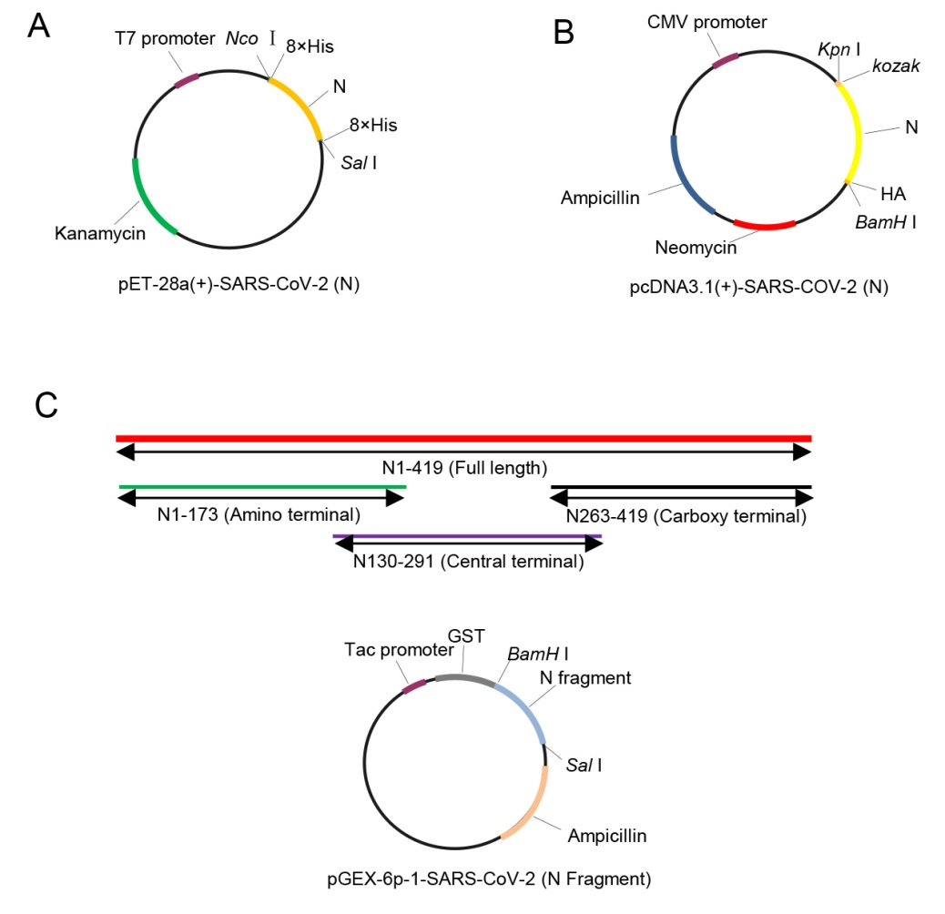
Figure S1 A Schematic description of the constructs. The N protein of SARS-CoV-2 was inserted between the Nco I and Sal I multiple cloning sites of the pET28a (+) vector. 8 histidine (His) were inserted at the amino- and carboxyl- terminal domains of the gene. Primers used for cloning were listed in Supplementary Table S3. The ATG of the enzyme restriction site Nco I is used as the starting codon for the fusion protein, and two bases of GC were added between the restriction enzyme sites and His-tag to avoid code shift mutations. B Schematic description of the constructs used to express SARS-CoV-2 N protein which was inserted between the Kpn I and BamH I restriction sites of the pcDNA3.1 (+) vector. Primers used for cloning were listed in Supplementary Table S3. C Schematic description of the constructs expressing truncated SARS-CoV-2 N proteins. The different truncated N genes of SARS-CoV-2 were inserted between the BamH I and Sal I restriction sites of the pGEX-6p-1 vector, respectively. Primers used for cloning were listed in Supplementary Table S3.

Table S1. Procedure for immunizing mice
Immune order | Immunization schedule (day) | Antigen dose (μg) | Method of immunization
1 | 0 | 100 in 100 μL CFA | Intraperitoneal (IP)
2 | 14 | 50 in 50 μL iCFA | IP
3 | 28 | 50 | Intravenous (IV)
4 | 29 | 50 | IV
5 | 30 | 50 | IV
CFA: Complete Freund's Adjuvant; iCFA: incomplete Freund's Adjuvant

Table S2. Subtype identification of Monoclonal Hybridoma Cell Lines
mAbs | Subclasses of heavy chain | Isotype of light chain
1C7 | IgG1 | λ
1D5 | IgG1 | λ
2E11 | IgG1 | λ
2G11 | IgG1 | к
3C6 | IgG1 | к
4F10 | IgG1 | λ
5E11 | IgG1 | λ

Table S3. Primers used for expressing recombinant SARS-CoV-2 N protein
Primer | Sequence
F1 (Nco I+8×His) | 5’-CATGCCATGGGCCACCACCACCACCACCACCACCACATCTCTGATAATGGACCCCAAAAT-3’
R1 (Sal I+8×His) | 5’-ACGCGTCGACTTAGTGGTGGTGGTGGTGGTGGTGGTGGGCCTGAGTTGAGTCCGCACTGC-3’
F2 (Kpn I+kozak) | 5’-GGGGTACCGCCACCATGTCTGATAATGGACCCCAAAAT-3’
R2 (HA+BamH I) | 5’-CGGGATCCTTAAGCGTAGTCTGGGACGTCGTATGGGTAGGCCTGAGTTGAGTCCGCA-3’
FP (N1–173) | 5'-GGATCCATCTGATAATGGAC-3'
RP (N1–173) | 5'-GTCGACTTATGCGTAGAAGCCTTTTGGC-3'
FP (N130–291) | 5'-GGATCCATCATATGGGTTGCAACTG-3'
RP (N130–291) | 5'-GTCGACTTATAGTTCCTGGTCCCCAA-3'
FP (N263–419) | 5'-GGATCCACTGCCACTAAAGCATAC-3'
RP (N263–419) | 5'-GTCGACTTAGGCCTGAGTTGAGTCC-3'
F1&R1 are primers used to express SARS-CoV-2 N protein in pET28a (+) vector; F2&R2 are primers used to express SARS-CoV-2 N protein in pcDNA3.1 (+) vector; All the other primers are used to express truncated SARS-CoV-2 N protein in pGEX-6p-1 vector.

Table S4. List of blood sample information
Sample No. | ID | Sample | ID | Sample No. | ID
1 | HD1 | 17 | #1,0127 | 33 | #18,0220
2 | HD2 | 18 | #3,0113 | 34 | #18,0226
3 | HD3 | 19 | #3,0202 | 35 | #19,0220
4 | HD4 | 20 | #4,0202 | 36 | #20,0217
5 | HD5 | 21 | #4,0223 | 37 | #20,0223
6 | HD6 | 22 | #7,0224 | 38 | #23,0226
7 | HD7 | 23 | #9,0208 | 39 | Ncov6,0229
8 | HD8 | 24 | #9,0217 | 40 | Ncov10,0226
9 | G2,0617 | 25 | #10,0223 | 41 | Ncov11,0226
10 | G2,0630 | 26 | #11,0208 | 42 | Ncov20,0226
11 | G4,0617 | 27 | #11,0223 | 43 | B14,0206
12 | G7,0617 | 28 | #13,0211 | 44 | B17,0209
13 | G9,0617 | 29 | #15,0220 | 45 | B19,0214
14 | G10,0617 | 30 | #16,0209 | 46 | B20,0214
15 | G12,0617 | 31 | #16,0220 | 47 | Y2,0303
16 | G15,0617 | 32 | #17,0217
ID; Identification; HD: health donor; All the other IDs started with G, #, B, and Y are patient blood samples with numbers after comma being the date of samples obtained. For example, G2,0617 is the blood sample obtained from patient G2 on date June 17th.

