Virologica Sinica

Supplementary Data

Establishment and Characterization of a New Cell Culture System for Hepatitis B Virus Replication and Infection
Yingying Song ª, Shuyu Shou ª, Huimin Guo ^{a,b,e}, Zixiang Gao ª, Nannan Liu ª, Yang Yang ª, Feifei Wang ª, Qiang Deng ª, Jing Liu ^{a, d, *}, Youhua Xie ^{a, c, *}

ª Key Laboratory of Medical Molecular Virology (MOE/NHC/CAMS) and Department of Medical Microbiology and Parasitology, School of Basic Medical Sciences, Shanghai Institute of Infectious Diseases and Biosecurity, Shanghai Medical College, Fudan University, Shanghai 200032, China
^{b} Institute for Hepatology, National Clinical Research Center for Infectious Disease, Shenzhen Third People’s Hospital, Shenzhen 518112, China
^{c} Children’s Hospital, Fudan University, Shanghai 201102, China
^{d} Shanghai Key Laboratory of Medical Epigenetics, Institutes of Biomedical Sciences, School of Basic Medical Sciences, Shanghai Medical College, Fudan University, Shanghai 200032, China
^{e} The Second Affiliated Hospital, School of Medicine, Southern University of Science and Technology, Shenzhen 518112, China

* Corresponding Authors:
Email: yhxie@fudan.edu.cn (Y. Xie); liujing212@fudan.edu.cn (J. Liu)
ORCID: Jing Liu (0000-0002-9728-8893); Youhua Xie (0000-0002-2416-7708)

Table S1. Primers used for real-time PCR
Primers | Sequence (5’-3’)
HNF4α-F | CGAAGGTCAAGCTATGAGGACA
HNF4α-R | ATCTGCGATGCTGGCAATCT
NTCP-F | AAGGACAAGGTGCCCTATAAAGG
NTCP-R | TTGAGGACGATCCCTATGGTG
β-actin-F | CACCAACTGGGACGACAT
β-actin-R | ACAGCCTGGATAGCAACG
Core-F | AATGCCCCTATCTTATCAACACT
Core-R | GAGATTGAGATCTTCTGCGACG
pgRNA (HBV2270F) | GAGTGTGGATTCGCACTCC
pgRNA (HBV2392R) | GAGGCGAGGGAGTTCTTCT
cccDNA (ccc-1582F)  cccDNA (ccc-2316R) | TGCACTTCGCTTCACCT  GACCACCAAATGCCCCT

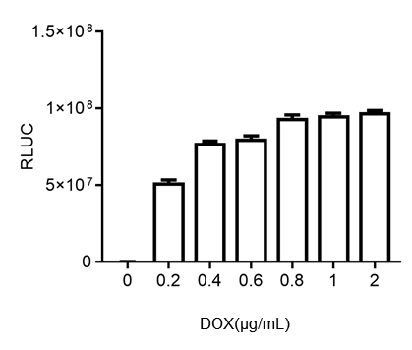
Figure. S1. Determination of optimal DOX concentration for induction of Tet-on system. 7404NT-HNF4α cells were transfected with pTRE-Luc plasmid and cultured in different concentrations of DOX. Luciferase Reporter System Detection kit (Promega) was used to analyze luciferase expression 48 hours later. No obvious changes in cell morphology were observed at the concentrations used.

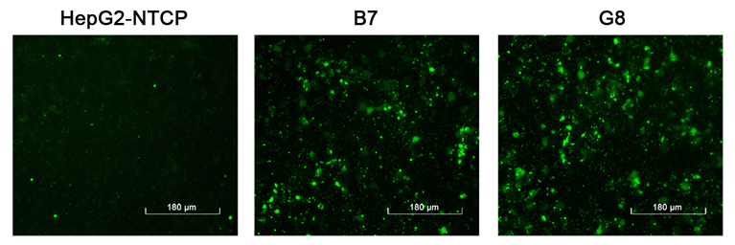

Figure. S2. Transfection efficiency of chemically synthesized siRNA was compared using FAM-labelled control siRNA to transfect HepG2-NTCP, B7 and G8 cells. Cells cultured in 24-well plates (1.5×10⁵ cells per well) were transfected with 40 nmol per well FAM-siRNA and fluorescence at 48 hours was visualized.

