Virologica Sinica

Supplementary Data

Pathogenic analysis of coxsackievirus A10 in rhesus macaques

Suqin Duanª, Fengmei Yangª, Yanyan Liª, Yuan Zhaoª, Li Shiª, Meng Qin^{b}, Quan Liuª, Weihua Jinª,
Junbin Wangª, Lixiong Chenª, Wei Zhangª, Yongjie Liª, Ying Zhangª, Jingjing Zhangª,
Shaohui Ma^{a, *}, Zhanlong He^{a, *}, Qihan Li^{a, *}.

a. Institute of Medical Biology, Chinese Academy of Medical Sciences & Peking Union Medical College, Yunnan Key Laboratory of Vaccine Research Development on Severe Infectious Disease, Kunming 650118, China
b. Beijing Advanced Innovation Center for Soft Matter Science and Engineering College of Life Science and Technology, Beijing University of Chemical Technology, Beijing 100029, China

*Corresponding authors
Email addresses: liqihan@imbcams.com.cn (Q. Li); hzl@imbcams.com.cn (Z. He); shaohuima@imbcams.com.cn (S. Ma)

Supplementary Materials
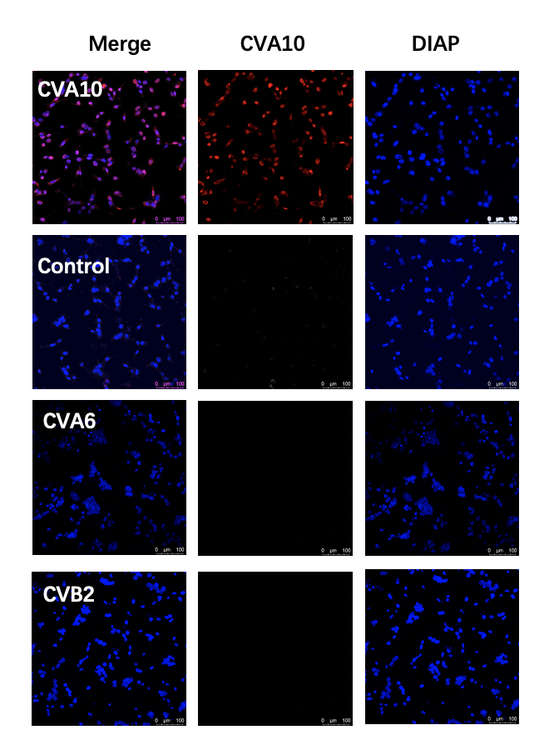
Supplementary Fig. S1. The specificity verification of CVA10 polyclonal antibody. Vero cells were infected by CV-A10, CV-A6, CV-B2 virus at MOI of 0.5. At 24h post infection, these cells were fixed in 4% paraformaldehyde for 60 min and then blocked using 4% bovine serum albumin. Then, the cells were sequentially incubated with purified CVA10 polyclonal antibody and secondary antibody Alexa Fluor® 647 Goat pAb to Rb IgG (Lot: GR33281 42-4, Abcam). All cell nuclei were detected with DAPI. Fluorescence was visualized at 647 nm and analyzed using a confocal microscope (TCS SP2, Leica).

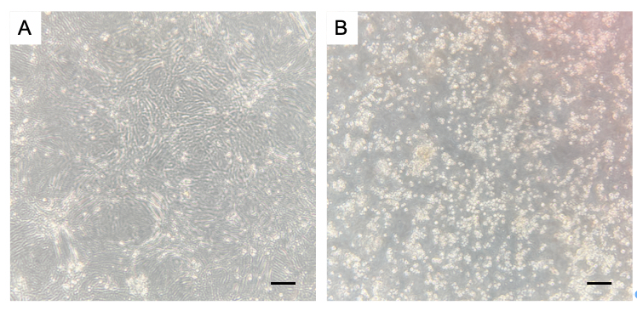
Supplementary Fig. S2. CPEs in Vero cells after viral isolation from rhesus monkey tissues at 10 d.p.i. A C1 rhesus control heart tissue; B rhesus B2 heart tissue. The black scale bar indicates 50 μm.

Supplementary Table S1. The genome sequencing results of viruses isolated from tissues.
Sample | Start | End | Match | Identity (%)
Reference sequence | 2157 | 2895 | 759 | 100%
lung | 2157 | 2895 | 756 | 99.99%
heart | 2157 | 2895 | 755 | 99.99%
liver | 2157 | 2895 | 758 | 99.99%
Note: Reference sequence: GenBank ID MK867823. The start and the end show the position in the sequence of the genome.

