Virologica Sinica

Supplementary Data

Similar aerosol emission rates and viral loads in upper respiratory tracts for COVID-19 patients with Delta and Omicron variant infection

Jiaming Li ^{a,} ¹, Yidun Zhang ^{b, 1}, Lina Jiang^{b, 1}, Hongliang Cheng ª, Jingjing Li ª, Li Li ^{b}, Zehui Chen ^{b},

Fei Tang ^{b}, Yingying Fu ª, Yifei Jin ª, Bing Lu ^{a,} *, Jing Zheng ^{b,} *, Zhongyi Wang ^{a,} *

ª Academy of Military Medical Sciences, Academy of Military Sciences in Beijing, Beijing 100071, China.
^{b} Xiamen Center for Disease Control and Prevention, Xiamen 361021, China.

¹ Jiaming Li, Yidun Zhang, and Lina Jiang contributed equally to this article.

*Corresponding authors:
Email addresses: zhongyi_wang@foxmail.com (Z. Wang), zhengjing1103@foxmail.com (J. Zheng), 13693506666@163.com (B. Lu);
ORCID : 0000-0002-8982-2806 (Z. Wang), 0000-0001-7123-5139 (J. Zheng), 0000-0003-0179-6146 (B. Lu);

Methods
1. Initial screening of SARS-CoV-2 in the exhaled breath condensates
SARS-CoV-2 in the exhaled breath condensate (EBC) was initially detected with a HONGSHI SLAN-96S Real-Time PCR Detection System (Shanghai Hongshi Medical Technology Co., LTD, Shanghai, China) by using a commercial kit (Liferiver, Shanghai ZJ Bio-Tech Co., Ltd, Shanghai, China). The cycling program was performed as followed: 45 °C for 10 min, 95 °C for 3 min, and 45 cycles at 95 °C for 15 s and 58 °C for 30 s.

2. Quantitative method by using SARS-CoV-2 RNA reference material
The viral load in all samples were further confirmed by using standard curve based on SARS-CoV-2 RNA reference material containing ORF1ab, N and E genes (provided by China National Institute of Metrology.
Each absolute quantitative experiment requires SARS-CoV-2 RNA reference material with concentrations of 10³ copies/mL, 10⁴ copies/mL, 10⁵ copies/mL, 10⁶ copies/mL, 10⁷ copies/mL, 10⁸ copies/mL. A standard curve containing the linear relationship between virus concentration and Ct values was drawn in each round of experiment. At the same time, the Ct value of EBC obtained by each nucleic acid amplification was substituted into the standard curve to calculate the viral concentration of EBCs. In this study, the corresponding relationship between the concentration of standard substance and Ct value (Supplementary Table S2), the standard curve (Supplementary Fig. S1), and the original Ct value and the calculation results (Supplementary Table S3 and Table S4) are described as followed.

3 Calculation of the breath emission rate
The exhaled breath in 5 min was collected and 800 µL exhaled breath condensate (EBC) was collected form each patient. Then 200 µL EBC was used for RNA extraction and finally got 50 µL RNA. A total of 4 µL RNA was used for reverse transcription reaction and got 20 µL of reverse transcription product (cDNA). Then the cDNA was further quantified by using standard plasmid containing spike gene of SARS-CoV-2. The breath emission rate of each patient was calculated by the following equation:
Breath emission rate (viruses/hour) = C_{cDNA}×V_{cDNA}×(V_{RNA}/V_{RNA for reverse})×(V_{EBC}/V_{EBC for RNA Extraction})×(60 min/T_{EBC})
Concentration in exhaled air (copies/m³) = Breath emission rate/Breathing rate
C_{cDNA}: the concentration of cDNA (copies/µL); V_{cDNA}: the overall volume of cDNA; V_{RNA}: the overall volume of RNA; V_{RNA for reverse}: the volume of RNA used for reverse transcription reaction; V_{EBC}: the overall volume of EBC; V_{EBC for RNA Extraction}: the volume of EBC used for RNA extraction; T_{EBC}: the time for EBC collection.

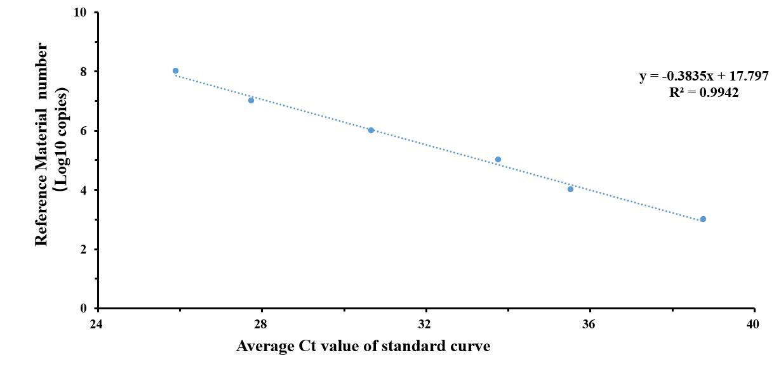

Figure S1. Standard curve in the absolute quantitative experiment for EBCs from the patients.

Table S1. The characteristics of patients with COVID-19.

Table S2. Relationship between standard substance concentration and Ct value in the absolute quantitative experiment for EBCs from the patients.
N gene reference material (Copies/mL) | N gene Ct values of reference material |  |  | Average N gene Ct values of reference material
10³ | 39.11 | 38.32 | 38.86 | 38.76
10⁴ | 35.47 | 34.68 | 36.44 | 35.53
10⁵ | 38.33 | 31.53 | 31.42 | 33.76
10⁶ | 28.21 | 28.46 | 35.35 | 30.67
10⁷ | 32.07 | 24.38 | 26.78 | 27.74
10⁸ | 28.63 | 20.79 | 28.3 | 25.9

Table S3. Original Ct value and the calculation results in the absolute quantitative experiment for EBCs from patient with Delta infection.
Patient ID | Ct values of EBCs for N gene | Absolute quantitative value (Copies/μL) | Average absolute quantitative value (Copies/μL)
3 | 36.09 | 9.05 | 617.89
11 | 39.4 | 0.49
18 | 33.53 | 86.75
19 | 39.68 | 0.38
25 | 29.52 | 2992.82

Table S4. Original Ct value and the calculation results in the absolute quantitative experiment for EBCs from patient with Omicron infection.
Patient ID | Ct values of EBCs for N gene | Absolute quantitative value (Copies/μL) | Average absolute quantitative value (Copies/μL)
1 | 35.72 | 12.54 | 58.52
3 | 34.92 | 25.42
6 | 33.32 | 104.42
7 | 33.14 | 122.41
8 | 37.51 | 2.58
12 | 40.46 | 0.19
34 | 40.43 | 0.20
36 | 33.57 | 83.73
37 | 40.3 | 0.22
40 | 40.61 | 0.17

