Virologica Sinica

Supplementary Data

Increased pathogenicity and aerosol transmission for one SARS-CoV-2 B.1.617.2 Delta variant over the wild-type strain in hamsters
Xinghai Zhang ^{a, 1, *}, Shaohong Chen ^{a, b, 1}, Zengguo Cao ^{a, 1}, Yanfeng Yao ^{a, 1}, Junping Yu ^{a, 1}, Junhui Zhou ^{a, b},
Ge Gao ª, Ping He ^{a, b}, Zhuo Dong ^{c}, Jie Zhong ^{c}, Jing Luo ^{c}, Hongping Wei ^{a, *}, Huajun Zhang ^{a, *}
ª State Key Laboratory of Virology, Key Laboratory of Special Pathogens and Biosafety, Wuhan Institute of Virology, Chinese Academy of Sciences, Wuhan, 430071, China.
^{b} University of Chinese Academy of Sciences, Beijing, 101409, China
^{c} Hubei International Travel Healthcare Center (Wuhan Customs Port Outpatient Department), Wuhan, 430040, China

¹ Xinghai Zhang, Shaohong Chen, Zengguo Cao, Yanfeng Yao, and Junping Yu contributed equally to this work.

* Corresponding authors:
E-mail addresses: hjzhang@wh.iov.cn (H. Zhang), hpwei@wh.iov.cn (H. Wei), zhangxh@wh.iov.cn (X. Zhang)
ORCID: 0000-0003-1677-5428 (H. Zhang); 0000-0002-9948-8880 (H. Wei); 0000-0001-8161-3949 (X. Zhang).
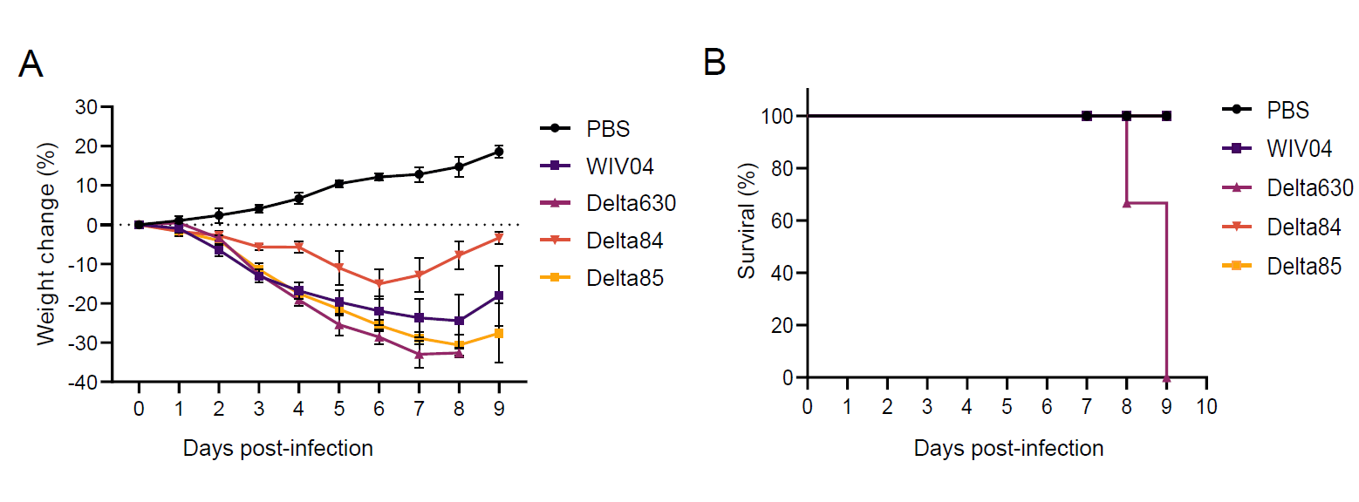Supplementary Figure S1 Loss of body weight and survival following SARS-CoV-2 infections. Golden hamsters aged 4–6 weeks were intranasal inoculated with 10 ³ PFU of WIV04 or Delta variant (Delta630, Delta84, and Delta85) (n = 3 per group). Body weights (A) and accumulated mortality (B) of infected hamsters were measured and recorded daily. Weight changes were expressed as the mean percent changes relative to the initial weights at day 0. Standard errors are shown as error bars.

Supplementary Table S1 Amino acid substitutions in amino acid sequences of WIV04 and different Delta variants. The table represents the specific sites (the positions of nucleotide and amino acid substitutions are listed) where substitutions were found after multiple sequence alignments with different strains.
Site |  | Virus
Nucleotide | Amino acid | WIV04 | Delta84 | Delta85 | Delta630
4181 | nsp3(488) | Ala | Ala | Ser | Ser
4752 | nsp3(678) | Thr | Thr | Thr | ILe
5184 | nsp3(822) | Pro | Leu | Pro | Leu
11332 | nsp6 (120) | Thr | Thr | Thr | Val
11418 | nsp6 (149) | Val | Ala | Val | Ala
12946 | nsp9 (87) | Tyr | Tyr | Tyr | Tyr
14408 | nsp12 (314) | Pro | Leu | Leu | Leu
15451 | nsp12 (662) | Gly | Ser | Ser | Ser
18176 | nsp14 (203) | Pro | Leu | Pro | Pro
19220 | nsp14 (320) | Ala | Ala | Val | Val
21618 | S (19) | Arg | Arg | Arg | Arg
21846 | S (95) | Thr | Thr | ILe | Thr
21987 | S (142) | Gly | Asp | Asp | Asp
22028-22039 | S (156-159) | Glu/Phe/Arg/Val | Glu/Phe/Gly/Val | Glu/Cys/Gly/Val | del(156-157)/Gly/Val
22917 | S (452) | Leu | Arg | Arg | Arg
22995 | S (478) | Thr | Lys | Lys | Lys
23403 | S (614) | Asp | Gly | Gly | Gly
23604 | S (681) | Pro | Arg | Arg | Arg
24410 | S (950) | Asp | Asn | Asn | Asn
24492 | S (977) | Leu | ILe | Leu | Leu
25469 | orf3a (26) | Ser | Leu | Leu | Leu
26767 | M (82) | ILe | Thr | Thr | Thr
27638 | orf7a (82） | Val | Ala | Ala | Ala
27666 | orf7a (91） | Glu | Glu | Asp | Glu
27752 | orf7a (120） | Thr | ILe | ILe | ILe
27740 | orf7a (116） | Leu | Phe | Leu | Leu
28245 | orf8 (118) | Leu | Leu | Val | Leu
28248-28253 | orf8 (119–120) | Asp/Phe | Val/Leu | Val/Leu | del
28461 | N (63) | Asp | Gly | Gly | Gly
28881 | N (203) | Arg | Met | Met | Met
28989-28991 | N (242) | Gln | del | Gln | Gln
29402 | N (377) | Asp | Tyr | Tyr | Tyr

Supplementary Table S2 Primer Sequences for qPCR of Hamster Gene Expression.
Gene | Description | Oligonucleotide sequence
Hamster ACTB | Primer 1 | 5′-GGC CAG GTC ATC ACC ATT-3′
 | Primer 2 | 5′-GAG TTG AAT GTA GTT TCG TGG ATG-3′
 | Probe | 5′-FAM-TTT CCA GCC TTC CTT CCT GGG TAT G-BHQ-3′
Hamster IFN-γ | Primer 1 | 5′-TTT CTC CAT GCT GCT GTT GAA-3′
 | Primer 2 | 5′-GGC CAT CCA GAG GAG CAT AG-3′
 | Probe | 5′-FAM-CAC CAT CAA GGC AGA CCT GTT TGC TAA CTT-BHQ-3′
Hamster IFNλ | Primer 1 | 5′-CCC ACC AGA TGC AAA GGA TT-3′
 | Primer 2 | 5′-CTT GAG CAG CCA CTC TTC TAT G-3′
 | Probe | 5′-FAM-ACA TAG CCC GGT TCA AGT CTC TGC-BHQ-3′
Hamster IL-2 | Primer 1 | 5′-AAG CTC CTG TAA GTC CAG CAG TAA C-3′
 | Primer 2 | 5′-GTG CAC CCA CTT CAA GCT CTA A-3′
 | Probe | 5′-FAM-AGG AAA CCC AGC AGC ACC TCG AGC-BHQ-3′
Hamster IL-4 | Primer 1 | 5′-GGG TCA CCT CAT GTT GGA AAT AAA-3′
 | Primer 2 | 5′-CCA CGG AGA AAG ACC TCA TCT G-3′
 | Probe | 5′-FAM-CAG GGC TTC CCA GGT GCT TCG CAA GT-BHQ-3′
Hamster IL-6 | Primer 1 | 5′-GGT ATG CTA AGG CAC AGC ACA CT-3′
 | Primer 2 | 5′-CCT GAA AGC ACT TGA AGA ATT CC-3′
 | Probe | 5′-FAM-AGA AGT CAC CAT GAG GTC TAC TCG GCA AAA-BHQ-3′
Hamster IL-10 | Primer 1 | 5′-TTC TGG CCC GTG GTT CTC T-3′
 | Primer 2 | 5′-GTT GCC AAA CCT TAT CAG AAA TGA-3′
 | Probe | 5′-FAM-CAG TTT TAC CTG GTA GAA GTG ATG CCC CAG G-BHQ-3′
Hamster IP-10 | Primer 1 | 5′-GCC ATT CAT CCA CAG TTG ACA-3′
 | Primer 2 | 5′-CAT GGT GCT GAC AGT GGA GTC T-3′
 | Probe | 5′-FAM-CGT CCC GAG CCA GCC AAC GA-BHQ-3′
Hamster MX2 | Primer 1 | 5′-CCA GTA ATG TGG ACA TTG CC-3′
 | Primer 2 | 5′-CAT CAA CGA CCT TGT CTT CAG TA-3′
 | Probe | 5′-FAM-TGT CCA CCA GAT CAG GCT TGG TCA-BHQ-3′

