Virologica Sinica

Supplementary Data

Nonmuscle myosin IIA promotes the internalization of influenza A virus and regulates viral polymerase activity through interacting with nucleoprotein in human pulmonary cells

Jian Chen^{a, b, c, #}, Jian Liu^{c, #}, Zhilu Chen^{c}, Daobin Feng^{c}, Cuisong Zhu^{c}, Jun Fan^{c}, Shuye Zhang^{a, c, *}, Xiaoyan Zhang^{a, c, *}, Jianqing Xu^{a, c, *}

ª Clinical Center for Bio-Therapy, Zhongshan Hospital, Fudan University (Xiamen Branch), Shanghai, 200032, China;
^{b} Center for Infectious Disease Research, Science of Life Sciences, Westlake University, Hangzhou, 310024, China.
^{c} Shanghai Public Health Clinical Center & Institutes of Biomedical Sciences, Shanghai Medical College, Fudan University, Shanghai, 201508, China.

1Jian Chen and Jian Liu contributed equally to this work.

Corresponding authors.
xujianqing@fudan.edu.cn (J. Xu), ORCID: 0000-0003-0896-9273
zhangxiaoyan@fudan.edu.cn (X. Zhang), ORCID: 0000-0002-3193-1401
shuye_zhang@fudan.edu.cn (S. Zhang), ORCID: 0000-0002-4749-6790

Table S1. List of primers.
Primer name | Primer sequence
RT-NP- vRNA | GGCCGTCATGGTGGCGAATGAATGGACGGAGAACAAGGATTGC
RT-NP- cRNA | GCTAGCTTCAGCTAGGCATCAGTAGAAACAAGGGTATTTTTCTTT
RT-NP- mRNA | CCAGATCGTTCGAGTCGTTTTTTTTTTTTTTTTTCTTTAATTGTC
IAV NP vRNA-F | GGCCGTCATGGTGGCGAAT
IAV NP vRNA-R | CTCAATATGAGTGCAGACCGTGCT
IAV NP cRNA-F | GCTAGCTTCAGCTAGGCATC
IAV NP cRNA-R | CGATCGTGCCCTCCTTTG
IAV NP mRNA-F | CCAGATCGTTCGAGTCGT
IAV NP mRNA-R | CGATCGTGCCCTCCTTTG
PR8-NP-F | TGTGTATGGACCTGCCGTAGC
PR8-NP-R | CCATCCACACCACACCAGTTGACTCTTG
H7N9-NP-F | CAGTGAAGGGGATAGGGACA
H7N9-NP-R | CCAGGATTTCTGCTCTCTCG
MYH9-FW-BamHI | AAGCTTGGTACCGAGCTCGGATCCATGGCACAGCAAGCTGCCGATAAGT
MYH9-RE-ECORI | CTGTGCTGGATATCTGCAGAATTCTTACTGGGCCTGCAGCTTCCGCAG
pCAGGS-flag-F | GATTACAAGGATGACGACGATAAGTGACTCGAGGGTACCCCCGG
PB1-flag-R | ATCGTCGTCATCCTTGTAATCTTTTTGCCGTCTGAGCTCTTCAATG
PB2-flag-R | ATCGTCGTCATCCTTGTAATCATTGATGGCCATCCGAATCCTTTTG
NP-flag-R | TATCGTCGTCATCCTTGTAATCATTGTCATACTCCTCTGCATTGTC
PA-flag-R | ATCGTCGTCATCCTTGTAATCTCTTAGTGCATGTGTGAGGAAGGAG
MYH9-sgRNA1 | ACGCCACGTACGCCAGATAC
MYH9-sgRNA2 | CACGTGCCTCAACGAAGCCT

Supplementary Figures.
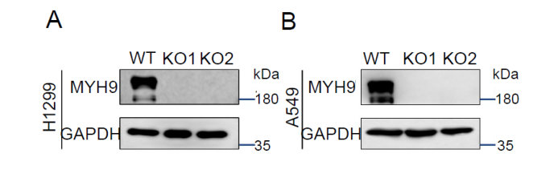
Figure. S1 MYH9 expression levels in wild type and MYH9 knockout H1299 and A549 clone cells. A Western blotting analysis on the knockout efficacy of MYH9 of H1299. B Western blotting analysis on the knockout efficacy of MYH9 of A549 cells.

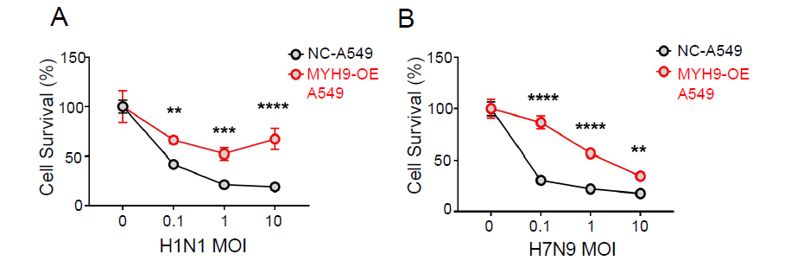
Figure. S2 MYH9 depletion prevents IAV-induced (A: H1N1_{PR8}, B: H7N9) cell death at varying viral doses. MOI = 0.1, 1, or 10. The data from three biological replicates are shown as the means (n=3). **, P < 0.01; ***, P < 001; ****, P < 0.0001.

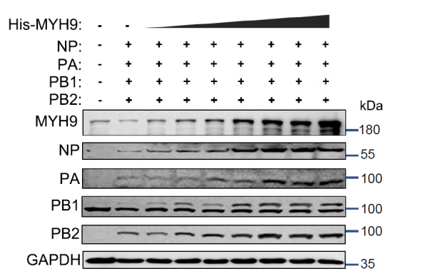
Figure. S3 MYH9 overexpression doesn’t affect the protein levels of IAV viral proteins. Immunoblot analysis of lysates from H1299 cells transfected with black vector or vector expressing NP, PB1, PB2, and PA with an increased dose of MYH9 for 24 h.

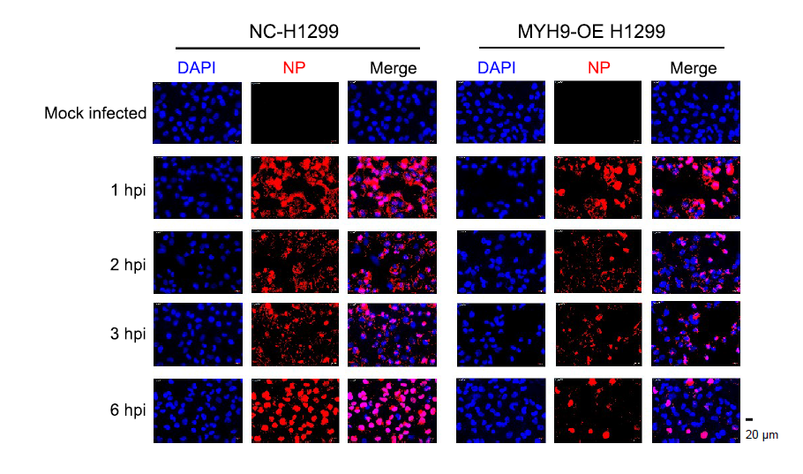
Figure. S4 The immunofluorescence images of NP protein. Immunofluorescence analyses of the binding and entry of H7N9 viruses in NC- and MYH9-H1299 cells. Cells were treated or untreated with H7N9 for 0, 1, 2, 3, and 6 hours. MOI=10. Scale bars, 20 μm. NP, red; DAPI, blue.

