Virologica Sinica

Supplementary Data

Integrated interactome and transcriptome analysis reveals key host factors critical for SARS-CoV-2 infection
Jie Sheng^{a, b, c, 1}, Lili Li^{a, b, 1}, Xueying Lv^{a, b, d}, Meiling Gao^{a, b}, Ziyi Chen^{a, b}, Zhuo Zhou^{a, b}, Jingfeng Wang^{a, b, *}, Aiping Wu^{a,b, *}, Taijiao Jiang^{a, b, e, f, *}
ª Institute of Systems Medicine, Chinese Academy of Medical Sciences & Peking Union Medical College, Beijing, 100005, China.
^{b} Suzhou Institute of Systems Medicine, Suzhou, 215123, China.
^{c} Institute of Basic Medical Sciences Chinese Academy of Medical Sciences, School of Basic Medicine Peking Union Medical College, Beijing, 100005, China.
^{d} Department of Microbiology and Parasitology, College of Basic Medical Sciences, China Medical University, Shenyang, 110122, China
^{e} Guangzhou Laboratory, Guangzhou, 510005, China
^{f} State Key Laboratory of Respiratory Disease, the First Affiliated Hospital of Guangzhou Medical University, Guangzhou Medical University, Guangzhou, 510120, China
¹Jie Sheng and Lili Li contributed equally to this work.
*Corresponding authors.
jiang_taijiao@gzlab.ac.cn (T. Jiang); wap@ism.cams.cn (A. Wu); wangjf@ism.cams.cn (J. Wang)
ORCID of all corresponding authors: 0000-0002-6071-0122 (T. Jiang); 0000-0002-5869-651X (A. Wu); 0000-0002-5170-3887 (J. Wang).

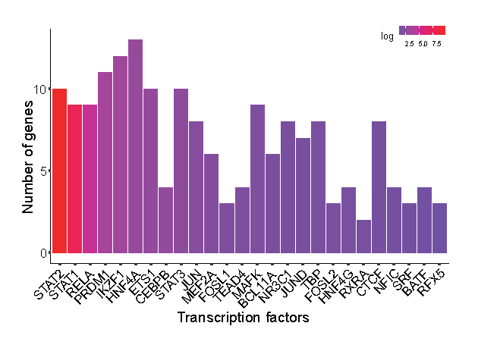
Figure S1. Prediction of upstream TFs that regulate the co-expression network. The ENCODE ChIP-seq library was chosen as the resource, with FET P-value < 0.05.
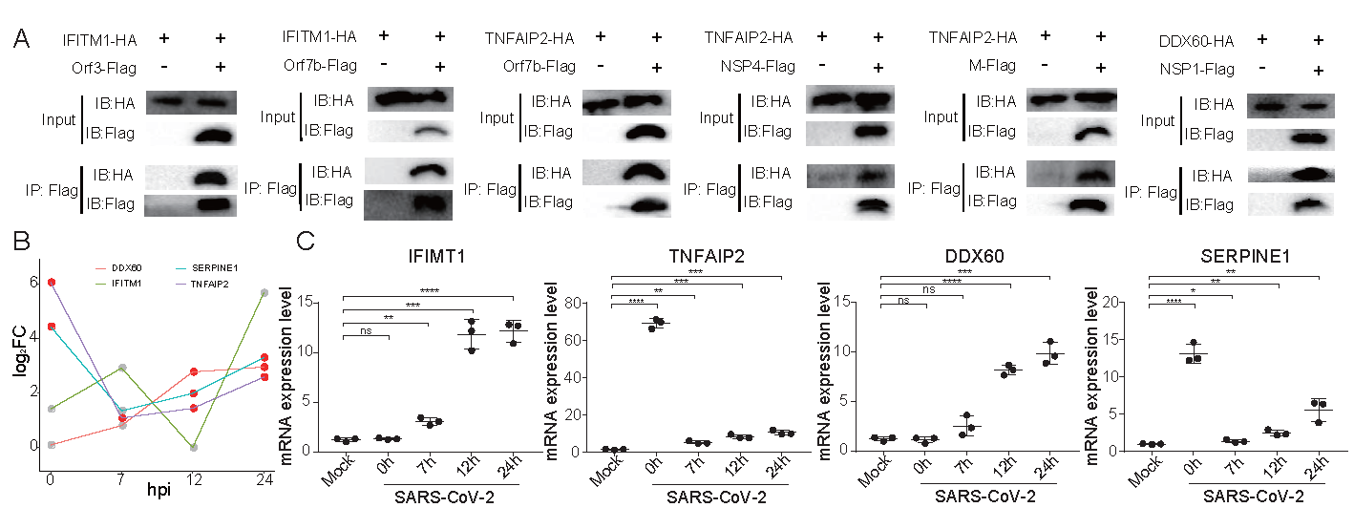
Figure S2. In vitro confirmation of key host factors. (A) Western blot analysis of lysates immunoprecipitated (IP) for Flag from HEK293T cells co-transfected with HA-tagged human IFITM1, TNFAIP2 and DDX60 expression plasmids and Flag-tagged SARS-CoV-2 viral proteins M, Orf7b, NSP4, Orf3, NSP1 and Orf8 expression plasmids. Western blot results are representative of three independent experiments. (B)Time-series expression of key host factors after SARS-CoV-2 infection. (C) qRT-PCR validation of key host factors expression. The label “mock” indicates mock samples at 0 hpi. The labels from 0 to 24 h represent infected samples at the indicated time points. Statistical significance is tested using t-test. "*" denotes significant difference and "ns" for no significance. The error bars represent mean ± SD. *P < 0.05, **P < 0.01, ***P < 0.001 and ****P < 0.0001.
(Please see separate excel files for supplementary Tables)

Table S1. Primers for RT-qPCR.
Table S2. Level 1: direct SARS-CoV-2-human PPIs
Table S3. Cellular component enrichment of SIPs for each viral protein.
Table S4. Biological process enrichment of SIPs for each viral protein.
Table S5. Detalis of transcriptomics data used for RRA
Table S6. GO and KEGG analysis of CLCGs.
Table S7. List of 35 core genes.
Table S8. TFs predicted to regulate the co-expression network.

