Virologica Sinica

Supplementary Data

Clinical practice of rapid antigen tests for SARS-CoV-2 Omicron variant: a single-center study in China

Mengyuan Chen^{a, 1}, Jiaqin Xu^{a, 1}, Lingjun Ying^{b}, Miaoguo Cai^{c}, Tao-Hsin Tung^{d}, Kai Zhouª, Yufen Zhengª, Xiaojie Biª, Jing Wangª, Xi Tuª, Bo Shen^{a, *}, Dongqing Lv^{e, *}

ª Department of Laboratory Medicine, Taizhou Hospital of Zhejiang Province affiliated to Wenzhou Medical University, Taizhou, 317000, China
^{b} Hepatology and Infectious Diseases Center, Taizhou Hospital of Zhejiang Province Affiliated to Wenzhou Medical University, Taizhou, 317000, China
^{c} Department of Radiation Oncology, Taizhou Hospital of Zhejiang Province Affiliated to Wenzhou Medical University, Taizhou, 317000, China
^{d} Evidence-based Medicine Center, Taizhou Hospital of Zhejiang Province Affiliated to Wenzhou Medical University, Taizhou, 317000, China
^{e} Department of Respiratory and Critical Diseases, Taizhou Hospital of Zhejiang Province affiliated to Wenzhou Medical University, Taizhou, 317000, China

* Corresponding author.
E-mail addresses: lvdq@enzemed.com (D. Lv), shenb@enzemed.com (B. Shen)

¹ Mengyuan Chen and Jiaqin Xu contributed equally to this work.

Supplementary Table S1 Evaluation of RAT performance (performed by professionals) in nasal swabs (n = 45) collected 6.80 ± 1.53 days after symptom onset from Omicron-infected patients compared with the RT-PCR results from nasopharyngeal swabs.

 | NAAT in NP swab
 | Ct value < 30 defines positive RT-PCR | Ct value < 38 defines positive RT-PCR
Sensitivity (%) | 79.17 | 51.35
Specificity (%) | 100.00 | 100.00
PPV (%) | 100.00 | 100.00
NPV (%) | 80.77 | 30.77
OPA (%) | 88.89 | 60.00
PPV, positive predictive value; NPV, negative predictive value; OPA, overall percent agreement, NAAT, nucleic acid amplification test; NP, nasopharyngeal.

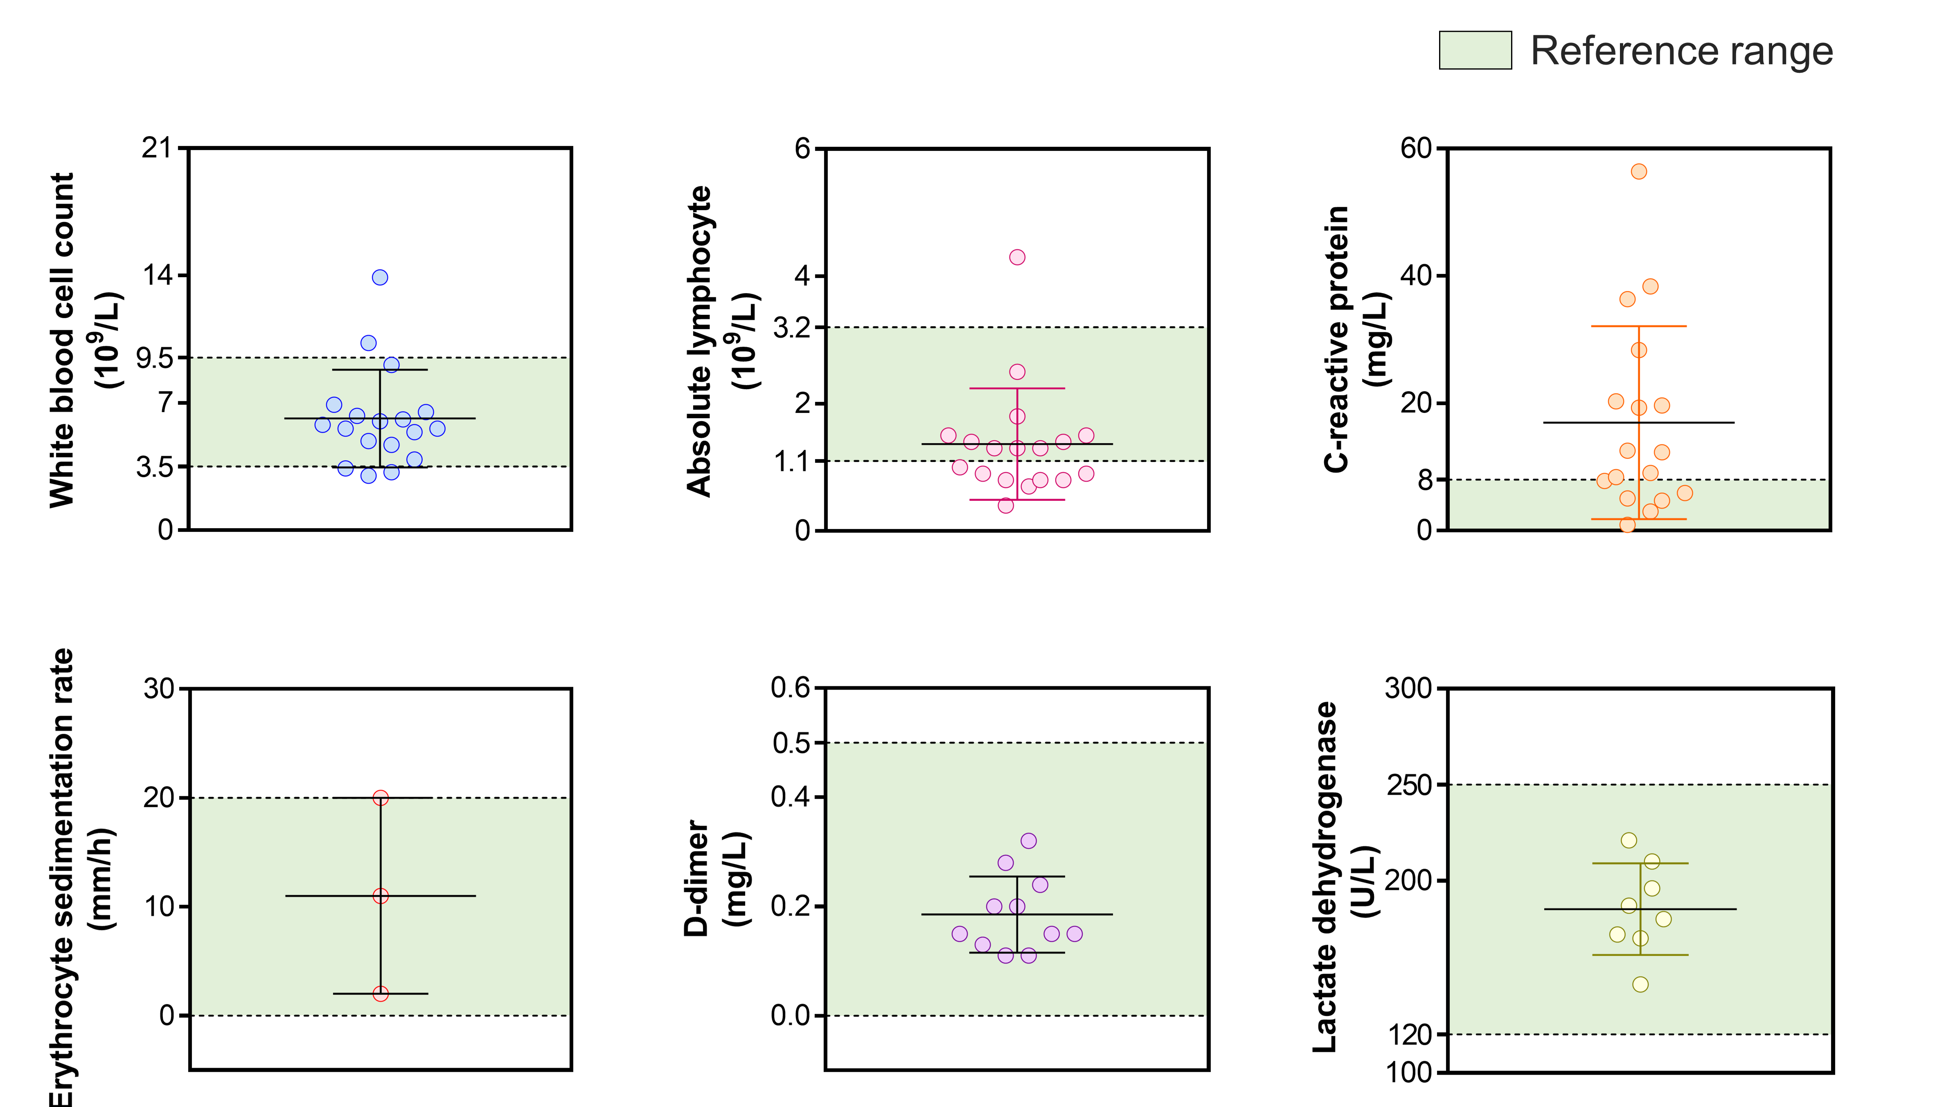
Supplementary Fig. S1 Serum indices of partial Omicron-infected inpatients in Group 3 at baseline.

Supplementary Fig. S2 The white blood cell count, absolute lymphocyte count and C-reactive protein level of Patient 45 at baseline and in therapy.

